Passover Lamb as a Type of Christ – 8 November 2018, Anno Domini

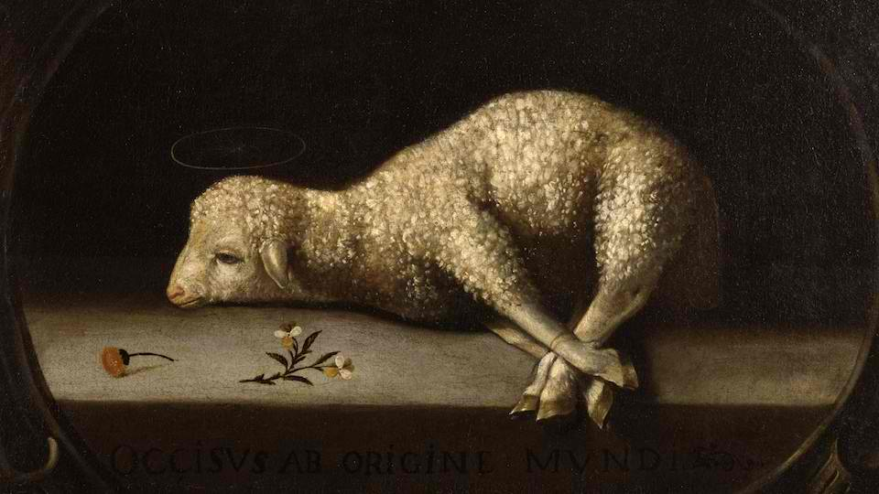

P
urge out therefore the old leaven, that ye may be a new lump, as ye are unleavened. For even Christ our passover is sacrificed for us: 8 Therefore let us keep the feast, not with old leaven, neither with the leaven of malice and wickedness; but with the unleavened bread of sincerity and truth. (1 Corinthians 5:7-8)

The typical aspects of the Passover Lamb to Christ are multitudinous. The extensive marks of similarity and exact congruence is beyond the scope of a single devotion, so I urge the Reader to please digest the beauty and grandeur of this Type through deeper study.

The Passover, inaugurated in the Land of Goshen in Egypt while the Children of Israel were subject to cruel bondage, was a signal Light from the Great Lighthouse of God to the Hebrew people, as well as to you and me, of His promise of Redemption to be made available in Christ. The effulgent beams of that Light swept the near and troubled Sea of the Hebrew people and beyond to the Pacific and Atlantic Waters of all races and tribes of people – even to those in the Islands of the Sea (who today sing praises to His Holy Name).

God often turns the assaults of the Devil back against him (by using the very means the Dark Prince employs) as a means of grace and salvation from it for His people. Due to the greed and cruelty of the Egyptians, Pharaoh had ordered all male children of the Israelites to be cast into the river Nile. The mother of Moses did, indeed, cast Moses into the River Nile, but in a small ark of bulrushes daubed with pitch and slime in order to save him. Pharaoh’s daughter was of a kind and loving disposition and, when she saw the baby in the ark, she took him for her own. Moses became the choice man of God, raised even in the very house of Pharaoh, to save His people from Pharaoh’s oppression. Moses became God’s ‘man for the time’ and obeyed God in his walk.

After sending forth nine terrible plagues against Egypt to persuade her king to release God’s people, God dictated new terms and a final plague for Moses to report to Pharaoh. Thus saith the LORD, About midnight will I go out into the midst of Egypt: And all the firstborn in the land of Egypt shall die, from the firstborn of Pharaoh that sitteth upon his throne, even unto the firstborn of the maidservant that is behind the mill; and all the firstborn of beasts. And there shall be a great cry throughout all the land of Egypt, such as there was none like it, nor shall be like it any more. (Ex 11:4-7) This would be the final plague God would send against Pharaoh, his household, and all of Egypt. But God always makes special provision for His people, and this time is no exception.

T
his month shall be unto you the beginning of months: it shall be the first month of the year to you. 3 Speak ye unto all the congregation of Israel, saying, In the tenth day of this month they shall take to them every man a lamb, according to the house of their fathers, a lamb for an house: 4 And if the household be too little for the lamb, let him and his neighbour next unto his house take it according to the number of the souls; every man according to his eating shall make your count for the lamb. 5 Your lamb shall be without blemish, a male of the first year: ye shall take it out from the sheep, or from the goats: 6 And ye shall keep it up until the fourteenth day of the same month: and the whole assembly of the congregation of Israel shall kill it in the evening. 7 And they shall take of the blood, and strike it on the two side posts and on the upper door post of the houses, wherein they shall eat it. And they shall eat the flesh in that night, roast with fire, and unleavened bread; and with bitter herbs they shall eat it. Eat not of it raw, nor sodden at all with water, but roast with fire; his head with his legs, and with the purtenance thereof. And ye shall let nothing of it remain until the morning; and that which remaineth of it until the morning ye shall burn with fire. And thus shall ye eat it; withyour loins girded, your shoes on your feet, and your staff in your hand; and ye shall eat it in haste: it is the LORD'S passover. For I will pass through the land of Egypt this night, and will smite all the firstborn in the land of Egypt, both man and beast; and against all the gods of Egypt I will execute judgment: I am the LORD. And the blood shall be to you for a token upon the houses where ye are: and when I see the blood, I will pass over you, and the plague shall not be upon you to destroy you, when I smite the land of Egypt. And this day shall be unto you for a memorial; and ye shall keep it a feast to the LORD throughout your generations; ye shall keep it a feast by an ordinance for ever. Seven days shall ye eat unleavened bread; even the first day ye shall put away leaven out of your houses: for whosoever eateth leavened bread from the first day until the seventh day, that soul shall be cut off from Israel. And in the first day there shall be an holy convocation, and in the seventh day there shall be an holy convocation to you; no manner of work shall be done in them, save that which every man must eat, that only may be done of you. And ye shall observe the feast of unleavened bread; for in this selfsame day have I brought your armies out of the land of Egypt: therefore shall ye observe this day in your generations by an ordinance for ever. In the first month, on the fourteenth day of the month at even, ye shall eat unleavened bread, until the one and twentieth day of the month at even. Seven days shall there be no leaven found in your houses: for whosoever eateth that which is leavened, even that soul shall be cut off from the congregation of Israel, whether he be a stranger, or born in the land. Ye shall eat nothing leavened; in all your habitations shall ye eat unleavened bread. (Ex 12:2-20)

That unblemished and innocent lamb, slain at first Passover, foreshadowed that innocent and perfect Lamb of God: Behold the Lamb of God, which taketh away the sin of the world. (John 1:29) This Passover was authenticated in Christ for He has become our Passover that we observe in the Lord’s Supper. If we are, like the Israelites in Goshen, covered under His blood, we shall not perish. The Cup (wine) of which we partake represents His warm and living blood that was shed for us. The unleavened bread (for the symbol must comport with that symbolized) represents His Body in all parts. The Passover Lamb was also foreshadowed by that animal which was the first death to cover the shame and sin of Adam and Eve eastward in the Garden at Eden. Christ was, like the unblemished lamb, without sin and an acceptable sacrifice for our sins.

The Passover Lamb was to be taken from the fold of other sheep just as Christ was made man and dwelt among us, and was taken from among us for the sacrifice at Calvary.

The Passover Lamb was to be one year old signifying its peak maturity. So was Christ at the peak of manhood slain for us. The Lamb was roasted whole just as was Christ crucified, pierced and recipient of the fire of God’s wrath. Our Lord, though wholly crucified, did not suffer a bone of His body to be broken.

The blood of the Passover Lamb was not to be allowed to spill upon the ground illustrating the preciousness of the blood of Christ which is to be revered. Just as the blood of the Passover Lamb was to be sprinkled upon the lintels and doorposts, so must Christ blood not only be shed wholly for us, but our consciences must be sprinkled by the notice of that blood. All who enter the house must see the blood of Christ as evidence of our salvation.

The flesh of the Passover Lamb was to be eaten in its entirety. So, must we feed upon Christ spiritually as our Bread of Life and drink His blood as a sacramental form and grace of His sacrifice. The Passover Lamb was to be eaten in one house symbolic of the ONE-NESS of the Body of Christ at the Communion, and at all times.

The sprinkling of the blood of the Lamb was to be done by dipping a cluster of hyssop into the blood to afford the sprinkling. Hyssop has many symbolic features. It will grow even on rock. The Christian will remain faithful even under hard oppression. Hyssop was used as a purgative to cleanse the inward body just as the blood of Christ first cleanses the inward heart, and then the outer.
The unleavened bread of the Passover symbolizes sinlessness, pure doctrine, and sincerity. Leaven symbolized the hypocrisy and false doctrine of the Pharisees. Christ is sinless, pure, and true. The symbol of bread we consume in the Supper should also reflect those qualities of Christ. O ye of little faith, why reason ye among yourselves, because ye have brought no bread? Do ye not yet understand, neither remember the five loaves of the five thousand, and how many baskets ye took up? Neither the seven loaves of the four thousand, and how many baskets ye took up? How is it that ye do not understand that I spake it not to you concerning bread, that ye should beware of the leaven of the Pharisees and of the Sadducees? Then understood they how that he bade them not beware of the leaven of bread, but of the doctrine of the Pharisees and of the Sadducees. (Matt 16:8-12)

The Passover symbolizes the coming of God’s people out of Egypt, or the spiritual bondage to sin. Christ, being our Passover, has freed us, too, from the yoke and bondage of sin.

The Passover Lamb was not to be eaten until all leaven (sin, hypocrisy, hate, impure hearts, grudges, etc) were removed from the house. We, too, should cleanse our hearts of all sin, ill-will, personal animosities – when we observe Holy Communion.

Next when you observe the Holy Communion (our present Passover) remember the first Passover in Egypt. Remember the blood over the doors and upon the door posts. Remember that we are spared the Angel of Death when we are in that blood-covenant relationship with Christ. Are you?

