First Death on Earth as a Type of Christ – 9 November 2018, Anno Domini

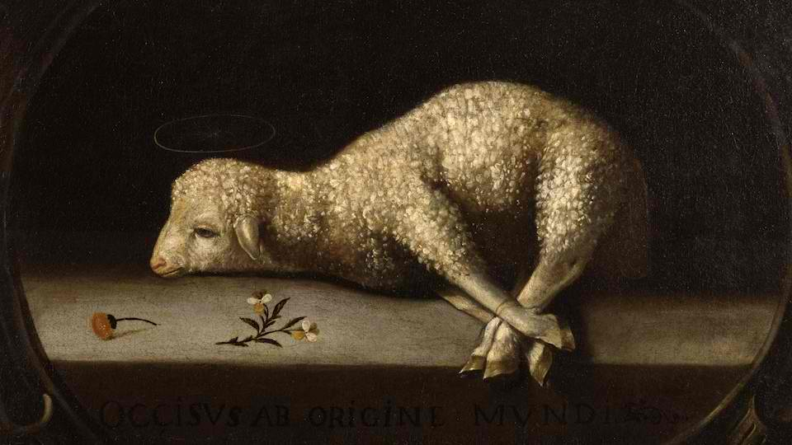

A
nd the LORD God called unto Adam, and said unto him, Where art thou? 10 And he said, I heard thy voice in the garden, and I was afraid, because I wasnaked; and I hid myself…………. 21 Unto Adam also and to his wife did the LORD God MAKE COATS OF SKIN, and clothed them. (Gen 3: 9-10, 21)

In reading this verse from Genesis 3:21, we must bear in mind that which has transpired most recently in the Garden at Eden. A full reading of the third chapter reveals that Eve was beguiled (deluded) by Satan (in the form of a serpent). She convinced Adam to share of the forbidden fruit from the cursed tree. Suddenly, Adam and Eve realized that they were naked. Such a consciousness had never occurred to them prior to partaking of the fruit from the Tree of the Knowledge of Good and Evil. So why were their eyes opened to their nakedness at this point? Disobedience is sin, and sin opens our eyes to our nakedness and depravity. But the answer to our hopelessness, sin tells us, is to cover ourselves with our own good works. “Go ahead, Adam, and sin. You can always cover your sins from the eyes of God!” But Adam could not cover his nakedness before God. It was a permanent condition, and only a temporary remedy, through the first death on earth, could be obtained from God.

A fig leaf is bloodless and inadequate, for there is no remission of sin without the shedding of blood. ….without shedding of blood is no remission. (Heb 9:22). The leaves of fig Adam and Eve made for the covering of their nakedness (sin) fell far short of the serious and bloody sacrifice necessary. If the wages of sin is death, the sacrifice must be by death of one not guilty of the sin if a covering is to be provided. At the very moment of Adam’s Fall, it became necessary for Christ to come unto us and die a humiliating and painful death on the cross at Calvary. The loving heart of God was crushed at that moment of Adam’s Fall. Of course, the provision had already been made, for all who would accept it, in the Councils of Heaven long before the Creation, yet, the actual event of Adam’s careless sin, leading to the necessary sacrifice of Christ, must have been a moment of great despondency in Heaven. It is doubtful that Adam was aware of the great price that his sin would entail, but his disobedience of a direct Commandment of God was gravely serious and one which Adam should have realized….and he did! Despite their every cunning effort to cover their nakedness with the flimsy inadequacies of a fig leaf, their labors were futile and hopeless. Hiding in the bushes availed no cover, either, from the penetrating eye of the Lord. We, too, often feel that we can sin more freely once we are outside the Garden Enclosed (the physical structure of the Church), but the Church is everywhere the people of God go, and there is no hiding from God.

Adam had proven his inability to remain faithful to God. Now, God must teach Adam the terrible consequences of sin. He did it so that hope could be consummated thousands of years in the sending of a Savior. But there must be a school of learning to be attended before that salvation could be understood and realized. Just as God had commanded the sacrifice of that first Passover Lamb in old Goshen, He would now teach Adam that a blood sacrifice was necessary to cover his nakedness. God found it necessary to sacrifice the first animal to die upon the earth (probably a lamb) to cover the nakedness of the two backslidden progenitors of the race.

21 Unto Adam also and to his wife did the LORD God make coats of skins, and clothed them Here begins the bloody sacrifices that would foreshadow and typify that once-and-for-all blood sacrifice of the Son of God upon a cross. If Adam could not keep ONE Commandment, God would give him TEN more, plus many entangling ordinances, to cause him to know that he was incapable of righteousness and needed a Savior to redeem him. That law of God, laid down in the Old Testament, became our school teacher to show us that we cannot be righteous – that we need a redeemer. That Law, owing to its demands of perfection, is a curse to all men. In fact, the very last word of the Old Testament (Books of the Law) is the word CURSE! We, like Adam, can never cover our own nakedness (sin). Someone guiltless of the smallest sin must be found to pay the sin penalty, which is death. That One and Only Person was Jesus Christ. He was the only One who was perfect in all of His ways, pure and sinless. Only such a One could bear our sins on the cross – and He did! Will you now turn in your fig leaf for that priceless Robe of Righteousness which Christ purchased for you at Calvary?

