Adam as a Type of Christ – 7 November 2018, Anno Domini

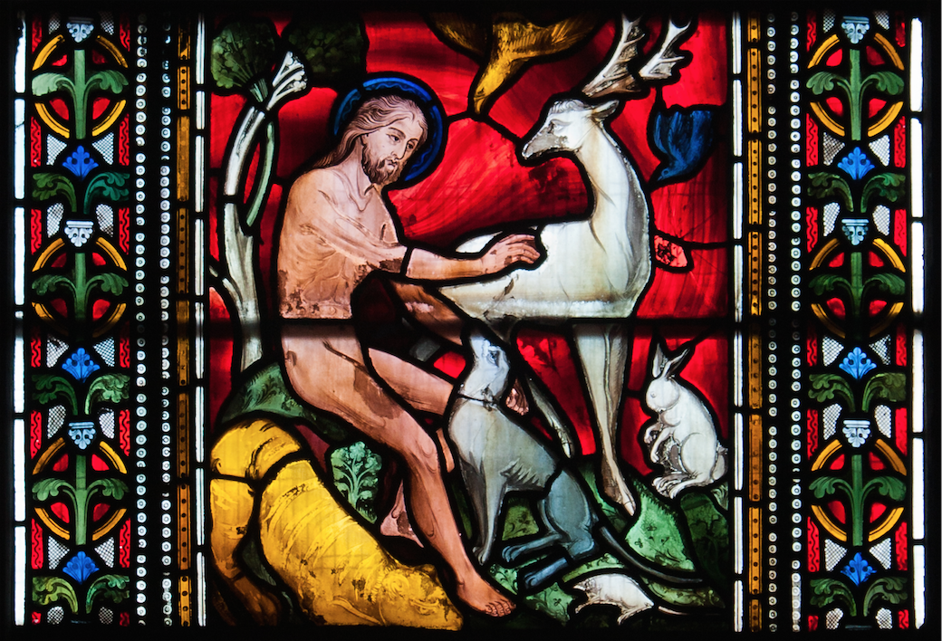

W
herefore, as by one man sin entered into the world, and death by sin; and so death passed upon all men, for that all have sinned: 13 (For until the law sin was in the world: but sin is not imputed when there is no law. 14 Nevertheless death reigned from Adam to Moses, even over them that had not sinned after the similitude of Adam's transgression, who is the figure of him that was to come. 15 But not as the offence, so also is the free gift. For if through the offence of one many be dead, much more the grace of God, and the gift by grace, which is by one man, Jesus Christ, hath abounded unto many. 16 And not as it was by one that sinned, so is the gift: for the judgment was by one to condemnation, but the free gift is of many offences unto justification. 17 For if by one man's offence death reigned by one; much more they which receive abundance of grace and of the gift of righteousness shall reign in life by one, Jesus Christ. (Romans 5:12-17)

There are many who take the Bible without the seriousness of discovering that the whole of the Word is of Christ and not just those words of the New Testament. It would be quite impossible to realize the full import of that first Easter (Paschal Feast) without knowing of that earthly Passover given in Goshen wherein the Angel of Death passed over all who were under the blood of the lamb, smeared over the lintels and upon the door posts. That innocent little lamb of Egypt was a type and figure of the true Lamb of God who was prophesied in that first Passover. All who are sealed under the Blood of the Lamb of God shall be passed over by that second death of the Judgment. As the beloved Matthew Henry (a true hero of the Word) has said: “Let us beware that we do not forget that the Old Testament and New Testament alike tell of Jesus. It can be truly said of the Bible: ‘The glory of God did lighten it, and the Lamb is the Light thereof. The name of Jesus, the supreme personality, the center of the world’s hope, is on every page.”
The TYPES that we are studying in no way measure up to that great Savior whom they represent in figure and example. They are given as lesser lights for us to understand that Greater Light that was to come in the process of time. If we are able to understand the brilliance of the sun, we may know that our God is comparable in extremity of light therewith. As Confucius once said, “Do you need proof of God? Does one light a candle to see the sun?”

We will turn our attention to the very first Type given of Christ in Scripture – the first man, Adam. Adam is almost a negative type of that which is represented in the Holy Jesus – but there are a number of overlapping characteristics in which they are the same.

W
herefore, as by one man sin entered into the world, and death by sin; and so death passed upon all men, for that all have sinned: 13(For until the law sin was in the world: but sin is not imputed when there is no law. 14 Nevertheless death reigned from Adam to Moses, even over them that had not sinned after the similitude of Adam's transgression, who is the figure of him that was to come. Condemnation came upon the entire human race as a result of the sin of the first man, Adam, our Grand Patriarch of the Race, and federal head of it. We, all being descended from Adam, inherit the DNA chromosome of sin we received from him. We are guilty for the blood in our veins for it is poisoned with sin. If our blood is poisoned to death, there is only one hope – a complete blood transfusion which is available only through Jesus Christ. We are told in the above passage that Adam is the FIGURE of Him who was to come. That One to come was Christ – the sinless One who was obedient unto the death of the Cross.

In what points does Adam prefigure our Lord Jesus Christ?
- Adam had no Father but God. There are two only genealogies of Christ given in Holy Scripture by detail. The first is found in Matthew 1 which begins at our Type for God in Abraham and descends DOWN to Christ. This signals that Christ is the Promised Seed who CAME DOWN. The second genealogy is found in Luke 3. In this genealogy, the author begins with Christ and goes through all of his progeny all the way back UP TO GOD. Christ is the only One who came DOWN from the Father and He is the only One who has ascended UP to the Father as clearly presented in these two genealogies. Which was the son of Enos, which was the son of Seth, which was the son of Adam, which was the son of God. (Luke 3:38) Adam, though the son of God, fell from that privileged place through willful sin. Adam was a son by creation – Christ by eternal generation.

- Adam was given dominion over the created world while Christ is given all power both in Heaven and in earth. Adam is the natural father of all humankind, lost in sin. The sin of Adam has been charged to all of his children born of woman. “….Wherefore, as by one man sin entered into the world, and death by sin; and so death passed upon all men, for that all have sinned.”Christ is the spiritual Father of all who have believed to the salvation of their souls. These are the children of the Promised Seed (Christ) whose righteousness is an “IMPUTED” righteousness belonging to Christ. 15 But not as the offence, so also is the free gift. For if through the offence of one many be dead, much more the grace of God, and the gift by grace, which is by one man, Jesus Christ, hath abounded unto many. 16 And not as it was by one that sinned, so is the gift: for the judgment was by one to condemnation, but the free gift is of many offences unto justification. 17 For if by one man's offence death reigned by one; much more they which receive abundance of grace and of the gift of righteousness shall reign in life by one, Jesus Christ I only desire ministers would have revealed these mysteries to my young mind while I was a lad. I was eager to know but was a victim of the adult mentality that believes such matters are beneath the understanding of children. We often sell our children short in failing to teach them at a challenging level.

- The first man, Adam, earned death for all mankind. Disease, death and sin came upon our race through Adam. For as in Adam all die, even so in Christ shall all be made alive. But every man in his own order: Christ the firstfruits; afterward they that are Christ's at his coming. (1 Cor 15:22-23) Though Adam did not fall down dead before the wretched Tree of the Knowledge of Good and Evil, his death was sealed at the moment he partook of the forbidden fruit (whatever it was). Though not physically, Adam was the first man to die spiritually. The second man, Christ, who died the same death for us (for He tasted death that we might live), is the first to arise, and He made it possible for all who believed to live eternally. This makes it possible for each believer to rise in Christ at the last trump.

- This fourth characteristic of Adam, in common with Christ, may set some aback. And Adam was not deceived, but the woman being deceived was in the transgression. (1 Tim 2:14) I am sure we have all read this verse before, but have we considered the ramifications? ADAM WAS NOT DECEIVED! So why did Adam partake of the forbidden fruit if he was not deceived? Could it be that Adam, like Christ, loved his bride so much that he was willing to share her fate and die the same death he knew she would suffer? Eve was the ONLY darling of Adam’s heart. Life in the Garden would have seemed near to meaningless without this precious gift that God had given. So Adam partook of the same deadly fruit as Eve, and perished with her! Adam sinned to join his bride in death. Christ, the all-righteous, was the sinless One who died in our stead to purchase an eternal life for His Bride, the Church.

I should make one point very clear: We actually inherit the sin NATURE from Adam. We are actually guilty by right of birth; but the IMPUTATION is valid insofar as righteousness is concerned of Christ. We are actually guilty as descendents of Adam, but we are only deemed righteous under the blood of Christ. We have no genuine righteousness on our own right, but we are privileged to lay claim to the righteousness of Christ through that righteousness being imputed to us. It is the righteousness of Christ that gets us into heaven. Our own sinful nature, inherited fromAdam, drives us into hell.

God, through His foreknowledge and perfect prerogative of predestination of all things, has brought to pass wonderful and true pictures that point us to His spotless, sinless, and glorious Son through the lives of those who have preceded Him. He has done so through the medium of types, figures, metaphors and allegories. Do you see the unsurpassed beauty of Christ in comparison with the desperate fall of Adam?
To which family do you now belong, Reader, for we must all belong to one or the other os these two? – Adam or Christ

