Ruth – Gleaning the Harvest - 25 September 2014, Anno Domini

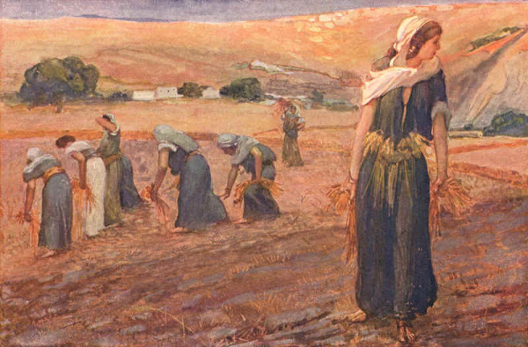

1 And Naomi had a kinsman of her husband's, a mighty man of wealth, of the family of Elimelech; and his name was Boaz. 2 And Ruth the Moabitess said unto Naomi, Let me now go to the field, and glean ears of corn after him in whose sight I shall find grace. And she said unto her, Go, my daughter. 3 And she went, and came, and gleaned in the field after the reapers: and her hap was to light on a part of the field belonging unto Boaz, who was of the kindred of Elimelech. (Ruth 2:1-3)

Indeed, Naomi had a kinsman who was a mighty man of wealth – Boaz. Boaz is a man of great power and influence and, most importantly, a near kinsman-redeemer to Naomi. Boaz, in this delightful pre-Gospel Book, is a type of the Lord Jesus Christ. Our Lord is King of Kings and Lord of Lords. Jesus is also our near Kinsman-Redeemer. But just as Boaz is not the man closest in relationship to Naomi, we too have a kinsman who is closer to us in our mortal births than Jesus - that man is the carnal man, Adam, from whom we have our direct and lineal descent. That kinsman must be dealt with first before Christ can be our Kinsman-Redeemer. Christ did, indeed, deal with that kinsman on the cross at Calvary. He defeated that death and sin to which we are heirs to through Adam.

Boaz, in the Hebrew, means a man of prompt action. The left pillar on the portico of the Temple of Solomon was also named Boaz. So Boaz is a Pillar of the Temple, but Christ is the Head thereof. Do not attribute the appearance of Boaz in our story to mere chance – it is the Providence and foreknowledge of God that places him in the way of Ruth and Naomi. God’s care for His people is not confined to our time calculations, but covers all of the earthly, and eternal, lives of His saints. We are never alone or without our Father’s provision and oversight.

This is the best time to examine the two leading characters, painted by the finger of God, for us in the Book of Ruth: “BOAZ is a type of Christ as the Lord of the Harvest, Redeemer and Bridegroom. RUTH is a type of the bride of Christ; a poor, penniless, helpless stranger, she became the happy bride of the lord of the harvest.” (Heslop, Rubies from Ruth). These are very real characters that prefigure for us the coming gospel truth. Let us examine in greater detail how Ruth and Boaz prefigure the Church and Christ:

*BOAZ:

- Boaz was a kinsman, for angels could not redeem.
- He was mighty, for a redeemer must be strong.
- He was wealthy, for redemption is costly.
- He was compassionate, for redemption is of grace.
- He came from Bethlehem, for the redeemer was to come from the house of bread.

*CHRIST:

- He too was a Kinsman-Redeemer, bone of our bone and flesh of our flesh, human and divine.
- He is mighty, for in Him was strength.
- He is wealthy, for He was the Creator of the universe;
- He is compassionate and kind,
- He is truthful and tender,
- He is good and gracious,
- He is sympathetic and strong.
- Christ, TOO, was born in Bethlehem.
*Rubies from Ruth, W.G. Heslop.

BOAZ and CHRIST loved unto death as Kinsmen-Redeemers. Of course, there is a profound difference between the two for Boaz redeemed Ruth only from the troubles of this life, but Christ redeems here and in Eternity – and all who are called and elected through grace by faith.

“And Ruth the Moabitess said unto Naomi, Let me now go to the field, and glean ears of corn after him in whose sight I shall find grace. And she said unto her, Go, my daughter.” What we call fate, God calls predestination. Unbeknown to either Boaz or Ruth, wealth and beauty are drawn together by the Mind of God. Ruth knows nothing of Boaz, or his fields. But her hand is a hand of diligence – not idle. She knows the conditions that she and her mother-in-law, Naomi, face. So she wastes no time in going into the fields to glean corn behind the reapers along with the poor of the city. You will note that Ruth, though beautiful, does not hesitate to subvert pride to necessity. She is not too proud to perform whatever labors are necessary for the two women’s sustenance. God likes that kind of soul very much, and He is already preparing a remedy for the straights of Ruth and Naomi. Perchance, said Ruth, I shall find grace. She knew not from what source, but believing Naomi’s God to be her Provision and help, she would find grace from some source. By the way, ALL grace comes from God. He may channel it through a Joseph, a Boaz, or His only Begotten Son.

It has been a custom in western and Middle Eastern countries for the poor to glean those grains of wheat or barley behind the reapers. There is always some portion left behind. Some compassionate landlords have even caused their servants to leave some extra for the poor. “And she went, and came, and gleaned in the field after the reapers.” Ruth may have appeared out of place gleaning among the poor. She was a young woman of class and breeding; yet, she did not consider herself above the common labors of the poor. In whatsoever state some folks find themselves, they are therein satisfied. One characteristic that distinguishes Ruth is that of satisfaction in whatever state she found herself. She could have remained in Moab with well-to-do parents and never soiled her hands; but love has driven her to gleaning in the fields among the poor. Loves sells itself for the object of its affection.

I literally LOVE the way God tells us of His preparation to bring Ruth and Boaz together: “. . . . and her hap was to light on a part of the field belonging unto Boaz, who was of the kindred of Elimelech.” Nothing in the works of God happen by accident! He foreordains and predestinates circumstances for His saints. There was not a slender thread of chance involved with the going of Ruth into the fields belonging to Boaz. If you remember back to the day that you surrendered your soul to Christ, does any part of that meeting of surrender seem to have been happenstance? I do not think so. Jesus saw Nathaniel as a baby under the fig tree while his mother was working the fields. God knew Jeremiah (and you and me) while he was yet unborn. Jesus, before meeting a certain Woman at Jacobs Well, “must needs go through Samaria.” We judge all things by the present razor-thin instant of time; but God judges from the beginning to the end, and all points in between.

This story happened a little more than three thousand years ago, but it was the way God chose to inform us, in advance, of the grace, compassion, and redemption that would also be offered in His Son, Jesus Christ. It did not fall the hap of Jesus to be born in Bethlehem – it was foreordained from before the foundation of the world. So, too, was your coming to Him. He knew you before you knew yourself. You did not choose Him, He chose YOU! Ye have not chosen me, but I have chosen you, and ordained you, that ye should go and bring forth fruit, and that your fruit should remain: that whatsoever ye shall ask of the Father in my name, he may give it you. (John 15:16)

God is a loving Father who shows us pictures of what to expect in this life, and in His Kingdom. Do you love to see the pictures, or do you turn away in boredom? Do you eagerly seek His counsel at the first light of day, or do you depend upon a single weekly sermon to feed your starving soul? I hope you will read ahead in the Book of Ruth so that we may examine together the beauty of this lustrous gem in the midst of sands of judgment and sin.

