Psalm 22 - Introduction – 19 March 2015, Anno Domini

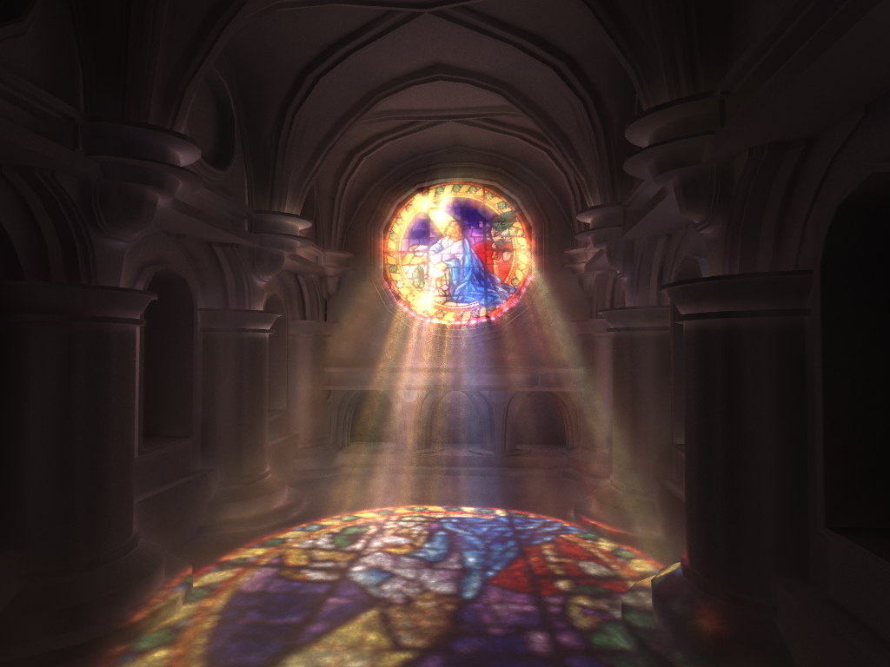

12 Therefore also now, saith the LORD, turn ye even to me with all your heart, and with fasting, and with weeping, and with mourning: 13 And rend your heart, and not your garments, and turn unto the LORD your God: for he is gracious and merciful, slow to anger, and of great kindness, and repenteth him of the evil. (Joel 2:12-13)

23 Oh that my words were now written! oh that they were printed in a book! 24 That they were graven with an iron pen and lead in the rock for ever! 25 For I know that my redeemer liveth, and that he shall stand at the latter day upon the earth: 26 And though after my skin worms destroy this body, yet in my flesh shall I see God: 27 Whom I shall see for myself, and mine eyes shall behold, and not another; though my reins be consumed within me. 28 But ye should say, Why persecute we him, seeing the root of the matter is found in me? 29 Be ye afraid of the sword: for wrath bringeth the punishments of the sword, that ye may know there is a judgment. (Job 19:23-29)

Job lamented he hoped his words could be written and printed in a book – which they ARE! Or, that pen was an IRON pen and written in a rock FOREVER. Need I tell you that his words truly are? They are written in the annals of both Heaven and Earth and are the immutable Word of God though expressed by His man, Job. But this devotion is not about Job, but about the Lord Jesus Christ.

This being the season of Lent, I have decided to conduct a devotional study of Psalm 22 which is classified as a Messianic Psalm. Many of you will already know that a Messianic Psalm is one which is about our Lord Jesus Christ. As you may know, Jesus quoted from the Psalms more than any other book. He even quoted from the first lines of Psalm 22 from the cross at Calvary: “Eli, Eli, lama sabachthani? that is to say, My God, my God, why hast thou forsaken me?” (Matt 27:46) Our old friend and ancient man of the cloth, John Donne, describes the Psalms in these words: “How abundantly is that word Blessed multiplied in the Book of Psalms! The book seems to be made out of that word, and the foundation raised upon that Word, for it is the first word of the book. But in all the book there is not one Woe”

Job, in the leading quote, speaks of his Redeemer – OUR Redeemer – and that He would stand in the latter days upon the earth. It is true that our Redeemer did stand upon the earth in these latter days. And Job expects to see Him face to face even in His flesh. That also is an accomplished fact in the resurrection. But our redemption was not an accomplished fact until Christ paid the full price for our sins.

At the beginning of the Lenten Season on Ash Wednesday, droves of professing Christians flocked to churches to have a little dab of ash smeared on their foreheads for all to see that they were fasting and pious people. Many of the same could awkwardly be witnessed at the local fast foods restaurants moments later to break that fast which they had, earlier the same day, so proudly professed. I wonder how much more of our worship facades are made of similar gossamer fabric?

So why do we consider Psalm 22 so appropriate for BOTH Lent and Easter? It is because the first 21 verses of Psalm 22 are about our Lord’s suffering and passion on the cross. Beginning at verse 22, the remainder of the Psalm is about His glorious victory over death and hell.

This Psalm is a Psalm of David, but David speaks the very words of Christ as do all prophets of the Lord. The title of the Psalm gives evidence of its direct application to Christ – “To the chief Musician upon Aijeleth Shahar, A Psalm of David.” Aijeleth Shatar, in Hebrew, means Hind of the Morning, which Christ was also called. The Hebrew, tlya 'ayeleth, = Hind and rxX Shachar = Morning, or dawn. The description by Robert Hawker in Poor Man’s Commentary: “Is not Christ discoverable in the very title of this Psalm? For who is the Hind of the Morning but Jesus? Aijeleth Shahar means Hind of the Morning, and so is rendered in the margin of our old Bibles. Sweet thought! Jesus was so from the everlasting morning, when set up from everlasting. And when in time, was he not hunted and slaughtered by the dogs spoken of in this Psalm?”

Make haste, my beloved, and be thou like to a roe or to a young hart (hind) upon the mountains of spices. (Song 8:14)

Please consider the circumstances that existed moments before the ordeal of Christ on the cross. Usually, when one is about to face serious surgery, or some other life-threatening ordeal, he is encouraged by his friends as he goes into the operating room. But this was not the case with the Lord Jesus Christ. He had, the night before, been betrayed by Judas. After the Last Supper, He went into the Garden of Gethsemane. He asked His three closely held disciples – Peter, James, and John – to watch with Him while He went a distance away to pray. My soul is exceeding sorrowful, even unto death: tarry ye here, and watch with me. (Matt 26:38) Three times, He found them sleeping rather than watching. 40 And he cometh unto the disciples, and findeth them asleep, and saith unto Peter, What, could ye not watch with me one hour? 41 Watch and pray, that ye enter not into temptation: the spirit indeed is willing, but the flesh is weak. 42 He went away again the second time, and prayed, saying, O my Father, if this cup may not pass away from me, except I drink it, thy will be done. 43 And he came and found them asleep again: for their eyes were heavy. 44 And he left them, and went away again, and prayed the third time, saying the same words. 45 Then cometh he to his disciples, and saith unto them, Sleep on now, and take your rest: behold, the hour is at hand, and the Son of man is betrayed into the hands of sinners. 46 Rise, let us be going: behold, he is at hand that doth betray me. (Matt 26:40-46)

These betrayals and complacent behaviors must have greatly saddened the heart of our beloved Lord. But there were other desertions to follow. Each of His disciples abandoned Him at the most crucial point of His ministry that night in the Garden. 50 And they all forsook him, and fled. (Mark 14:50) Then, Peter cowardly denied His Lord three times the night of His Trail. On the third denial, we read: 60 And Peter said, Man, I know not what thou sayest. And immediately, while he yet spake, the cock crew. 61 And the Lord turned, and looked upon Peter. And Peter remembered the word of the Lord, how he had said unto him, Before the cock crow, thou shalt deny me thrice. 62 And Peter went out, and wept bitterly. (Luke 22:60-62) Perhaps we, too, should weep bitterly in our cowardly denials of our Lord through our actions, thoughts, and even our sins of omission.

These are the memories that are vividly before the Mind of our Lord as He was nailed to the cruel cross. But those thoughts were not all that was on the Mind of Christ – you and me, and every child future and past, were on His Mind at Calvary that fateful day in the beginning of Passover.

The opening verse reads, “My God, my God, why hast thou forsaken me? why art thou so far from helping me, and from the words of my roaring?” (v. 1) See how this echo precisely the words of Christ from the cross: “My God, my God, why hast thou forsaken me? (Matt 27:46 & Mark 15:44)

Before continuing to the next devotional on this Psalm, I request that the reader study at least the first 21 verses of Psalm 22. As you read, try to detect the marks of Christ abundantly scattered throughout.

As we read, we should bear in mind that in His human form, Jesus experienced all of the pain, and more, of the human condition. Though He held great dread of the humiliating circumstances of the cross, and pitifully expressed those dreads in His prayer the Night in the Garden – and from the cross itself – His faith never failed though His heart and soul were hurt by the pain of our sins and our rejection. I have expressed the events of that Garden experience in the following poem:

Night in the Garden
By Bishop Jerry Ogles
Judas then, having received a band of men and officers from the chief priests and Pharisees, cometh thither with lanterns and torches and weapons. John 18:3

Out of the darkest Halls of Hell
Came the marchers with torches raised.
Into the Garden quiet and still
They wandered forlorn and crazed.

Up to the Sovereign Lord of Love
Their spears shining bright in the mist
With arrogant air and a hateful shove
They took Him who wouldn’t resist.

Now to the head of Scribe and Priest
Was the Savior led that night,
And to Herod’s Court and Pilate’s Seat
Where Right gave way to the Night.

To the craggy heights of the Lonely Skull
They took Him and laid Him down
And into His Hands of Love they drove
Iron spikes with a terrible Sound!

On His Brow a thorny Crown He wore
And His flesh was torn and bruised.
His Heart of Grace grew cold and sore
As the Spirit of Life was loosed.

The world of woe a Hope has found
In the Promise made sure by His Death
And the Saints of God with Faith abound
In the Fields that their Lord has blessed!
Amen

PSALM 22
To the chief Musician upon Aijeleth Shahar, A Psalm of David.

1 My God, my God, why hast thou forsaken me? why art thou so far from helping me, and from the words of my roaring?
2 O my God, I cry in the daytime, but thou hearest not; and in the night season, and am not silent.
3 But thou art holy, O thou that inhabitest the praises of Israel.
4 Our fathers trusted in thee: they trusted, and thou didst deliver them.
5 They cried unto thee, and were delivered: they trusted in thee, and were not confounded.
6 But I am a worm, and no man; a reproach of men, and despised of the people.
7 All they that see me laugh me to scorn: they shoot out the lip, they shake the head, saying,
8 He trusted on the LORD that he would deliver him: let him deliver him, seeing he delighted in him.
9 But thou art he that took me out of the womb: thou didst make me hope when I was upon my mother's breasts.
10 I was cast upon thee from the womb: thou art my God from my mother's belly.
11 Be not far from me; for trouble is near; for there is none to help.
12 Many bulls have compassed me: strong bulls of Bashan have beset me round.
13 They gaped upon me with their mouths, as a ravening and a roaring lion.
14 I am poured out like water, and all my bones are out of joint: my heart is like wax; it is melted in the midst of my bowels.
15 My strength is dried up like a potsherd; and my tongue cleaveth to my jaws; and thou hast brought me into the dust of death.
16 For dogs have compassed me: the assembly of the wicked have inclosed me: they pierced my hands and my feet.
17 I may tell all my bones: they look and stare upon me.
18 They part my garments among them, and cast lots upon my vesture.
19 But be not thou far from me, O LORD: O my strength, haste thee to help me.
20 Deliver my soul from the sword; my darling from the power of the dog.
21 Save me from the lion's mouth: for thou hast heard me from the horns of the unicorns.
22 I will declare thy name unto my brethren: in the midst of the congregation will I praise thee.
23 Ye that fear the LORD, praise him; all ye the seed of Jacob, glorify him; and fear him, all ye the seed of Israel.
24 For he hath not despised nor abhorred the affliction of the afflicted; neither hath he hid his face from him; but when he cried unto him, he heard.
25 My praise shall be of thee in the great congregation: I will pay my vows before them that fear him.
26 The meek shall eat and be satisfied: they shall praise the LORD that seek him: your heart shall live for ever.
27 All the ends of the world shall remember and turn unto the LORD: and all the kindreds of the nations shall worship before thee.
28 For the kingdom is the LORD'S: and he is the governor among the nations.
29 All they that be fat upon earth shall eat and worship: all they that go down to the dust shall bow before him: and none can keep alive his own soul.
30 A seed shall serve him; it shall be accounted to the Lord for a generation.
31 They shall come, and shall declare his righteousness unto a people that shall be born, that he hath done this.

