Devotion on Firsts of the Bible - First to Descend and Ascend of Heaven – 30 December 2015, Anno Domini

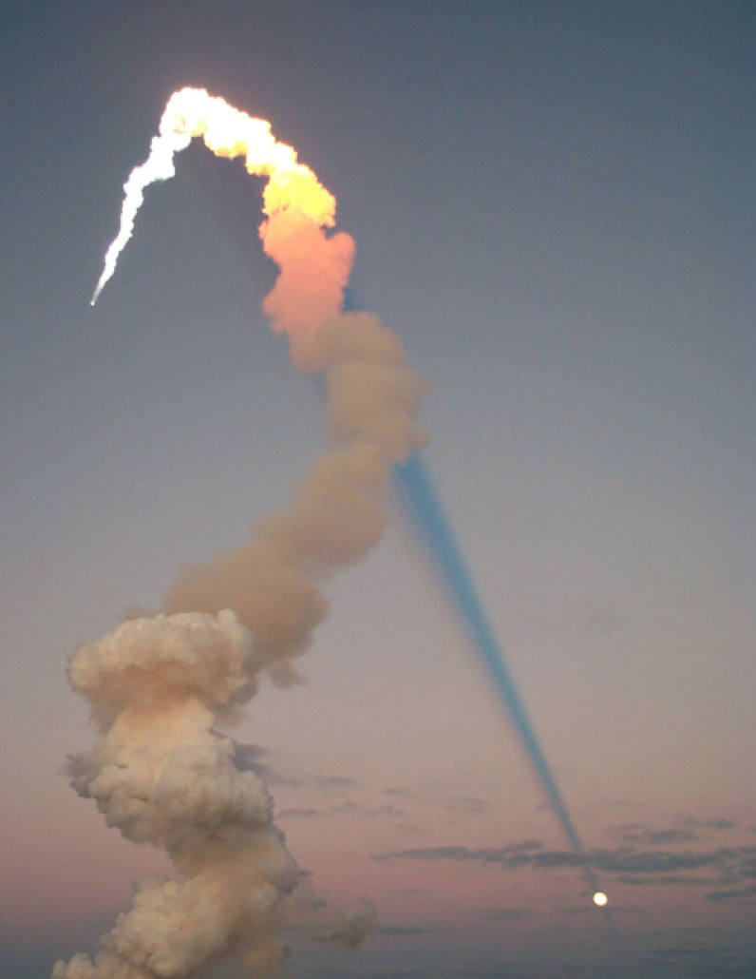

Now that he ascended, what is it but that he also descended first into the lower parts of the earth? He that descended is the same also that ascended up far above all heavens, that he might fill all things. (Eph 4:9-10)

And no man hath ascended up to heaven, but he that came down from heaven, even the Son of man which is in heaven. (John 3:13)

Our Lord probably spoke to correct a false notion among the Jews, viz. that Moses had ascended to heaven, in order to get the law. It is not Moses who is to be heard now, but Jesus: Moses did not ascend to heaven; but the Son of man is come down from heaven to reveal the Divine will.

That came down—The incarnation of Christ is represented under the notion of his coming down from heaven, to dwell upon earth.

Which is in heaven—Lest a wrong meaning should be taken from the foregoing expression, and it should be imagined that, in order to manifest himself upon earth he must necessarily leave heaven; our blessed Lord qualifies it by adding, the Son of man who is in heaven; pointing out, by this, the ubiquity or omnipresence of his nature: a character essentially belonging to God; for no being can possibly exist in more places than one at a time, but HE who fills the heavens and the earth. Adam Clarke's Commentary

If there was ever any justification for self-flagellation as the Roman Catholics and Moslems practice, it would seem justifiable for any who purchased books of some conniving fool relating how they spent 90 minutes in Heaven or Hell and now came back to publish a book relating their experiences (for a handsome profit, of course.) I feel myself on solid ground to state, unequivocally, that anyone who winds up in Hell will not get out, and anyone who winds up in Heaven had better stay there for there is only one other destination for the dead.

Our Lord Jesus Christ is the Word from everlasting to everlasting. He was the Word when the worlds and universes were not yet made; He was the Word at the early dawn of that Creation Morning in Genesis 1; He is the Word that was made flesh and dwelt among us; and He is the Word that shall judge the world (a time unknown to any mortal) at God's own time and discretion. Here are some related verses for your perusal:

In the beginning was the Word, and the Word was with God, and the Word was God. The same was in the beginning with God. All things were made by him; and without him was not any thing made that was made. In him was life; and the life was the light of men. And the light shineth in darkness; and the darkness comprehended it not. (John 1:1-5)

That was the true Light, which lighteth every man that cometh into the world. He was in the world, and the world was made by him, and the world knew him not. He came unto his own, and his own received him not. But as many as received him, to them gave he power to become the sons of God, even to them that believe on his name: Which were born, not of blood, nor of the will of the flesh, nor of the will of man, but of God. And the Word was made flesh, and dwelt among us, (and we beheld his glory, the glory as of the only begotten of the Father,) full of grace and truth. (John 1:9-14)

And he that sat upon the throne said, Behold, I make all things new. And he said unto me, Write: for these words are true and faithful. And he said unto me, It is done. I am Alpha and Omega, the beginning and the end. I will give unto him that is athirst of the fountain of the water of life freely. He that overcometh shall inherit all things; and I will be his God, and he shall be my son. (Rev 21:5-7)

Our Lord did not have to leave His glorious estate in Heaven and come as a little baby of poor and common parents. He did not have to come and suffer the rejection, the hate, the scorn, the beatings, the cursings, and the cross at Calvary; but He did! He did so out of a divine love for those of us who were at enmity with God (and that is ALL of us) that we might be reconciled with the Father and be One with Him, as He is One with the Father. He came down to a place of perversity and poverty from the regal robes and accommodations of Heaven - for you and me, and all the elect of God. That is an unfathomable love beyond our frail comprehension!

He came down as a baby, born of a virgin, whose comings had been foretold from the Garden at Eden to Bethlehem. He was at once, even as a baby, hated by the powers of Judea - in fact, King Herod had all babies of two years age and below murdered (to be certain that Jesus was included) out of jealous rage. The jealous rage of Herod was not confined to him alone, but to the religious leaders - the big preachers of the day - as well. None wanted the comforts of their sordid little gilted nests of spiritual straw and fur to be disrupted. As prophesied of old, He was carried down into Egypt. When Israel was a child, then I loved him, and called my son out of Egypt. (Hosea 11:1), and, When he arose, he took the young child and his mother by night, and departed into Egypt: And was there until the death of Herod: that it might be fulfilled which was spoken of the Lord by the prophet, saying, Out of Egypt have I called my son. (Matt 2:14-15)

The biblical account provides for no man ever descending from Heaven to earth. The only man who was not born here was Adam, and he was CREATED here. But the Son of Man, being the Son of God, did so descend and was made flesh subject to all of the pain, miseries, struggles, and temptations of us all. But he possessed not the sin-tainted blood of Adam, and was sinless throughout His earthly journey. He was the FIRST to descend, and He shall be the FIRSTS to ascend! In the process of God's timing, we shall all ascend who are the Elect of God; but that would never have been possible if Christ did not make it so. Who hath delivered us from the power of darkness, and hath translated us into the kingdom of his dear Son: In whom we have redemption through his blood, even the forgiveness of sins: Who is the image of the invisible God, the firstborn of every creature: For by him were all things created, that are in heaven, and that are in earth, visible and invisible, whether they be thrones, or dominions, or principalities, or powers: all things were created by him, and for him: And he is before all things, and by him all things consist. And he is the head of the body, the church: who is the beginning, the firstborn from the dead; that in all things he might have the preeminence. (Col 1:13-18)

For every physical creature of God's Creation, He made a progenitor - whether of fish of the sea, or land mammals, or trees of the forest. And there must needs be a progenitor of the glorified body and life that is destined for Heaven. Jesus Christ is the First Born of all who are of the family of God. As He died on the cross for our sins, we die to sin and are made alive in Him. As He carried His cross, literally, all the years of His journey among us, we bear our crosses in following Him. Dying to self and living for God, we also have part in the Kingdom of God which was purchased by His glorious blood. As He rose from the dead, so have, and will, we. As He ascended to Heaven, so shall those who have followed Him thus far.

He descended as a baby, and ascended as the Savior of the World; but He shall descend once more to receive His own and to judge the world and those who rejected so great a redemption.

He ascended up from the mount of Bethany: And he led them out as far as to Bethany, and he lifted up his hands, and blessed them. And it came to pass, while he blessed them, he was parted from them, and carried up into heaven. (Luke 24:50-51) As He ascended, a cloud received Him (blessed cloud). And He shall come again in just the same way, but with the Hosts of Heaven in trail. And when he had spoken these things, while they beheld, he was taken up; and a cloud received him out of their sight. And while they looked stedfastly toward heaven as he went up, behold, two men stood by them in white apparel; Which also said, Ye men of Galilee, why stand ye gazing up into heaven? this same Jesus, which is taken up from you into heaven, shall so come in like manner as ye have seen him go into heaven. (Acts 1:9-11) On this last ascension, only those who loved Christ were privileged to see His Ascent; but on His return, every eye shall behold Him. And I saw heaven opened, and behold a white horse; and he that sat upon him was called Faithful and True, and in righteousness he doth judge and make war. His eyes were as a flame of fire, and on his head were many crowns; and he had a name written, that no man knew, but he himself. And he was clothed with a vesture dipped in blood: and his name is called The Word of God. And the armies which were in heaven followed him upon white horses, clothed in fine linen, white and clean. And out of his mouth goeth a sharp sword, that with it he should smite the nations: and he shall rule them with a rod of iron: and he treadeth the winepress of the fierceness and wrath of Almighty God. And he hath on his vesture and on his thigh a name written, KING OF KINGS, AND LORD OF LORDS. (Rev 19:11-16)

WARNING! There is no such thing as a 'casual believer.' Either you believe unto salvation, or you fall short. Which are you, friend?

