Devotion on Firsts of the Bible - First and Only Prophet Swallowed by a Whale – 9 September 2015, Anno Domini

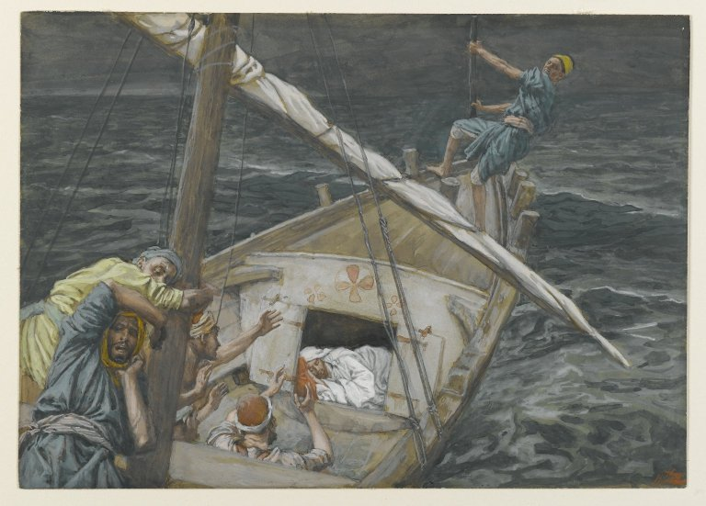

… Jonah was gone down into the sides of the ship; and he lay, and was fast asleep…

Part Three – The Storm Cometh

4 But the LORD sent out a great wind into the sea, and there was a mighty tempest in the sea, so that the ship was like to be broken. 5 Then the mariners were afraid, and cried every man unto his god, and cast forth the wares that were in the ship into the sea, to lighten it of them. But Jonah was gone down into the sides of the ship; and he lay, and was fast asleep. 6 So the shipmaster came to him, and said unto him, What meanest thou, O sleeper? arise, call upon thy God, if so be that God will think upon us, that we perish not. 7 And they said every one to his fellow, Come, and let us cast lots, that we may know for whose cause this evil is upon us. So they cast lots, and the lot fell upon Jonah. 8 Then said they unto him, Tell us, we pray thee, for whose cause this evil is upon us; What is thine occupation? and whence comest thou? what is thy country? and of what people art thou? 9 And he said unto them, I am an Hebrew; and I fear the LORD, the God of heaven, which hath made the sea and the dry land. 10 Then were the men exceedingly afraid, and said unto him, Why hast thou done this? For the men knew that he fled from the presence of the LORD, because he had told them. (Jonah 1:4-10)

All reversals in life are not necessarily sponsored by our Adversary the Devil – many are sent by God to correct our course and set us on the right path. Jonah has a direct calling of God to go DIRECTLY into a certain city. Jonah does not doubt the word of the Lord to go to Nineveh, but, instead, he disagrees with the Lord. He is self-willed and headstrong against going to his enemies with the warning that God desires to issue against that "Great City." It is a comfort to know that our Lord Jesus Christ did not forbear to come down into a world of sin and darkness in which all men were at enmity with His Father. Ye adulterers and adulteresses, know ye not that the friendship of the world is enmity with God? whosoever therefore will be a friend of the world is the enemy of God. (James 4:4) Jonah may have conceivably justified his disobedience in the proud supposition that he (Jonah) knew better about how to handle the enemies of his God then did God. The shrewd machinations of the mind are so very inclined to rationalize away every thought and deed that is contrary to the will of God.

It should be noted going down to Joppa, or even to Nineveh, is not a wrong direction if done in accordance with the perfect will of God. God sent Moses DOWN into Egypt (symbolically the land of sin) not to join with the sinners, but to bring the people of God out from among them. Perhaps our modern pulpits should be more animated to bring God's people out from among the luke-warm church and into the church that worships in faith and reverence. Jesus, too, came the greatest distance down of any to save us, not to become like us. So many moderns are attempting to redefine Christ and make Him like unto them rather than becoming more like Him. But whether to a higher elevation, or a lower one, any who depart from the will of God are headed DOWN on the road to destruction.

Jonah is feeling quite content in his rebellion as we open our study today. He has gone down from Jerusalem to Joppa which, he believes, is taking him further out of the Presence of God. He has arrived and even found the very ship that he believes will complete his escape. Being a man of God, Jonah should realize that God is in every place, and that He is the Master of the Seas as well as the Sovereign of the Land. He has purchased a ticket that may have been at such a bargained price as to make any Jew happy. Little does Jonah know that the ticket may be the most costly he will ever purchase even it if does provide a free ride in the depths of the sea aboard a great fish. He has gone DOWN into the ship, and the sails have been unfurled, and the anchor weighed. All is well for the Judean redneck, Jonah. He may have thought, "It can't get any better than this." The ship slides smoothly out of port and is underway. "Mission accomplished, right?" WRONG! Jonah is sailing more into the Presence of God than he had ever been on the heights of Jerusalem. God is displeased with Jonah. It is a terror to sail into the Seas of the Displeasure of the Lord; but the Winds of God are alluring the ship, along with Jonah, and its many innocent souls to the very place where God will finally deal with Jonah. Unaware of the coming storm, Jonah is sleeping like a baby. He has been willing to change his entire life and circumstances in order to escape the Word of God. He will fare well, he believes, on the coast of far away Tarshish (Spain).

About a decade ago, a missionary was traveling with his two young sons through a village on the east coast of southern India (not far from Mumbai). He was tired of the long drive as darkness descended. He parked in a village on the coast to sleep. It was a place well-lit and one which he believed offered the greatest safety. The Hindu villagers were agitated by their religious leaders to proceed with a devilish plan to murder the missionary and his children. They silently poured gasoline on the car, held the doors closed with poles, and set the automobile on fire burning its three struggling occupants to death. Even as they did so, and unbeknownst to them, a great storm was brewing opposite the village and across the Bay of Bengal. That typhoon sustained 50 ft waves that destroyed the village and coastal region associated therewith the next morning. The villagers believed that act of nature was also an act of the vengeance of Nature's God. They resolved never again to murder any persons of faith. God is always alert and acting even if we believe we have escaped the penalties of our sins. So, Jonah sleeps.

4 But the LORD sent out a great wind into the sea, and there was a mighty tempest in the sea, so that the ship was like to be broken. The word 'BUT' in the Scriptures is a most powerful word. Jonah is fine and dandy, sleeping in peace and satisfaction, yet, here comes the word 'BUT.' Were it not for that 'BUT' Jonah may have gone all the way to Tarshish. God always has a 'BUT' for our ungodly schemes. Remember our old VFW comrade, Naaman? Now Naaman, captain of the host of the king of Syria, was a great man with his master, and honourable, because by him the LORD had given deliverance unto Syria: he was also a mighty man in valour, Yes, he was. He was very great and powerful. He commanded one of the greatest armies of the day. He was mighty and courageous - a man of valor! If the sentence ended there, all would be fine in Naaman's life, but wait, there is that troubling little 'BUT' at the end of the verse: but he was a leper. (2 Kings 5:1) No matter the shining armor, or silk robes that Naaman wore, he was in constant fear that someone would detect the fowl odor of leprosy that afflicted his body. All of the perfume in Asia would not cover that stench of leprosy, nor all the flattering gestures of polished men cover their sins. Now comes the little unexpected counseling session that the Lord has scheduled for Jonah. The storm was sent out by the Lord, not by happenstance. Bear in mind, though Jonah was in rebellion against God, God did not give up on Jonah even if He had to teach him a harsh lesson.

The tumultuous waves that accompany a storm at sea can be most terrifying to a landlubber, but, in this case, it was of such severity as to strike terror into the hearts of seasoned sailors. It was beyond their human skills to master this storm. It threatened their very survival as the ship itself was in danger of shipwreck at sea. 5 Then the mariners were afraid, and cried every man unto his god, and cast forth the wares that were in the ship into the sea, to lighten it of them. But Jonah was gone down into the sides of the ship; and he lay, and was fast asleep. Unbelievably, as the seaman struggled against the oars, the sails, and the rudder, Jonah, the most guilty of the party, slept. He was the cause of the storm. You will remember that our good Lord also slept on the Galilean Sea during such a storm; but the difference was this: Jonah was the CAUSE of the storm, and Jesus was the REMEDY for it.

When the storms of life assail, it is time to get rid of those little sins that have appealed so greatly to us so that we might ride out the storm. These poor mariners knew not the true God, so they called upon whatever gods they imagined might be of help in their desperation. It is very likely that these weather-worn men were never so 'religious' than at this hour of danger and impending doom. How remiss we are in allowing those whom we greet on the street to go on in life unaware of the true God who is able and ready to answer prayer. Jonah had not only gone DOWN into the ship, but once aboard, he went further DOWN into the hull to sleep. A troubled conscience may find a temporary respite in the immediate aftermath of pleasurable sin, but he may be awakened in the terror of the storm.

6 So the shipmaster came to him, and said unto him, What meanest thou, O sleeper? arise, call upon thy God, if so be that God will think upon us, that we perish not. The rough, shipmaster was more concerned for Jonah than Jonah was concerned for all others aboard. Perhaps the shipmaster had a glimpse of brilliant revelation in the God of a man who could sleep through such a terrifying storm. If we have gone away from God and hit upon a storm, it is time to pray! The shipmaster did not make reference to his gods, but to Jonah's God. He is the one who, if He "will think upon us" can save us from perishing. Somehow, the shipmaster realized this in a moment of grave danger. God uses often an unlearned man to awaken His own who know, yet act in rebellion.

7 And they said every one to his fellow, Come, and let us cast lots, that we may know for whose cause this evil is upon us. So they cast lots, and the lot fell upon Jonah. God does not gamble. With him, there is nothing left to chance or to the casting of lots, but God uses the occasion to allow the casting of lots to be His Finger of Revelation to the seaman. The ominous Finger pointed to Jonah! If a perceived chance is taken, and the result is confirmed in proof, then the lot was not by chance but of God. The seaman realized that. So the prophet of the Lord is reduced to cringing in his bed robes while his treasonous flight is revealed even to those who know not the Lord our God. How pitiful and how demeaning!

8 Then said they unto him, Tell us, we pray thee, for whose cause this evil is upon us; What is thine occupation? and whence comest thou? what is thy country? and of what people art thou? These rude men knew that there was something unusual about Jonah. If a mighty storm would be sent after such a fellow, they wondered, "What cause, this storm?" What does Jonah do for a living?" "Where does he come from and to what nation does he belong?" The last question is the most revealing and humiliating: "Of what people art thou?" Many in our sinful society today may wonder of what people we are. Are we different enough from the world for those who see us to ask that question? Do they suspect that we are of the People of God, or just another carefree pagan? Where we come from and to what people we belong is an important question. Do we fit in with the 'locals' of the world, or is our nature so different that all will recognize it? Are we not pilgrims on this earth who seek after a better city not made with hands? These all died in faith, not having received the promises, but having seen them afar off, and were persuaded of them, and embraced them, and confessed that they were strangers and pilgrims on the earth. For they that say such things declare plainly that they seek a country. And truly, if they had been mindful of that country from whence they came out, they might have had opportunity to have returned. But now they desire a better country, that is, an heavenly: wherefore God is not ashamed to be called their God: for he hath prepared for them a city. (Heb 11:13-16)

Just as this ship in the storm must be made light to better weather the relentless waves, so must the pilgrim travel light so that his burdens delay not his travels. The Christian Pilgrim will not be over-burdened by worldly possessions and concerns. He knows, and seeks, something far better - not made with hands, but made by God. Howbeit the most High dwelleth not in temples made with hands; as saith the prophet, Heaven is my throne, and earth is my footstool: what house will ye build me? saith the Lord: or what is the place of my rest? (Acts 7:48-49) Your church building is not the House of God, either, it is the collective hearts of believers that define the Church.

9 And he said unto them, I am an Hebrew; and I fear the LORD, the God of heaven, which hath made the sea and the dry land. We are not told if Jonah was of the tribe of Judah (Jewish) for he is identified only as a Hebrew which could mean any of the other twelve tribes. But professing himself to be Hebrew was perhaps enough to make even these strangers of the Kingdom to know something of his God and his faith. Jonah puzzles me. He did not suddenly come to know that the Lord was the "God of Heaven who made the sea and the dry land." Was he so delusional with rebellion that he forgot that the Presence of God was also on the seas as well as the land masses? One day, I hope to ask Mr. Jonah about that. In the mean time, it remains a mystery to me.

10 Then were the men exceedingly afraid, and said unto him, Why hast thou done this? For the men knew that he fled from the presence of the LORD, because he had told them. Amazing turn of events when the same kind of lost souls to whom God would send Jonah in Nineveh now chastise Jonah for fleeing from the Presence of the very Lord of whom Jonah should have told them earlier. They are clearly upset that Jonah would flee from such a Mighty God. The glimmering light of faith begins to burn softly somewhere deep in the hidden chambers of their heart, and it is a warm presence to them. They begin to wonder about this God. These men feared a God whom they did not know, more than Jonah feared a God whom he DID know.

What will happen next in this intriguing story. Read tomorrow's devotion, or you might even get the advantage of a preview by reading ahead of this writer.....'

