Devotion on Firsts of the Bible - First and Only Prophet Swallowed by a Whale – 3 September 2015, Anno Domini

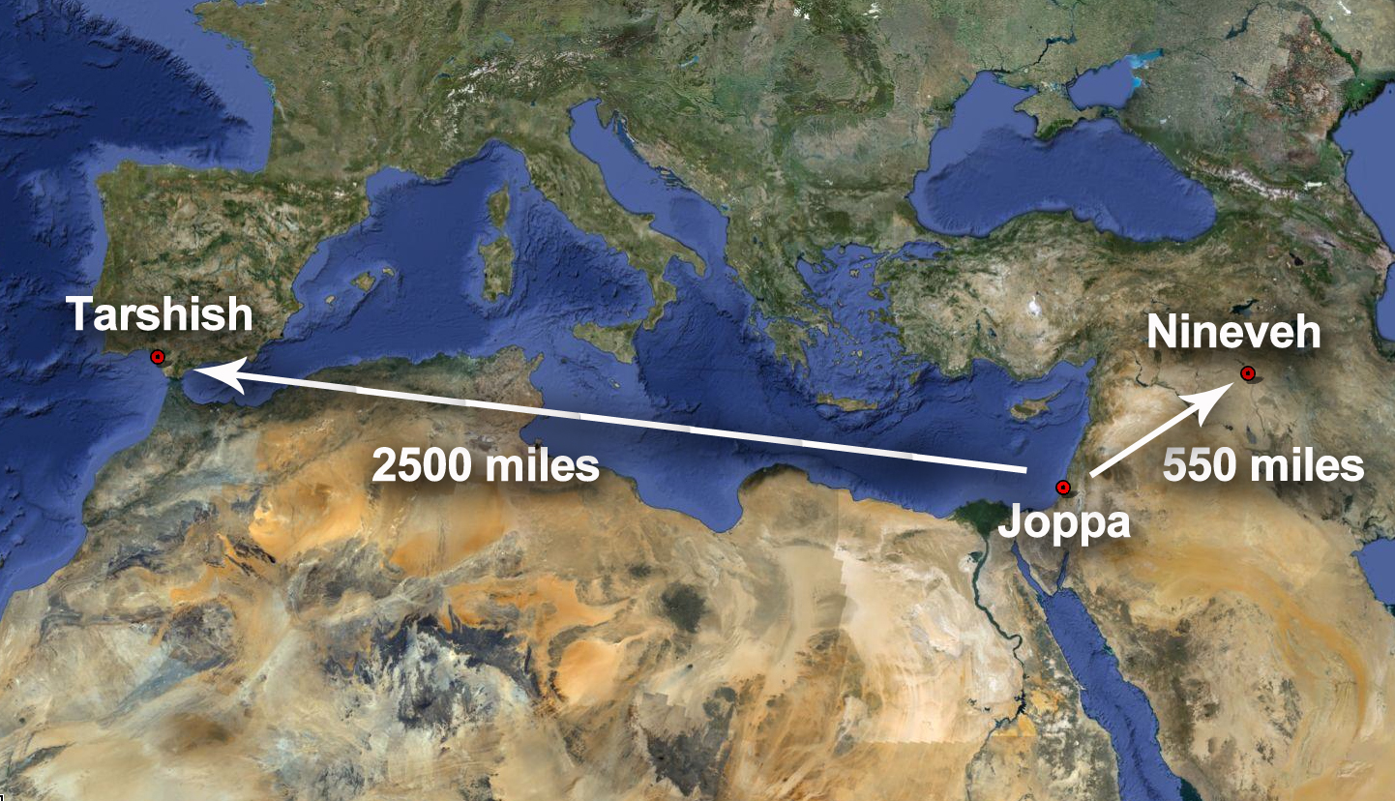

… Jonah rose up to flee unto Tarshish from the presence of the LORD, and went down to Joppa; and he found a ship going to Tarshish…

Part Two – The Journey Begins

3 But Jonah rose up to flee unto Tarshish from the presence of the LORD, and went down to Joppa; and he found a ship going to Tarshish: so he paid the fare thereof, and went down into it, to go with them unto Tarshish from the presence of the LORD. (Jonah 1:3)

In Jerusalem (on Mt. Moriah) Jonah walked with the Lord in that lofty city and heeded His beckon and call, but now Jonah has elected to go out of the will of God which is a continual spiral downward and finally Jonah finds himself going down into the depths of the sea. In the way of postscript to yesterday’s Introduction of this book, I will add that the Book of Jonah is not simply an account of what happened in the life of a single prophet of the ancient day, or to the thousands of people of Nineveh, previously ignorant of the true God; but it is given as a SIGN to us and to all peoples of all time. An evil and adulterous generation seeketh after a SIGN; and there shall no sign be given to it, but the sign of the prophet Jonas: For as Jonas was three days and three nights in the whale's belly; so shall the Son of man be three days and three nights in the heart of the earth. (Matt 12:39-40, see also Matthew 16:4) Today, worshippers are mad to find a church which makes fabulous claims of miracles and extra-biblical teaching, but they walk in abject darkness if they seek such.

God has provided a sufficient sign for us in the works of His prophets of old, and in the consummating life, death, and resurrection of His dearly beloved, only Begotten Son. God has punctuated His signs among the people during all times. It was intended as much to awaken Israel to the promise of the coming Savior as it was to lighten the darkness of the back streets of Nineveh of the Assyrians. That brazen serpent, lifted on high by Moses for the healing of those bitten by the fiery serpents, was also a sign to those who are bitten by that deadly Old Serpent, called Satan. Those who look to Christ lifted up on the cross, and risen to the Father, are healed of the deadly penalty of sin. Therefore the people came to Moses, and said, We have sinned, for we have spoken against the LORD, and against thee; pray unto the LORD, that he take away the serpents from us. And Moses prayed for the people. And the LORD said unto Moses, Make thee a fiery serpent, and set it upon a pole: and it shall come to pass, that every one that is bitten, when he looketh upon it, shall live. And Moses made a serpent of brass, and put it upon a pole, and it came to pass, that if a serpent had bitten any man, when he beheld the serpent of brass, he lived. (Num 21:7-9) The relationship of that SIGN was pointed out by Christ: And as Moses lifted up the serpent in the wilderness, even so must the Son of man be lifted up: That whosoever believeth in him should not perish, but have eternal life. (John 3:14-15, see also John 8:28, 12:32, and 1 Peter 2:24)

As we proceed in our study of Jonah, we must recognize that in many points, Jonah is a type of Christ, just as was Adam, except in those areas of failure and weakness. He went down from the close presence of God as did Jesus, but Jonah went in the wrong direction. Jonah went to the wicked people of Nineveh just as Christ came down to the wicked world. Jonah lamented the forgiveness of god for the people of Nineveh, but Christ rejoices in it.

Whereas, Jesus humbled Himself in descending to our level and becoming flesh and blood like unto us, Jonah rebelled and rose up AGAINST the commandment of God. But Jonah rose up to flee unto Tarshish from the presence of the LORD.” See the contrast with that of Christ in his actions: “Let this mind be in you, which was also in Christ Jesus: Who, being in the form of God, thought it not robbery to be equal with God: But made himself of no reputation, and took upon him the form of a servant, and was made in the likeness of men: And being found in fashion as a man, he humbled himself, and became obedient unto death, even the death of the cross. (Phil 2:5-8) Have we not all, from the eldest to the youngest, not behaved in the like manner as Jonah at some point? We know what the Lord has commanded, but we think we are somehow special and can disregard that commandment in our peculiar circumstances. We go in the opposite direction from obedience. Is there a great and hungry fish awaiting us in our flight from God? Please note, again, from the 5th verse of Philippians, that we surrender our old free wills when we accept the Lordship of Christ and take His will upon us.

Jonah used his own will to subvert the perfect will and commandment of God. He was angry and dismayed God would command him to go to the terrible, Gentile enemies of Israel. He knew, instinctively, that God would not warn a people of their gross sins unless He was ready to forgive them in their repentance. Jonah was fearful that his mission would be successful! He did not fear its failure. See? Jonah had a firm knowledge of God’s Mind, and he had faith in knowing that whatever God disposed to do, He would accomplish. Yet, Jonah fled from what he deemed the “Presence of the Lord.” How futile is the effort when we attempt to flee and hide ourselves from the commanding Eyes of God! The first to learn this hard lesson was our ancient parents in the Garden eastward in Eden. The next to learn was Cain. And now, Jonah will learn the same, but he must first suffer much effort in escaping by sea – but in two different conveyances – a ship and a whale! How do we ever expect to escape the All-Seeing Eye of god when all of the Universe is His, and He made it?

Nineveh was the capital of the Assyrian Empire, and it was located some great distance to the EAST of Jerusalem; but Jonah went the opposite direction. He went WEST to the coast of Joppa. If God would go with him to Nineveh, did her believe that God would not follow to sea and to Tarshish (coasts of Spain)? Anger and rebellion blinds men to the will of God. So was Jonah blinded by his own small mind? . . . and went down to Joppa; and he found a ship going to Tarshish” There was another opposite direction taken by Jonah. When Jonah went out from the will and presence of God, he, like all who disobey, went DOWN. He went DOWN to Joppa. The Lord had sent a ship there to meet Jonah. But Jonah thought that he, himself, had found that ship. It was prepared and furnished with crew and canvas to sail the seas; but today, it would sail into a teeming gale of such force that the crew could not maintain control of either sail or rudder – but God could! When we run from God and His plan for our lives, He is able to bring us into the great storms and buffeting breakers of life. He watches us there for He is the “God that seeth me.” We may worry about the outcome, but He does not for He has already ruled it. The ship that Jonah ‘found’ may have, indeed, been going to Tarshish, but Jonah was NOT!

If we do not allow the Lord to provide our means of passage, we will pay a very great price from our own treasure: . . . so he paid the fare thereof. Little did Jonah know exactly how great that fare would be in the end of three days. How wasteful it is to run on our own way and depart from the Narrow Way of God!

. . . and went down into it, to go with them unto Tarshish from the presence of the LORD. So far, Jonah has gone DOWN twice in our narrative, but he has THREE more occasions remaining in which he goes DOWN. The way is always a spiraling DOWN to the abyss when we flee from God. Jonah went DOWN into the ship which he presumed would take him to Tarshish. He had his own ticket, but a ticket is no better than its issuing authority – in this case, man. He believed man’s sailing ticket would take him out of the Presence of God. Good luck with that one, ole boy, for it is a dangerous delusion. Jonah would actually come INTO a presence he did not contemplate; yet, the Lord would be there with him in that sea-monster’s belly after Jonah had become just another dish of seafood.

Do we struggle against the pricks of God? I KNOW that I have done so and will, doubtless, so struggle again. I am, by nature, a stubborn thing. God may use our stubbornness to achieve his purposes if we allow, but when we use it for our own ends, we may wind up in the depths of the sea in a conveyance not of our own choosing. Jonah has gone in the opposite direction on earth that he was commanded to go. He should have gone East to Nineveh, but Jonah went West to Joppa. He also went in the opposite direction spiritually from that which he should have gone. Jonah went DOWN to Joppa, and DOWN into the ship, instead of going UP to a closer fellowship with God. Quite often, good Christian people so get immersed in doing the WORK of the Lord that they forget the LORD! The labors of Martha were beneficial to the Lord and dinner guests, but Mary chose the better part – at the feet of Christ where she was often wont to be. The struggles of Godly living are moment by moment – not year to year. We must constantly be aware of the allurements of the world AWAY from God. We must cast away our free wills daily, and put on that Mind which was in Christ Jesus! Have you done today, friend?

