Devotion on Firsts of the Bible - First and Only Prophet Swallowed by a Whale – 29 August 2015, Anno Domini

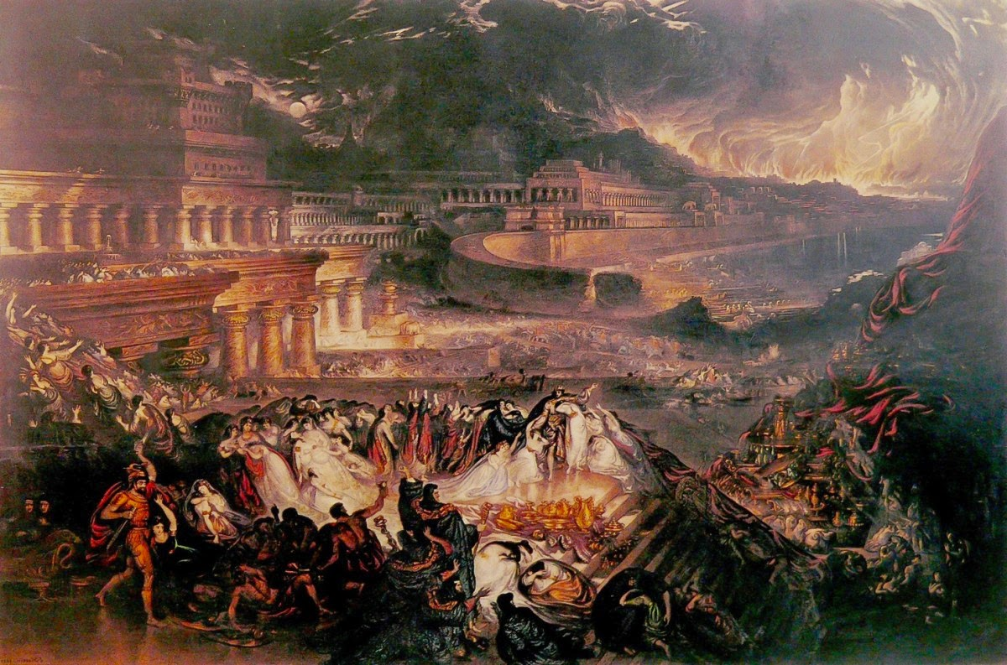

… Arise, go to Nineveh, that great city, and cry against it; for their wickedness is come up before me…

Part One - Introduction

1 Now the word of the LORD came unto Jonah the son of Amittai, saying, 2 Arise, go to Nineveh, that great city, and cry against it; for their wickedness is come up before me. (Jonah 1:1-2)

There is an old Appalachian bluegrass song entitled, "Down to the River to Pray." It reminds me of Jonah with notable exceptions - Jonah went down to the sea - not the river - (and INTO it); and not to have communion with God, but to ESCAPE God.

We begin today a devotional study of the Book of Jonah which is not a prophetic, but historical, book - though the historical aspects themselves are prophetic of all who try to outrun God.. It reveals God's calling of a man named Jonah - a real person of ancient times - to go into a wicked and fearful city to carry His warning to the pagan people there. We learn herein that God not only exercises His oversight of nations, but also of individual persons. His Providence is over you and me just as surely as it is over the nations of the world. Secondly, we learn that God calls men of His choosing to execute His Will and to carry forth His Word. God seldom calls one unfamiliar with His Word and Name to call others to repentance, or to prophesy on His behalf, but mainly those who know Him and are courageous to do His Will. Jonah was just that man though Jonah had to learn that truth through some hard trials. One who is called of God may delay in his responding, but he will not finally escape the unrelenting persistence of God. Rather than kick against the prods, we would suffer far less wounds in our bodies and souls if we would simply obey at once when God calls.

You will recall the experience of Saul of Tarsus, a great persecutor of the Church, on the Road to Damascus: And as he journeyed, he came near Damascus: and suddenly there shined round about him a light from heaven: And he fell to the earth, and heard a voice saying unto him, Saul, Saul, why persecutest thou me? And he said, Who art thou, Lord? And the Lord said, I am Jesus whom thou persecutest: it is hard for thee to kick against the pricks. And he trembling and astonished said, Lord, what wilt thou have me to do? And the Lord said unto him, Arise, and go into the city, and it shall be told thee what thou must do. (Acts 9:3-6) Paul (Saul) learned a hard lesson from the Lord on that Road to Damascus. He was not short on faith, but of the knowledge of the Lord. Young Samuel was asleep when the Lord called to him. He didn't recognize the Voice, being of tender years. But when he knew the Voice, he never relented. Now Samuel did not yet know the LORD, neither was the word of the LORD yet revealed unto him. And the LORD called Samuel again the third time. And he arose and went to Eli, and said, Here am I; for thou didst call me. And Eli perceived that the LORD had called the child. Therefore Eli said unto Samuel, Go, lie down: and it shall be, if he call thee, that thou shalt say, Speak, LORD; for thy servant heareth. So Samuel went and lay down in his place. (1 Sam 3:7-9)

Mr. Jonah is different. Mr. Jonah did not lack either faith, or knowledge. He heard and recognized the Voice of the Lord, but did not AGREE with the Lord, and chose to flee to a distant land where he must have presumed the Lord would not follow. He was WRONG. The whole earth is the Lord's! Perhaps Jonah lacked that which many professing Christians today lack - COMPASSION! He was well aware of the compassion that the Lord would feel for a repentant people, but did not desire that the Lord forgive such desperate enemies of Israel. The further Jonah fled from the Lord, the more awesome became the Lord's presence. It is a great error to forbear witnessing to a people of your own choosing rather than those to whom the Lord sends us. We cannot discount any race, tribe, or nationality of people as being unreceptive, or unworthy, of hearing the Word of the Lord. We preach the Gospel without distinction to all, and allow the Holy Ghost to separate the wheat from the chaff.

What was the message that Jonah was to deliver? 2 Arise, go to Nineveh, that great city, and cry against it; for their wickedness is come up before me. Jonah was to pronounce God's coming judgment against that wicked city. So why would Jonah bolt at such a mission? First of all, Nineveh was a powerful city whose wickedness was felt and renowned in the Holy Land. This city had sent armies out to conquer and take spoils from all of their surrounding neighbors. They treated their victims with such cruelty that the mention of their name struck terror in the hearts of the people. They often impaled their victims on sharp poles while they died a slow and excruciating death. Their armies were strong and terrible. Secondly, Jonah, being a prophet of God, knew that God's heart would melt should the city repent, and God would forgive them. It was THIS fact that most bothered Jonah. He felt that, if he were taken out of the way, this intention of God could not be fulfilled. Of course, the works of God depends not upon the will of any man. Jonah was soon to learn that the Will of God overrides that of men - even His own prophets.

Nineveh was a GREAT city, even in the Words of the Lord. How great was Nineveh? The city itself was a three day's journey - Now Nineveh was an exceeding great city of three days' journey. (Jonah 3:3) That means that it would take a traveler three days to go from one gate of the city to the opposite gate (by foot). In spite of modernist skeptic's claims that there was not, nor ever had been, an historic city called Nineveh (that the Bible was wrong); Dr. Henry Layard, Esq., sought out the ruins of Nineveh in the 1840s. He proceeded to modern day Mosul on the Tigris River. Searching out the environs of the area, he came to a mound which the locals called 'Tippeh Yona' (mound of Jonah). This he presumed to be the tomb of Jonah. But looking some short distance to the north, he spied a mound of earthen works of tremendous proportion. Later excavation proved this to be the ruins of "that GREAT CITY - Nineveh!"

Skeptics had also claimed that the Book of Daniel was in error in naming Belshazzar as King of Babylon at the time of the "Finger that wrote upon the Wall." In the central ruins of Nineveh, Dr. Layard found some thousands of clay tablets recording daily commerce and legal matters. One such clay tablet contained this remark: "I am King Nabonidas of Babylon who is visiting in Nineveh. I have left my son, Belshazzar, as king in my stead at Babylon." This finding answered another mystery of Daniel as well. Then commanded Belshazzar, and they clothed Daniel with scarlet, and put a chain of gold about his neck, and made a proclamation concerning him, that he should be the third ruler in the kingdom. (Dan 5:29) Skeptics have argued that there was never, historically, a second ruler in Babylon, no King Belshazzar, and no justification to make Daniel third ruler in the kingdom. since there was no second. But Belshazzar, himself, was the second ruler under his father; therefore, the greatest honor he could bestow on Daniel was to name him third ruler. You would think that this overwhelming empirical evidence would close the mouths of such critics, but many still cling to the false thread of fantasy over truth.

Suffice it to say Nineveh was a GREAT CITY. Though Jonah may have feared his own safety in going there, it seems that his greater concern was that the Lord would have compassion on the city. Though we may harbor great malice for a people, or even the President of the United States, our prayers must be that the Lord will guide them and open their eyes to faith and reason. If we can make a believer of our adversary, we have made a double friend - one more friend, one less enemy!

As we learn from many places in God's Word, the beginning of sin is a DIRECTION away from God. Naomi and Elimelech left Bethlehem-Judah (the city of Bread and Praise) and went into the cursed land of Moab. It was the WRONG direction. The Jew left Jerusalem (City of Peace) and went DOWN to Jericho - again, the WRONG direction. The Prodigal Son took his inheritance early and went out on the long road to a FAR country - WRONG direction! Psalm 1 tells us the RIGHT direction as well as the WRONG. Blessed is the man that walketh not in the counsel of the ungodly, nor standeth in the way of sinners, nor sitteth in the seat of the scornful. But his delight is in the law of the LORD; and in his law doth he meditate day and night. And he shall be like a tree planted by the rivers of water, that bringeth forth his fruit in his season; his leaf also shall not wither; and whatsoever he doeth shall prosper. (Psalms 1:1-3) We begin by walking in the wrong direction with the wrong company; we find ourselves, after a while, stopping in the place of sinners; and finally we find that we have made ourselves at home with the wicked by sitting down with them in intercourse. Well does Eve prove the point in going before the wrong tree, stopping there, and finally chatting with the evil voice. Likewise, did Lot cast his eyes upon the plain before Sodom. Later, we find that he had moved into that wicked city and, later still, sat in the gate of the city. So, we see that Jonah chooses the wrong direction - and it is constantly DOWN. Please read this very short book and meditate on its contents as we cover each verse in the coming days.

For those who look with smug indignation upon Jonah, Let him who is without sin cast the first stone. We have all demonstrated that same attitude of Jonah to escape the calling of God at some point, or points, in our lives though perhaps with less drama. History is a great teacher, and we do, indeed, see ourselves reflected in the obstinate Jonah. Which shall we be: the fisherman, or the BAIT!

