Devotion on Firsts of the Bible - First Table of the Laws at Sinai, 12 June 2015, Anno Domini

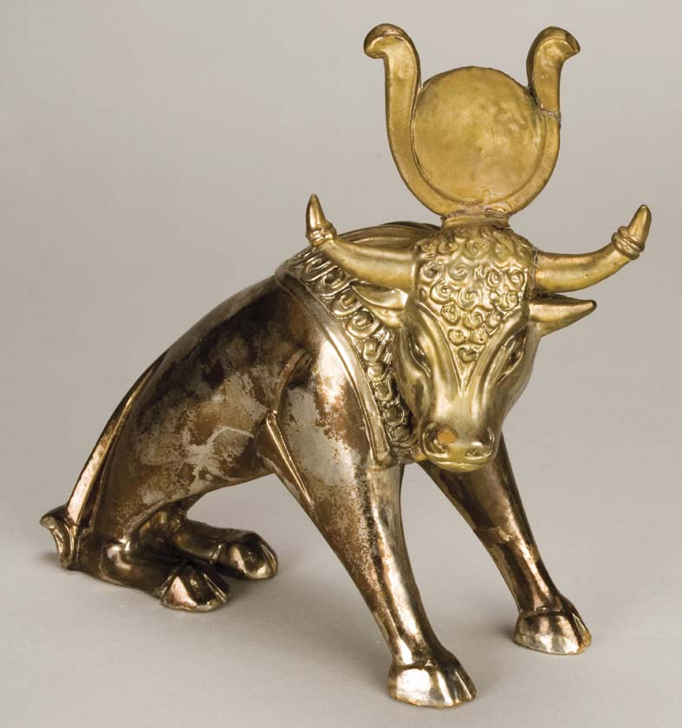

… I cast it into the fire, and there came out this calf …

3 And Moses went up unto God, and the LORD called unto him out of the mountain, saying, Thus shalt thou say to the house of Jacob, and tell the children of Israel; 4 Ye have seen what I did unto the Egyptians, and how I bare you on eagles' wings, and brought you unto myself. 5 Now therefore, if ye will obey my voice indeed, and keep my covenant, then ye shall be a peculiar treasure unto me above all people: for all the earth is mine: 6 And ye shall be unto me a kingdom of priests, and an holy nation. These are the words which thou shalt speak unto the children of Israel. (Ex 19:3-6)

The words of the Lord spoken to Moses and Israel apply no less to us today than to them in their day. The words of God to Moses are a doubled edged sword: 1) Ye have seen what I did unto the Egyptian; This warning puts us on notice that the same will happen to any nation or people who reject the Law and Word of God. 2) “How I bare you on eagles' wings, and brought you unto myself.” Being with God is always the favored and blessed place. God carried Israel as an Eagle bears her young – on her wings rather than by her strong talons which may crush the young. Moreover, God places himself between His people (Pillar of Fire & Cloud) just as the eagle places herself between the archer on the ground and her young. But grace is a gift that must be received and kept; otherwise it ceases to be a gift.

Why did God give His Law to His people? Was it to frighten them, to place them in bondage, to become a tyranny to them? Not at all – it was given to reveal Himself and His righteousness, and to be an example and rule of life for the people to follow so that they could, indeed, be happy and prosper. No one who believes there is no God is happy. No one who labors all the day long, seven days a week to lay up treasure, is happy. No one who despises and dishonors his parents is happy. No one who cheats, steals, commits adultery, or craves the resources of his neighbor is happy. But those whose lives conform to the righteousness of God’s Law are happy and will prosper both in body and spirit. That is the reason for the Law Given and Received.

God spoke to Moses out of the thunderous cloud so that the people could also hear Him and know that Moses was, in truth, given this Law by the very hand of God. It is important that we keep this Law both in spirit and in written record.

The Ten Commandments were written (twice) with the very Finger of God – there were at least five such occasions when the Finger of God wrote in Scripture. Can you name them? God not only gave the Commandments to Moses, but instructed Him in their administration and keeping. “18 And he gave unto Moses, when he had made an end of communing with him upon mount Sinai, two tables of testimony, tables of stone, written with the finger of God.” (Ex 31:18) God had given particular counsel following His verbally giving the Commandments to Moses in Exodus 20 concerning graven images and false gods. He addresses this matter first and foremost after the giving of the Law. He KNEW that the people of Israel would violate this Law first of all. 22 And the LORD said unto Moses, Thus thou shalt say unto the children of Israel, Ye have seen that I have talked with you from heaven. 23 Ye shall not make with me gods of silver, neither shall ye make unto you gods of gold. 24 An altar of earth thou shalt make unto me, and shalt sacrifice thereon thy burnt offerings, and thy peace offerings, thy sheep, and thine oxen: in all places where I record my name I will come unto thee, and I will bless thee. 25 And if thou wilt make me an altar of stone, thou shalt not build it of hewn stone: for if thou lift up thy tool upon it, thou hast polluted it. 26 Neither shalt thou go up by steps unto mine altar, that thy nakedness be not discovered thereon. (Ex 20:22-26)

Strangely, though their own Bible contains it, the Roman Church omits the Commandment against graven images, and divides the last (coveting) into two parts, to make up the missing the Commandment. Man is constantly trying to bring God down to his level rather than aspiring to rise to the righteousness of God.

The nature of the Commandments of God is unique among all of the laws of the earth. They define a garment of whole cloth rather than a seamed garment. Every Commandment hangs upon all of the others, and all hang upon one. We cannot covet our neighbor’s possessions without violating the very first Commandment. If God is uppermost in our hearts, we can neither steal nor lie about our neighbor. Jesus was so compassionate as to give worldly examples to us for our understanding – often in parables, and at other times, in real life situations.

We have a perfect example of the Commandments given by our Lord in Matthew, Mark and Luke. I have chosen the passages from Mark for they are most descriptive of detail: 17 And when he was gone forth into the way, there came one running, and kneeled to him, and asked him, Good Master, what shall I do that I may inherit eternal life? 18 And Jesus said unto him, Why callest thou me good? there is none good but one, that is, God. 19 Thou knowest the commandments, Do not commit adultery, Do not kill, Do not steal, Do not bear false witness, Defraud not, Honour thy father and mother. 20 And he answered and said unto him, Master, all these have I observed from my youth. 21 Then Jesus beholding him loved him, and said unto him, One thing thou lackest: go thy way, sell whatsoever thou hast, and give to the poor, and thou shalt have treasure in heaven: and come, take up the cross, and follow me. 22 And he was sad at that saying, and went away grieved: for he had great possessions. (Mark 10:17-22)

There are several illuminating points raised by this account of the rich young ruler:

- He was eager to know by what means he could be saved. “there came one running.”
- He was respectful to Jesus: “kneeled to him.”
- He did not address Jesus as Lord, but as “Good Master” (Teacher).
- He asked the WRONG question: “what shall I do that I may inherit eternal life?” Salvation is gained through the works of Christ and not our own works (doing)!
- Jesus asked why the young man called Him ‘good’ since only God is good. By so doing, Jesus was testing the spiritual knowledge of the young man to see if he knew that He (Jesus) was also God.
- Jesus told the young man that all he needed do was keep (in perfection) the Ten Commandments and that would gain him salvation. Jesus asked this question rhetorically since no man can keep the Law of God without breach. Because we cannot keep God’s Law with perfection, we need a Redeemer to deliver us from the penalty of that Law.
- The young man is sure that he has kept the Commandments from his youth. Obviously, he has tried diligently to do so. “Master, all these have I observed from my youth.” With this last comment, Jesus has drawn out the soul’s great need of this lad. The young man has not kept even the FIRST Commandment as the follow-up invitation of the Lord reveals.
- There was one Commandment that the young man could not keep. He could not place the service to God above his ambitions for wealth. Wealth was his god, not the God of Heaven: “One thing thou lackest: go thy way, sell whatsoever thou hast, and give to the poor, and thou shalt have treasure in heaven: and come, take up the cross, and follow me.” Jesus knew what premium the man placed on his wealth – it exceeded his desire to follow God and be saved. It is possible to be wealthy, but to use that wealth to the glory of God; but another thing to place wealth above our love of God. The young man went away disheartened and unsaved. “And he was sad at that saying, and went away grieved: for he had great possessions.”

The people of Israel had a very primitive understanding of God. Their father, Jacob, had been dead the 400 years of their bondage in Egypt. They lacked teaching and understanding in its fullness. Moses was the closest man they knew as a savior. God spoke directly to Moses, but not to them. So when Moses was away on Mount Sinai for a protected period of time, they fell into old pagan rituals and customs of the Land of their Bondage – Egypt. Moses, coming down from Sinai, was incensed to see the people engaged in pagan orgy and having made an idol of gold which was like unto the little bull-god of Egypt. Moses was so angry that he is the first man to break all Ten Commandments at once; however, if we break one only, we have broken them all. Such irreverence of the people also angered God: “And the LORD said unto Moses, I have seen this people, and, behold, it is a stiffnecked people: Now therefore let me alone, that my wrath may wax hot against them, and that I may consume them: and I will make of thee a great nation.” (Ex 32:9-10) God expressed a desire consume these people in their sins, but Moses, a type of Christ, interceded with on their behalf and the Lord relented. “And it came to pass, as soon as he came nigh unto the camp, that he saw the calf, and the dancing: and Moses' anger waxed hot, and he cast the tables out of his hands, and brake them beneath the mount.” (Ex 32:19) Man will forever rationalize away his sins in his wicked heart, but the excuse of Aaron when asked why such transgression had happened responded with the most ridiculous excuse recorded in the Bible: I said unto them, Whosoever hath any gold, let them break it off. So they gave it me: then I cast it into the fire, and there came out this calf. (Ex 32:24)

What is YOUR excuse, friend?

