Devotion on Firsts of the Bible - First Post Ascension Appearance of Christ – 7 November 2015, Anno Domini

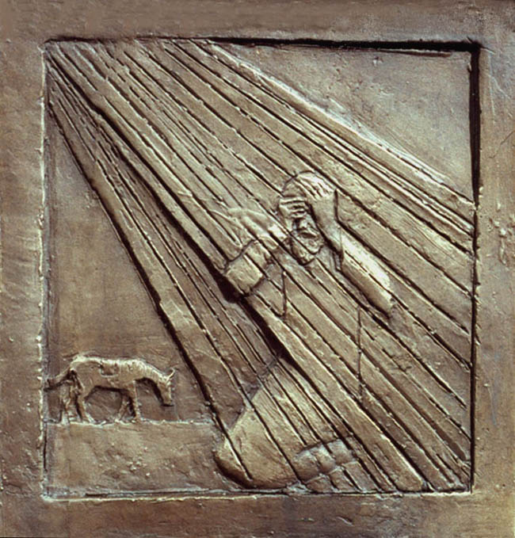

Acts 9:1-19

A
nd Saul, yet breathing out threatenings and slaughter against the disciples of the Lord, went unto the high priest,
2 And desired of him letters to Damascus to the synagogues, that if he found any of this way, whether they were men or women, he might bring them bound unto Jerusalem.
3 And as he journeyed, he came near Damascus: and suddenly there shined round about him a light from heaven:
4 And he fell to the earth, and heard a voice saying unto him, Saul, Saul, why persecutest thou me?
5 And he said, Who art thou, Lord? And the Lord said, I am Jesus whom thou persecutest: it is hard for thee to kick against the pricks.
6 And he trembling and astonished said, Lord, what wilt thou have me to do? And the Lord said unto him, Arise, and go into the city, and it shall be told thee what thou must do.
7 And the men which journeyed with him stood speechless, hearing a voice, but seeing no man.
8 And Saul arose from the earth; and when his eyes were opened, he saw no man: but they led him by the hand, and brought him into Damascus.
9 And he was three days without sight, and neither did eat nor drink.
10 And there was a certain disciple at Damascus, named Ananias; and to him said the Lord in a vision, Ananias. And he said, Behold, I am here, Lord.
11 And the Lord said unto him, Arise, and go into the street which is called Straight, and enquire in the house of Judas for one called Saul, of Tarsus: for, behold, he prayeth,
12 And hath seen in a vision a man named Ananias coming in, and putting his hand on him, that he might receive his sight.
13 Then Ananias answered, Lord, I have heard by many of this man, how much evil he hath done to thy saints at Jerusalem:
14 And here he hath authority from the chief priests to bind all that call on thy name.
15 But the Lord said unto him, Go thy way: for he is a chosen vessel unto me, to bear my name before the Gentiles, and kings, and the children of Israel:
16 For I will shew him how great things he must suffer for my name's sake.
17 And Ananias went his way, and entered into the house; and putting his hands on him said, Brother Saul, the Lord, even Jesus, that appeared unto thee in the way as thou camest, hath sent me, that thou mightest receive thy sight, and be filled with the Holy Ghost.
18 And immediately there fell from his eyes as it had been scales: and he received sight forthwith, and arose, and was baptized.
19 And when he had received meat, he was strengthened. Then was Saul certain days with the disciples which were at Damascus.

1 And Saul, yet breathing out threatenings and slaughter against the disciples of the Lord, went unto the high priest, 2 And desired of him letters to Damascus to the synagogues, that if he found any of this way, whether they were men or women, he might bring them bound unto Jerusalem. 3 And as he journeyed, he came near Damascus: and suddenly there shined round about him a light from heaven: 4 And he fell to the earth, and heard a voice saying unto him, Saul, Saul, why persecutest thou me? 5 And he said, Who art thou, Lord? And the Lord said, I am Jesus whom thou persecutest: it is hard for thee to kick against the pricks. 6 And he trembling and astonished said, Lord, what wilt thou have me to do? And the Lord said unto him, Arise, and go into the city, and it shall be told thee what thou must do. 7 And the men which journeyed with him stood speechless, hearing a voice, but seeing no man. 8 And Saul arose from the earth; and when his eyes were opened, he saw no man: but they led him by the hand, and brought him into Damascus.9 And he was three days without sight, and neither did eat nor drink. (Acts 9:1-9)

God can turn your most dreadful enemy into your most cherished defender. God can do wonders with the open heart. If the heart is calloused and hardened, He is able to melt it and remake it in an instant. Saul has been the agent of hard and wicked persecution against the church. He was a prominent figure in the stoning of Stephen, and now he continues unabated in his bitter pursuit of the Christian Church.

And Saul, yet breathing out threatenings and slaughter against the disciples of the Lord, went unto the high priest, And desired of him letters to Damascus to the synagogues, that if he found any of this way, whether they were men or women, he might bring them bound unto Jerusalem. Saul is as enthusiastic in his work of persecution of Christ’s Church as he later became in its defense and propagation. The object of his actions was not only the Christian disciples, but Christ Himself. Now he has approached the high priest for a warrant of letters to travel to Damascus to search out every vestige of the Church of Christ. Little did Saul realize what would befall him on his journey?

And as he journeyed, he came near Damascus: and suddenly there shined round about him a light from heaven: 4 And he fell to the earth, and heard a voice saying unto him, Saul, Saul, why persecutest thou me? Evil men must beware of “lights from heaven”. It puts them ill at ease. This light apparently startled Saul so much so that he fell to the ground, and his companions with him. (Acts 26:14) The voice of Christ is heard by Saul: Saul, Saul, why persecutest thou me? Only Saul of the company heard with understanding the voice of Christ for he only was the man called of God. (Acts 22:9) He was on the road to destroy the lives of disciples, but to hurt the Disciples of Christ is to hurt Christ Himself! And he trembling and astonished said, Lord, what wilt thou have me to do. It is easier to recognize the Lord’s presence when one is afraid. Saul knows this is the Lord even if he does not know the person of Christ. He calls him LORD.

And the Lord said, I am Jesus whom thou persecutest: it is hard for thee to kick against the pricks. A man cannot fight against the powers of Heaven. Saul was called of God long before the idea ever arose in Saul’s mind. He has resisted from the beginning. Perhaps his enthusiasm to destroy is his weapon of opposition to the call. How often men struggle against God’s Calling until God places them down and out on the road so that they will finally listen. We see that the incident has caused Saul to have a sudden change of, not only heart, but attitude! And he trembling and astonished said, Lord, what wilt thou have me to do. He knows this is no dream as well as he knows that this is not a Person to resist. What wilt thou have me to do? This is the main thing Saul has asked and the main thing for each of us to ask as well.

And the Lord said unto him, Arise, and go into the city, and it shall be told thee what thou must do. Yes, to the city where you hoped to persecute the people of God – the same city! A man may be called to the ministry without a firm spiritual knowledge of to what he is being called. The important point here is to answer the call and then await further orders. And the men which journeyed with him stood speechless, hearing a voice, but seeing no man. The voice was heard but not understood by the company.

And Saul arose from the earth; and when his eyes were opened, he saw no man: but they led him by the hand, and brought him into Damascus. As an enemy of God’s people, Saul was struck blind by the Light of Heaven. He would not see the things of the world until his eyes were opened anew to the beauties of Heavenly Truth. He required an escort to get about. He would become the Apostle that would lead thousands out of darkness, but now he needs a guide just to move about.

And he was three days without sight, and neither did eat nor drink. 10 And there was a certain disciple at Damascus, named Ananias; and to him said the Lord in a vision, Ananias. Saul was blind in like number of days as Christ was in the tomb. The man who would die daily to self would also suffer the darkness for three days. Now the Lord is preparing a man to receive Saul by the name of Ananias. The Lord calls him by name, but only once. Ananias was a man accustomed to listening to the voice of Christ unlike Saul. So the Lord need only pronounce his name once to gain his attention. Ananias knew the Voice and the Person of Christ: And he said, Behold, I am here, Lord.

And the Lord said unto him, Arise, and go into the street which is called Straight, and enquire in the house of Judas for one called Saul, of Tarsus: for, behold, he prayeth, 12 And hath seen in a vision a man named Ananias coming in, and putting his hand on him, that he might receive his sight. When the Lord calls us on mission, He will always require us to travel in a straight way. Our example and impression is most important as a testimony to the lost. The Lord provides full accounting of that which He expects of Ananias. Saul was not sentient to the voice of the Lord and had to await further counsel, but Ananias is a veteran disciple who knows the Lord and understands His ways.

The cause of Ananias going to this man does not seem reasonable to Ananias in view of Saul’s reputation for cruelty to Christians. Why, Lord, would you have me go to this man? “Then Ananias answered, Lord, I have heard by many of this man, how much evil he hath done to thy saints at Jerusalem:14 And here he hath authority from the chief priests to bind all that call on thy name.” None of this made sense to Ananias and, frequently, the Lord calls us to a circumstance whose purpose is known only to the Lord. Ananias never questions the Lord’s orders, but he questions if he has understood aright.

But the Lord said unto him, Go thy way: for he is a chosen vessel unto me, to bear my name before the Gentiles, and kings, and the children of Israel: 16For I will shew him how great things he must suffer for my name's sake. Saul is being called to a very high Office, but he will suffer at least as badly as he has caused others to suffer in the cause of Christ. Were these decisions made by mere men, you and I would probably have ended Saul’s life long before the Damascus Road, but God knows the end from the beginning and the end of Saul will be a glorious one.

And Ananias went his way, and entered into the house; and putting his hands on him said, Brother Saul, the Lord, even Jesus, that appeared unto thee in the way as thou camest, hath sent me, that thou mightest receive thy sight, and be filled with the Holy Ghost. Poor Ananias. He is a man of courage in the Lord. For all he knew, Saul would lash out at him and have him arrested and perhaps stoned. But we must obey God and not take counsel of our fears. When a blind man receives his sight again, the world seems full of light and color. But when he receives his spiritual sight, the earth appears bland and unappealing. Heaven looms large and beautiful! The Holy Ghost gives spiritual eyes to Saul! Now Saul knows the Person of the Lord who appeared to him on the way was Jesus.

And immediately there fell from his eyes as it had been scales: and he received sight forthwith, and arose, and was baptized. Were it not so very solemn an event, it would almost be humorous to observe this man, breathing out threatenings and slaughter against the disciples of the Lord, suddenly and completely changed in his nature, and becoming the very thing he came to destroy. This is the Lord’s work. It is much like a plain bar of metal that has every physical property of a magnet, except magnetism. When it is properly charged with the invisible electromagnetic charge, it assumes the same property of that other magnet. That is what happens when God brings us to salvation. We may appear as the old man, but there is a new nature inside. Saul was made to see, not only physically but spiritually. Not time to waste when we come to the Lord. We must come all the way. Saul was immediately baptized.

And when he had received meat, he was strengthened. Then was Saul certain days with the disciples which were at Damascus. When a man is blind, he may not eat the Bread of Heaven. But now Saul has his sight restored and he does eat physical bread and also the Bread of Heaven. Instead of coming in the fires of persecution, Saul is now sojourning with the disciples whom he would have never thought to do only three days past. When you came to Christ, did your vision change and did your fellowship along with it?

Can you understand the meaning now of “He saw the light” when used to comment on someone who finally understood?

