Devotion on Firsts of the Bible - First Note to an Individual – 23 September 2015, Anno Domini
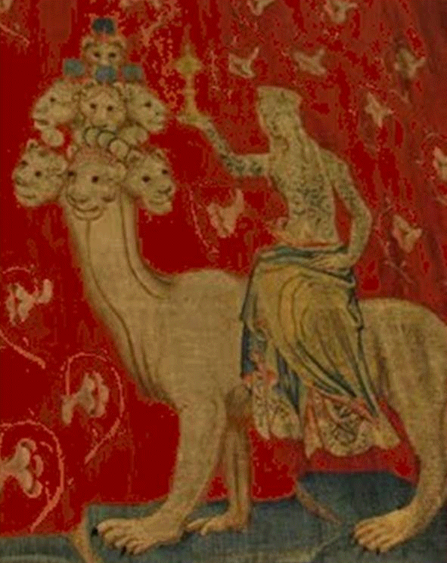

And this is the writing that was written, MENE, MENE, TEKEL, UPHARSIN.
(Daniel 5:25)

The Bible, from Genesis 1:1 to Revelations 22:21, is all the Word of God; and most was dictated to the scribes by the Holy Ghost. But there are five instances in which God wrote the very words with His own Finger. As you will recall, He wrote the Ten Commandments twice with His very Finger. (Exodus 32:15-16; & 34:1). And our Lord Jesus Christ wrote twice upon the ground when challenged by the Scribes and Pharisees to have a Woman taken in Adultery stoned to death (John 8:1-11). The Commandments were written as a rule of life for all who would reverence God and His Law. The two times Jesus wrote upon the ground was to condemn and convict those who would practice justice without mercy. O LORD, the hope of Israel, all that forsake thee shall be ashamed, and they that depart from me shall be written in the earth, because they have forsaken the LORD, the fountain of living waters. (Jeremiah 17:13)

In each of the cases cited above, God wrote for the benefit of all, or of an assembly of people; but the quote from Daniel 5:25 was written directly by the Finger of God to one man – King Belshazzar of Babylon. In order to understand the full import of this occasion, one must be cognizant of the history of Babylon then current to the event of its fall to Cyrus the Great. Cyrus had surrounded and besieged the city of Babylon for the past two years prior to its fall. No siege engines or weapons fashioned by the Medes and Persians could penetrate the mighty walls of Babylon which were some fifty feet thick at the base and eighty fee high. And should, perchance, the outer wall to be breached, there was a second wall of the same dimensions surrounding the city. For two years, Cyrus was arrayed about the city; but the inhabitants laughed at his army from high atop the impregnable walls. The city was of sufficient size to raise their own food in the many gardens of the city – Babylon was fifteen miles square! Reluctantly, Cyrus prepared to withdraw from his siege of the city.

As Cyrus retreated on a northeast route from Babylon toward Elam and Persia, he observed a great basin to the south which Queen Nitocris (a builder of Babylon) had used into which to re-route the Euphrates River while the walls of the city were being constructed down to below the water line of the river. Just in case an enemy would be able to get through this submerged waterway and gain access to the city, a second set of walls lined the course of the river through the city with iron-leaved gates that could be raised to allow access to the river as it coursed through Babylon. Cyrus lit upon the same plan to re-route the Euphrates into that basin in order to provide a dry approach to the city, enter through the water-gate, and march into the city by subterfuge.

Cyrus was unwittingly the anointed of God to bring about a fulfillment of his ancient prophecies concerning Babylon. 19 And Babylon, the glory of kingdoms, the beauty of the Chaldees' excellency, shall be as when God overthrew Sodom and Gomorrah. 20 It shall never be inhabited, neither shall it be dwelt in from generation to generation: neither shall the Arabian pitch tent there; neither shall the shepherds make their fold there. (Isaiah 13:19-20) This describes, in detail, the condition of Babylon today. It is a merely collection of brick and mortal piles scattered over the desert plain. The waters, putrid and poisoned by the azure blue dye used to color the brick walls and images. Nothing can live there but the scorpion and the desert reptile. The Arabs are fearful of camping there in their superstitions. The prophecy of Jeremiah many decades and centuries earlier, perfectly describe the wastes of Babylon today: And Babylon shall become heaps, a dwellingplace for dragons, an astonishment, and an hissing, without an inhabitant. (Jeremiah 51:37) The manner in which Babylon fell to such devastation is the point of today’s study.

You will recall above Cyrus would divert the waters of the Euphrates from the walls of Babylon. In a stunning and shocking prophecy uttered two hundred years earlier by Isaiah, we see a remarkable fulfillment in the Fall of Babylon to Cyrus. This is made even more amazing when the absolute proofs of the timing of Isaiah’s writings are realized. Isaiah wrote his prophecy of Cyrus around 740 BC, while it was fulfilled in the Fall of Babylon to the Medes and Persians under Cyrus in 539 BC (Before Christ). It is interesting how the Jehovah Witnesses and other unbelievers (pseudo-scientist, atheist, etc) try to change our calendar dating system from being computed on the birth of Christ – either before (BC) or AFTER (AD) They try to change the dates to BCE (Before Common Era) or CE (Common Era). But they cannot evade the great event that occurred some 2000 years ago in the birth of Christ.

24 Thus saith the LORD, thy redeemer, and he that formed thee from the womb, I am the LORD that maketh all things; that stretcheth forth the heavens alone; that spreadeth abroad the earth by myself; 25 That frustrateth the tokens of the liars, and maketh diviners mad; that turneth wise men backward, and maketh their knowledge foolish; 26 That confirmeth the word of his servant, and performeth the counsel of his messengers; that saith to Jerusalem, Thou shalt be inhabited; and to the cities of Judah, Ye shall be built, and I will raise up the decayed places thereof: 27 That saith to the deep, Be dry, and I will dry up thy rivers: 28 That saith of Cyrus, He is my shepherd, and shall perform all my pleasure: even saying to Jerusalem, Thou shalt be built; and to the temple, Thy foundation shall be laid. (Isaiah 44:24-28) A careful reading of this prophecy, or prophecies, will yield a profound perspective to God’s timelessness. This prophecy was written before Judah was taken into a seventy year captivity in Babylon; yet, Isaiah makes reference to the rebuilding of the cities of Judah! Did you notice other prophecies that have an amazing fulfillment?

- God says that the deep places (river beds of Euphrates, shall be made dry).
- Jerusalem (still standing at the time of the prophecy) shall be rebuilt by order of Cyrus.
- The foundation of the Temple (still standing at Isaiah’s writing) shall have its foundation rebuilt.
- Though a Gentile, Cyrus is the anointed Shepherd of the Lord to do His will.

We will study more of the remarkable Cyrus the Great in a subsequent study. But there are yet some very germane issues involving Cyrus that are applicable to that writing of God on the wall of Bel’s temple. When Nebuchadnezzar captured Jerusalem, the walls were destroyed and the Temple desecrated and ruined. The golden vessels were taken from the Temple at Jerusalem and brought to Babylon as spoils of war. (586 BC) Nebuchadnezzar reigned for a number of years and was counselled by God and Daniel. After his death, a king named Nabonidas ascended the throne. He was king of Babylon during the era preceding Babylon’s fall. This fact has been used by the so-called higher critics to deny the veracity of Daniel’s account of the writing on the wall. They claim Daniel was inaccurate in claiming Belshazzar to be king in Babylon. However, Dr. Augustus Layyard, a British archaeologist, excavated the ruins of Nineveh in the mid-19th century to discover a library in the central grounds of the city containing a clay tablet, executed by Nabonidas, which reads: I am King Nabonidas, King of Babylon. I am on visit to Nineveh and have left my son, Belshazzar as King in my stead. This would seem to clarify the doubts of said critics, but they simply ignore the evidence and continue in their obstinate attack upon Holy Scripture, and by producing modern and corrupting versions of the Bible.

Though under siege, Belshazzar throws a drunken orgy in which he has the golden vessels taken from the Temple in Jerusalem brought to him from which the company gathered will drink. Unbeknownst to Belshazzar (name means Fire of Bel) Cyrus has not completely withdrawn his forces from the environs of Babylon. In fact, the re-routed river has dried up revealing an opening beneath the eastern wall of Babylon. Over the years, rushes have grown up around the opening formerly beneath the water’s surface. These Cyrus burns in order to clear his approach into the city. So, Cyrus’ advance back to Babylon has not been hindered by the winding Euphrates – being dried up, his way is made STRAIGHT! 1 Thus saith the LORD to his anointed, to Cyrus, whose right hand I have holden, to subdue nations before him; and I will loose the loins of kings, to open before him the two leaved gates; and the gates shall not be shut; 2 I will go before thee, and make the crooked places straight: I will break in pieces the gates of brass, and cut in sunder the bars of iron: 3 And I will give thee the treasures of darkness, and hidden riches of secret places, that thou mayest know that I, the LORD, which call thee by thy name, am the God of Israel. (Isaiah 45:1-3)

So the armies of Cyrus enter into the river channel that winds through Babylon. But there are yet the inner walls constructed along the river’s course to hinder his entrance to Babylon proper. How shall he gain access therein. Remember, there are iron-leaved gates that block access through the walls; however, this is a time of wanton celebration in Babylon. The king, and all others, are drinking and making merry – and God said He would break the bars of those gates, didn’t He? Well, the guards were drunk and inadvertently left these gates open and a messenger ran from one end of the city to the king to inform him that the city had fallen. It was just before this news that the Finger appeared in Belshazzar’s drunken chamber and wrote, succinctly, his destiny. MENE, MENE, TEKEL, UPHARSIN. Daniel interprets for Belshazzar: 26 This is the interpretation of the thing: MENE; God hath numbered thy kingdom, and finished it. 27 TEKEL; Thou art weighed in the balances, and art found wanting. 28 PERES; Thy kingdom is divided, and given to the Medes and Persians. 29 Then commanded Belshazzar, and they clothed Daniel with scarlet, and put a chain of gold about his neck, and made a proclamation concerning him, that he should be the third ruler in the kingdom. (Dan 5:25-29)

Here is another point of contradiction of the Higher Critics. They claimed Daniel would have been named the SECOND ruler if Belshazzar was truly king and the first ruler; however, the clay writing of Nabonidas found at Nineveh refutes their claim and confirms the inerrancy of Holy Scripture. Belshazzar was NOT the first ruler in Babylon – that honor belonged to his father Nabonidas. So Belsahazzar honored Daniel with the highest honor he had the power to grant – THIRD ruler in the kingdom – once again demonstrating it is the critic, and not God’s Word, that fails!

We will read in the next study how Cyrus was moved by the prophesies uttered regarding him, and became the benefactor to restore the people of Judah back to Jerusalem and the rebuilding of the Temple.

