Devotion on Firsts of the Bible - First Mountain of the Lord in the Wilderness, 10 June 2015, Anno Domini

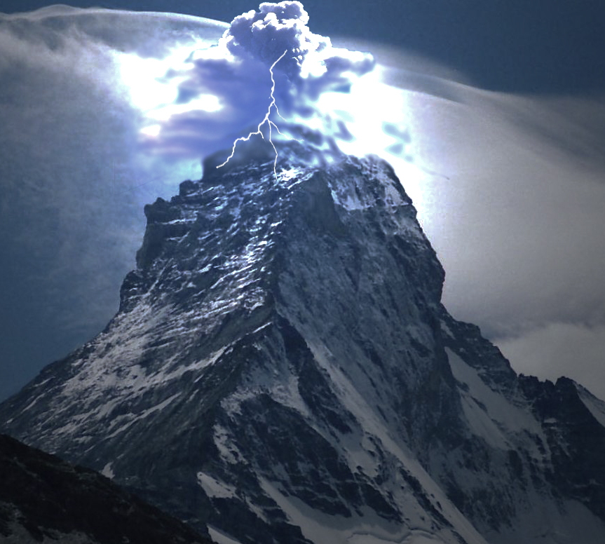

… the mountain of God …

1 Now Moses kept the flock of Jethro his father in law, the priest of Midian: and he led the flock to the backside of the desert, and came to the mountain of God, even to Horeb. 2 And the angel of the LORD appeared unto him in a flame of fire out of the midst of a bush: and he looked, and, behold, the bush burned with fire, and the bush was not consumed. (Ex 3:1-2)

5 And the LORD said unto Moses, Go on before the people, and take with thee of the elders of Israel; and thy rod, wherewith thou smotest the river, take in thine hand, and go. 6 Behold, I will stand before thee there upon the rock in Horeb; and thou shalt smite the rock, and there shall come water out of it, that the people may drink. And Moses did so in the sight of the elders of Israel. 7 And he called the name of the place Massah, and Meribah, because of the chiding of the children of Israel, and because they tempted the LORD, saying, Is the LORD among us, or not? (Ex 17:5-7)

After coming out of Egypt and crossing the Red Sea, the Children of Israel are led from the Wilderness of Sin to a place called Rephidim which was at Horeb – the same mountain at which the Lord appeared to Moses in the burning bush. The scriptures refer to Mount Horeb as the Mountain of God (Exodus 3:1). Mount Sinai is also referred to as the Mountain of God. How so? Because Horeb and Sinai are both part and parcel of the same mountain. It was at this place that the people incurred the wrath of God for doubting His presence among them. The Children of Israel were particularly endowed with the loathsome habit of murmuring. Formerly, they had come to a place called Marah at which the water was bitter. They complained, and Moses was told to cast a designated Tree into the waters after which the waters were sweet to the taste. That Tree was a type of Christ who makes our bitter waters sweet if we drink of the Water of Life which He offers. Passing through Elim to the Wilderness of Sin, they once more murmur about the lack of bread. It is true that the body (and spirit) needs both Bread and Water, but God has made covenant to provide all things if they will keep His Commandments – not yet given in complete form. But having been so blessed with the sweet water of Marah (bitter), made so by the Tree God designated, God sends quail at eventide followed by Manna each morning for six days of each week (excepting the Sabbath Day which suggests that the Sabbath was holy even before the giving of the Law).

At the base of Mount Horeb (the Mountain of God) the people again murmur and complain of no water. God tells Moses to gather the elders together and go and stand before the Rock of Horeb. The Lord will stand upon that Rock out of which torrents of water will flow when Moses strikes the Rock with his staff. We have discussed this Rock many times in devotions – it represents the Lord Jesus Christ stricken for our sins. 1 Moreover, brethren, I would not that ye should be ignorant, how that all our fathers were under the cloud, and all passed through the sea; 2 And were all baptized unto Moses in the cloud and in the sea; 3 And did all eat the same spiritual meat; 4 And did all drink the same spiritual drink: for they drank of that spiritual Rock that followed them: and that Rock was Christ. (1 Cor 10:1-4)

Let us consider the nature of Mount Horeb where the Rock was struck, and Mount Sinai where the Law was given. Remember, they are the same mountain. What is the significance of the Rock of Mount Horeb where mercy and covenantal grace were so effusively granted by God compared with Mount Sinai where the Law of God was given? The lesson, I believe is expressed in the nature of Grace ‘vis à vis’ Law.

You will remember the Holy of Holies in the Tabernacle in which the Candlestick of seven candles on the left side represented the Light of the Holy Ghost, the Shewbread Table (on the right facing the Holiest of Holies) represents the presence of Christ, and the Table of Incense standing before the Veil represented the prayers of the people rising to God. This, too, represents our Lord’s role as intercessor for us with the Father. What was behind the Veil? The Ark of the Covenant containing the Tables of the Law and a portion of Manna was in the Ark. Above the Ark was the Mercy Seat. This, too, represents Christ and His atoning sacrifice for us. Mercy and Grace is above Law in the Holiest of Holies. The High Priest alone was permitted to make intercession once per year before the opened Veil. The Veil, being torn at the moment of Jesus’ giving up the ghost, has been removed as a barrier of the people to come directly to the Father through the Lord Jesus Christ (Mercy Seat). Jesus has become our High Priest and has eliminated that position as one held by men on earth.

The Rock at Horeb represents Mercy and Grace to us, and it comes BEFORE the giving of the Law! God would not give the Law first before making an allowance for the grace required to annul the penalty thereof. These are all symbols and types of that fulfillment that would be satisfied in Christ!

Even today, there is a huge rent rock on the slopes of Horeb that some believe to be the same which was rent by Moses’ staff.

There are eight sacred mountains referred to in the Bible:

- Mount Moriah upon which Abraham undertook to sacrifice Isaac. (Gen 22:2; 1 Chr 21:18 & 2 Chr 3:1)
- Mount Horeb and Sinai (same mount): Horeb (Ex. 3:1; 4:27; 18:5; 24:13; Num. 10:33; 1Ki. 19:8). Sinai is mentioned as a wilderness and a mountain 37 times (Ex. 19:1- 23; Num. 1:1; 3:1; Gal. 4:24- 25). In 17 passages the same desert and mountain are called Horeb (Ex. 3:1; 33:6; Dt. 1:6; 4:10- 15; 5:2; 29:1; 1Ki. 19:8; Ps. 106:19; Mal. 4:4)
- Mount Zion (Ps. 48:2; Isa. 2:2- 4; 8:18; 24:23; 66:20; Mic. 4:7; Dan. 11:45; Joel 3:17; Zech. 8:3)
- The Mount of Olives (Zech. 14:4; Mt. 24:3; 26:30; Acts 1:12)
- The Mount of Transfiguration (2 Pet. 1:18)
- Mount Calvary (Lk. 23:33) same range as Mount Moriah and perhaps even the exact same point.
- The heavenly Mount Zion (Heb. 12:22; Rev. 14:1; 21:10)
- The mountain of God where Lucifer was cast out (Ezek. 28:11- 17)

Why does the Bible pay so much space to mountains and relate them to things heavenly? The answer resides in the nature of mountains compared to the common plain. Christ often resorted to mountains to pray and meditate. If you wish to draw a large crowd to a rock fest, or even to a church gathering, do not plan to draw a crowd on some mountain peak. You must choose a place that is convenient and easily accessed by large numbers of people; but, if you desire to be alone with God and avoid the distractions of the world, go to the mountain top. The means of accessing the peak requires efforts in competition to the gravity of the world. One must climb UP, rather than leisurely walking downhill to the valley. You will find a lot more people on the downhill road than on the narrow uphill path. 13 Enter ye in at the strait gate: for wide is the gate, and broad is the way, that leadeth to destruction, and many there be which go in thereat: 14 Because strait is the gate, and narrow is the way, which leadeth unto life, and few there be that find it. (Matt 7:13-14) Obviously, the first step is the salient point here. If you undertake to follow Christ, the Way is STRAIGHT, and NARROW, and leads up to eternal life. There is no room or occasion to turn back once undertaken in sincerity and fervor. There are FEW on this Way because no one desires to take the “path less traveled.” (Robert Frost) The crowd desires to be part of the mob on the downward path. All of their friends are doing it; it is easy because it is downward (never mind the gaping gates of Hell at the bottom); and it is ever so EASY! Not the effort and condition required to climb the upward way. You will note that the things of the world fall away more and more as one ascends the slopes of the mountain. The surrounding terrain falls away as we climb. When we attain the heights, there is no one around (EXCEPT GOD!) upon which to focus our attention. On the mountain top, the only parts of the world with which we have contact is that small dirt beneath our feet. Now we can hear clearly the still, small Voice of God. No loud and irreverent music, no vulgarity expressed, no pornographic media – just us and God! That is the meaning of a mountain, and God can build a mountain in the valley of our heart as well as upon the floor of the ocean deep. The elevation of our mountain is only limited by the floor of heaven. What a great comfort! Let us partake of the Water of Life from the Rock of Mount Horeb before we suffer the penalty of the Law without it. That Law was given that Grace, too, might abound.

How can we know Light unless we have suffered the Darkness? Amen

