Devotion on Firsts of the Bible - First Messenger of Christ – 7 October 2015, Anno Domini

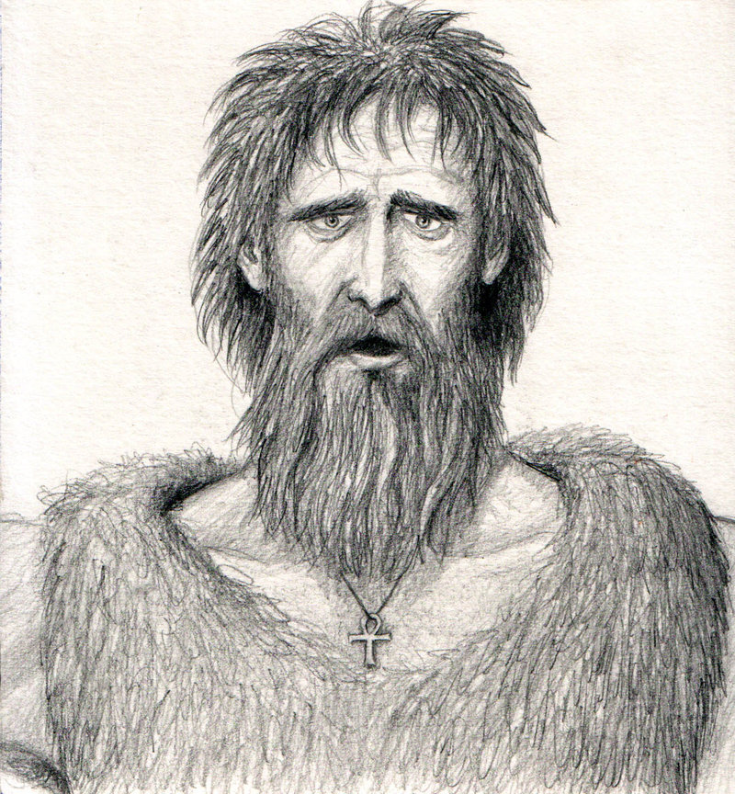

24 For John was not yet cast into prison. 25 Then there arose a question between some of Johns disciples and the Jews about purifying. 26 And they came unto John, and said unto him, Rabbi, he that was with thee beyond Jordan, to whom thou barest witness, behold, the same baptizeth, and all men come to him. 27 John answered and said, A man can receive nothing, except it be given him from heaven. 28 Ye yourselves bear me witness, that I said, I am not the Christ, but that I am sent before him. 29 He that hath the bride is the bridegroom: but the friend of the bridegroom, which standeth and heareth him, rejoiceth greatly because of the bridegrooms voice: this my joy therefore is fulfilled. 30 He must increase, but I must decrease. 31 He that cometh from above is above all: he that is of the earth is earthly, and speaketh of the earth: he that cometh from heaven is above all. 32 And what he hath seen and heard, that he testifieth; and no man receiveth his testimony. 33 He that hath received his testimony hath set to his seal that God is true. 34 For he whom God hath sent speaketh the words of God: for God giveth not the Spirit by measure unto him. 35 The Father loveth the Son, and hath given all things into his hand. 36 He that believeth on the Son hath everlasting life: and he that believeth not the Son shall not see life; but the wrath of God abideth on him. (John 3:24-36)

The Old Testament begins with Creation - "In the beginning God created the heaven and the earth. 2 And the earth was without form, and void; and darkness was upon the face of the deep. And the Spirit of God moved upon the face of the waters." (Gen 1:1-2) and ends with a curse, because the Law is a curse to those who do not believe: "And he shall turn the heart of the fathers to the children, and the heart of the children to their fathers, lest I come and smite the earth with a curse." (Mal 4:6) Everything in the space-time-matter continuum has a beginning and an end - EXCEPT a mans soul. The soul of man is immortal and shall endure through the eternities future. Only a mans faith will dictate where that soul spends his days in eternity - Heaven or Hell.

Before the beginning of all things created, there was God the Father, God the Son, and God the Holy Spirit. Jesus Christ, being the central figure of the Triune Godhead, is the ancient of Days with neither beginning nor end. But His earthly ministry did, indeed, have a beginning as prophesied by all of the Old Testament prophets and confirmed in the life of our Lord Jesus Christ on this earth. "For unto us a child is born, unto us a son is given: and the government shall be upon his shoulder: and his name shall be called Wonderful, Counsellor, The mighty God, The everlasting Father, The Prince of Peace. Of the increase of his government and peace there shall be no end, upon the throne of David, and upon his kingdom, to order it, and to establish it with judgment and with justice from henceforth even for ever. The zeal of the LORD of hosts will perform this.
(Isaiah 9:6-7) "Therefore the Lord himself shall give you a sign; Behold, a virgin shall conceive, and bear a son, and shall call his name Immanuel." (Isaiah 7:14) This was the great Advent message of hope given to the Old Testament Church, and confirmed in our day. Christ was coming to the Old Testament people, and they looked with hope to His appearing; and Christ is coming again to the New Testament Church and it is a thing to be celebrated and hoped for in faith.

The first coming of Christ was abundantly foreseen and prophesied by the prophets of old; but there was a greater prophet to come who would serve as Herald to the King of Kings - the man, John the Baptist. "24 What went ye out into the wilderness for to see? A reed shaken with the wind? 25 But what went ye out for to see? A man clothed in soft raiment? Behold, they which are gorgeously apparelled, and live delicately, are in kings courts. 26 But what went ye out for to see? A prophet? Yea, I say unto you, and much more than a prophet. 27 This is he, of whom it is written, Behold, I send my messenger before thy face, which shall prepare thy way before thee. 28 For I say unto you, Among those that are born of women there is not a greater prophet than John the Baptist: but he that is least in the kingdom of God is greater than he." (Luke 7:24-28) John was the Kings Herald who came without pomp and circumstance, or heralding trumpeteers. He was forerunner to one of like humble birth and earthly standing, yet owner of all Creation.

John preached in simplicity and truth, and he resorted to wilderness areas as his sanctuary. He preached of the One "whose shoe latchets I am not worthy to loose." He was as the Bridegrooms best man who, according to Hebrew custom, would run before the Bridegroom to proclaim His coming to all who would hear but, most especially, to the Bride who would be waiting for the Bridegrooms appearing. John was the voice of one crying in the wilderness: "In those days came John the Baptist, preaching in the wilderness of Judaea, And saying, Repent ye: for the kingdom of heaven is at hand. For this is he that was spoken of by the prophet Esaias, saying, The voice of one crying in the wilderness, Prepare ye the way of the Lord, make his paths straight. And the same John had his raiment of camels hair, and a leathern girdle about his loins; and his meat was locusts and wild honey. Then went out to him Jerusalem, and all Judaea, and all the region round about Jordan, And were baptized of him in Jordan, confessing their sins." (Matt 3:1-6)

Our day is a solemn period in the history of the Church. The days are more evil than those in which Johns preached as one crying in the wilderness. This may seem contradictory to the realization that today we have more churches today than ever before in America; but we also have a lower view of Holy Scripture and moral living than at any point in the history of our Republic. Youth churches allow the youth to congregate in the shadows of the church at youth gatherings and behave in a manner befitting a night club - and the music is worldly and befitting the nightclub scene. The minister preach more of lessons learned on the golf course than from the pages of Gods Holy word. They preach from modern Bible versions that dilute and demean the dignity of the Lord Jesus Christ. And Christians no longer have the courage and moral integrity to stand to the Standard of our faith and prepare for the battle! For those few Godly preachers and laity who remain steadfast and strong in faith, we may compare to that Herald of Christ - John the Baptist - for their voices are as ones crying in the wilderness: "Prepare ye the way of the Lord, make his paths straight."

The faith and determination of John was not deterred by the sparse surroundings, or the weakness of faith in his listeners; and neither must we today be deterred for the lack of faith. We must bear in mind, in our day, that counsel that Christ gave of our times: "Let no man deceive you by any means: for that day shall not come, except there come a falling away first, and that man of sin be revealed, the son of perdition; Who opposeth and exalteth himself above all that is called God, or that is worshipped; so that he as God sitteth in the temple of God, shewing himself that he is God. Remember ye not, that, when I was yet with you, I told you these things?" (2 Thess 2:3-5) Wake up church and observe the social and political terrain hereabouts, and see that faith has fallen forlorn of action and bereft of fidelity to Holy Writ! We have not protected our sons and daughters from the encroaching and insidious influences of humanism and even satanic deception. In fact, we have embraced the same ourselves and left our children orphans to God.

We preach and teach the Word of God in love and should not be appalled or disappointed at its rejection by the mad, mad world. Remember, His Word is sharper than a two-edged sword. A two-edged sword, like the Word of God, cuts BOTH ways - either to convict of sin, or to condemn the sinner. Such a one can never declare before the White Throne judgment, "No one ever told me!"

The ministry of John served a particular purpose - to inform, to warn, and to convict. His ministry was one of particular purpose - to prepare the hearts and minds of the people for the coming of the Lord Jesus Christ. There are only two recorded meetings of John and Jesus noted in Scripture. Both met before birth in the household of Elizabeth. "And Mary arose in those days, and went into the hill country with haste, into a city of Juda; And entered into the house of Zacharias, and saluted Elisabeth. And it came to pass, that, when Elisabeth heard the salutation of Mary, the babe leaped in her womb; and Elisabeth was filled with the Holy Ghost: And she spake out with a loud voice, and said, Blessed art thou among women, and blessed is the fruit of thy womb." (Luke 1:39-42) The second meeting occurred some thirty years later by Jordan Banks (though there may have been other, unrecorded meetings in intervening years). THE TESTIMONY OF JOHN: "The next day John seeth Jesus coming unto him, and saith, Behold the Lamb of God, which taketh away the sin of the world. This is he of whom I said, After me cometh a man which is preferred before me: for he was before me. And I knew him not: but that he should be made manifest to Israel, therefore am I come baptizing with water. And John bare record, saying, I saw the Spirit descending from heaven like a dove, and it abode upon him. And I knew him not: but he that sent me to baptize with water, the same said unto me, Upon whom thou shalt see the Spirit descending, and remaining on him, the same is he which baptizeth with the Holy Ghost. And I saw, and bare record that this is the Son of God. Again the next day after John stood, and two of his disciples; And looking upon Jesus as he walked, he saith, Behold the Lamb of God! (John 1:29-36)

From the moment of Christs beginning ministry at Jordan Banks, John grew smaller, and Christ larger. John died soon after a martyr’s death. The lesson for us is that we do not preach or teach or walk for our own glory. We are accounted as of no worth compared to the sovereign whom we serve. We need more John the Baptists and fewer Joel Osteens or Marilyn Hickeys. Stand up! Speak Truth! Do not worry about the results! John was a Messenger of Christ, and so are we all who are of the true faith of the Bible!

