Devotion on Firsts of the Bible - First Man called of Israel, 2 May 2015, Anno Domini

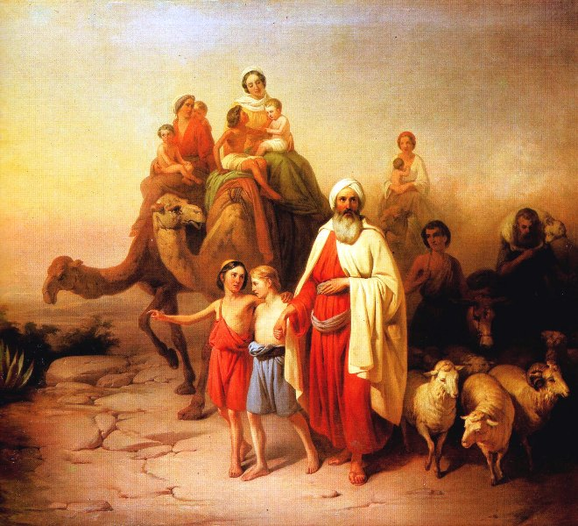
… Abram, Get thee out of thy country, and from thy kindred, and from thy father's house, unto a land that I will shew thee.…

1 Now the LORD had said unto Abram, Get thee out of thy country, and from thy kindred, and from thy father's house, unto a land that I will shew thee: 2 And I will make of thee a great nation, and I will bless thee, and make thy name great; and thou shalt be a blessing: 3 And I will bless them that bless thee, and curse him that curseth thee: and in thee shall all families of the earth be blessed. (Gen 12:1-3)

Archaeologists have unearthed evidence at Ur of the Chaldees of the most ancient civilization of the known world. This was the home of the Patriarch called out to be the means by which God would bring forth the Seed of Promise. There was nothing written in Scripture to distinguish Abram either as a great leader, or a particularly righteous man – but the ways of God are beyond finding out by man. He rules in the capacity of His predestined plan and purpose.

For just a moment, let us pretend we are Abram, busily going about our business in Ur of the Chaldees. The only worship we have known from childhood has been that of idol worship. From the cloudless sky, so common in that part of the world, there sudden burst forth a Voice from somewhere high above and far away from this dirty little town: Get thee out of thy country, and from thy kindred, and from thy father's house, unto a land that I will shew thee: And I will make of thee a great nation, and I will bless thee, and make thy name great; and thou shalt be a blessing: And I will bless them that bless thee, and curse him that curseth thee: and in thee shall all families of the earth be blessed. This is not wooden or stone idol! This is a Voice of the Almighty. What are the precise instructions given? The Voice of the Lord, as readily recognized by Abram as did Saul on the Road to Damascus as belonging to the true Lord of all, told Abram to leave his home, and all of his kindred, and go someplace that the Lord would show him – no further details about the destination! What would you do?

The Counsel of God is always accompanied by rewards for obedience. Those today who live a life that is honoring to the Lord enjoy better health, greater joy, and have more of their needs met, than all of the godless of society who hustle and cut corners to get advantage over others, or who lie in gutters of sin night after night. The reward offered to Abram is even greater than his mind could have comprehended. It meant, ultimately, that he would be recipient of that same favor and satisfaction that all are beneficiaries of in the Kingdom of God. But in more immediate sense, it meant that God would call His people from among the descendants of Abram (later Abraham). Note: I said from AMONG, for all who are the fleshly offspring of Abraham are not necessarily the children of God. They which are the children of the flesh, these are not the children of God: but the children of the promise are counted for the seed. (Romans 9:8) This means that the same faith in that Promised Seed to which Abraham looked forward in obedience is the same to which we look back upon in the works of Redemption done on our behalf by the Lord Jesus Christ. And if ye be Christ's, then are ye Abraham's seed, and heirs according to the promise. (Gal 3:29)

So how did father Abram respond to that call of God? He responded in the same way that we most often respond to God’s Counsel – with less than total obedience.

- So Abram departed, as the LORD had spoken unto him. (Gen 12:4a)
  - Commendable, so far. There is no delay, but IMMEDIATE obedience. But wait!
- . . . . and Lot went with him: and Abram was seventy and five years old when he departed out of Haran. And Abram took Sarai his wife, and Lot his brother's son, and all their substance that they had gathered, and the souls that they had gotten in Haran; and they went forth to go into the land of Canaan; and into the land of Canaan they came. (Gen 12:4b-5)

Is THIS in exact obedience to what God had commanded? Did God not say, “Get thee out of thy country, and from thy kindred, and from thy father's house?” That little detail about leaving behind his kindred resulted in many a grief and hindrance to Abraham in later trials. He was delayed at Haran until after his aging father passed away, and he was engaged in war against the enemies of Lot, rescuing them in the process. Later, God destroyed Sodom and Gomorrah in which Lot had set up residence. If we overlook the detail of God’s Word, it will only result in heartache and spiritual setback later.

Need I mention the dangers that developed for Abraham on two separate occasions due to having his beautiful wife, Sarah, along? Here is what Abraham (Abram) took with him from Haran: 5 And Abram took Sarai his wife, and Lot his brother's son, and all their substance that they had gathered, and the souls that they had gotten in Haran; and they went forth to go into the land of Canaan; and into the land of Canaan they came. (Gen 12:5) Seems like quite a lot of kindred to me, does it to you? I can almost hear you second-guessing God on this one, but read the counsel of Jesus in St. Matthew’s Gospel: And every one that hath forsaken houses, or brethren, or sisters, or father, or mother, or wife, or children, or lands, for my name's sake, shall receive an hundredfold, and shall inherit everlasting life. (Matt 19:29) This does not mean to literally abandon one’s familial responsibilities, but it does mean places the Word of God above every other affection. When we are called to serve the Lord, the first question that comes to mind should be “What has the Lord commanded” not “How will this affect my family!”

I am not putting the faithful Abraham down to scorn! He has already demonstrated greater faith than most by his immediate obedience to God’s command to leave Ur of the Chaldees and go to a destination of which he knows not. I simply point out the chinks in the armor of a great man of God. If Abraham was subject to such weaknesses, where do you believe you and I stand in our own obedience to God?

And the LORD appeared unto Abram, and said, Unto thy seed will I give this land: and there builded he an altar unto the LORD, who appeared unto him. (Gen 12:7) No idol god had ever made a miraculous appearance to Abram, but the Lord is the only true God, and He makes more than one appearance to Abram. When Abram has finally arrived on Canaan’s land, he built and altar to the Lord just as had Noah when he departed on dry land from the Ark. Abram moves on to near Bethel and builds yet another altar, and there calls upon the name of the Lord. He has arrived at the land in which God has promised to bless him and give him an inheritance, yet, Abram does not stay put. There is a famine in that land. Instead of toughing it out where God has planted him, Abram continues moving south into Egypt – far away from the land in which God has sent him to dwell. When we add our will to that of the Lord, trouble will surely ensue, and it does now for Abram.

Abram fails to tell the whole truth in Egypt. 10 And there was a famine in the land: and Abram went down into Egypt to sojourn there; for the famine was grievous in the land. 11 And it came to pass, when he was come near to enter into Egypt, that he said unto Sarai his wife, Behold now, I know that thou art a fair woman to look upon: 12 Therefore it shall come to pass, when the Egyptians shall see thee, that they shall say, This is his wife: and they will kill me, but they will save thee alive. 13 Say, I pray thee, thou art my sister: that it may be well with me for thy sake; and my soul shall live because of thee. (Gen 12:10-13)

The sordid results are all recorded in the following text of this chapter. Sarai does fall victim to Pharaoh’s amorous intentions. Pharaoh decides to take Sarai to wife, but the Lord sends boils and discomfort upon his house. Even Pharaoh knows this is from God. So he releases Sarai and rebukes Abram for lying to him. He sends them out of the land of Egypt with ample provision for their sustenance.

These and many more painful experiences happen to Abram because he didn’t take very detailed notes of what God had said to him. Do you suppose God was shocked that Abram was slow to obey the letter of His Word to him? I do not believe God is ever shocked at any behavior of His people. He allows the dirty laundry to be displayed along with the robes of silk so that we may learn lessons concerning our own hearts and the weak defenses of its walls against temptations of every kind.

The Word of God is a mirror to our souls. We see our own failures and weakness in men such as David, in Jacob, in Absalom, in the Woman taken in Adultery, and in the Woman at the Well. If we do not see our sinful natures reflected there, we are in the company of the Pharisees who considered themselves too moral to learn a lesson from a supposed Carpenter’s Son.

Lessons that we may take to heart on the calling of Abram include:

- We must promptly obey the call of God;
- We must leave off our old idols of gold and silver to follow the only true God;
- We must place God’s command above every other consideration of family and domicile;
- We must go where the Lord tells us to go, and we must STOP where the Lord commands us to stop;
- We must never add our wills to that of the Lord. His will must become our own.

