Devotion on Firsts of the Bible - First Jewish Queen of a Gentile Nation – 26 September 2015, Anno Domini

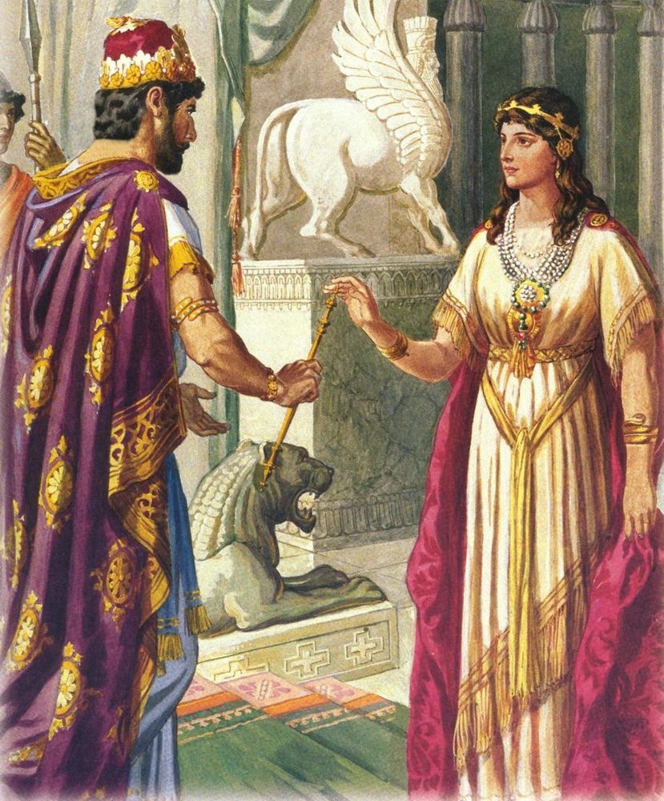

7 And Mordecai told him of all that had happened unto him, and of the sum of the money that Haman had promised to pay to the king's treasuries for the Jews, to destroy them. 8 Also he gave him the copy of the writing of the decree that was given at Shushan to destroy them, to shew it unto Esther, and to declare it unto her, and to charge her that she should go in unto the king, to make supplication unto him, and to make request before him for her people. 9 And Hatach came and told Esther the words of Mordecai. 10 Again Esther spake unto Hatach, and gave him commandment unto Mordecai; 11 All the king's servants, and the people of the king's provinces, do know, that whosoever, whether man or woman, shall come unto the king into the inner court, who is not called, there is one law of his to put him to death, except such to whom the king shall hold out the golden sceptre, that he may live: but I have not been called to come in unto the king these thirty days. 12 And they told to Mordecai Esther's words. 13 Then Mordecai commanded to answer Esther, Think not with thyself that thou shalt escape in the king's house, more than all the Jews. 14 For if thou altogether holdest thy peace at this time, then shall there enlargement and deliverance arise to the Jews from another place; but thou and thy father's house shall be destroyed: and who knoweth whether thou art come to the kingdom for such a time as this? 15 Then Esther bade them return Mordecai this answer, 16 Go, gather together all the Jews that are present in Shushan, and fast ye for me, and neither eat nor drink three days, night or day: I also and my maidens will fast likewise; and so will I go in unto the king, which is not according to the law: and if I perish, I perish. 17 So Mordecai went his way, and did according to all that Esther had commanded him. (Esther 4:7-17)

Esther is a name of rare beauty owing, not only to the images evinced in the imagination, but also for character and sense of purpose. I love the name as well for the tenderness even its pronunciation evokes. Esther is a woman of great courage and of self-sacrificial disposition. She was the first Jewish woman to be named Queen of a Gentile Nation – Persia. Persia is a land noted for the beauty of its women and its oriental gardens.

Esther would become the wife of Xerxes (Ahasuerus). The kings of the east have a great problem at drinking parties. You will remember Belshazzar of Babylon held a drinking orgy in the King’s Court at Babylon and ordered the golden vessels taken by Nebuchadnezzar from the Temple at Jerusalem to be brought and used in drinking. That is was the straw that broke the camel’s back, and God sent forth His finger to write Belshazzar, and Babylon’s, ruin on the adjacent wall. Now, Xerxes has a similar problem. His throws a drinking party at Shushan (Suza in modern-day Iran). This is the same city from which Daniel later prophesied after the Fall of Babylon. It is a huge tippeh (mound) of miles in dimensions. One can see it as a low mountain when approaching from the east, and it is located on the plain of the ancient Persian province of Elam (ancient Semite descendant of Shem). One has a sense of awe in standing on the ruins of such a city of historic biblical import.

Before discussing how Esther became Queen of Persia, let us observe that Esther, and her cousin, Mordecai, are buried in Persia (Iran) and their gravesite may be seen in Ecbatana (modern day Hamadan, Iran). Ecbatana was the capital of the Medes, was defeated by the Persian King, Cyrus the Great, and therefore the empire became the Medo-Persian Empire of which the Bible speaks. Ecbatana is the site also of the discovery of the famous Behistun Inscription which describes the Persian’s, Darius the Great, defeat of a rebel;lion of Ecbatana against Persia. Cyrus was the progenitor of the Achaemenid Dynasty of Persia, and Ecbatan, according to the Greek historian, Xenophon (c.430-c.355 BC), became the summer residence of the Persian kings. Another Greek historian, Polybius, reports that Ecbatana was richer and more beautiful than any other city in the world. I relate these historical facts for the benefit of the readers faith in Holy Scripture. Xerxes himself is buried in modern day Iran at Persepolis. His tomb is carved from solid rock on the southern face of the Mountain of Mercy overlooking the ruins of Persepolis. All of these areas mentioned in the Bible are still extant, and may be examined today (given access).

But for now, let us return now to Xerxes’ drinking party. The reader may recall that the decree of a Persian King was considered immutable and unchangeable – even by the King himself. On the seventh day, when the heart of the king was merry with wine, he commanded Mehuman, Biztha, Harbona, Bigtha, and Abagtha, Zethar, and Carcas, the seven chamberlains that served in the presence of Ahasuerus the king, To bring Vashti the queen before the king with the crown royal, to shew the people and the princes her beauty: for she was fair to look on. But the queen Vashti refused to come at the king's commandment by his chamberlains: therefore was the king very wroth, and his anger burned in him. (Esth 1:10-12) It must be remembered Vashti was a virtuous woman and declined the invitation of Xerxes out of a sense of moral dignity to both herself and the king. The invitation was to have Vashti dance lewdly and immodestly before the king’s guests. This Vashti refused to do, so the king was angry and asked of his priests, the Magi, their advice. While the king was still drunk, he listened to his depraved counsellors and issued a decree that Vashti would no longer come before him. This was an irreversible decree of the realm. When he had sobered, Xerxes regretted his hasty and foolish act, but was powerless to reverse his own decree.

Esther (Hadasseh) was left orphaned as a child and her cousin, Mordecai, took her to raise as his own child. Esther became a blessed daughter to Mordecai, and she honored him all the days of her life. When procedures for selecting a new queen for the Xerxes were implemented, Esther was chosen as one of the possible candidates. She would be kept in the chambers of the king’s concubines until her purification (one year) and then be presented, along with the other candidates, to the king to see which he would select. When the time came for Esther to appear before the king, Xerxes was overtaken by her beauty and manners, and gave her the crown of Vashti to be Queen in Persia.

In the meantime, the king had been less discerning in matters of state and honored one, Haman, and appointed him as chief Prince in Persia above all others. All who saw Haman bowed before him – except Mordecai. Being a devout Jew, Mordecai bowed only to God and to no man. Being assessed of Mordecai’s behavior, Haman, a vengeful man, sought to put all Jews to death. He lobbied the king to have all of those disobedient people dispersed abroad in Persian called Jews put to death. The king was deceived by Haman and issued the decree. Mordecai related by the messenger, Hatach, the details of the king’s decree. Remember Xerxes did not know of Esther’s Jewish background. It was a dangerous circumstance for Esther to maneuver. When Esther informed Mordecai of the danger of approaching the king with the petition of the Jews, he answered her in these words: For if thou altogether holdest thy peace at this time, then shall there enlargement and deliverance arise to the Jews from another place; but thou and thy father's house shall be destroyed: and who knoweth whether thou art come to the kingdom for such a time as this? (Esth 4:14) What would you do, friends, if the lives of your friends, family, and neighbors hung upon your own courage to protect?

Esther’s response to Mordecai was succinct and full of brave resolution: Go, gather together all the Jews that are present in Shushan, and fast ye for me, and neither eat nor drink three days, night or day: I also and my maidens will fast likewise; and so will I go in unto the king, which is not according to the law: and if I perish, I perish. (Esth 4:16) Though God is not mentioned directly in the Book of Esther, there are subtle references to man’s responsibility in the worship of fasting. In the meantime, Esther goes before the king holding her life by a single thread, setting a trap for Haman, but the king hears Esther’s request: 1 Now it came to pass on the third day, that Esther put on her royal apparel, and stood in the inner court of the king's house, over against the king's house: and the king sat upon his royal throne in the royal house, over against the gate of the house. 2 And it was so, when the king saw Esther the queen standing in the court, that she obtained favour in his sight: and the king held out to Esther the golden sceptre that was in his hand. So Esther drew near, and touched the top of the sceptre. 3 Then said the king unto her, What wilt thou, queen Esther? and what is thy request? it shall be even given thee to the half of the kingdom. 4 And Esther answered, If it seem good unto the king, let the king and Haman come this day unto the banquet that I have prepared for him. (Esth 5:1-4)

Haman is delighted in the sudden advance in favor, and also to be invited by the queen only in company with Xerxes. He shares the news with Zeresh, his wife: 12 Yea, Esther the queen did let no man come in with the king unto the banquet that she had prepared but myself; and to morrow am I invited unto her also with the king. 13 Yet all this availeth me nothing, so long as I see Mordecai the Jew sitting at the king's gate. 14 Then said Zeresh his wife and all his friends unto him, Let a gallows be made of fifty cubits high, and to morrow speak thou unto the king that Mordecai may be hanged thereon: then go thou in merrily with the king unto the banquet. And the thing pleased Haman; and he caused the gallows to be made. (Esth 5:12-14) There is a grave lesson in this last passage: He who allows vengeance to rule his heart will build his own gallows!

Esther makes her request, and reveals her race, to the king before Haman at the banquet. The king asked who was the party who had contrived this evil against the Jews? Esther identified Haman. The king was furious and went out to the palace garden. On his return to the banquet room, Haman had fallen (out of fear) on Esther’s bed. That did the trick! Haman was hanged that night on the gallows he had made for Mordecai.

Mordecai, who had been the source of revealing an earlier plot to kill Xerxes, was advanced to the second place in the Persian Empire. The Jews in all provinces were provided, by order of the king, means and weapons with which to defend themselves. This they did having killed in battle all of the kin of Haman; and receiving their wealth as spoils. Thus, were the Jews of Persia saved from massacre by a brave and faithful queen of their own blood. We read in the final chapter of Esther: 1 And the king Ahasuerus laid a tribute upon the land, and upon the isles of the sea. 2 And all the acts of his power and of his might, and the declaration of the greatness of Mordecai, whereunto the king advanced him, are they not written in the book of the chronicles of the kings of Media and Persia? 3 For Mordecai the Jew was next unto king Ahasuerus, and great among the Jews, and accepted of the multitude of his brethren, seeking the wealth of his people, and speaking peace to all his seed. (Esth 10:1-3) The Jews of today still celebrate that event of their salvation on the fourteenth day of Adar as Purim. Pur (in Persian) referred to the lots cast for their destruction, so Purim derives from that Persian word. Therefore the Jews of the villages, that dwelt in the unwalled towns, made the fourteenth day of the month Adar a day of gladness and feasting, and a good day, and of sending portions one to another. (Esth 9:19)

