Devotion on Firsts of the Bible - First Forward Air Controller (FAC) – 16 December 2015, Anno Domini

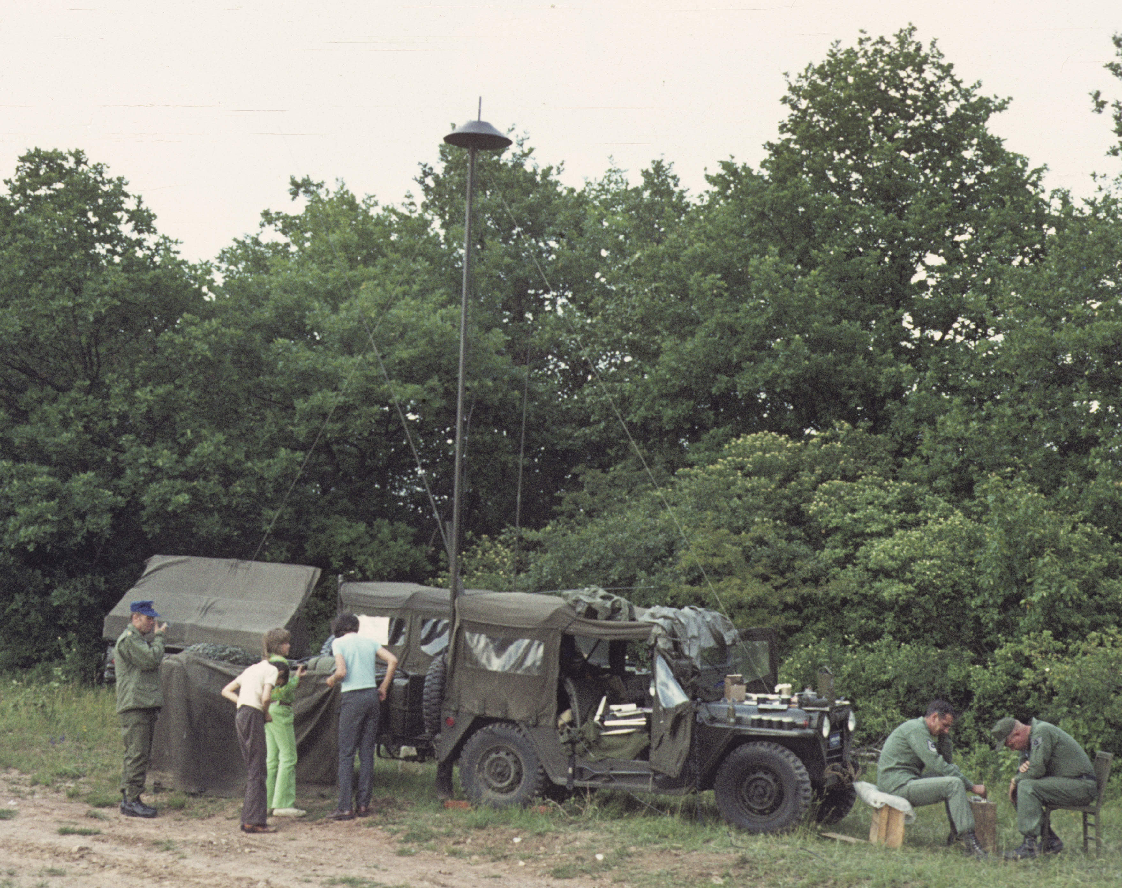

Sons of Thunder - James & John
Special request of Mrs. Dru Arnold

And it came to pass, when the time was come that he should be received up, he stedfastly set his face to go to Jerusalem, And sent messengers before his face: and they went, and entered into a village of the Samaritans, to make ready for him. And they did not receive him, because his face was as though he would go to Jerusalem. And when his disciples James and John saw this, they said, Lord, wilt thou that we command fire to come down from heaven, and consume them, even as Elias did? But he turned, and rebuked them, and said, Ye know not what manner of spirit ye are of. For the Son of man is not come to destroy men's lives, but to save them. And they went to another village. (Luke 9:51-56)

A young Jordanian lieutenant (a flight student of mine) once said: "When you fight the Israelis, if they expend all of their armor and artillery rounds, they will then call in lightning strikes against the enemy." I doubt the theological soundness of that charge, but it does express the dreaded power of lightning.

The Voice of our God is compared to the sound of Thunder. It is a mighty Voice which man could not abide unless enabled by the Holy Ghost. There are many voices in the world, but only one Voice of Thunder from on High. No other voice can be heard over that of God's thunderous Voice.

Thunder results from the great heat of the lightning bolt (approx 55,000 degrees Fahrenheit and five times hotter than the sun's surface) as it instantly heats the surrounding air in its path. The acoustic shock of lightning as the air rapidly expands due to this heat manifests itself in the sound of lightning. The lightning bolt, like God's Word, comes down to earth and returns in precisely the same path of its coming. For as the lightning cometh out of the east, and shineth even unto the west; so shall also the coming of the Son of man be. (Matt 24:27)

When we consider that God is a "consuming fire," this comparison of God's Word to Thunder makes sense. 28 Wherefore we receiving a kingdom which cannot be moved, let us have grace, whereby we may serve God acceptably with reverence and godly fear: 29 For our God is a consuming fire. (Heb 12:28-29 , see also Deut 4:24)

If Thunder represents the Voice of God, His Great Power and Purpose is comparable to Lightning. 1 Give unto the LORD, O ye mighty, give unto the LORD glory and strength. 2 Give unto the LORD the glory due unto his name; worship the LORD in the beauty of holiness. 3 The voice of the LORD is upon the waters: the God of glory thundereth: the LORD is upon many waters. 4 The voice of the LORD is powerful; the voice of the LORD is full of majesty. 5 The voice of the LORD breaketh the cedars; yea, the LORD breaketh the cedars of Lebanon. 6 He maketh them also to skip like a calf; Lebanon and Sirion like a young unicorn. 7 The voice of the LORD divideth the flames of fire. 8 The voice of the LORD shaketh the wilderness; the LORD shaketh the wilderness of Kadesh. (Psalms 29:1-8)

In our introductory text from Luke 9, we read Jesus sent His disciples ahead of Him to a village of the Samaritans to make arrangements for His visitation there (on His final trip to Jerusalem to be offered up). The village refused to receive Christ because it was apparent that He was enroute to Jerusalem. The Samaritans were hostile to the Jews and did not desire to receive any who befriended them. And when his disciples James and John saw this, they said, Lord, wilt thou that we command fire to come down from heaven, and consume them, even as Elias did? Jesus rebuked these two: Ye know not what manner of spirit ye are of. For the Son of man is not come to destroy men's lives, but to save them. And they went to another village. God is too big to deal in trifles of rejection. Those who reject the King, do so to their own detriment, for no one receives the Kingdom without the King. We teach and preach the Gospel of Christ to all. It is not our concern to award or punish those who accept or reject that message.

These two disciples, James and John, were brothers. John was the disciple for whom Jesus had a particular love and affection - in fact, his name 'John' means to receive the grace, or love, of God. John would be the longest to live of all of the disciples having written the last Book of the Bible (Revelations). Jesus also had given these two, James & John, a particular surname - Sons of Thunder! And Simon he surnamed Peter; 17 And James the son of Zebedee, and John the brother of James; and he surnamed them Boanerges, which is, The sons of thunder (Boanhrgevß Boanerges) (Mark 3:16-17)

Since the Word of God is so often compared to Thunder, it must have been a conspicuous distinction to be termed by the Savior as "Sons of Thunder." Conceivably, this distinction resulted from their fervor in preaching the Gospel as well as their proclivity to call fire down on a city in Luke 9.

Would we all not desire to be the Sons and Daughters of the Thunderous Voice of God? In actuality, all who claim their adoption as sons and daughters of God in Christ should bear this same distinction as sons and daughters of Thunder if we are adamant in sharing the Gospel and Word of God with others.

Just as there is great power in thunder caused by the great heat of Heaven, the Word of God has great power to sever asunder the soul and spirit. For the word of God is quick, and powerful, and sharper than any two edged sword, piercing even to the dividing asunder of soul and spirit, and of the joints and marrow, and is a discerner of the thoughts and intents of the heart. (Heb 4:12)

In addition, like thunder and lightning, God's Word always accomplishes His purpose and returns to Him via the same route of its coming. So shall my word be that goeth forth out of my mouth: it shall not return unto me void, but it shall accomplish that which I please, and it shall prosper in the thing whereto I sent it. (Isaiah 55:11)

Does our voice of faith bear the character of thunder?

Thunder comes from heaven
Thunder is formed unseen in the clouds of Heaven. God's Word comes from on high and may not always be fully understood by us. But regardless of our understanding, we must know that the Word of God is True and Immutable.

Thunder is not timid
No power on earth can still the Voice of Thunder, or of God. It matters not what powers or majesties are beneath the clouds of lightning, lightning does not hesitate to thunder forth. So must the sons and daughters of thunder be ready to speak out on matters of the moral law and the grace of God in Scripture. Thunder is no respecter of persons. Its bolts strike wherever the conditions of electrical charge direct them.

Thunder is not subject to our management
Thunder is God-sent and not subject to the will of man. Though we may thunder the Word of God, in reality, our voices are not even a whisper if we speak our own wills and not His.

Thunder is formed by heat and light
The fervor and fire created in our hearts by the Gospel is the progenitor of our speaking out even under perilous conditions. That fervor and fire is also the offspring of brilliant light caused by the Lightning of God's Word.

Thunder most often comes during stormy skies
On clear summer days, it is less likely we will hear the thunder of God's Voice. The sun is bright, our hearts are light, and our needs seem negligible. But when the storm arises and our way is treacherous, God's Lightning Thunders in the way, and we can both see and feel the heat and light of His Word, and our own depravity before it.

Thunder leaves clean air and clearing skies
Emersion in God's Word clears our souls and leads to hope and joy!

If we look about us, we see the storm clouds arising on the dark horizon of the world. If we erect the Lightning Rod of God (our Lord Jesus Christ) above our heads and lodgings (just as Israel brushed the blood of the lamb on their door posts and lintels) we shall not be hurt by the lightning that is to come.

