Devotion on Firsts of the Bible - First Ensign Lifted Up – 1 October 2015, Anno Domini

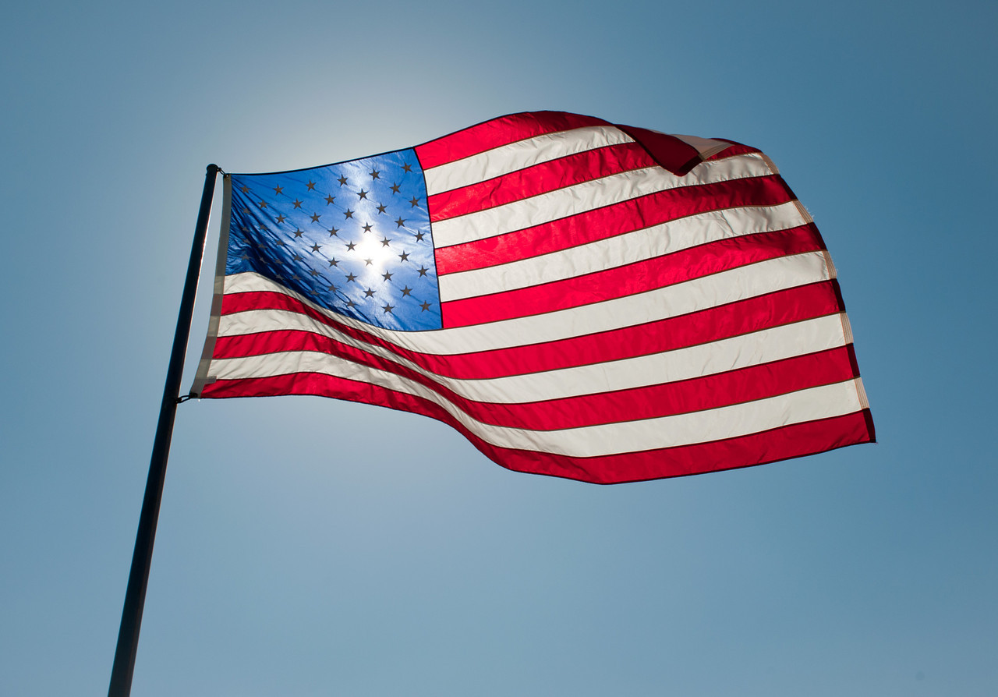

Every man of the children of Israel shall pitch by his own standard, with the ensign of their father's house: far off about the tabernacle of the congregation shall they pitch. (Numbers 2:2)

Every soldier and seaman knows ensigns are of great importance. In the great sea battles of the past, and even aboard modern battleships, some form of semaphore is practiced. In the smoke and confusion during battles on the high seas, Naval gunners peered through the drifting midst to identify which flag was flying aboard nearby vessels. Infantry soldiers, and armored vehicles, still fly an ensign to identify the nation or unit they represent. In platoon and company formations, during marches or runs, the guide-on bearer carries the ensign of the unit out front to enhance direction of movement and to augment the commands of the commander.

The first use, in Holy Scripture, of the term, ENSIGN, occurs in Numbers 2:2: Every man of the children of Israel shall pitch by his own standard, with the ensign of their father's house. The standard is a banner, and the ensign is a particular kind of banner lifted aloft. The meaning of the term here in Numbers is 'to lift the banner aloft' (miraculously) of the tribal Father (Patriarch). It is no different today for the Christian - we lift high aloft the banner (ensign) of our Father and our God. We thus allow no mistaken identity as to whose we are. One great difference in the Islamic faith (and there are tremendous differences) and the Christian faith is that the Christian cannot deny his Lord under pain of death; but the Moslem, in accordance with the tenets of his 'faith' can lie, cheat, or steal to cover his identity as a Moslem under duress. Christianity requires a courageous and manly faith. The Christian soldiers wages war with compassion while the Islamist wages war on the innocents of the land raping and pillaging women and children. We carry our Standard openly out front, and we lift our Ensign and Banner aloft for all to see. We do not do so arrogantly or in hateful ways, but to show the unbeliever that there is hope and refuge beneath that banner of Christ!

There are seven additional references in the Old Testament to the word 'ensign;' but the word is slightly different in the Hebrew. Numbers uses the term 'owth meaning a banner lifted up, even miraculously; but the last seven references are derivatives of the Hebrew word 'nec' having a very strong accent to lift the banner high aloft. The last reference in Zechariah 9:16 is 'naca' with a very strong connotation. Let us examine the seven remaining references to the Ensign:

And he will lift up an ensign to the nations from far, and will hiss unto them from the end of the earth: and, behold, they shall come with speed swiftly: (Isaiah 5:26) There is only ONE Ensign who possesses the power referenced here - that is the Lord Jesus Christ - the Ensign in our midst. For where two or three are gathered together in my name, there am I in the midst of them. (Matt 18:20) And, Behold, he cometh with clouds; and every eye shall see him, and they also which pierced him: and all kindreds of the earth shall wail because of him. Even so, Amen. I am Alpha and Omega, the beginning and the ending, saith the Lord, which is, and which was, and which is to come, the Almighty. (Rev 1:7-8)

Further along in Isaiah, we have more reference to the Ensign: And in that day there shall be a root of Jesse, which shall stand for an ensign of the people; to it shall the Gentiles seek: and his rest shall be glorious. And it shall come to pass in that day, that the Lord shall set his hand again the second time to recover the remnant of his people, which shall be left, from Assyria, and from Egypt, and from Pathros, and from Cush, and from Elam, and from Shinar, and from Hamath, and from the islands of the sea. And he shall set up an ensign for the nations, and shall assemble the outcasts of Israel, and gather together the dispersed of Judah from the four corners of the earth. (Isaiah 11:10-12) This is clearly a prophecy of The Coming Redeemer. The countries mentioned have a double meaning - they are both of contemporary application to the time of the Babylonian captivity as well as type and foreshadow of the time of Christ's coming.

Behold, I shew you a mystery; We shall not all sleep, but we shall all be changed, In a moment, in the twinkling of an eye, at the last trump: for the trumpet shall sound, and the dead shall be raised incorruptible, and we shall be changed. For this corruptible must put on incorruption, and this mortal must put on immortality. (1 Cor 15:51-53) That time is coming, friends: All ye inhabitants of the world, and dwellers on the earth, see ye, when he lifteth up an ensign on the mountains; and when he bloweth a trumpet, hear ye. (Isaiah 18:3)

One thousand shall flee at the rebuke of one; at the rebuke of five shall ye flee: till ye be left as a beacon upon the top of a mountain, and as an ensign on an hill. (Isaiah 30:17) Most often the Ensign is a Banner of Battle, but in this case, it serves as a signal of defeat to those who turn from God - a grave marker so to speak. God will winnow his people before that last day.

And he shall pass over to his strong hold for fear, and his princes shall be afraid of the ensign, saith the LORD, whose fire is in Zion, and his furnace in Jerusalem. (Isaiah 31:9) It has never made a great deal of earthly sense that a small, ill-equipped army could defeat, handily, an army of far greater numbers and resources; but this is God's work. He performed that mysterious work with Gideon, with Moses, with Joshua, and with Elisha. He shall do it at the last day with greater profundity than ever before! Just before the White Throne Judgment, we read: 7 And when the thousand years are expired, Satan shall be loosed out of his prison, 8 And shall go out to deceive the nations which are in the four quarters of the earth, Gog and Magog, to gather them together to battle: the number of whom is as the sand of the sea. 9 And they went up on the breadth of the earth, and compassed the camp of the saints about, and the beloved city: and fire came down from God out of heaven, and devoured them. 10 And the devil that deceived them was cast into the lake of fire and brimstone, where the beast and the false prophet are, and shall be tormented day and night for ever and ever. (Rev 20:7-10)

In the Godly and glorious days of America's past, there was a great deal of power and a mysterious fear that the Stars and Stripes of Old Glory evidenced on the field of battle. Its presence was like a fifth column of combat seasoned troops added to the fray. There was that power in Old Glory because God and His word were the currency of the realm of America in her by-gone days of yore. Today, we have become a roving band of pampered, spiritual wimps. We fall for every wind of doctrine, and Satan's anti-Christ leads us about by the nose as if we were store-bought fools.

The Ensign of Victory for the remnant peoples of God is approaching the time of its being lifted up on the hills round about that 'Camp of the Saints.' Many precious Christian souls - men, women, and little children, are suffering unmentionable acts of barbarity and beheadings today at the hands of Islam. And as Moses lifted up the serpent in the wilderness, even so must the Son of man be lifted up: That whosoever believeth in him should not perish, but have eternal life. (John 3:14-15) Christ has two advents - that of two thousand years ago, and that which shall soon come upon the earth. You will remember the murmuring hordes of the Children of Israel in the Wilderness. They wanted everything handed to them on a silver platter - much like the greater population of America today. Because of their obstreperous and divisive behavior, God sent them something to occupy their idle time - fiery serpents. These are still called 'two-step' snakes in the Middle East for, if one is bitten, he may take only two steps before he collapses with intense and fiery pain of death. The only remedy for this serpent bite was for the people to look up to the brazen serpent which Moses had nailed to a wooden pole.

In the same way as the serpent was lifted up for the healing of the deadly bite of the serpent, so was Christ lifted up for you and me on a wooden cross so that whoever suffers the sting of death caused by sin, and its Serpent, may look up to Him crucified for our sins and be thereby healed.

Just as Christ was crucified, dead and buried; and arose from the tomb on the third day; so can the people who look to Him for healing be lifted up from the grave and become a crown and ensign to the glory of God. And the LORD their God shall save them in that day as the flock of his people: for they shall be as the stones of a crown, lifted up as an ensign upon his land. (Zechariah 9:16)

