Devotion on Firsts of the Bible - First Encounter of our Lord in the Temple – 6 January 2016, Anno Domini – The Epiphany

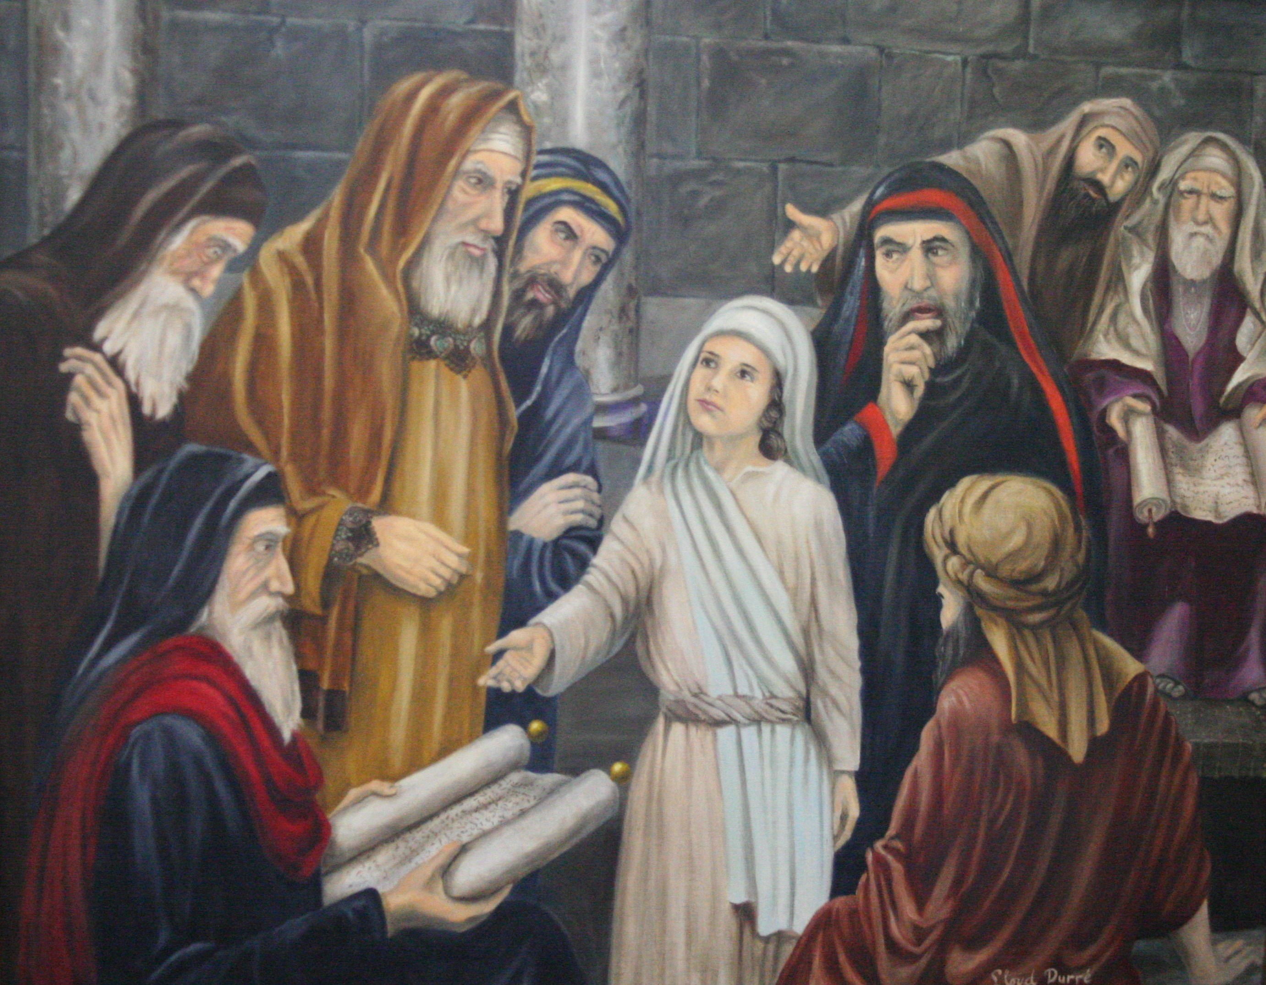

… wist ye not that I must be about my Father's business…

41 Now his parents went to Jerusalem every year at the feast of the passover. 42 And when he was twelve years old, they went up to Jerusalem after the custom of the feast. 43 And when they had fulfilled the days, as they returned, the child Jesus tarried behind in Jerusalem; and Joseph and his mother knew not of it. 44 But they, supposing him to have been in the company, went a day's journey; and they sought him among their kinsfolk and acquaintance. 45 And when they found him not, they turned back again to Jerusalem, seeking him. 46 And it came to pass, that after three days they found him in the temple, sitting in the midst of the doctors, both hearing them, and asking them questions. 47 And all that heard him were astonished at his understanding and answers. 48 And when they saw him, they were amazed: and his mother said unto him, Son, why hast thou thus dealt with us? behold, thy father and I have sought thee sorrowing. 49 And he said unto them, How is it that ye sought me? wist ye not that I must be about my Father's business? 50 And they understood not the saying which he spake unto them. 51 And he went down with them, and came to Nazareth, and was subject unto them: but his mother kept all these sayings in her heart. 52 And Jesus increased in wisdom and stature, and in favour with God and man. (Luke 2:41-52)

Imagine losing our Lord Jesus Christ from your life, and then contrast that loss with Mary losing the Son of her own bosom from her care! The loss was the result of presumption and carelessness. How often do seasoned Christians lose the very presence of Christ from their hearts through foolish pursuits that begin with the right motive and end in a separation from God? Many churches are begun with a very devoted desire to serve the Lord with all the heart; but as the institution grows in prestige and wealth, Christ is forgotten and left in the very ruins of faith. The separation may be so great that once the heart returns to Christ, we are less able to understand His Word as in Verse 49 above.

The occasion of our Lord's first cognizant visitation to the Temple is a noteworthy glimpse of an otherwise concealed history of His young life from circumcision to baptism. It signifies the early dawning of His yearnings to be about His Father's business. We need not point out that Jesus had no earthly father as some modern (per)versions of the Bible now suggest. He was the only Begotten Son of His Father in Heaven.

One point that needs illuminating here is that Jesus kept the Law of God without exception. He was circumcised on the eighth day according to the Law, and made annual visits to Jerusalem to observe the Passover. "Now his parents went to Jerusalem every year at the feast of the passover. And when he was twelve years old, they went up to Jerusalem after the custom of the feast." He is the only Man in history to have kept the Ten Commandments without a single violation. You may ask, "Why is this important to us?" It is important to understand that Christ saved us by way of the Law and Grace and, by His sinlessness, was the only One qualified to pay that price.. He fulfilled the complete requirements of the Law, and by His Grace, He saved us according to the demands of the same Law. One Lamb, without blemish, must die to atone for sin; and that Lamb of God (our Lord Jesus Christ) became our sacrificial Lamb who saved us under the demands of the Law - once and for all. He attended every Passover in His earthly ministry and has become, for us, our eternal PASSOVER. It was not grace that required His sacrifice, but the Law. It was grace that removed the penalty (by means of the Law). The Law of God is immutable, and we are to have it written on our hearts with love today.

The feast of the Passover having been observed, the family began the journey back to Nazareth in the company of many others of their neighbors. One thing was missing - the Lord Jesus Christ! How many pious members of the Church attend faithfully week to week and leave, every Sunday, without a thought to bringing Christ with them? They presume that they are righteous and do not need to insure that He is with them when they depart His Holy Church. Nothing has changed under the sun. Mary and Joseph simply presumed that Jesus was with them, but they did not go to the trouble to make certain of it. Do we not need to make certain that our lives are so attuned to His will that He will be with us on every road of life? "Study to shew thyself approved unto God, a workman that needeth not to be ashamed, rightly dividing the word of truth." (2 Tim 2:15) If the very mother of Jesus can be so negligent in insuring His accompaniment, surely you and I can be as well. "43 And when they had fulfilled the days, as they returned, the child Jesus tarried behind in Jerusalem; and Joseph and his mother knew not of it." We are often oblivious to the most precious elements of our faith. It is caused by a careless regard for detail. But remember, "The words of the LORD are pure words: as silver tried in a furnace of earth, purified seven times. Thou shalt keep them, O LORD, thou shalt preserve them from this generation for ever." (Psalm 12:6-7) Every Word of the Lord is to be kept and cherished by the believer; and Jesus was the WORD Incarnate!

How long will you go without giving a thought to Jesus? A day is too long! "But they, supposing him to have been in the company, went a day's journey; and they sought him among their kinsfolk and acquaintance." Do not ever take Christ for granted. He is a blessing each day beyond every blessing. You will not find Christ in the person of friends and kin. You may see His reflection there, but you will find His presence and person only in Him. I know I refer often to the woman at the Well of Jacob, but I do so because Christ has made her memory relative to our learning truth.

After Jesus had revealed to her heart who He was, "The woman then left her waterpot, and went her way into the city, and saith to the men, Come, see a man, which told me all things that ever I did: is not this the Christ? Then they went out of the city, and came unto him. . . . . . And many of the Samaritans of that city believed on him for the saying of the woman, which testified, He told me all that ever I did. So when the Samaritans were come unto him, they besought him that he would tarry with them: and he abode there two days. And many more believed because of his own word; And said unto the woman, Now we believe, not because of thy saying: for we have heard him ourselves, and know that this is indeed the Christ, the Saviour of the world." (John 4:28-30,39-42) You will learn in this exchange we do not come to know Christ through an intermediary, though we can be led to Christ by such. We know Christ by coming to Him individually and face-to-face.

Christ was absent from His disciples another time for three days and nights, was He not? He was dead to them, and to a mother's heart, a child missing for three days is as good as dead. " And when they found him not, they turned back again to Jerusalem, seeking him. And it came to pass, that after three days they found him in the temple, sitting in the midst of the doctors, both hearing them, and asking them questions." Amazingly, at the tender age of twelve, Jesus was able to converse effectively with the best theologians and doctors of the Temple. He was on familiar ground - the Temple, and He was the true Temple of God. Imagine the relief and wounded pride of the mother in finding Jesus where she did not expect to find Him. Haven't we all done so? Yes, we expect to find Him in the blooming roses of the morning, or by the placid shores of the blue sea; but do we expect to find Him on the stormy seas, or in the Critical Care Unit of a hospital? He is most often where we least expect to find Him - even walking on the tumultuous Sea of Galilee. But here, we find a twelve year old Jesus conversing on a par with the most learned men of the Temple. Such men were impressed by His learning: "And all that heard him were astonished at his understanding and answers."

In great relief as much as in rancor, His mother was amazed: "And when they saw him, they were amazed: and his mother said unto him, Son, why hast thou thus dealt with us? behold, thy father and I have sought thee sorrowing." Was Mary completely correct in her rebuke? No, she offered a technical falsehood. Jesus was not the son of Joseph but of God! No doubt, for the sake of social acceptance, all who knew Mary may have believed that He was the son of Joseph, but He was certainly not! Sometimes, we may pass off our wayward children to friends and neighbors as Christian believers while, in our hearts, we know it isn't so.

Our frail human memories are too easily forgetful of God's Word and promises to us. Mary and Joseph had both been told who the child was - the Son of God. But they seem to have forgotten that one little detail. "And he said unto them, How is it that ye sought me? wist ye not that I must be about my Father's business? And they understood not the saying which he spake unto them." There are to salient points, at least, contained in this exchange. First, Jesus was eager to begin the ministry for which He was sent. We should also be eager to get on with the business to obeying our calling in God. Second, we all forget the Words that God has spoken to us - even in profound manner. It seems less likely that we would forget any Word related by such a mighty angel as Gabriel, the Archangel; but Mary and Joseph had apparently forgotten the divinity of their charge. This same impression, perhaps out of mercy, seems to be the case with Mary throughout the ministry of Christ.

"And he went down with them, and came to Nazareth, and was subject unto them: but his mother kept all these sayings in her heart. And Jesus increased in wisdom and stature, and in favour with God and man." Jesus satisfied His responsibility both to His Father in Heaven, and His earthly parents.

Not only did He grow physically (stature) but in His Godly Wisdom day by day.

Do we?

