Devotion on Firsts of the Bible - First Disciples – Andrew and John – 14 October 2015, Anno Domini

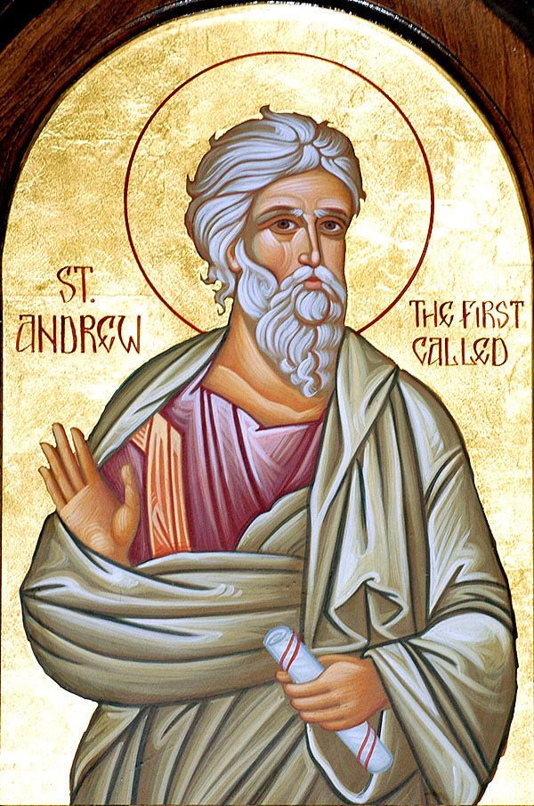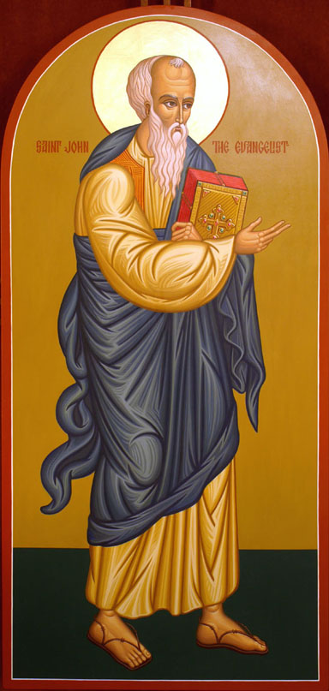

37 And the two disciples heard him speak, and they followed Jesus. 38 Then Jesus turned, and saw them following, and saith unto them, What seek ye? They said unto him, Rabbi, (which is to say, being interpreted, Master,) where dwellest thou? 39 He saith unto them, Come and see. They came and saw where he dwelt, and abode with him that day: for it was about the tenth hour. 40 One of the two which heard John speak, and followed him, was Andrew, Simon Peter's brother. 41 He first findeth his own brother Simon, and saith unto him, We have found the Messias, which is, being interpreted, the Christ. 42 And he brought him to Jesus. And when Jesus beheld him, he said, Thou art Simon the son of Jona: thou shalt be called Cephas, which is by interpretation, A stone. (not a Rock, but a stone) (John 1:37-42) Later, Jesus would formally call Andrew and Peter by the shores of Galilee. And Jesus, walking by the sea of Galilee, saw two brethren, Simon called Peter, and Andrew his brother, casting a net into the sea: for they were fishers. And he saith unto them, Follow me, and I will make you fishers of men. And they straightway left their nets, and followed him. (Matt 4:18-20)

Andrew was one of the two first disciples, and later chosen as one of the first two Apostles (with Peter). The other was most likely John (who followed Jesus with Andrew at Jordan Banks) though his name is not mentioned here. John never holds himself up in his Gospel out of an exalted love for Christ and a modest and humble view of himself. You will remember the climactic moment when Jesus proclaimed, One of you will betray me! at the Last Supper of which John, referring to himself as the disciple Jesus loved (and not by name) - Now there was leaning on Jesus' bosom one of his disciples, whom Jesus loved. Simon Peter therefore beckoned to him, that he should ask who it should be of whom he spake. He then lying on Jesus' breast saith unto him, Lord, who is it? Jesus answered, He it is, to whom I shall give a sop, when I have dipped it. And when he had dipped the sop, he gave it to Judas Iscariot, the son of Simon. (John 13:23-26) Later, at the foot of the cross, John writes this account without mentioning his name - When Jesus therefore saw his mother, and the disciple standing by, whom he loved, he saith unto his mother, Woman, behold thy son! Then saith he to the disciple, Behold thy mother! And from that hour that disciple took her unto his own home. (John 19:26-27) What a blessed comfort to be called, as are all who follow Him, the disciple whom Jesus loves.

John had a particular quality as a disciple - humility and modesty. In fact, each of the disciples were marked by a defining personality which, if turned on the wrong path, could be tragic; but when turned onto the Way of Christ, good and Holy. The same is true of each of us who claim the Lord Jesus Christ as Lord and Savior. Peter was impulsive, and that sometimes got him into trouble, but, later, that impulsiveness to serve the Lord was turned to the glory of God. Thomas was a doubter, but once his curiosity was satisfied, he was a steadfast disciple who gave his life for the Gospel. John is one of my two favorite disciples - the other being Andrew, the older brother of Simon Peter. With God, a silk purse can, indeed, be fashioned from a sow's ear.

I named my Church in Alabama after St. Andrew. I did so for two reasons: First of all, Andrew followed Jesus early being one of the first disciples. This accorded well with my target members at St. Andrew - very young children up to adulthood. O God, thou art my God; early will I seek thee: my soul thirsteth for thee, my flesh longeth for thee in a dry and thirsty land, where no water is; To see thy power and thy glory, so as I have seen thee in the sanctuary. (Psalm 63:1-2) If we are able to nourish the twig before it is bent by the ill winds of the world, it will grow into a tall Cedar of Lebanon. That has been my hope and prayer for my family of young people.

Secondly, Andrew, as soon as he knew Christ, went to seek his brother, Peter, and bring him Jesus. When word was noised about in the local community here that there was this peculiar little church to which many races and nationalities were welcome, many more youth came - but most came at the behest of those who were with me from the beginning. What a blessing in my life to have so many young Americans of Asian, European, African, and middle Eastern descent come and sit attentively through my 45 minute sermons. I love them all and consider them to be my own children in Christ.

Andrew was a native of Bethsaida in Galilee, brother of Simon Peter, a disciple of John the Baptist, and afterwards an apostle of Christ. He is said to have been crucified at Patrae in Archaia. He died a brave man's death and his name, in fact, means, in the Greek - MALY (Andreas). Andrew was an observer of men and persons. He had heard and followed John the Baptist because he recognized truth when he heard it. Later, after the baptism of Jesus, He marked the man (Jesus) and followed Him. He never relented in his following.

On the mount overlooking the Sea of Galilee, Jesus raised the issue of feeding the five thousand men (plus women and children) who had followed him these past few days: And the passover, a feast of the Jews, was nigh. When Jesus then lifted up his eyes, and saw a great company come unto him, he saith unto Philip, Whence shall we buy bread, that these may eat? And this he said to prove him: for he himself knew what he would do. Philip answered him, Two hundred pennyworth of bread is not sufficient for them, that every one of them may take a little. One of his disciples, Andrew, Simon Peter's brother, saith unto him, There is a lad here, which hath five barley loaves, and two small fishes: but what are they among so many? (John 6:4-9 KJV) Andrew did not know how the five thousand would be fed, but he knew that whatever resources of faith were available - even five barley loaves and two small fishes - it would be sufficient in the Master's hands. So, observing the crowd, he spotted this lad and informed Jesus. Not knowing exactly what Jesus would do to satisfy the need, and in order to avoid the impression of presumptuousness, Andrew added: . . . . but what are they among so many? Yes, and what WERE they among so many? Enough to fill the stomachs of all present with fragments enough remaining to fill twelve large baskets.

Andrew knew people - that was one of his strengths, and he knew and recognized the most powerful and righteous man who ever walked upon earth - the Lord Jesus Christ. He brought people to Christ - those whom he loved, such as his brother, Simon, and those who needed to know Christ and serve Him such as the lad with the five loaves and two fishes. Andrew, unlike his brother Peter, was not impulsive but rather subdued in his demeanor. We do not hear a lot about Andrew in the Gospels for Andrew said little, but observed much. He was not a contentious man, but congenial and of one mind with the other apostles of Christ. When the day of Pentecost arrived at the foundation of the New Testament Church, Andrew was found among the disciples and, as usual, of one mind with them in Christ. 12 Then returned they unto Jerusalem from the mount called Olivet, which is from Jerusalem a sabbath day's journey. 13 And when they were come in, they went up into an upper room, where abode both Peter, and James, and John, and Andrew, Philip, and Thomas, Bartholomew, and Matthew, James the son of Alphaeus, and Simon Zelotes, and Judas the brother of James. 14 These all continued with one accord in prayer and supplication, with the women, and Mary the mother of Jesus, and with his brethren. (Acts 1:12-14)

We each are blessed with much variety in tastes and personality. Some are impetuous. Some are dreamers. Some are loners. Some are doers. Some are teachers. But all of these qualities can find a vacuum to fill in the walls of the Temple of God. We can act with great passion and impetuosity when our actions are dictated by the Holy Ghost just as did Jesus in chasing the money-changers from the House of the Lord. (But in many churches, those money changers have returned) When our dreams are informed by the Holy Ghost, as was Peter's, we may dream with love and truth. If we find ourselves isolated and abandoned as loners in a crowd of unbelievers, we can be as John on Patmos where he wrote the Book of Revelation. If we are doers, we are on sound ground if our deeds follow the salvation unto good works in grace. If we are teachers, we may be blessed abundantly in teaching right and not error. Some may even be what my Irish mother called 'ramblers.' There is a place for ramblers, too, in the Kingdom of God if their feet take them in their rambling to good paths. Andrew was such a rambler. He traveled far and wide in preaching the Gospel and was martyred on the rocky shores of a Mediterranean island. Every weakness of the lost soul can be molded into a strength in the Kingdom of Heaven.

What are your weaknesses, and how will you employ them to the glory of God?

