Devotion on Firsts of the Bible - First Crossing of the River Jordan Part Three – 1 July 2015, Anno Domini

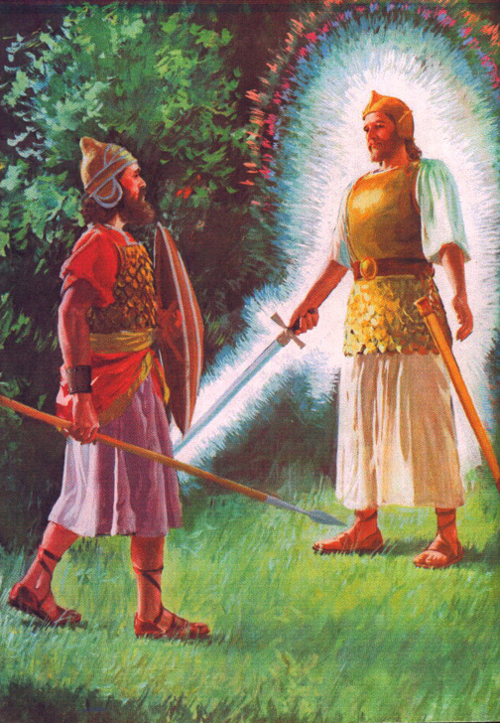

… Captain of the Host of the Lord …

1 And it came to pass, when all the kings of the Amorites, which were on the side of Jordan westward, and all the kings of the Canaanites, which were by the sea, heard that the LORD had dried up the waters of Jordan from before the children of Israel, until we were passed over, that their heart melted, neither was there spirit in them any more, because of the children of Israel."
(Josh 5:1)
8 And it came to pass, when they had done circumcising all the people, that they abode in their places in the camp, till they were whole. 9 And the LORD said unto Joshua, This day have I rolled away the reproach of Egypt from off you. Wherefore the name of the place is called Gilgal unto this day. (Josh 5:8-9)

Gilgal is of particular significance to this account of Joshua. The word itself, in the Hebrew, means "to roll away." (I rolled away the reproach of Egypt from off you.) It is also the first place of observance of Passover in the Promised Land and that before the very sight of a terrified enemy holed up behind the walls of Jericho. It is noteworthy that the heathen peoples of Canaan were terrified at the power of God. It is also noteworthy that only one person - a harlot - of the whole of the land had the inclination to come forward to accept that Mighty God of the Hebrew Children (Rahab). Though terrified, the rest were more disposed to die without God than to live with Him. These are the nonsensical values of the wicked world. Even if given the choice, the greater portion of the world's population would choose Hell over Heaven at the return of Christ.

10 And the children of Israel encamped in Gilgal, and kept the passover on the fourteenth day of the month at even in the plains of Jericho. 11 And they did eat of the old corn of the land on the morrow after the passover, unleavened cakes, and parched corn in the selfsame day. 12 And the manna ceased on the morrow after they had eaten of the old corn of the land; neither had the children of Israel manna any more; but they did eat of the fruit of the land of Canaan that year. (Josh 5:10-12) The 14th of Nisan is the Passover which is in late March or April (Lunar).

This supports my opinion the Jordan was crossed at its highest crest in March.

When salvation has come to us, the Manna that was given liberally becomes a bread for which we will need to vigorously seek out through the pages of the Bible. Now that the Children of Israel are in the Land of Promise, there is no further need for the Manna to be supplied daily, so it ceases.

Though God may separate the waters of Jordan for our crossing (since we cannot do so ourselves), He nonetheless expects evidence of faith for us to proceed against the enemy of the land. Just as God granted the American colonies liberty through many strong and miraculous acts, He nonetheless expects us to be vigilant and to stand at the ready to oppose the defilement of those liberties. It matters not whether the President, the Congress, or a maverick Supreme Court issues laws that are contrary to the Higher Law, we are to obey God's Law and not man's. (Acts 5:29).

We now come upon a mysterious appearance of a Personage that must, in all reason, be the Pre-Incarnate Christ. I will provide my reason for believing so as we explore the text. 13 And it came to pass, when Joshua was by Jericho, that he lifted up his eyes and looked, and, behold, there stood a man over against him with his sword drawn in his hand: and Joshua went unto him, and said unto him, Art thou for us, or for our adversaries? 14 And he said, Nay; but as captain of the host of the LORD am I now come. (Josh 5:13-14) The Personage that Joshua saw appeared to be like unto a man. The Man had His sword drawn ready for battle. When Joshua asked if He was friend or foe, the response is one that gives evidence of Christ. Only Christ is the Captain of the Host of the Lord. He will be the leading Captain who returns with the Armies of Heaven in trail at the end. 11 And I saw heaven opened, and behold a white horse; and he that sat upon him was called Faithful and True, and in righteousness he doth judge and make war. 12 His eyes were as a flame of fire, and on his head were many crowns; and he had a name written, that no man knew, but he himself. 13 And he was clothed with a vesture dipped in blood: and his name is called The Word of God. 14 And the armies which were in heaven followed him upon white horses, clothed in fine linen, white and clean. 15 And out of his mouth goeth a sharp sword, that with it he should smite the nations: and he shall rule them with a rod of iron: and he treadeth the winepress of the fierceness and wrath of Almighty God. 16 And he hath on his vesture and on his thigh a name written, KING OF KINGS, AND LORD OF LORDS. (Rev 19:11-16)

There are other following bits of evidence to reveal the identity of this Man! At the proclamation that this was the Captain of the Hoist of the Lord, what did Joshua do? "And Joshua fell on his face to the earth, and did worship, and said unto him, What saith my lord unto his servant?" (Josh 5:14) Every reader should know that the Christian bows and worships no man - not even angels - only God! Moreover, Joshua called the Man LORD! So what other evidence do we have that this figure was the LORD? 15 And the captain of the LORD'S host said unto Joshua, Loose thy shoe from off thy foot; for the place whereon thou standest is holy. And Joshua did so. (Josh 5:15) The reference to HOLY GROUND suggests that Joshua is in the presence of God. It was the same command that God issued to Moses from out the Burning Bush.

When our battles are righteous and in accord with God's Word, it is the LORD who leads the battle and gives the victory.

1 Now Jericho was straitly shut up because of the children of Israel: none went out, and none came in. 2 And the LORD said unto Joshua, See, I have given into thine hand Jericho, and the king thereof, and the mighty men of valour. 3 And ye shall compass the city, all ye men of war, and go round about the city once. Thus shalt thou do six days. (Josh 6:1-3) Clearly, the Sabbath belongs to the Lord from the beginning in Eden. 1 Thus the heavens and the earth were finished, and all the host of them. 2 And on the seventh day God ended his work which he had made; and he rested on the seventh day from all his work which he had made. 3 And God blessed the seventh day, and sanctified it: because that in it he had rested from all his work which God created and made. (Gen 2:1-3) The number 'seven' suggests completion, and so we will find the same in the account of the investment of the walls of Jericho. Six days running, the men of valor were to march around the walls of Jericho. Bear in mind, that this may have seemed frivolous and almost comical to the men behind the walls of Jericho. It may even have seemed strange to those who marched about the city. We may not always understand God's reason for commanding us to do a thing, but like seasoned soldiers, we obey without question.

The presence of the ark at the lead of the marching columns represents the leading presence of God.

6 And seven priests shall bear before the ark seven trumpets of rams' horns: and the seventh day ye shall compass the city seven times, and the priests shall blow with the trumpets. (Josh 6:4) Now that the men of war have done all of their labors for six days, now comes the seventh day on which the Lord will finish all of His work against the walls of the wicked city of Jericho. 4 and the seventh day ye shall compass the city seven times, and the priests shall blow with the trumpets. 5 And it shall come to pass, that when they make a long blast with the ram's horn, and when ye hear the sound of the trumpet, all the people shall shout with a great shout; and the wall of the city shall fall down flat, and the people shall ascend up every man straight before him. (Josh 6:4-5)

This was literally the manner in which Jericho fell. Archaeological evidence suggests that the walls did not fall inward as with battering rams, but strangely, they fell outward. This makes no sense at all to the world, but the ways of God are unknown to the world.

15 And it came to pass on the seventh day, that they rose early about the dawning of the day, and compassed the city after the same manner seven times: only on that day they compassed the city seven times. 16 And it came to pass at the seventh time, when the priests blew with the trumpets, Joshua said unto the people, Shout; for the LORD hath given you the city. (Josh 6:15-16) You will observe that Joshua added none of his own ideas to the tactics laid down by God, but followed the mysterious counsel of the Lord verbatim. When the last Trump of God sounds, their will likewise arise a shout from His people as the walls of 'worldly' Jericho come tumbling down. The world watches the people of God today in amazement of our frivolity 9or so it seems to them), but the tune will change suddenly and drastically when the doors of the Great Ark of Christ are closed and the desolations and fires consume all without. God always honors His Word, and so do His people. The harlot, Rahab, and all her family and possessions were spared. God remembers, even a harlot, that places their trust in Him. 20 So the people shouted when the priests blew with the trumpets: and it came to pass, when the people heard the sound of the trumpet, and the people shouted with a great shout, that the wall fell down flat, so that the people went up into the city, every man straight before him, and they took the city. 21 And they utterly destroyed all that was in the city, both man and woman, young and old, and ox, and sheep, and ass, with the edge of the sword. 22 But Joshua had said unto the two men that had spied out the country, Go into the harlot's house, and bring out thence the woman, and all that she hath, as ye sware unto her. 23 And the young men that were spies went in, and brought out Rahab, and her father, and her mother, and her brethren, and all that she had; and they brought out all her kindred, and left them without the camp of Israel. (Josh 6:20-23)

When sowing the seed of the Gospel, we will be wise to sow on all soils - even the harlots and tramps of this world.

