Devotion on Firsts of the Bible - First Crossing of the River Jordan Part Two – 27 June 2015, Anno Domini

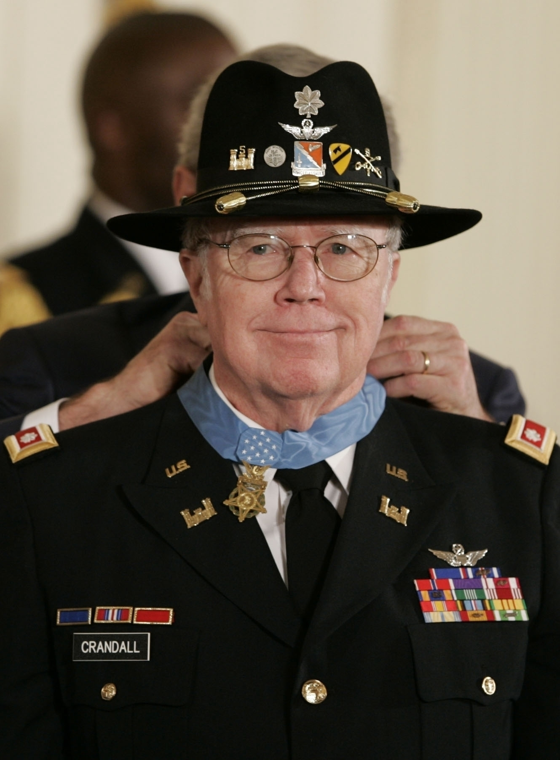

… Stones of Remembrance …

1 And Joshua the son of Nun sent out of Shittim two men to spy secretly, saying, Go view the land, even Jericho. And they went, and came into an harlot's house, named Rahab, and lodged there. 2 And it was told the king of Jericho, saying, Behold, there came men in hither to night of the children of Israel to search out the country. 3 And the king of Jericho sent unto Rahab, saying, Bring forth the men that are come to thee, which are entered into thine house: for they be come to search out all the country. 4 And the woman took the two men, and hid them, and said thus, There came men unto me, but I wist not whence they were: 5 And it came to pass about the time of shutting of the gate, when it was dark, that the men went out: whither the men went I wot not: pursue after them quickly; for ye shall overtake them. 6 But she had brought them up to the roof of the house, and hid them with the stalks of flax, which she had laid in order upon the roof. 7 And the men pursued after them the way to Jordan unto the fords: and as soon as they which pursued after them were gone out, they shut the gate. (Joshua 2:1-7)

We approach a most solemn event that has troubled some theologians and Christian believers over the ages: Why would God require all inhabitants (including women and children) of Jericho to be killed? This matter will arise in Part III of our devotion, but we may make some explanation in prelude to it at this point. You will remember that God is gracious to those who love Him and obey His will. Recall the city of Sodom in which God could not find even two who were righteous in the city. Even the daughters of Lot were less than righteous, and were saved only as a favor to Lot. So God destroyed the whole city - every man, woman, and child. Was this just? Of course it was just. Sodom had become a den of iniquity and had turned to the most horrendous of sensual sins. In His omniscience and Providence, God knew every last one of their offspring would likewise reject righteousness and follow in the path of their fathers. None who reject God are worthy of life and grace. That is just. They deserve, as did we before we were accounted among the Elect, death!

So, out of Sodom, God saved the only righteous man of the whole lot - LOT! (no pun intended) Jericho is likewise a city lying just to the west of Jordan Waters. Its rulers and inhabitants knew all about the saving graces of God in bringing the Children of Israel out of Egyptian bondage and the manner in which He followed (and led) them in the wilderness with many miraculous interventions. Yet, they rejected God and chose rebellion to Him. This is born out in the testimony of Rahab. God knows His people wherever they be, and God had a certain harlot in Jericho whom He would raise to righteousness and renown - Rahab. Because of her, just as with Zaccheus, she and her whole family would be saved from the ravages of war to come. Here her testimony of God: 8 And before they were laid down, she came up unto them upon the roof; 9 And she said unto the men, I know that the LORD hath given you the land, and that your terror is fallen upon us, and that all the inhabitants of the land faint because of you. 10 For we have heard how the LORD dried up the water of the Red sea for you, when ye came out of Egypt; and what ye did unto the two kings of the Amorites, that were on the other side Jordan, Sihon and Og, whom ye utterly destroyed. 11 And as soon as we had heard these things, our hearts did melt, neither did there remain any more courage in any man, because of you: for the LORD your God, he is God in heaven above, and in earth beneath. (Josh 2:8-11)

It does not take an overly wise farmer to realize that a peach tree will bear peaches just as a wicked generation will bear fruit of a nature like unto itself. So God would rid the country of the poison of Jericho in one fateful day! That is justice for all deserve death having fallen short of the righteousness of God, but some are granted grace and forgiveness by being drawn to the breast of God, and forsaking a sinful past. This did Rahab! Please do not doubt that God may soon render such a judgment against the fair haven of these United States for its abject rejection of Him and turning to the filth and grit of the sensual gutter. Naturally, as long as planting and harvest time endures, He is always alert to hear the combined prayers of his people as noted in 2 Chron 7:14-15 - If my people, which are called by my name, shall humble themselves, and pray, and seek my face, and turn from their wicked ways; then will I hear from heaven, and will forgive their sin, and will heal their land. Now mine eyes shall be open, and mine ears attent unto the prayer that is made in this place. You will also note that God does not demand every citizen of the land to pray in such a way - only those who are "called by my Name (i.e. Christian). From what I see of the modern church, this may never happen until the fires are falling.

Rahab extracts a vow from the spies who have come into Jericho to spy the city out that they will spare her house and her family since she has helped the men escape. They agree and ask that she tie a scarlet cord in her window piece as a sign of her fidelity to Israel. This was much like the lamb's blood over the doorpost in Goshen. Behold, when we come into the land, thou shalt bind this line of scarlet thread in the window which thou didst let us down by: and thou shalt bring thy father, and thy mother, and thy brethren, and all thy father's household, home unto thee. And it shall be, that whosoever shall go out of the doors of thy house into the street, his blood shall be upon his head, and we will be guiltless: and whosoever shall be with thee in the house, his blood shall be on our head, if any hand be upon him. (Josh 2:18-19) As Christians, should we, too, not bring our " father, and thy mother, and thy brethren, and all thy father's household, home unto" the place of safety and salvation in Christ? For the sake of brevity, I am passing over many inspiring details of the story that may be had by a personal reading of the text by our readers of this devotion.

The two spies escape Jericho and return to report to Joshua. "Truly the LORD hath delivered into our hands all the land; for even all the inhabitants of the country do faint because of us." (Josh 2:24) Please note what truth is revealed in the report of the two spies: the agnostics, atheists, and pagans fear God, but choose to deny Him. See with what audacity and fervor those who claim themselves to be atheists attempt to eradicate every memorial and mention of God in our society. If they believed our faith in God to be nonsense, why would they be so zealous to extinguish the mention of His Name? Mere superstition does not evoke such animated opposition, does it?

Joshua now issues his Operations Order through his subordinates: And Joshua rose early in the morning; and they removed from Shittim, and came to Jordan, he and all the children of Israel, and lodged there before they passed over. (this position constituted Joshua's Line of Departure) And it came to pass after three days, that the officers went through the host; And they commanded the people, saying, When ye see the ark of the covenant of the LORD your God, and the priests the Levites bearing it, then ye shall remove from your place, and go after it. Yet there shall be a space between you and it, about two thousand cubits by measure: come not near unto it, that ye may know the way by which ye must go: for ye have not passed this way heretofore. And Joshua said unto the people, Sanctify yourselves: for to morrow the LORD will do wonders among you. And Joshua spake unto the priests, saying, Take up the ark of the covenant, and pass over before the people. And they took up the ark of the covenant, and went before the people. (Josh 3:1-6) I doubt any land force in the then civilized world observed such detailed and organized structure as this host about to cross the Jordan. Unquestioned discipline is imperative during great ventures and occasions.

And the LORD said unto Joshua, This day will I begin to magnify thee in the sight of all Israel, that they may know that, as I was with Moses, so I will be with thee. (Josh 3:7) God will always magnify a good Christian leader who is obedient to His Word, but He is truly magnifying His own glory since all glory belongs to God. The Lord, too, will forever precede His people in dark, as well as light, paths. Behold, the ark of the covenant of the Lord of all the earth passeth over before you into Jordan. (Josh 3:11)

Here, the hosts of our fathers, and our father's God, encamp by Jordan Banks. The occasion has great and deep meaning on our spiritual lives. It represents the crossing from the wilderness of the sinful world of the righteous people of God into His Kingdom at last. The name of the river, Jordan, means "descender." This is representative of the Lord Jesus Christ who is the only One to descend from Heaven and live among us. I have written another devotion regarding the nature and comparison of this river with the life of our Lord.

The season of this crossing is Spring - most surely March, when the melting snows of Mt. Hermon fill the river bed to overflowing. God chooses the most difficult times and obstacles for us to cross to show forth His great power and glory.

10 And Joshua said, Hereby ye shall know that the living God is among you, and that he will without fail drive out from before you the Canaanites, and the Hittites, and the Hivites, and the Perizzites, and the Girgashites, and the Amorites, and the Jebusites. 11 Behold, the ark of the covenant of the Lord of all the earth passeth over before you into Jordan. (Josh 3:10-11) Jesus passed over Jordan Banks before us that we may be also privileged to pass into that Paradise of God that awaits His people. Such an historical event is worthy of memorials, and God provides that consideration just as surely as the cross at Calvary stands in for a memorial. And it came to pass, when the people removed from their tents, to pass over Jordan, and the priests bearing the ark of the covenant before the people; And as they that bare the ark were come unto Jordan, and the feet of the priests that bare the ark were dipped in the brim of the water, (for Jordan overfloweth all his banks all the time of harvest,) That the waters which came down from above (from Galilee) stood and rose up upon an heap very far from the city Adam. (Josh 3:14-16) Adam was about 30 miles to the north of the encampment and site of crossing. God expects us to remember His Providential intercessions in the lives of nations and individuals. and all the Israelites passed over on dry ground, until all the people were passed clean over Jordan. (Josh 3:17) So what memorial have we to erect of our passing over Jordan, or in our establishment as a God-fearing nation?

And it came to pass, when all the people were clean passed over Jordan, that the LORD spake unto Joshua, saying, Take you twelve men out of the people, out of every tribe a man, And command ye them, saying, Take you hence out of the midst of Jordan, out of the place where the priests' feet stood firm, twelve stones, and ye shall carry them over with you, and leave them in the lodging place, where ye shall lodge this night. (Josh 4:1-3) For what purpose was the strange command given by God to Joshua? And Joshua said unto them, Pass over before the ark of the LORD your God into the midst of Jordan, and take ye up every man of you a stone upon his shoulder, according unto the number of the tribes of the children of Israel: That this may be a sign among you, that when your children ask their fathers in time to come, saying, What mean ye by these stones? Then ye shall answer them, That the waters of Jordan were cut off before the ark of the covenant of the LORD; when it passed over Jordan, the waters of Jordan were cut off: and these stones shall be for a memorial unto the children of Israel for ever. (Josh 4:5-7) Stones of remembrance are important, for if we know not how far the Lord has saved us out of bondage, how shall we know the value of that salvation?

I am troubled to believe that America has forgotten her Stones of Remembrance; and what are these stones? They are the way markers of our freedoms, and of the God whose Providence led our way in the days of our ancient founding as a nation - the Bridge at Concord, the Liberty Bell, the Declaration of Independence, Valley Forge, the bombardment of Ft. McHenry and the Star Spangled Banner aloft - these are only some of our Stones of Remembrance. The courageous men and women, living and dead, who fought and bled for our freedoms are also stones of remembrance. Do you remember them, or has Israel forgotten her stones: And the children of Israel remembered not the LORD their God, who had delivered them out of the hands of all their enemies on every side. (Judges 8:34) Have we forgotten Yorktown, Vera Cruz, Gettysburg, San Juan Hill, Flanders Field, Normandy, Bastogne, Iwo Jima, Bataan, Chosin Reservoir, or Hue Phubai?

Perhaps our memories have faded, but the memory of the Lord has not faded.

He remembers, and we had best remember!

https://en.wikipedia.org/wiki/Bruce_P._Crandall

