Devotion on Firsts of the Bible - First Crossing of the River Jordan - 26 June 2015, Anno Domini

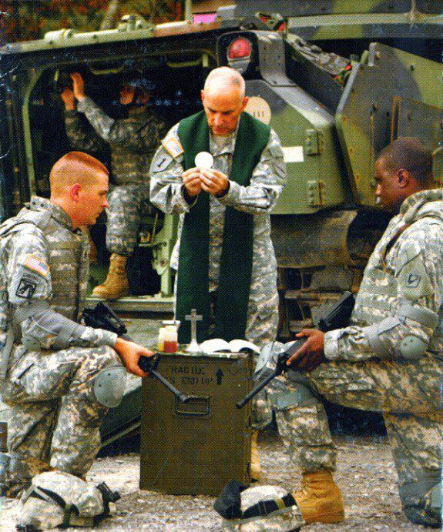

… Be strong and of a good courage; be not afraid, neither be thou dismayed: for the LORD thy God is with thee whithersoever thou goest …

1 Now after the death of Moses the servant of the LORD it came to pass, that the LORD spake unto Joshua the son of Nun, Moses' minister, saying, 2 Moses my servant is dead; now therefore arise, go over this Jordan, thou, and all this people, unto the land which I do give to them, even to the children of Israel. 3 Every place that the sole of your foot shall tread upon, that have I given unto you, as I said unto Moses. 4 From the wilderness and this Lebanon even unto the great river, the river Euphrates, all the land of the Hittites, and unto the great sea toward the going down of the sun, shall be your coast. 5 There shall not any man be able to stand before thee all the days of thy life: as I was with Moses, so I will be with thee: I will not fail thee, nor forsake thee. 6 Be strong and of a good courage: for unto this people shalt thou divide for an inheritance the land, which I sware unto their fathers to give them. 7 Only be thou strong and very courageous, that thou mayest observe to do according to all the law, which Moses my servant commanded thee: turn not from it to the right hand or to the left, that thou mayest prosper whithersoever thou goest. 8 This book of the law shall not depart out of thy mouth; but thou shalt meditate therein day and night, that thou mayest observe to do according to all that is written therein: for then thou shalt make thy way prosperous, and then thou shalt have good success. 9 Have not I commanded thee? Be strong and of a good courage; be not afraid, neither be thou dismayed: for the LORD thy God is with thee whithersoever thou goest. (Josh 1:1-9)

It is true that Moses, in a physical sense, is dead; yet God is not the God of the dead, but of the living; and God was the God of Moses. The Wilderness is comparable to the journey of life and sin. There were at least a few million Hebrews who came out of Egypt, but owing to their besetting sins of murmuring and distrust of God, none of them lived to set foot in the Promise Land beyond Jordan Waters – except TWO (Caleb and Joshua). Caleb and Joshua trusted that their God was greater than all of the armies of the Canaanites, the Amalekites, the Amorites, and the sons of Anak (giants). Moreover, they averred that the false gods of the land are no match for the mighty God of Israel who would have the victory. (see Num 13:28-33) But the people disbelieved and gave counsel of their fears and not their faith. So they wandered aimlessly in the Wilderness until all who made the Red Sea crossing had died except Caleb and Joshua – men of courage and faith. Even Moses and Aaron were not permitted to cross over. So, as Israel encamps of the borders of the Promised Land, they comprise a vital and well-organized army of young men and women (all less than forty years of age).

It seems spiritually awkward that out of so many, only two of the original legions to leave Egypt were found suitable to enter the Land for which they had suffered long in desert areas. But this is the life of the Christian pilgrim. He looks up and forward to the promises of God without hesitation or murmur. This, Caleb and Joshua had been faithful in doing. I wonder how many saints of the Church in the wilderness world will be permitted to cross the Jordan Banks at the close of this age? I believe it will be found true that many of the Wilderness pilgrims will be present in Heaven with Moses when we cross the Heavenly Jordan, but were not permitted, as a point of order, to cross the physical Jordan Waters. In a manner of speaking, the Israelites crossing over Jordan is a perfect picture of the saints of the New Testament Church passing the cold waters of the deathbed into the splendor of Heaven. John Ruskin has said, “Death is not a journeying into an unknown land; it is a voyage home. We are not going to a strange country, but to our Father’s House, and among our kith and kin.” We see that Ruskin was absolutely correct in the case of Moses – why not for every saint. We are, after all, strangers and pilgrims in a strange land, and we seek a faire country. (Hebrews 11) The world is strange to us, but not Heaven!

Joshua will be the field commander to lead the children across Jordan, but he merely is commissioned by the God of Battles to act on His behalf and according to His pleasure. The name, Joshua, is of particular significance. It is the same name as the Hellenized name of Jesus - [Yehowshuwa` (yeh-ho-shoo'-ah) – meaning, “Jehovah is Salvation.” The great prophets and shepherds such as Moses, Aaron, Isaiah, Jeremiah, etc, can lead us to Jordan Banks, but only Jesus (Joshua) can bring us across those turbid waters into God’s Land of Promise. Only Jesus could redeem us and make our salvation possible to cross over “to the other side.”

The tribes occupying Canaan, with their strange little gods, dwell in walled cities. They are not organized in the manner of the Israelites. God has caused, long ago around the Tabernacle, for the Israelites to be organized in squads, companies, battalions and brigades (in the modern military vernacular). This was beyond the comprehension of the primitive armies of the pagans of Canaan. Jethro, Moses’ father-in-law had given Moses Godly counsel, which Moses followed, early in the wilderness: 19 Hearken now unto my voice, I will give thee counsel, and God shall be with thee: Be thou for the people to God-ward, that thou mayest bring the causes unto God: 20 And thou shalt teach them ordinances and laws, and shalt shew them the way wherein they must walk, and the work that they must do. 21 Moreover thou shalt provide out of all the people able men, such as fear God, men of truth, hating covetousness; and place such over them, to be rulers of thousands, and rulers of hundreds, rulers of fifties, and rulers of tens: 22 And let them judge the people at all seasons: and it shall be, that every great matter they shall bring unto thee, but every small matter they shall judge: so shall it be easier for thyself, and they shall bear the burden with thee. 23 If thou shalt do this thing, and God command thee so, then thou shalt be able to endure, and all this people shall also go to their place in peace. (Ex 18:19-23) A host so organized in units from small to large represents a formidable force to armies no so organized; however, Israel’s strength resided not in their commendable military structure, but in their faith in God who had been their mainstay and Rock from Egypt until this day.

An army commander, or even a President, inspired by the Word of God, will give wise and Godly counsel. So does Joshua in preparation for the crossing of the Jordan River. 10 Then Joshua commanded the officers of the people, saying, 11 Pass through the host, and command the people, saying, Prepare you victuals; for within three days ye shall pass over this Jordan, to go in to possess the land, which the LORD your God giveth you to possess it. (Josh 1:10-11) Any military logistician will tell you that the army only travels as far as her well stocked train of provision. Not only does Joshua counsel preparation, but also states, as a good commander, the objective. Joshua had a vision, as should every great leader, but the vision was not his own, but that which God gave him. Suppose, in these latter days, that we had a national leader who looked to God for his vision?

Joshua further commands, but ye shall pass before your brethren armed, all the mighty men of valour, and help them (Josh 1:14), that is, officered or marshaled under five leaders in the old and approved caravan order. Our National Pledge of Allegiance is not unlike that which was proclaimed by Israel in loyalty to the leadership, under God, of Joshua: 16 And they answered Joshua, saying, All that thou commandest us we will do, and whithersoever thou sendest us, we will go. 17 According as we hearkened unto Moses in all things, so will we hearken unto thee: only the LORD thy God be with thee, as he was with Moses. 18 Whosoever he be that doth rebel against thy commandment, and will not hearken unto thy words in all that thou commandest him, he shall be put to death: only be strong and of a good courage. (Josh 1:16-18)

A valiant army cannot proceed on valor alone, but needs to know both its enemy and the terrain of the battlefield. On the one occasion that Napoleon failed to reconnoiter the battlefield (at Waterloo) he met his demise. 1 And Joshua the son of Nun sent out of Shittim two men to spy secretly, saying, Go view the land, even Jericho. And they went, and came into an harlot's house, named Rahab, and lodged there. (Josh 2:1) In performing our service to the Lord, He expects us, as a means of common sense and reason, to use the faculties with which He has graced us. On some occasions, such common sense may require us to go where we would not otherwise go, and stay where we were not wont to stay.

Staying at the house of a harlot (Rahab) may seem beneath the dignity of men of God, but if Rahab failed of dignity, the Lord made up the difference by granting her the privilege to being accounted in the genealogical line of the Lord Jesus Christ: 1 The book of the generation of Jesus Christ, the son of David, the son of Abraham. 2 Abraham begat Isaac; and Isaac begat Jacob; and Jacob begat Judas and his brethren; 3 And Judas begat Phares and Zara of Thamar; and Phares begat Esrom; and Esrom begat Aram; 4 And Aram begat Aminadab; and Aminadab begat Naasson; and Naasson begat Salmon; 5 And Salmon begat Boaz of Rachab; (Matt 1:1-5)

We shall take up our continuing study of the Jordan River crossing on the next devotion.

