Devotion on Firsts of the Bible - First Commandment, 13 June 2015, Anno Domini

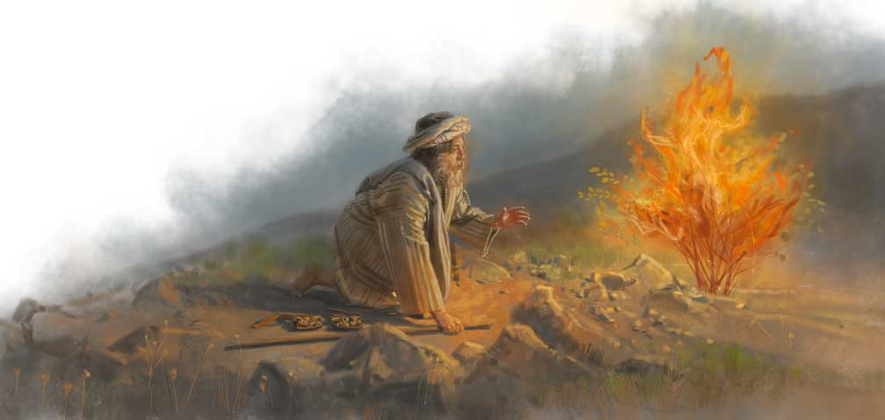
… I AM …

2 I am the LORD thy God, which have brought thee out of the land of Egypt, out of the house of bondage. 3 Thou shalt have no other gods before me. (Ex 20:2-3)

The Great I AM!

This is a preface to the Ten Commandments addressed singularly and individually to each of us and showing that the reasonableness of the law is founded in our eternal relation as creatures to our Creator, and our mutual relations to each other.

The term ‘God’ in the English originates in the old English meaning Good. God is of the supreme GOOD. This is the source of the English Term, Good bye. Good bye is a contraction and derivative of the term meaning “God be wi’ ye!” or “God be with you!”

The term for God here, as in Genesis 1:1, is Elohim – a peculiar (to English) word in Hebrew which is termed a plurality in one (Eloah being the singular form). Elohim is plural with a singular meaning. It may warp our brains a bit to realize this, but it alludes to the Trinity from the very first line of Scripture and every place thereafter. The venerable Dr. Adam Clarke describes the term in these words: “The original word ‏אלהים‎ Elohim, God, is certainly the plural form of ‏אל‎ El, or ‏אלה‎ Eloah, and has long been supposed, by the most eminently learned and pious men, to imply a plurality of Persons in the Divine nature. As this plurality appears in so many parts of the sacred writings to be confined to three Persons, hence the doctrine of the TRINITY, which has formed a part of the creed of all those who have been deemed sound in the faith, from the earliest ages of Christianity. Nor are the Christians singular in receiving this doctrine, and in deriving it from the first words of Divine revelation. An eminent Jewish rabbi, Simeon ben Joachi, in his comment on the sixth section of Leviticus, has these remarkable words: "Come and see the mystery of the word Elohim; there are three degrees, and each degree by itself alone, and yet notwithstanding they are all one, and joined together in one, and are not divided from each other."

It is important for us to know who our God is if we are to follow Him and obey His law; thus the purpose of catechism in Church. God is a stranger to the world, but known by all who love and follow Him in knowledge, wisdom, and obedience to His Law.

Insofar as being and existence is concerned, there is no past, or future, tense with God. He is forever and always the great I Am for His presence is forever NOW. He does not conform to the space-time continuum of His own creation. Jesus referred to Himself as “I AM” seven times in the Gospel of St. John.

- Bread - I am the bread of life; he who comes to Me shall not hunger. John 6:35
- Light - I am the light of the world; he who fallows Me shall not walk in the darkness, but shall have the light of life. John 8:12
- Gate - I am the door: by me if any man enter in, he shall be saved, and shall go in and out, and find pasture. John 10:9
- Good Shepherd - I am the good shepherd: the good shepherd giveth his life for the sheep. John 10:11
- Resurrection and Life - I am the resurrection, and the life: he that believeth in me, though he were dead, yet shall he live: And whosoever liveth and believeth in me shall never die. Believest thou this? John 11:25-26
- Way, Truth, Life – I am the way, the truth, and the life: no man cometh unto the Father, but by me. John 14:6

True vine - I am the true vine, and my Father is the husbandman. John 15:1 Until we come to grasp with the sovereignty of God as Creator, Sovereign, Lord, Redeemer, and Savior, we are yet on the Marshes of Glynn. There is no solid ground for the foot without faith in God and a knowledge of His wondrous works in nature and in the hearts of men. It is God Almighty who has brought us out of the Land of Bondage to Sin (figuratively, Egypt). It is God whose Laws govern in all of nature, and it governs the destinies of men and nations. Being set free and at liberty, our actions must reflect the values of that family to which we have been adopted and under whose name and banner we march – CHRISTIAN!

As old Israel was baptized in the Red Sea, so are we baptized into the New Jerusalem of God. Our mortal salvation comes at a lesser cost than did that of our souls. The only Begotten son of God was the Passover Lamb at Calvary foreshadowed by the lamb without blemish of the Passover in Egypt. If we have been brought out of that old house of bondage, we have been set free indeed to do all things convenient for our souls. Our old desires and wants were left to fester in Egypt, and our new desires are those of the Father who loved us and bought us with such a great price of the blood shed by His only Begotten Son.

He desires that we know more than a simple term. “I am the Lord thy God…” I have set your feet on solid ground and made you free. I made your soul and body at the beginning, and I am steward of the same until today if you hear and follow my Voice. I have brought you to a place of promise – not alone did you come out of bondage. I was with you all of the way and more….I both followed you and led you through the Wilderness of Sin to a safe haven where sin has no sway over you.

Do you KNOW me?

Do you hear my Voice?

Do you follow me?

Do you LOVE me as I have loved you? The most important of all!

Being your God, I will now command, and I expect to be obeyed. Here are my Commandments given to you for your good health and happiness – not as a bar to pleasure or joy! I am your Maker and I know what behavior is best suited to your joy and long life. Keep these Commandments and live a full, rich life both now, and forevermore!

If you forget the first of these Commandments, you may as well ignore the others, for they will be meaningless without the acknowledgment of their Author.

Keep these whole and live!

