Devotion on Firsts of the Bible - First Book of the Bible named after a Woman - Part Six – 22 July 2015, Anno Domini

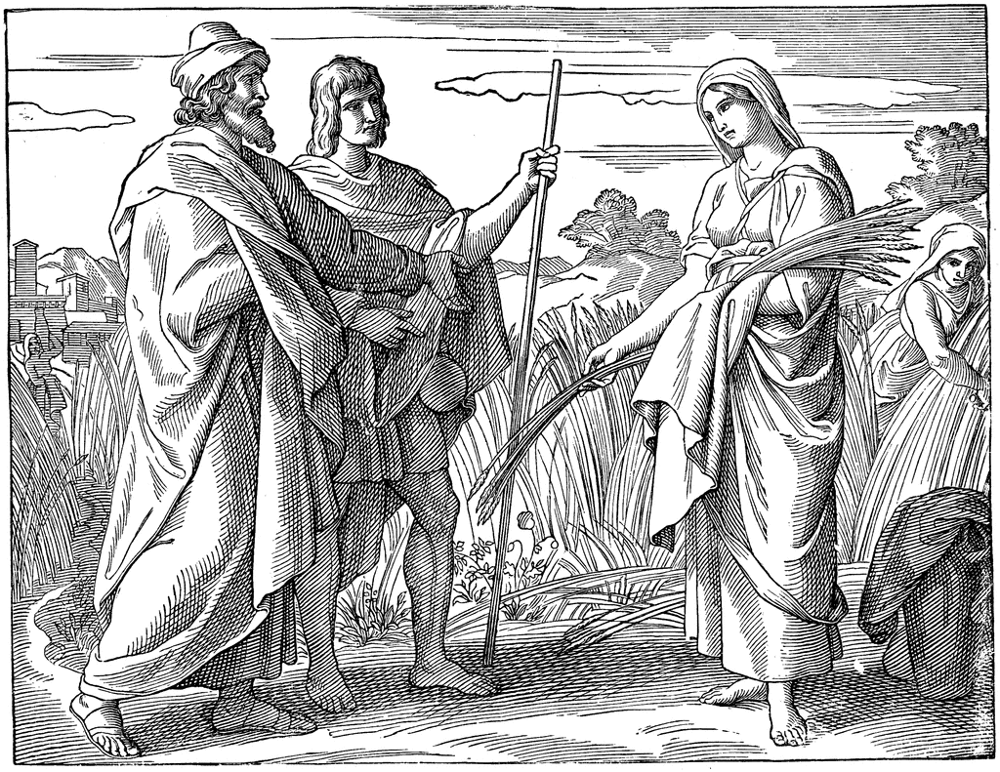
… Whose damsel is this?…

Part Six - Gleaning in Grace

4 And, behold, Boaz came from Bethlehem, and said unto the reapers, The LORD be with you. And they answered him, The LORD bless thee. 5 Then said Boaz unto his servant that was set over the reapers, Whose damsel is this? 6 And the servant that was set over the reapers answered and said, It is the Moabitish damsel that came back with Naomi out of the country of Moab: 7 And she said, I pray you, let me glean and gather after the reapers among the sheaves: so she came, and hath continued even from the morning until now, that she tarried a little in the house. 8 Then said Boaz unto Ruth, Hearest thou not, my daughter? Go not to glean in another field, neither go from hence, but abide here fast by my maidens: 9 Let thine eyes be on the field that they do reap, and go thou after them: have I not charged the young men that they shall not touch thee? and when thou art athirst, go unto the vessels, and drink of that which the young men have drawn. 10 Then she fell on her face, and bowed herself to the ground, and said unto him, Why have I found grace in thine eyes, that thou shouldest take knowledge of me, seeing I am a stranger? (Ruth 2:4-10)

The Book of Ruth begins with a family branch of Israel leaving the blessed city of Bethlehem and going into a far country – Elimelech, his wife (Naomi), and two sons, to sojourn in Moab and they continued there. In fact, Elimelech and the two sons continued there until death. The story ends with another branch family of Israel – one half of which was Gentile (Boaz & Ruth), living again with Naomi in Bethlehem and becoming the royal line through which King David and, eventually, the Lord Jesus Christ would be reckoned. From the departure of Elimelech from Bethlehem-Judah until the return of Naomi and Ruth, all was under the Providential and divine oversight of Almighty God. Even when His elect venture from the straight and narrow way, the Lord will bring His will to pass for their lives.

You may be one of those inobservant persons who believe that times are no worse now than when you were growing up – but think again! Where are the courageous men who are willing to be burned at the stake over the change of a single jot or tittle of God’s Word (such as Ridley, Cranmer, and Hus)? Where are those men who risked “Our Lives, our Fortunes, and our Sacred Honor” in founding a nation based on freedom of conscience and religion? What of that last great generation of World War II? We have no such men in public life today – they may exist in some relegated role of insignificance, for society cares not for such men today. The days of yore, long faded into the scattered mists of time, were days in which character, at least in the Christian nations, was reflected in daily speech, thought, and action – even in simple greetings. The manner of speaking of days past was gentle and kind. Here are examples of the derivation of some more modern greetings:

- German - Grüß Gott (God greet you);
- Spanish – adiós;
- Italian – addio;
- French – adieu;
- Portuguese – adeus;
- Catalan – adéu
- (each meaning, “I entrust you to God.”
- English has not failed of Godly greetings either – “good-bye” is an Old English contraction for “God be with you” (God b’wi ye).

Today, we are more likely to hear, “Hey, dude!” or “What’sup Man?” or a simple “Hi.” Please observe how Boaz, in the days of the Judges, greets his workers as we read the text today.

And, behold, Boaz came from Bethlehem, and said unto the reapers, The LORD be with you. And they answered him, The LORD bless thee. Bethlehem is the City of David (or would be so called), and it was the dwelling place of Boaz. His fields, however, were outside the city perhaps on the very plains and slopes where the great angels heralded the birth of Christ to the shepherds of the fields. So, we have a record of three great men who came also from Bethlehem – Boaz, David, and, the last and greatest – Jesus Christ!

Note with what respect and cordiality Boaz greets his servants: “The LORD be with you!” Boaz owned the fields and the crops. His servants labored for him according to his wishes, yet, Boaz is the kind of landlord who loves his people. His fields provide for their own families as well as to enrich the wealth of Boaz. His greeting is genuine, and deeply religious, for it evokes a similar response from the laborers: “The LORD bless thee.” There is no greater harmony than that which exists between owner and servant whose hearts are centered in the love of God. The landlord (Boaz) trusts these laborers to diligently work his fields and gain the greatest harvest. On the other hand, the laborers know and trust that Boaz, as a compassionate master, will reward them for their labors, and more, if need be to feed their families. There were never any union strikes against Boaz; and it is unlikely that Boaz ever found reason to discharge any of his servants – they loved each other and respected one another.

Boaz is a wise and observant man. The young lady who is gleaning behind the reapers has not escaped his notice. Though she may have been of similar age to the others, she must have been strikingly different in some way. She may have yet worn the better apparel that she had brought from Moab, and she probably, due to her dedication, worked more fervently than the others. Moreover, I believe Ruth was beautiful in every way! Whatever it may have been, Boaz wants to know more of this young lady – Ruth. “Then said Boaz unto his servant that was set over the reapers, Whose damsel is this?” Boaz asks his faithful servan, who is the overseer of the reapers, about Ruth. “Whose damsel is this?” The title ‘damsel’ means young lady, or maid of marriageable age. This suggests that Ruth retained her youthful beauty and vigor. She was much younger than Boaz if the textual suggestions are considered. Here, in referring to her as a damsel, suggests that he is much older since a young man does not so refer to a woman of equal age. But there is a greater reason to believe that Boaz is much older than Ruth. We shall see shortly.

Due to the directness of Boaz’s questions, Ruth must have ceased working and stood listening to the exchange. “And the servant that was set over the reapers answered and said, It is the Moabitish damsel that came back with Naomi out of the country of Moab. And she said, I pray you, let me glean and gather after the reapers among the sheaves: so she came, and hath continued even from the morning until now, that she tarried a little in the house.” This last remark may have unsettled Ruth’s nerves a tiny bit since the Moabites were enemies of Israel. She did not know how Boaz might react to her being a Moabitess damsel. Ruth did not know of the relationship of Boaz (as kinsman-redeemer) to Naomi. But Boaz immediately knew of Ruth when he heard this news of the true-blooded young woman who had accompanied Naomi all of the way from Moab. You may not have known Christ before He called you, but He knew YOU! This account of Ruth’s dependability and steadfastness is music to Boaz’s ears. He knows that such conduct in one’s life pays dividends – both material and spiritual. Ruth had travelled all of the way with Naomi from Moab, and she has continued all day long in the field with only short breaks in the field house for shelter from the hot sun.

We may take counsel here, too, that once we commit to walk with God, there can be no turn-around. If we will plow the field together for Christ, we must not glance back at our sinful lives and cause our plowing to be crooked. No man, having put his hand to the plough, and looking back, is fit for the kingdom of God. (Luke 9:62) and as our, brother, Apostle Paul says: Wherefore seeing we also are compassed about with so great a cloud of witnesses, let us lay aside every weight, and the sin which doth so easily beset us, and let us run with patience the race that is set before us, Looking unto Jesus the author and finisher of our faith; who for the joy that was set before him endured the cross, despising the shame, and is set down at the right hand of the throne of God. (Heb 12:1-2)

Then said Boaz unto Ruth, Hearest thou not, my daughter? Boaz refers to Ruth as a daughter which even more reveals her younger age to him. He tells her by this statement –“Listen carefully to what I say!” Boaz already is drawn to Ruth – perhaps out of a beginning prospect of romance, or as kinsman-redeemer to Naomi. (By the way, a kinsman-redeemer in Israel was determined by a near blood relationship to a widow or orphan. If her husband dies, the nearest of kin has a responsibility to redeem her from poverty and loss of property. If the nearest kinsman-redeemer refuses, then the obligation moves to the next of kin in line of descent.) “Go not to glean in another field, neither go from hence, but abide here fast by my maidens: Let thine eyes be on the field that they do reap, and go thou after them: have I not charged the young men that they shall not touch thee? and when thou art athirst, go unto the vessels, and drink of that which the young men have drawn.” Perhaps Boaz is already considering how he might redeem Naomi and Ruth from the nearest kinsman-redeemer. He wants her to labor in no other fields than his own. Christ is much the same – He desires that we stay near Him and His people and remove from the people of the world. If we abide fast by the side of Jesus and His companions, how blessed will our lives be!

Boaz has instructed the young men not to touch or molest Ruth which seems like a man with an eye for love. When thirsty, she is to drink – not from her bottle from home – but the freshly drawn, cold water from the well of Bethlehem. This water was renowned for its good taste and cold nature. Remember how David (a great grandson of Ruth), while driven into the wilderness, longed for this water: “And David was then in an hold, and the garrison of the Philistines was then in Bethlehem. And David longed, and said, Oh that one would give me drink of the water of the well of Bethlehem, which is by the gate!” (2 Sam 23:14-15).

Ruth’s response to the kindness and grace of Boaz should echo our own to the love and grace of Christ to those who were strangers to the commonwealth of Heaven: “Then she fell on her face, and bowed herself to the ground, and said unto him, Why have I found grace in thine eyes, that thou shouldest take knowledge of me, seeing I am a stranger?” It was a wonderful event in Ruth’s life, but it was, as well, too good to be true. She wondered why a man of such wealth and power would pay any regard at all to a poor stranger from the accursed land of Moab. She truly needed to know why. She may have dared to hope against all odds that Boaz took more than a casual interest in her. And he did! I wonder how could Christ take notice of Jerry Ogles and grant such unmerited privilege to me as to be called Christian! He knows more of us than that of which we are aware. When Christ looks upon the sinner, He does not regard the filthy rags of the pig sty – He regards us as what we might be in Him. Good bye (God be with you), my friends!

