Devotion on Firsts of the Bible - First Book of Poetry and Wisdom – 30 September 2015, Anno Domini

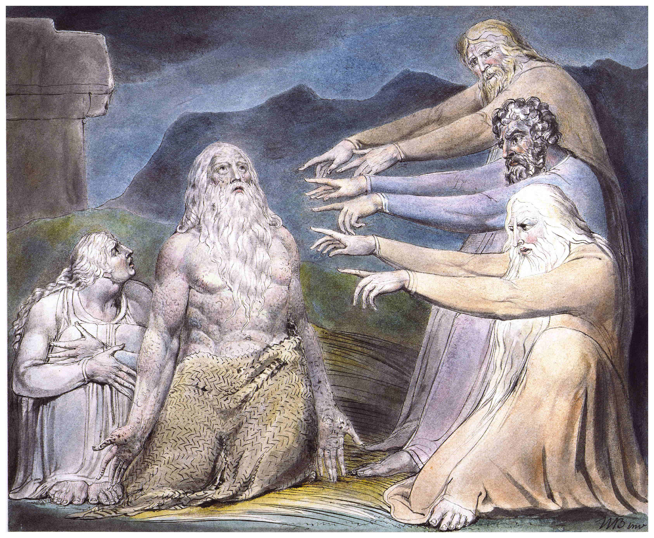

23 Oh that my words were now written! oh that they were printed in a book! 24 That they were graven with an iron pen and lead in the rock for ever! 25 For I know that my redeemer liveth, and that he shall stand at the latter day upon the earth: 26 And though after my skin worms destroy this body, yet in my flesh shall I see God: 27 Whom I shall see for myself, and mine eyes shall behold, and not another; though my reins be consumed within me. (Job 19:23-27)

There are many poetic passages in interspersed throughout Holy Scripture for, indeed, God is the inventor of poetry and music. God is the first recorded musician and poet. From the moment of Creation, music resounded across the expanse of the heavenly canopy: Where wast thou when I laid the foundations of the earth? declare, if thou hast understanding. Who hath laid the measures thereof, if thou knowest? or who hath stretched the line upon it? Whereupon are the foundations thereof fastened? or who laid the corner stone thereof; When the morning stars sang together, and all the sons of God shouted for joy? (Job 38:4-7) This is the question that God asked of Job. He also asks the same question of you and me. We only existed in the Mind and foreknowledge of God at that early moment in eternity past. We had no hand in Creation, or even in the molding of our own DNA - that is God's role! A few words about biblical poetry before we address Job.

There is some difference between biblical poetry and English poetry. Our English poetry is often composed in rhyming lines, though both biblical - and English - poetry are written in meter. It is the English metered method of writing that endears the King James Bible to Christians everywhere, and facilitates memorization. But Hebrew poetry does not usually employ rhyme, but emphasizes content through a process called 'parallelism' - or balancing ideas and concepts in lineal pairs. Its repetition of important truths brands the truth into our hearts and thence into our minds. One example of parallelism is 'synonomous parallel.' In this mode, the truth is stated in the first line, and repeated in the second in different words. Examples of synomous parallel are: He that sitteth in the heavens shall laugh: the Lord shall have them in derision. (Psalm 2:4); O LORD, rebuke me not in thine anger, neither chasten me in thy hot displeasure. (Psalm 6:1) There are many more examples of this technique.

Another technique employed in biblical poetry is that of 'antithetic parallel' in which the first line presents a truth and the second a contrasting parallel. Examples include: A false balance is abomination to the LORD: but a just weight is his delight. (Prov 11:1) & A soft answer turneth away wrath: but grievous words stir up anger. (Prov 15:1)

A 'synthetic parallel' the last line of a stanza strengthens and expands the meaning of the first. Example: And he shall be like a tree planted by the rivers of water, that bringeth forth his fruit in his season; his leaf also shall not wither; and whatsoever he doeth shall prosper. (Psalm 1:3) & He that winketh with the eye causeth sorrow: but a prating fool shall fall. (Prov 10:10) The science of literature owes its livelihood to the Hebrew poetry of the Holy Bible!
The poetry of Job is a combination of beauty in poetry and exposition of truth. The effect of such poetry is obvious from the results. How many of us remember such lines as "For I know that my Redeemer liveth!" or, "When the morning stars sang together?" When poetic beauty is combined with immutable truth, its effects are eternal and memorable.

The whole Book of Job is a poetic drama. It explores the question of the justice of God in relation to the pain and suffering of his people. Why do the people of God suffer so? Does the justice of God prevail on their behalf? The ending of the Book demonstrates that the hidden hand of God was working throughout to bring a glorious finality to Job's sufferings. Does the suffering of Job help to enlighten our own view of suffering? It should do so!

Job's friends come to comfort Job, but wind up adding to Job's misery. In this case, a multitude of counselors was of no benefit to Job; but the dialogue between Job and his friends are very valuable counsel to us which reminds us that Job's suffering was vicarious to our own and, in this way, like that of our Lord. Job's suffering was for OUR benefit to reveal that, though God's people suffer the "slings and arrows of outrageous fortune" in this world, they are victorious in the Lord their Savior when the shadows lengthen at Sunset. God does not simply even the balance for Job at the end - he doubles EVERYTHING and shows the vindication of those who suffer in Christ!

So in our reading of Job, we are struck, first of all, by the beauty of expression. Once that beauty has found repose in our hearts, the glorious truth of those expressions of beauty find life expression in our souls so that we are nearly overcome with the joy of it all. I have written a comprehensive study of each chapter of Job which is available for the asking from our National Office. But the purpose of this devotion is simply to point to the beauty of Job as a work of art. When one beholds the Last supper by Da Vinci, he is struck by a strange and mysterious beauty that he may not at first be able to express. But once the beauty has been sown in the heart, the greater meaning and scriptural science of the painting comes to the light of one's understand - its employment of 'point perspective;' its detailed array of disciples with the personality of each revealed; of Peter with the reversed knife behind the back of Judas; the overturned salt shaker by Judas' hand grasping the money bag; and the dear Savior's left hand extended, palm up, as if to receive the Bread of Life (which He IS), and the right hand appearing to push at the Cup which He prayed His Father to take from Him. Job is a literary work of art that surpasses that greatest of all works of art by Da Vinci! But it is one which we must read, appreciate, digest, and meditate upon forever after.

Let us examine just a few passages for the sake of resting in the beauty of the lines of Job:

7 O remember that my life is wind: mine eye shall no more see good. 8 The eye of him that hath seen me shall see me no more: thine eyes are upon me, and I am not. 9 As the cloud is consumed and vanisheth away: so he that goeth down to the grave shall come up no more. 10 He shall return no more to his house, neither shall his place know him any more. 11 Therefore I will not refrain my mouth; I will speak in the anguish of my spirit; I will complain in the bitterness of my soul. 12 Am I a sea, or a whale, that thou settest a watch over me? (Job 7:7-12)

12 With the ancient is wisdom; and in length of days understanding. 13 With him is wisdom and strength, he hath counsel and understanding. 14 Behold, he breaketh down, and it cannot be built again: he shutteth up a man, and there can be no opening. 15 Behold, he withholdeth the waters, and they dry up: also he sendeth them out, and they overturn the earth. 16 With him is strength and wisdom: the deceived and the deceiver are his. 17 He leadeth counsellors away spoiled, and maketh the judges fools. 18 He looseth the bond of kings, and girdeth their loins with a girdle. 19 He leadeth princes away spoiled, and overthroweth the mighty. 20 He removeth away the speech of the trusty, and taketh away the understanding of the aged. 21 He poureth contempt upon princes, and weakeneth the strength of the mighty. 22 He discovereth deep things out of darkness, and bringeth out to light the shadow of death. 23 He increaseth the nations, and destroyeth them: he enlargeth the nations, and straiteneth them again. 24 He taketh away the heart of the chief of the people of the earth, and causeth them to wander in a wilderness where there is no way. 25 They grope in the dark without light, and he maketh them to stagger like a drunken man. (Job 12:12-25)

God broods patiently the words of Job and his friends, then He fires a salvo across the bow of them all:

1 Then the LORD answered Job out of the whirlwind, and said, 2 Who is this that darkeneth counsel by words without knowledge? 3 Gird up now thy loins like a man; for I will demand of thee, and answer thou me. 4 Where wast thou when I laid the foundations of the earth? declare, if thou hast understanding. 5 Who hath laid the measures thereof, if thou knowest? or who hath stretched the line upon it? 6 Whereupon are the foundations thereof fastened? or who laid the corner stone thereof; 7 When the morning stars sang together, and all the sons of God shouted for joy? 8 Or who shut up the sea with doors, when it brake forth, as if it had issued out of the womb? 9 When I made the cloud the garment thereof, and thick darkness a swaddlingband for it, 10 And brake up for it my decreed place, and set bars and doors, 11 And said, Hitherto shalt thou come, but no further: and here shall thy proud waves be stayed? 12 Hast thou commanded the morning since thy days; and caused the dayspring to know his place; 13 That it might take hold of the ends of the earth, that the wicked might be shaken out of it? 14 It is turned as clay to the seal; and they stand as a garment. 15 And from the wicked their light is withholden, and the high arm shall be broken. 16 Hast thou entered into the springs of the sea? or hast thou walked in the search of the depth? 17 Have the gates of death been opened unto thee? or hast thou seen the doors of the shadow of death? 18 Hast thou perceived the breadth of the earth? declare if thou knowest it all. 19 Where is the way where light dwelleth? and as for darkness, where is the place thereof, 20 That thou shouldest take it to the bound thereof, and that thou shouldest know the paths to the house thereof? 21 Knowest thou it, because thou wast then born? or because the number of thy days is great? 22 Hast thou entered into the treasures of the snow? or hast thou seen the treasures of the hail (Job 38:1-22) Poetry cannot be better than this!

Well, dear reader, I could simply reprint all of Job here for your good pleasure, but you have eyes to see, and a heart to feel, and an abundance of time enjoy a full study of Job. It beats every poetic work of any man, and edifies the soul in the process.

Please read this book for your comfort and soul's profit.

