Devotion on Firsts of the Bible - First Bad Choice of Lot - 6 May 2015, Anno Domini

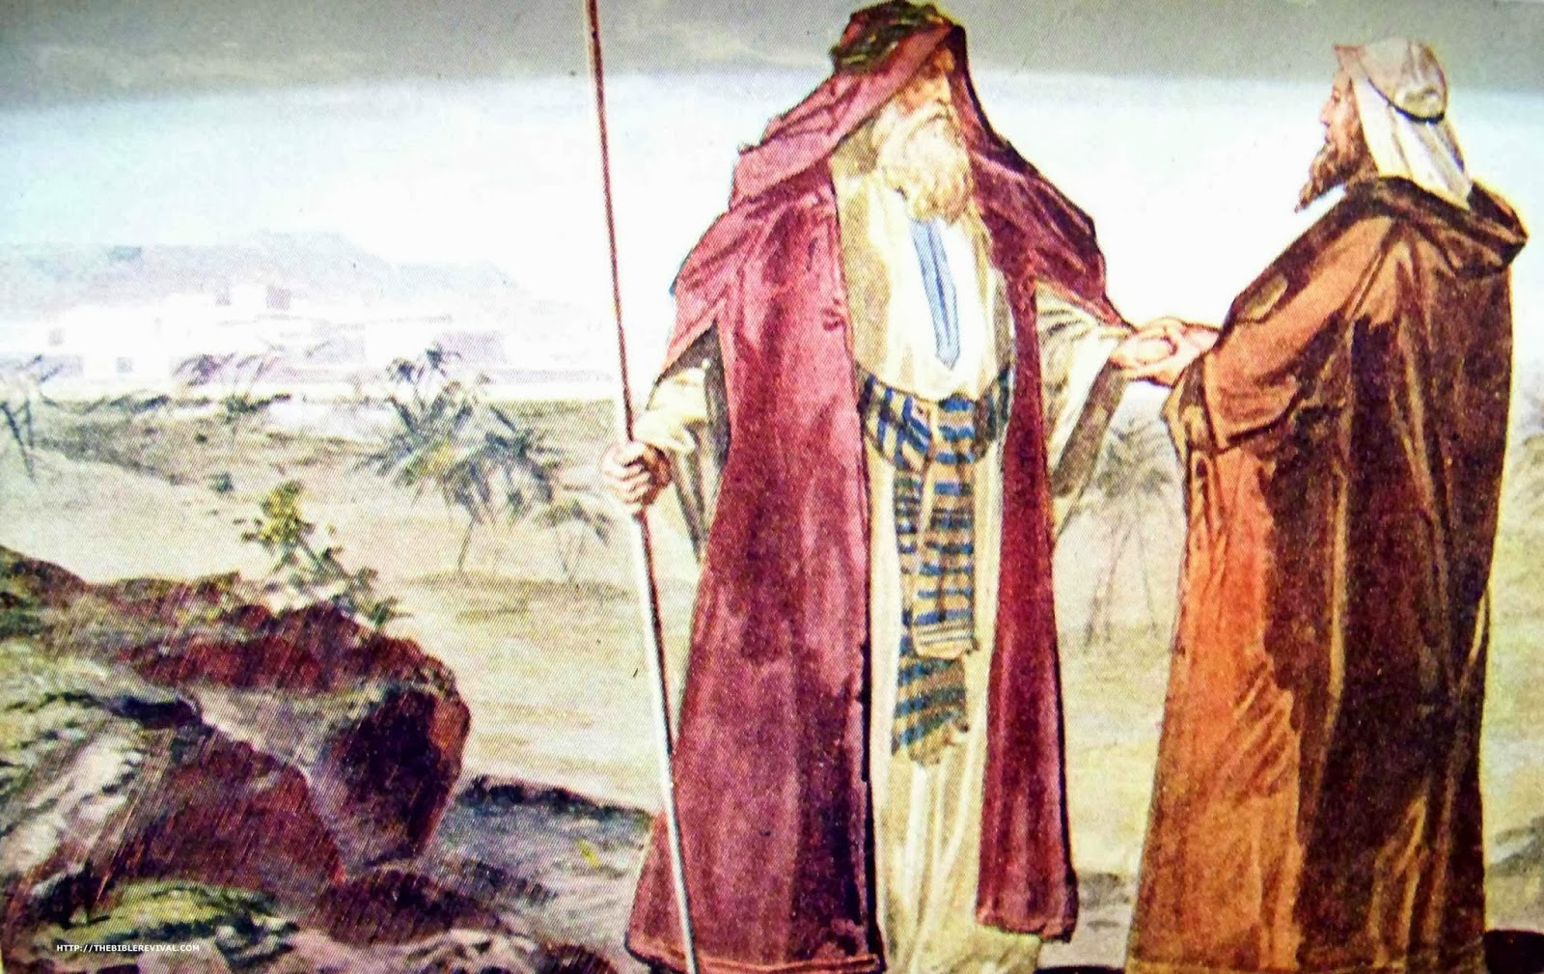

… Is not the whole land before thee? separate thyself, I pray thee, from me: if thou wilt take the left hand, then I will go to the right; or if thou depart to the right hand, then I will go to the left…

8 And Abram said unto Lot, Let there be no strife, I pray thee, between me and thee, and between my herdmen and thy herdmen; for we be brethren. 9 Is not the whole land before thee? separate thyself, I pray thee, from me: if thou wilt take the left hand, then I will go to the right; or if thou depart to the right hand, then I will go to the left. 10 And Lot lifted up his eyes, and beheld all the plain of Jordan, that it was well watered every where, before the LORD destroyed Sodom and Gomorrah, even as the garden of the LORD, like the land of Egypt, as thou comest unto Zoar. 11 Then Lot chose him all the plain of Jordan; and Lot journeyed east: and they separated themselves the one from the other. 12 Abram dwelled in the land of Canaan, and Lot dwelled in the cities of the plain, and pitched his tent toward Sodom. 13 But the men of Sodom were wicked and sinners before the LORD exceedingly. (Gen 13:8-13)

You will remember that God told Abraham to depart from Ur of the Chaldees and from his kindred. Abram did not fully heed God’s advice and pays a consequent price for it. Abram was rich in cattle and other resources. So was Lot! The land could not accommodate both men’s possessions, so strife arose between the herdsmen of Lot and Abram. Churches that grow too encumbered with wealth and too much vacant of love may find it necessary to split – not by the essentials of faith, but by the dark spirit of greed. This separation will not be the first affair involving Lot to aggrieve Abram. Abraham will later find it necessary to go to war in order to save Lot and his family from servitude. He will also find himself later pleading with God to save Lot from God’s Destroying Angels at Sodom.

Rather than remaining together in the service of God, Abram and Lot decide to part ways over property considerations and not remain together over considerations of fellowship and mutual worship to God – story of the modern conglomerates that pass in our day for ‘mainline’ churches. The choice Lot makes is one of compelling interest and importance.

Abram makes a generous offer to Lot: Is not the whole land before thee? separate thyself, I pray thee, from me: if thou wilt take the left hand, then I will go to the right; or if thou depart to the right hand, then I will go to the left. He will allow Lot to decide which part of Canaan he desires. Lot is far more greedy than Abram. His eyes (and heart) are attracted to the well-watered, green plains over toward Sodom. The potential wealth of that land is more important to Lot than the abject sinfulness and ungodliness of Sodom. And Lot lifted up his eyes, and beheld all the plain of Jordan, that it was well watered every where, before the LORD destroyed Sodom and Gomorrah, even as the garden of the LORD, like the land of Egypt, as thou comest unto Zoar.

So Lot makes a very costly mistake: Lot dwelled in the cities of the plain, and pitched his tent toward Sodom. But the men of Sodom were wicked and sinners before the LORD exceedingly. When men and nations make choices based more upon financial expediency in complete disregard of righteousness and justice, trouble stands at the door – in fact, devastating doom!

I love the first Psalm of David for it sets the pattern for all other of the Psalms; but it also sets the pattern for righteous living as opposed to the wicked way of mankind. This Psalm speaks directly to the attitude exercised by Lot in making his choice to pitch his tent TOWARD Sodom! This is precisely what America and the European powers are doing today! Our corrupt politicians see some political fortune in siding with the ungodly for advantage. Let us look, again, at Psalm 1. There are only six verses – three positing the way of the righteous man; and three the ways of the sinful.

The Righteous Man:
1 Blessed is the man that walketh not in the counsel of the ungodly, nor standeth in the way of sinners, nor sitteth in the seat of the scornful. 2 But his delight is in the law of the LORD; and in his law doth he meditate day and night. 3 And he shall be like a tree planted by the rivers of water, that bringeth forth his fruit in his season; his leaf also shall not wither; and whatsoever he doeth shall prosper. (Psalms 1:1-3) What points does the Psalm make?

- Blessed is the man that walketh not in the counsel of the ungodly;
- nor standeth in the way of sinners;
- nor sitteth in the seat of the scornful.

How do these verses apply to Lot? Did Lot not choose the land over against (in the direction of) Sodom? Did he not undertake to do commerce with them inside their gates for he moved eventually INTO the city? Lastly, did Lot not sit as a political judge within the gates of Sodom by the coming of the Holy Angels? And there came two angels to Sodom at even; and Lot sat in the gate of Sodom: and Lot seeing them rose up to meet them; and he bowed himself with his face toward the ground. (Gen 19:1)

Lot was not like a tree planted by the rivers of water; but more like a briar planted by the sewer canal of sewage and waste. Perhaps because of his dim faith in the God of Abraham, God considered Lot to be a righteous man in the midst of wickedness. God would utterly destroy Sodom for her sins – the major sin of which was sodomy (homosexuality); but God would spare righteous Lot. For the LORD knoweth the way of the righteous: but the way of the ungodly shall perish. (Psalms 1:6)

We in America can take some counsel from the story of Lot. Surely, it has ever been the case that the righteous ones of a nation are forever in the minority; but when the righteous become so few as Lot and his family, God will send judgment. He will spare, perchance, the righteous, but their nation will be destroyed or given over to the enemy avenger, and the accumulated wealth of the righteous will be lost with the nation.

Lot’s choice, in the eyes of the realtor or investment broker, was wise and sound; but it neglected to rely upon the will of God and His righteousness. God does not want parents to place their children in the paths of temptation and wicked associations. Even when we avoid temptation with great effort, we still may be confronted with it. But when we deliberately place our souls in the way of wickedness and temptation, we are tempting the devil to take our souls along with our children.

There is a pseudopygraphal book entitled, ENOCH, which is not canonical, but relates historical facts regarding the age – much as does Josephus or Eusebius. It gives an account of Sodom of unimaginable sexual perversion and wickedness. It reads a bit like the streets of modern America. By turning to the most filthy and unimaginable perversions, America is placing herself in a greater jeopardy than was Lot. 21 Because that, when they knew God, they glorified him not as God, neither were thankful; but became vain in their imaginations, and their foolish heart was darkened. 22 Professing themselves to be wise, they became fools, 23 And changed the glory of the uncorruptible God into an image made like to corruptible man, and to birds, and fourfooted beasts, and creeping things. 24 Wherefore God also gave them up to uncleanness through the lusts of their own hearts, to dishonour their own bodies between themselves: 25 Who changed the truth of God into a lie, and worshipped and served the creature more than the Creator, who is blessed for ever. Amen. 26 For this cause God gave them up unto vile affections: for even their women did change the natural use into that which is against nature: 27 And likewise also the men, leaving the natural use of the woman, burned in their lust one toward another; men with men working that which is unseemly, and receiving in themselves that recompence of their error which was meet. (Romans 1:21-27) I need make no exposition of these verses – they speak very clearly for themselves.

We may say, but we are like Lot – we do not participate in such wickedness. We simply have a “live-and-let-live” approach to these perverted sinners. Really? Read Levicus 18: 24 Defile not ye yourselves in any of these things: for in all these the nations are defiled which I cast out before you: 25 And the land is defiled: therefore I do visit the iniquity thereof upon it, and the land itself vomiteth out her inhabitants. 26 Ye shall therefore keep my statutes and my judgments, and shall not commit any of these abominations; neither any of your own nation, nor any stranger that sojourneth among you: 27 (For all these abominations have the men of the land done, which were before you, and the land is defiled;) 28 That the land spue not you out also, when ye defile it, as it spued out the nations that were before you. 29 For whosoever shall commit any of these abominations, even the souls that commit them shall be cut off from among their people. 30 Therefore shall ye keep mine ordinance, that ye commit not any one of these abominable customs, which were committed before you, and that ye defile not yourselves therein: I am the LORD your God. (Lev 18:24-30)

America has been a pleasant land under the beneficence of the Hand of God; however, God will not forever look away from the multiplying sins of our nation. When He considers that our iniquity is full, He will bring a stinging judgment.

So America, like Lot, has a choice to make: Either the fertile, sin-stained plains over against Sodom; or the City on a Hill which beckons from afar every faithful pilgrim! Remember God’s warning to us of Sodom: Even as Sodom and Gomorrha, and the cities about them in like manner, giving themselves over to fornication, and going after strange flesh, are set forth for an example, suffering the vengeance of eternal fire. (Jude 1:7)

