Devotion on Firsts of the Bible - First Apostle Martyred – 20 November 2015, Anno Domini

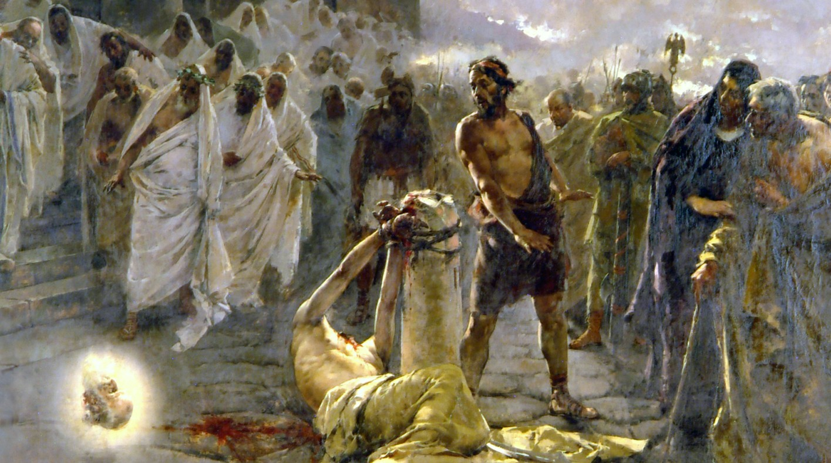

1 Now about that time Herod the king stretched forth his hands to vex certain of the church. 2 And he killed James the brother of John with the sword. 3 And because he saw it pleased the Jews, he proceeded further to take Peter also. (Acts 12:1-3)

Historical accounts of the reign of Herod inform us (Paley) King Herod did not exercise supreme authority over Judea during the first thirty years of his reign; however, he did exercise that authority during the last three years during which time the Apostle James was martyred. James, in the providence of God, had served a great purpose in the church at Jerusalem, but there comes a time, decreed by God, when our circuit on this earth is finished. This was the case with James; however, it was not so with Peter for whom the Lord intervened powerfully to spare even by breaking the chains from Peter’s arms and legs and opening the iron-leaved gates of the prison. He had more work for Peter, but not for James. We often regret the death of a good man or woman of God in early age, but God’s Eyes see through the mist of time of future events that our mortal eyes cannot comprehend. “The Lord giveth and the Lord taketh away – blessed be the Name of the Lord.” Regardless the length and span of our days, even if brief, our lives are yet a gift, therefore if a wealthy benefactor gives us $10,000.00 or one million, in each case it was a gift. We must be thankful for all life and not be displeased with the grace of God in shortening the life that He has granted.

Modern chief executives of nations are not the first to use ‘political correctness’ in aggrandizing their power over the citizens of a nation. Herod was no less ruthless in its use then those in Washington today, or Paris, or London, or Teheran. The Church in Jerusalem posed, in the mind of Herod (a jealous king) a threat to his rule. Though the Christian religion fosters a sense of honor and patriotism to the nation, even that influence is a thorn in the side of despots. They want no other voice but that of mammon to fall on the ears of their subjects; thus we have a ban on prayer in public places, exclusion of Bibles and even mention of it in our public schools, and an effort to force the consciences of Christians to support sinful and diabolical sins such as abortion and homosexual marriage with their own tax dollars. Any small compromise is as serious as a large one.

Did God have a purpose in allowing the martyrdom of the deacon Stephen?

Though it seems a terrible fate in our eyes, the martyrdom of Stephen served to water the faith of the Church in tremendous ways. Had Stephen remained a deacon only, and served in preaching and teaching, he would have been remembered and honored to a far less extent than he has come to be remembered. Every Christian knows of Stephen and the manner of his courageous death. IT tells us that our best and finest may be the first to face such a fate as did Stephen. The same is true of the apostle James. He was dearly favored by the Lord and privileged in special was with his brother, John, and the apostle Peter. These three were privy to mysteries that the others may not have been able to either understand or brood.

The Church at Jerusalem had become a strong influence there. It wielded influence among many of Jerusalem. It may have been even influenced by the local politics of the city; and there was another problem with the Church at Jerusalem. Though it was needful to begin in Jerusalem and serve as a model and support for other churches to be formed, it had become almost like the See of Rome in the manner in which other Christians looked to it for guidance. So its purpose had been served as an avant garde in the early church movement, but now it needed to be pruned. James was the largest branch and the one needful to be taken out to serve the plan of the Lord to expand His Church to every nation and tongue. By the way, this is my sole interpretation based on my understanding of the history of the Church. That interpretation is not based on a direct scriptural evidence of the matter. I believe it was for this reason that the Lord allowed the martyrdom of James (which He could have cancelled) and disallowed that of Peter. Peter, as we learned in the baptism of Cornelius, was needed to carry the Gospel to borders beyond Judea and to the Gentiles rather than concentrating all ministerial efforts in Jerusalem. An Army needs a base camp from which to operate but, once greater territory is taken and the Army operates further and further away from its original base camp, others must be established in the formerly hostile land.

So King Herod saw the beheading of James (by the sword) pleased those enemies of the Gospel in Jerusalem. So he immediately undertook to do the same to Peter. Amazing how nothing ever changes is it not? Planned Parenthood, the greatest and most gruesome enemy of innocent life is now the closest ally to big government against the Church. The political correctness of Herod’s day, and that of our own, is identical. It is designed to strike the fear of free expression into the hearts of its victims; and ultimately to void any First Amendment guarantees. The effect of the chief Apostle of Jerusalem being beheaded was sure warning to the lesser leadership and laity of Jerusalem. It dampened their testimony, which was precisely the goal and purpose of Herod.

Many believe that government should not interfere with the free practice of religion; but the free practice of religion compels the Christian to insist on justice in government, honor in its elected representatives, the protection of human life and the compassionate concern for ALL life (both animal and human), and an openness based upon the presumption that government has nothing to hide from its subjects. This galls the conscience of political figures. They love their backroom deals and bargains that by-pass the public interest and will. Those who constantly harp on a separation of church and state (a concept which the Constitution fails to mention, by the way) will always insist that the Christian professor cannot bring his Christian values into the public venue. But they do, at the same time, violate the First Amendment guarantees of the free practice of religion by forbidding religious expression by any who love God and practice their faith.

Government has an enormous appetite, and is never satisfied with its daily fare. Once one additional and unconstitutional power is achieved, it grasp for the next simply because oppression of the people moves nearer its ravaging appetite. If Congress can make no law respecting the establishment of religion, or the free exercise thereof, from whence originate laws that forbid little children from praying in school or reading the Bible there? If our nation’s capital is furnished with such a tremendous array of Christian and biblical symbols in the design of our national monuments, why is it suddenly taboo for a community to erect a monument of the Ten Commandments? Is it because murder is now acceptable according to the definition of the state; or lying and subterfuge now honorable by the same standard; or licentious sex with same-sex partners and even animals now fashionable; or any reliance on the moral law to justify order in society somehow contrary to the interest of the state? But some will say, “You cannot legislate morality!” Really, now! If we pass a law against burglary, or vandalism, or the abuse of children, or trespass, have we not legislated morality? I suppose the question boils down to WHOSE morality do we follow – man’s or God’s.

It may seem that we have drifted some distance from the subject of today’s devotion – that is, the martyrdom of the apostle James – and perhaps we have; but I insist that the issue of James and our modern dilemma of unconstitutional misappropriation of Executive Powers is precisely related to that ugly and wicked deed of King Herod in putting James to death. Once we get past the formalities of limit to power, there can be no end to tyrannical exercise of power – even to the putting to death of any who disagree with government. Who would have imagined, only ten years ago, that we would have students on college campuses rioting because they want all speech with which they do not agree banned from campus? or the dregs of society marching in the streets promoting the notion that only black lives matter and screaming for the outright murder of law enforcement officers. This plays directly into the hands of government which is often the originators of those sentiments, planted in the minds of poorly educated and government-indoctrinated vandals. We are even inviting into our midst those whose sole intention is to sow the seeds of ruin in our own nation.

So James was murdered by the sword at the whimsical order of a tin-horned potentate. Do you believe that the government which grasp for all power will be more lenient with you when all power is indisputably in its hands? We have no king but King Jesus! We honor our king regardless the claims of all other government. Should Christians obey the ministers of government? Of course, but only so long as the laws of government do no impinge upon the clear conscience of our duty to God. Even our duty to country compels us to disown governments that become abusive of our freedoms.

Do not be shocked at those things that we are about to see coming upon our nation, and the world. We lose no honor if we suffer the same fate of James.

