Devotion on Firsts of the Bible - First Wrestling with an Angel, 22 May 2015, Anno Domini

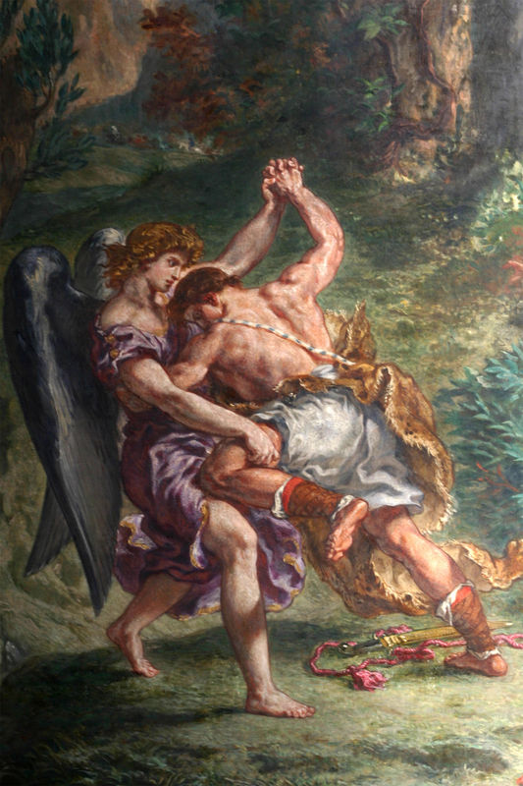
Thy name shall be called no more Jacob, but Israel

24 And Jacob was left alone; and there wrestled a man with him until the breaking of the day. 25 And when he saw that he prevailed not against him, he touched the hollow of his thigh; and the hollow of Jacob's thigh was out of joint, as he wrestled with him. 26 And he said, Let me go, for the day breaketh. And he said, I will not let thee go, except thou bless me. 27 And he said unto him, What is thy name? And he said, Jacob. 28 And he said, Thy name shall be called no more Jacob, but Israel: for as a prince hast thou power with God and with men, and hast prevailed. 29 And Jacob asked him, and said, Tell me, I pray thee, thy name. And he said, Wherefore is it that thou dost ask after my name? And he blessed him there. 30 And Jacob called the name of the place Peniel: for I have seen God face to face, and my life is preserved. 31 And as he passed over Penuel the sun rose upon him, and he halted upon his thigh. 32 Therefore the children of Israel eat not of the sinew which shrank, which is upon the hollow of the thigh, unto this day: because he touched the hollow of Jacob's thigh in the sinew that shrank. (Gen 32:24-32)

When I was a three year old, I went with my older sister and her playmates into a wooded area near my grandmother’s farmhouse. There was a delicate little spring-fed stream that ran between two moss-covered banks of the stream. My older sister was telling her friends some tale about fairies. I was excluded from any direct participation in the conversation, but I could see all that my sister said in my mind’s eye. I was concentrating on a little mound of moss punctuated by tiny wild flowers near the stream. Suddenly, as sure as I am writing this devotion, I saw tiny fairies come from a door in the mound and begin to dance (ballet fashion) around the mound. They wore just the kind of gossamer, pastelle dresses one would think a fairy would wear – some blues, some yellows, and some greens. I can still starkly see those tiny figures in my mind’s eye. (At this point, you may be wondering if you should ever read another of my devotions). Of course, it was an over-active imagination that gave birth to those visions, but to me, they were as real as a drink of cold water. When I told my parents, my father threatened to spank me for lying, but I would not relent.

I relate this story to remind the reader of Jacob’s predicament in relating his experiences to friends and family of having met the angels of God at Mahanaim, and then actually wrestling with the Angel of the Lord – and gained therefrom a blessing. Such news was probably received with the same unbelieving disdain as was my tale of imagination of fairies. But this story of Jacob is real, and even more fantastic in reality than the dream I had. It is the recorded Word of God. Why did these things occur to Jacob? With God, there is a purpose for everything that He does, and so it is with Jacob and the unsponsored wrestling match.

“And Jacob was left alone.” May I suggest to the reader that the strongest company of God’s presence is most often experienced when one is ALONE with God? There are no worldly suggestions or pursuits to distract one’s mind from that Almighty Personage. It is even possible for a devout man or woman to be alone with God in the presence of a crowd of people. There are six men mentioned is Scripture who were alone with God:

- Jacob – Gen 32:24
- Moses – Ex. 24:2
- Jeremiah – Jer. 15:17
- Daniel – Dan. 10:7-8
- Our Lord Jesus – Luke 9:18
- Paul – 1 Thess. 3:1

When you are to meet a person who means more than life to you, do you not want to get alone with them so that you can concentrate your attention on their every word. Should it not be so with the Lord as well?

“. . . and there wrestled a man with him until the breaking of the day.” The Hebrew word for ‘wrestle’ is ‘abaq’ which means to physically grapple or struggle with. This was not a dream or vision; this was actual, physical struggle with God (either the Angel of God, or the Pre-Incarnate Christ). Whichever, the Angel had a physical body that could be grappled with. You will remember the tenacity of Jacob in his birth: “25 And the first came out red, all over like an hairy garment; and they called his name Esau. 26 And after that came his brother out, and his hand took hold on Esau's heel; and his name was called Jacob: and Isaac was threescore years old when she bare them.” (Gen 25:25-26) Jacob was a plain man, we are told; and Esau was a cunning hunter and man of the fields. But if a plain man has drive, he will leave the cunning hunter behind just as did the tortoise outrun the rabbit. Jacob and the Angel struggled all night long. The Angel made as if He could not get the advantage, but had to leave ere the day dawned. So Jacob invokes a blessing from the Angel. It was precisely God’s point in the match. “I will not let thee go, except thou bless me.” Our secretary, Cinder, in Statesville, is a strong believer in persevering prayer, and this account of Jacob is strong evidence in support of that kind of prayer. We hold God’s attention in prayer until we learn His will!

God will always leave evidence that a man or woman has had a close communion in life with Him. He leaves such evidence in the form of a shrunken sinew on Jacob’s thigh. This would be a reminder to us - from Jacob’s constant limp - to Jacob as well for the awkward gait he would have.

27 And he said unto him, What is thy name? And he said, Jacob. 28 And he said, Thy name shall be called no more Jacob, but Israel: for as a prince hast thou power with God and with men, and hast prevailed. Jacob simply received the blessing that God had already granted, however, he did also receive a new name as does every person who comes in surety to the Lord. Our names at salvation is called Christian from henceforth; and in eternity, even another name that no one knows but its owner! To him that overcometh will I give to eat of the hidden manna, and will give him a white stone, and in the stone a new name written, which no man knoweth saving he that receiveth it. (Rev 2:17) What is the purpose of this new name that no one else knows? What would be the scandal in heaven if we were to drag these old disreputable names with us there? All of our sinful life before Christ would be spoken of by all who saw us. But there is no scandal at all associated with that new name written in a white stone (signifying INNOCENCE). Jacob’s new name is that by which all of the church is known today – ISRAEL! The name ISRAEL means “God prevails.” So this is evidence that Jacob did not win the wrestling match, but God did in reality!

There are many and sundry things that God intends to be a mystery to us for a time, though you will be hard put to find a theologian that will admit to any mystery in God’s Word. They will aver that all is perfectly explainable in natural terms. They are WRONG. God does keep mysteries from us until the due time of their being made known in His calendar of events. We find one such mystery here: “29 And Jacob asked him, and said, Tell me, I pray thee, thy name. And he said, Wherefore is it that thou dost ask after my name? And he blessed him there.” Which Person of the Godhead did Jacob wrestle? We do not know, but the text implies that it was, indeed, God, or his Vicegerent, with whom Jacob wrestled. This is deduced from the name God gave Jacob – Israel, God prevails. See also Hosea 12:3-6 – He took his brother by the heel in the womb, and by his strength he had power with God: Yea, he had power over the angel, and prevailed: he wept, and made supplication unto him: he found him in Bethel, and there he spake with us; Even the LORD God of hosts; the LORD is his memorial. Therefore turn thou to thy God: keep mercy and judgment, and wait on thy God continually. (Hosea 12:3-6)

Jacob was near to the Banks of Jordan Waters (at Jabbok) where he wrestled with God. And Jacob called the name of the place Peniel: for I have seen God face to face, and my life is preserved. (Gen 32:30) Peniel means, “Facing God,” because Jacob came face-to-face with God short of Jordan Banks. As we approach the troubled Banks of Jordan waters, will it not be worth a life of devotion to see God face-to-face ere we cross those waters? There is an old song that expresses that sentiment:

When I come to the river at the ending of day
When the last winds of sorrow have blown
There'll be somebody waiting to show me the way I won't have to cross Jordan alone

Refrain
I won't have to cross Jordan alone
Jesus died all my sins to atone
In the darkness I see he'll be waiting for me
I won't have to cross Jordan alone

Often times I'm weary and troubled and sad
When it seems that my friends have all flown
There is one thought that cheers me and makes my heart glad
Refrain

Though the billows of trouble and sorrow may sweep
Christ the Saviour will care for his own
Till the end of my journey my soul he will keep and I won't have to cross Jordan alone
Refrain

Well friend, if you do a bit of wrestling with God before those Jordan Waters loom ahead, neither will you have to cross Jordan alone. He will be with you every step of the way!

