Devotion on Firsts of the Bible - First Marriage, 18 April 2015, Anno Domini

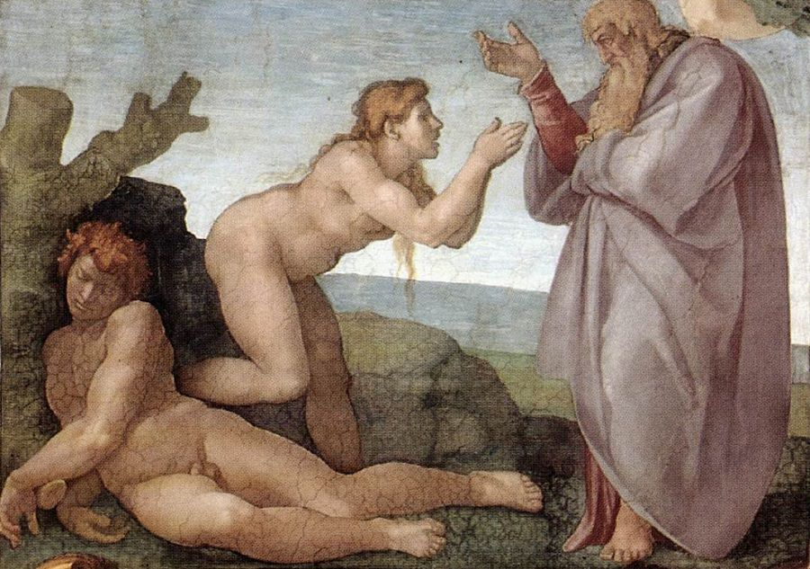
… and they shall be one flesh …

21 And the LORD God caused a deep sleep to fall upon Adam, and he slept: and he took one of his ribs, and closed up the flesh instead thereof; 22 And the rib, which the LORD God had taken from man, made he a woman, and brought her unto the man. 23 And Adam said, This is now bone of my bones, and flesh of my flesh: she shall be called Woman, because she was taken out of Man. 24 Therefore shall a man leave his father and his mother, and shall cleave unto his wife: and they shall be one flesh. (Gen 2:21-24)

Each and every ‘FIRST’ of God was perfect in its composition and beauty – this includes that first Garden that God created eastward in Eden, and in which He placed the man that He had formed from the dust of the earth. But beauty is so much more perfect when it can be shared with another in love. The animals, flora, and butterflies possessed unmatchable intrinsic beauty, but they could not relate fully to the thoughts and emotions of Adam. So God would create a ‘helpmeet’ for Adam that would be every bit as much human and autonomous as was Adam. In fact, the woman (womb-man) would also be one with Adam, and Adam would be one with the woman. In the western nations, it is tradition that a woman takes the name of the husband at marriage. This mandate is derived from the Holy Bible for Eve’s name would also be ‘ADAM.’ 1 This is the book of the generations of Adam. In the day that God created man, in the likeness of God made he him; 2 Male and female created he them; and blessed them, and called their name Adam, in the day when they were created. (Gen 5:1-2)

Today we find God’s first institution which He ordained and blessed in Eden. It is so important in the eyes of the Lord it would serve as a model and example of that Second Institution called the Church; for, just as Christ loved His Bride, the Church, and gave His life for it, so should marriage constitute the same values of love, commitment, and sacrifice. 22 Wives, submit yourselves unto your own husbands, as unto the Lord. 23 For the husband is the head of the wife, even as Christ is the head of the church: and he is the saviour of the body. 24 Therefore as the church is subject unto Christ, so let the wives be to their own husbands in every thing. 25 Husbands, love your wives, even as Christ also loved the church, and gave himself for it; 26 That he might sanctify and cleanse it with the washing of water by the word, 27 That he might present it to himself a glorious church, not having spot, or wrinkle, or any such thing; but that it should be holy and without blemish. 28 So ought men to love their wives as their own bodies. He that loveth his wife loveth himself. 29 For no man ever yet hated his own flesh; but nourisheth and cherisheth it, even as the Lord the church: 30 For we are members of his body, of his flesh, and of his bones. 31 For this cause shall a man leave his father and mother, and shall be joined unto his wife, and they two shall be one flesh. 32 This is a great mystery: but I speak concerning Christ and the church. 33 Nevertheless let every one of you in particular so love his wife even as himself; and the wife see that she reverence her husband. (Eph 5:22-33)

Since we, as members of the Body of Christ, are One with Him, and He is One with the Father, a separation of the Body from the Head cannot occur without a resulting catastrophic result. But it is not possible for the true believer to be severed from Christ for He will not lose a single soul that is entrusted to Him by the Father.

21 And the LORD God caused a deep sleep to fall upon Adam, and he slept. This deep sleep is not a dreamy-sleep, but so deep that there is no consciousness at all. Adam had no conscious role in the creation of woman. He could not even know to desire the woman, but God knew that man was not a complete man without the other half of his being (which was to be woman). Here we see another First of God – ANESTHESIA! Did God rob Adam of his rib? Not at all! Adam was made by God and all of his substance belonged to God. God simply took, in love, a portion of Adam’s own being to create his own kind that would be a blessing to Adam. This cycle of creation continues today as a tiny portion of man is taken to produce another child of mankind (DNA). Presumably, a tiny part of Adam has never died since it lives in that same DNA passed down from generation to generation. Modern science, often unwittingly, confirms the reality of God’s Creation. 20 And Adam called his wife's name Eve; because she was the mother of all living. (Gen 3:20) As we see in this verse from Genesis 3, woman has become the pivotal figure in all of the history of man since no man is born of man, but of woman. She has become God’s progenitor for every child born upon the earth.

Please bear in mind God NEVER intended men to be drawn to other men in the sense of marriage; nor of women to be drawn to women. It was not only unnatural, but denied the Creative Model of the Maker. 2 Male and female created he them; and blessed them, and called their name Adam, in the day when they were created. (Gen 5:2) God did not create the first marriage as ‘male and male’ or female and female;’ but He created them male and female! At the fall of Adam there would arise deviations in character as a result of the poisoned blood of sin. Those deviations lent themselves to inclinations to sin, that is, to lie, to steal, to murder, to dishonor God, to commit adultery, to covet, and, tragically, for men to dishonor their own bodies with other men. These are the natural fruits of the sinful nature inherited from father Adam. But these inclinations do no arise to the level of sin unless acted upon. But man does sin, and stands in need of a Savior. In the Prescience of God, provision was made for that Savior in the eons of time before Creation – the Lord Jesus Christ. Homosexuality is a grave and lamentable sin, but the mere inclination (or temptation) produced by that sin is not deadly until succumbed to by the sinner. In this sense, it is no different from murder, or adultery.

The heart of God is an overflowing Fountain of Love. He perceived the loneliness of man, and made loving provision for it. Adam, having awakened from a sleep that seemed no different to him than all others, was unaware of the beautiful gift God had prepared for him. I believe God, too, was made merry and joyful at the thought of presenting this wonderful present to Adam! 22 And the rib, which the LORD God had taken from man, made he a woman, and brought her unto the man. God knew that Eve would make Adam the happiest man on earth (that is a certainty since Adam was also the ONLY man on earth). The important principle herein is that marriages truly are ‘made in Heaven.’ God made ONE woman for ONE man, or, if you please, One Man for ONE woman. It matters not the order since they were intended to become ONE flesh. It was never the intention of God that a man, or woman, has more than one mate during their lifetimes.

What was Adam’s reaction to the wonderful gift God has given? 23 And Adam said, This is now bone of my bones, and flesh of my flesh: she shall be called Woman, because she was taken out of Man. 24 Therefore shall a man leave his father and his mother, and shall cleave unto his wife: and they shall be one flesh. Being taken out of man does not convey inferiority, but rather an exact likeness in opposites. Only God can devise these wonderful attributes that cause the science of nature to function. Marriage might be compared to electric current. The current is valuable and produces great benefits, but the poles that are necessary for electric current are opposites. The negative pole is no more, or less, important than the positive pole.

Adam spoke his definition of marriage by inspiration of God since there were no earthly parents of Adam and Eve – Therefore shall a man leave his father and his mother, and shall cleave unto his wife: and they shall be one flesh. ONE FLESH! This is a perfect definition of true marriage. It means more than flesh – it means also ONE MIND, and that is how it most closely identifies with Christ (the Bridegroom) and His Church, the Bride! When we have forsaken our own self-wills and taken upon us the Mind that was in Jesus Christ, we, too, shall be of ONE Flesh and Mind with Him. There can be no cause of division among the brothers and sisters of the Church if they are fully conformed to the Mind of Christ because Christ is not divided against Himself.

Today, along with other mundane affairs, marriage has become an option limited by the will of man and not of God. Young couples enter marriage on the basis of a ‘trial run.’ If the union satisfies the selfish needs of both parties, fine; but, if not, they claim the privilege of ungodly divorce. Sacrifice, at all levels of human society, is no longer a leading consideration. The church is so blessed that God did not feel that the marriage of His Son and the Church was not worth the ‘SACRIFICE.’

Observe that Adam was not deceived in partaking of the ill-natured fruit of Satan in the Garden. He did so with his eyes open to the penalty. It was Eve who was deceived. 13 For Adam was first formed, then Eve. 14 And Adam was not deceived, but the woman being deceived was in the transgression. 15 Notwithstanding she shall be saved in childbearing, if they continue in faith and charity and holiness with sobriety. (1 Tim 2:13-15)

So why did Adam partake of the forbidden fruit knowing its penalty? I believe Adam, being an inferior type of our Lord, partook out of a desire to share the fate of His beloved wife, Eve. This is consistent with the love that compelled Jesus to die for His Love, the Church – the type in perfection! The difference is that Adam’s death could not atone for the sin of Eve, but the death of Christ was a full atonement and redemption for the Church. Have you known this redemption and been sheltered by those Everlasting Arms that only God can provide?

