The following is a fitting devotion for our Lenten observance (sent in by Jim & Karen Whiting of Connecticut):

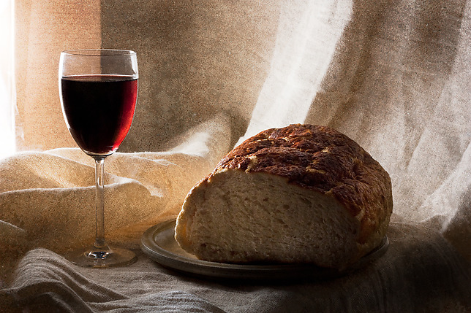

In God's cup of salvation!

(Alexander Smellie, "The Hour of Silence" 1899)

Ho, every one that thirsteth, come ye to the waters, and he that hath no money; come ye, buy, and eat; yea, come, buy wine and milk without money and without price. (Isaiah 55:1)

In God's cup of salvation, I discover all that I can crave! There is no deficiency here, and no disappointment.

There is water in this cup--the water of spiritual life. I am dying of thirst in the desert--the desert of my sin and guilt. But He puts the cup to my lips, and I live. It brings me . . .
- full and free pardon,
- the remission of all my transgressions,
- His own eternal favor and fellowship,
- the assurance that He is pacified toward me!

There is milk in this cup--the milk of spiritual nourishment. I am frail and powerless . . .
- against temptation,
- against my besetting and beguiling iniquities,
- against the world and the flesh and the devil.

But He puts the cup to my lips, and I am strong. My sanctification is there. His own Holy Spirit is there. I am more than a conqueror now. My weakness, casting itself upon Him--is exchanged for His mightiness!

There is wine in this cup--the wine of spiritual joy. I am restless, uneasy, disillusioned, troubled. My heart has no deep and abiding contentment. I wander into fruitless seedbeds of sorrow, with a proud dejectedness and a cheerless weariness. But He puts the wine-cup to my lips, and I rejoice. For there is the peace of God here, and the indwelling of the Holy Spirit, and the victory over the world, and the sure and invincible hope of glory!

Water, milk, wine--and I may have them, now and here, without money and without price! I am at the source of every gracious and glorious thing; and my part is simply to receive my Lord's munificence, and to say farewell to my hunger and thirst, and to be eternally satisfied!

