Devotion on the Book of Job (Chapter Twenty-Nine) - 6 February 2013, Anno Domini
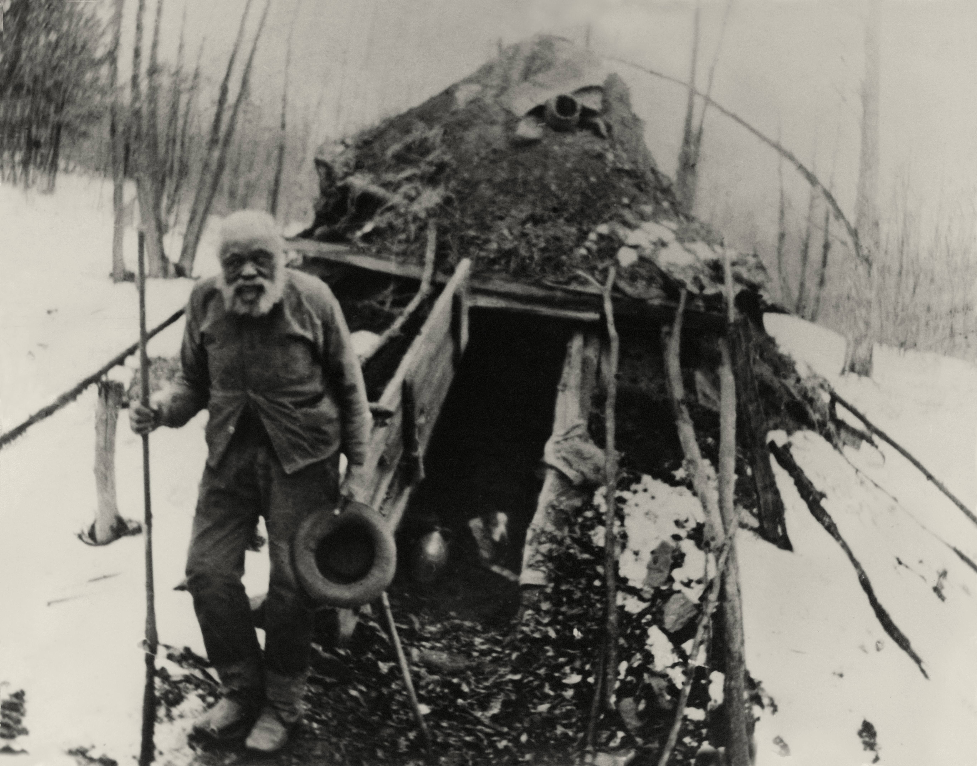

The Sunday called Sexagesima, or the
second Sunday before Lent.
The Collect.

O
LORD God, who seest that we put not our trust in any thing that we do; Mercifully grant that by thy power we may be defended against all adversity; through Jesus Christ our Lord. Amen.

Job 29
King James Version (KJV)
29 Moreover Job continued his parable, and said,
2 Oh that I were as in months past, as in the days when God preserved me;
3 When his candle shined upon my head, and when by his light I walked through darkness;
4 As I was in the days of my youth, when the secret of God was upon my tabernacle;
5 When the Almighty was yet with me, when my children were about me;
6 When I washed my steps with butter, and the rock poured me out rivers of oil;
7 When I went out to the gate through the city, when I prepared my seat in the street!
8 The young men saw me, and hid themselves: and the aged arose, and stood up.
9 The princes refrained talking, and laid their hand on their mouth.
10 The nobles held their peace, and their tongue cleaved to the roof of their mouth.
11 When the ear heard me, then it blessed me; and when the eye saw me, it gave witness to me:
12 Because I delivered the poor that cried, and the fatherless, and him that had none to help him.
13 The blessing of him that was ready to perish came upon me: and I caused the widow's heart to sing for joy.
14 I put on righteousness, and it clothed me: my judgment was as a robe and a diadem.
15 I was eyes to the blind, and feet was I to the lame.
16 I was a father to the poor: and the cause which I knew not I searched out.
17 And I brake the jaws of the wicked, and plucked the spoil out of his teeth.
18 Then I said, I shall die in my nest, and I shall multiply my days as the sand.
19 My root was spread out by the waters, and the dew lay all night upon my branch.
20 My glory was fresh in me, and my bow was renewed in my hand.
21 Unto me men gave ear, and waited, and kept silence at my counsel.
22 After my words they spake not again; and my speech dropped upon them.
23 And they waited for me as for the rain; and they opened their mouth wide as for the latter rain.
24 If I laughed on them, they believed it not; and the light of my countenance they cast not down.
25 I chose out their way, and sat chief, and dwelt as a king in the army, as one that comforteth the mourners.

This chapter expresses the painful sentiments of one who has been to the mountain of God and now finds himself in the shadow of death. During such moments, it is not easy to remember that God was with you on the mountain, but that He is also with you just as surely in the shadow of death. The memory of bygone days of joy and prosperity no longer comfort, but pain our hearts to consider the depths to which, and from which, we have fallen. I am reminded of that old black spiritual by Stephen Foster which reflects the pining of an old black field hand as his years draw toward the winter of his days:

1 Gone are the days when my heart was young and gay,
2 Gone are my friends from the cotton fields away,
3 Gone from the earth to a better land I know,
4 I hear their gentle voices calling 'Old Black Joe.'

5 [Chorus] I'm coming, I'm coming, for my head is bending low:
6 I hear those gentle voices calling, 'Old Black Joe.'

7 [Solo] Why do I weep when my heart should feel no pain
8 Why do I sigh that my friends come not again,
9 Grieving for forms Now departed long a go?
10 I hear their gentle voices calling 'Old Black Joe.'
11 [Chorus]

13 [Solo] Where are the hearts once so happy and so free?
14 The children so dear that I held upon my knee,
15 Gone to the shore where my soul has longed to go.
16 I hear their gentle voices calling 'Old Black Joe.
' 17 [Chorus]

Unless we have been to the Valley of the Shadow of Death, it is difficult to fully appreciate the view that is enjoyed from the Mountain of God. But once we have known the majesty of God, and His many splendored palaces, it a vision we can never forget. We carry that vision to the grave and beyond. The Christian, once embarked on the Narrow Way that leads up, will never desire to leave that upward climb until the gate is reached.

On unspoken, but salient, point in this chapter of Job is that we must learn to value of memories – good and bad. Every journey must have a starting point from which way-points are calculated. Without a starting point, there can be no destination point. We should not gloomily focus on past sins forgiven, but we neither should forget the great mercy of God that has forgiven such a miserable sinner as you and me. If we do not remember how low we have been, we shall not fully appreciate how high God has lifted us.

Job’s memories in this chapter are keen in the things he has lost, but color-blind to the blessings he has received at God’s hand instead of so much regretting his present spell of troubles. Of course, I can understand his pain and dismay of losing his dear children, but should he not thank God for the gift of children in the first place – even if for a brief time? God gives us family in our temporary existence on earth. Children are a gift from the Lord. We should not regret the gift whether it is for many decades, or only a span of months or years.

Job recapitulates in six areas his past years: 1) His days of religious joy. 2) His days of domestic felicity. 3) His past prosperity. 4) His time of public and civic honor. 5) His philanthropy towards needy. And, 6) His days of unexpected evil.

When we are sad, it is good to remember the glimmering years of past joy. God has blessed Job with abundance of everything. If anything, God has spoiled Job as a doting father spoils his favored son.

His days of religious bliss: 2 Oh that I were as in months past, as in the days when God preserved me; Has God forsaken Job to preserve him? Not at all. God is watching Job with greater interest now than before the trials and tribulations that Satan has wrought. 3 When his candle shined upon my head, and when by his light I walked through darkness; Does god not provide a CONTINUAL Light to His people? The light shines more brilliantly in the dark canyon than on the starlit mountain. For thou wilt light my candle: the LORD my God will enlighten my darkness. (Psalms 18:28) 4 As I was in the days of my youth, when the secret of God was upon my tabernacle; The Temple of God is the Heart. Has God really left Job’s heart? No, and the remainder of this Book bears that truth out!

His days of domestic felicity: 5 When the Almighty was yet with me, when my children were about me; Has Job forgotten that God is a constant companion of those who love Him? Though He keeps His silence, He is right beside.

His past prosperity: 6 When I washed my steps with butter, and the rock poured me out rivers of oil; Material prosperity is no more a sign of God’s favor than silken robes inlaid with gold.

His time of public honor and service: 7 When I went out to the gate through the city, when I prepared my seat in the street! Such blessing often leads us to believe that we DESERVE them, but DO we? He remembers these blessings seemingly more than his communion with God. 8. The young men saw me, and hid themselves: and the aged arose, and stood up. 9 The princes refrained talking, and laid their hand on their mouth. 10 The nobles held their peace, and their tongue cleaved to the roof of their mouth. 11 When the ear heard me, then it blessed me; and when the eye saw me, it gave witness to me
He remembers his own good works and philanthropy: 12 Because I delivered the poor that cried, and the fatherless, and him that had none to help him. 13 The blessing of him that was ready to perish came upon me: and I caused the widow's heart to sing for joy. 14 I put on righteousness, and it clothed me: my judgment was as a robe and a diadem. 15 I was eyes to the blind, and feet was I to the lame. 16 I was a father to the poor: and the cause which I knew not I searched out. 17 And I brake the jaws of the wicked, and plucked the spoil out of his teeth. This is unbecoming a man of Job’s faith – to brag, even to his own heart, of his righteous deeds. These are not acts of supererogation, but the minimum expected of a child of God. These are past blessings upon which we can all lay our heads in a peaceful rest.

Job now launches out in self-pity at his unexpected hardship: 18 Then I said, I shall die in my nest, and I shall multiply my days as the sand. Has Job’s expectations been denied? Will he not, at last, die in his nest (comfort of home)? Will his days not be multiplied far beyond this present day? He shall live to gather riches and sons and daughters. He will rest at last in greater blessing than he has ever had. We cannot count God as finished with us until we close our eyes in the sleep of the just. 19 My root was spread out by the waters, and the dew lay all night upon my branch. Has Job forgotten that his root is still spread out in the heart of God? Does he foolishly believe that God cannot be his friend in trouble as well as blessing? God is always more abundantly present with us in our trials than in our prosperity. 20 My glory was fresh in me, and my bow was renewed in my hand. 21 Unto me men gave ear, and waited, and kept silence at my counsel. Ah, yes! This is perhaps what Job misses most – the admiration of men, and the audience of the crowds. He would be better advised to take joy in having the ear of the Lord to hear him. 22 After my words they spake not again; and my speech dropped upon them. See how Job considers himself to be above other men (as the Pharisee and the publican)? Men were moved to silence at his commanding voice which he “dropped” down upon them. He must have been much better than them if his words must be dropped upon them. 23 And they waited for me as for the rain; and they opened their mouth wide as for the latter rain. Tribulation brings out the weaker demons of our spirits rather than our better angels. We have not seen this prideful side of Job heretofore. 24 If I laughed on them, they believed it not; and the light of my countenance they cast not down. Job is simply carried away with his boasting as an old soldier relating his landing on the beaches of Normandy. He says that even when he spoke in jest, his listeners understood and did not discredit his character. 25 I chose out their way, and sat chief, and dwelt as a king in the army, as one that comforteth the mourners. Unwittingly, Job is describing the character of Christ. Though Job falls far short, we can never fall short in our praise for the works of Christ! Even on His last entry into Jerusalem, Christ entered as a King and a Commander of Armies. But that entry will appear far less glorious compared to His entry into New Jerusalem as King of Kings and Lord of Lords. Man is unable to possess the perfection of Christ, and neither could Job. Job will come to know that. Have you come to know that, my Friend?

