Devotion on The Book of Job (Chapter Thirty-Eight – Part Two) for Ember Friday after the First Sunday in Lent - 21 February 2013, Anno Domini
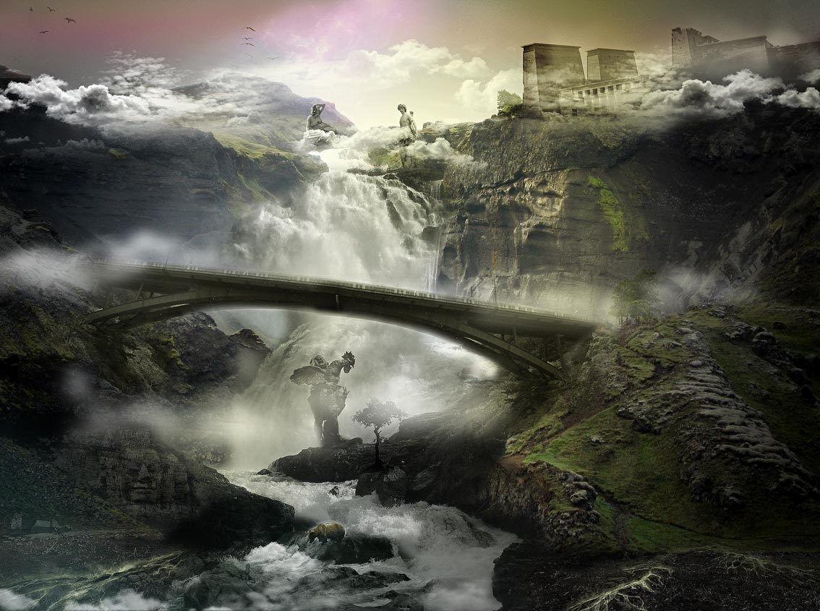

The First Sunday in Lent.
The Collect.

O
LORD who for our sake didst fast forty days and forty nights; Give us grace to use such abstinence, that, our flesh being subdued to the Spirit we may ever obey thy godly motions in righteousness, and true holiness, to thy honour and glory, who livest and reignest with the Father and the Holy Ghost, one God, world without end. Amen.

The first day of Lent, commonly called
Ash Wednesday.
The Collect.

A
LMIGHTY and everlasting God, who hatest nothing that thou hast made, and dost forgive the sins of all those who are penitent; Create and make in us new and contrite hearts, that we, worthily lamenting our sins and acknowledging our wretchedness, may obtain of thee, the God of all mercy, perfect remission and forgiveness; through Jesus Christ our Lord. Amen.
¶ This Collect is to be said every day in Lent, after the Collect appointed for the day, until Palm Sunday.

17 Have the gates of death been opened unto thee? or hast thou seen the doors of the shadow of death? 18 Hast thou perceived the breadth of the earth? declare if thou knowest it all. 19 Where is the way where light dwelleth? and as for darkness, where is the place thereof, 20 That thou shouldest take it to the bound thereof, and that thou shouldest know the paths to the house thereof? 21 Knowest thou it, because thou wast then born? or because the number of thy days is great? 22 Hast thou entered into the treasures of the snow? or hast thou seen the treasures of the hail, 23 Which I have reserved against the time of trouble, against the day of battle and war? 24 By what way is the light parted, which scattereth the east wind upon the earth? 25 Who hath divided a watercourse for the overflowing of waters, or a way for the lightning of thunder; 26 To cause it to rain on the earth, where no man is; on the wilderness, wherein there is no man; 27 To satisfy the desolate and waste ground; and to cause the bud of the tender herb to spring forth? 28 Hath the rain a father? or who hath begotten the drops of dew? 29 Out of whose womb came the ice? and the hoary frost of heaven, who hath gendered it? 30 The waters are hid as with a stone, and the face of the deep is frozen. 31 Canst thou bind the sweet influences of Pleiades, or loose the bands of Orion? 32 Canst thou bring forth Mazzaroth in his season? or canst thou guide Arcturus with his sons? 33 Knowest thou the ordinances of heaven? canst thou set the dominion thereof in the earth? 34 Canst thou lift up thy voice to the clouds, that abundance of waters may cover thee? 35 Canst thou send lightnings, that they may go, and say unto thee, Here we are? 36 Who hath put wisdom in the inward parts? or who hath given understanding to the heart? 37 Who can number the clouds in wisdom? or who can stay the bottles of heaven, 38 When the dust groweth into hardness, and the clods cleave fast together? 39 Wilt thou hunt the prey for the lion? or fill the appetite of the young lions, 40 When they couch in their dens, and abide in the covert to lie in wait? 41 Who provideth for the raven his food? when his young ones cry unto God, they wander for lack of meat. (Job 38:17-41)
Have you tasted the growing savor of this Book from our early chapters weeks ago? Throughout the narrative, we can see, feel, and hear the Word of God preparing our hearts for the wondrous revelations of beauty which we now, and shortly shall, savor. With God, the best wine is always reserved to the last, and we see this is the case with Job. Slowly, a great and mighty truth is being revealed to our minds as a long sought out, and labored over, gem of delight. Job's imperfection along the way only adds to the comfort of God's love for us in spite of our failures and shortcomings. We, today, can boast of no stronger faith than Job. We still fail of the righteousness of God in our normal day to day endeavors. Like Job, we are often blind to our own blindness; but God will bring to our realization that it is He who is perfect in justice and righteousness, and it is He who has offered a reconciliation for us through the sacrifice of His only Begotten Son at a Hill called Golgotha. God's vision is far-looking while ours is very shortsighted. He looks down the eternity of ages and time, beyond the millennia, through the centuries of struggle, and His eye settles on insignificant little YOU. He has known you from Eternity Past, and He knows you in your present years. But He also knows you in your future ears. This is why God's judgment is righteous and just. He allows the court proceedings of your life to run until after the last witness is heard, and the last breath given, before rendering a verdict of justice. The DOOR spoken of in John 10:1-18 is not closed until all life is extinguished. Does this not give us cause for joy and hope?
Many beauties of Creation are gradually revealed to us, as a proud Jeweler slowly uncovers His stones of brilliance, in the remaining verses of this chapter.
- God reveals the mystery of the Death Gate and Shoal of which He alone is Keeper. Further the formulation of snow, the rains o seasons, the silent dew, the clamorous thunders, and of the cold frost and icy blast. (verses 17-30)
- God's government of the natural formation of stars and clouds. (verses 31-38)
- Finally, the innate instincts instilled by God, into the natures of the beasts and fowl of the air – how the generous Hand of God feeds them in their wanderings.
Though the Words of God, conveyed by His prophets to us, bear that same authority and power as the words before us now, I am still made to wonder as a child does at his first glimpse of a multi-lighted Christmas Tree, when I survey these very Words of God presented to us here. How can our souls not be moistened with the silent Dews of Heaven as we read them?
Despite all popular acclaim to the contrary, no person has entered into the gates of death and returned to us for a visit – except the Lord Jesus Christ who rose eternally, and those whom He raised from a temporary tomb. 17 Have the gates of death been opened unto thee? or hast thou seen the doors of the shadow of death?
Death continues a mystery to us. We may only enter its gates once, but we shall never depart the gate until that Eternity-Piercing Voice of Christ shouts, "Arise! Come up Here!" No the `shadow of death' has no doors! Yea, though I walk through the valley of the shadow of death, I will fear no evil: for thou art with me…… (Psalms 23:4a) Death is only a shadow, and not real, to the child of god who forever has the Presence of God with Him. Where God is, there is no death. Do not forget, either, God's Rod and Staff. The Shepherd's staff has a crook on one end to save the lost or trapped sheep; but it has a sharp point on the other end to keep the sheep in line. God is using both ends in the life of Job – and in your life as well. "….thy rod and thy staff they comfort me." (Psalms 23:4b)
18 Hast thou perceived the breadth of the earth? declare if thou knowest it all. Have you, Job, beheld the globe of the earth in its fullness, and yet pretend to know the ways of God its Maker? Every bucket we draw from the Well of the Water of Life becomes more amazing and more edifying as we go, as evidenced by the next verse: 19 Where is the way where light dwelleth? and as for darkness, where is the place thereof, 20 That thou shouldest take it to the bound thereof, and that thou shouldest know the paths to the house thereof?Do we KNOW the origin and home of Light, Mr. Scientist? We claim to see light, but we do not – we see only its effect on the material objects it touches. Do we know that darkness is no force at all – only the absence of light? A tiny candle can dispel a room full of darkness at an instant. Do we know the limits of light's travel? I dare say we do not know, but God knows who placed the light ray in space and bound the constellations in their arrayed grandeur. At the final line, all Light comes from God – both spiritual and physical. And, just like the Holy Spirit and its nourishing Manna, light cannot be stored in jars and flasks.
21 Knowest thou it, because thou wast then born? or because the number of thy days is great? God is making jest of our short experience compared to that of the Ancient of Days who has existed from before the foundation of the world, the Creation of the Universe, and of all terrestrial life. God has been eye-witness to every detail of His Creation, for it was His own Artful Hands that shaped the hallowed scenes of morning dawning and evening sunset. Next comes one of the most beautiful half-verses of the Bible: 22 Hast thou entered into the treasures of the snow? Were you present at the forming of the perfect ice crystals that form the snowflake? These form as ice crystals are produced from moisture condensation in clouds. These droplets adhere around a speck of dust or other particle in the atmosphere. As these small droplets are carried higher by the winds of God, they begin to freeze into crystals. As they gather more ice, they become heavier and may fall as snow. But snow crystals cannot become white until they are carried into the heights of heaven – much like the purity of a Christian witness. As we are drawn higher and higher in the turbulence of God's Winds, we are made purer and whiter. Is a snowflake perfect in its whiteness? No, it is not. I call to the bar the Psalmist: Purge me with hyssop, and I shall be clean: wash me, and I shall be whiter than snow. (Psalms 51:7) Though a snowflake appears very white, at its core is a particle of impurity around which the ice crystals have formed. God first cleanses us inside with the purgative figuratively called hyssop, and then he washes our appearance as well so that we now can be even whiter than snow. The Holy Spirit making its abode in the Heart-Temple of God cleans house of all demons, then God makes our appearance vibrant and alive in purity of walk.
"….or hast thou seen the treasures of the hail, 23 Which I have reserved against the time of trouble, against the day of battle and war?" Hail was considered an expression of God's vengeance. During the heat of battle, a driving hailstorm may fall full face upon belligerents on the far side of the battle line and the backs of those on the near side. It could very easily decide the outcome of battle. 24 By what way is the light parted, which scattereth the east wind upon the earth? Are we not struck speechless by these wonderful questions? God has divided the light evenly through all continents of the world even though they are at times on opposite sides of the light. The variations in landmass and sea water temperatures create the winds that blow landward. But this can only be observed by man and not created by him.
25 Who hath divided a watercourse for the overflowing of waters, or a way for the lightning of thunder; 26 To cause it to rain on the earth, where no man is; on the wilderness, wherein there is no man; 27 To satisfy the desolate and waste ground; and to cause the bud of the tender herb to spring forth? What great Architect was it that designed the course of the Nile and the Amazon Rivers, or directed the course a bolt of lightning takes from cloud to cloud, and cloud to ground? God supplies His nourishing rains equally on the many people of the plains as well as the few in remote regions. Even that tender flower of beauty in the Desert Wilderness comes at the beckoning Voice of God. Man cannot yet create even a bud of Edelweiss. I am struck by the near-immortal words of Thomas Gray in elegy Written in a Country Churchyard:
Full many a gem of purest ray serene The dark unfathom'd caves of ocean bear: Full many a flower is born to blush unseen, And waste its sweetness on the desert air.
So God distributes His riches in random places without regard to the merits of the city.
28 Hath the rain a father? or who hath begotten the drops of dew? I hope the reader can see the great beauty of this allegorical language of God. Who has fostered the rain? Can a man command rain to fall, or cause the meadows to be covered with sparkling dew? Dew forms silently and unnoticed in the hours of darkness. The moisture-laden air baths the green plants and their waters condensate around the tender plants so that they are gradually covered with the morning dew. That dew is not unlike the operation of the Holy Spirit in bringing love into our hearts, and forming the Waters of Life in our heart's chambers. Much more could be written to describe this wonderful phenomenon, but space does not permit. 29 Out of whose womb came the ice? and the hoary frost of heaven, who hath gendered it? 30 The waters are hid as with a stone, and the face of the deep is frozen. There is only one compound that behaves in the manner of a molecule of water. All substances contract with declining temperatures all the way to absolute cold; however, water contracts until it reaches four degrees above freezing, then it mysteriously begins to EXPAND!. This allows ice to cover lakes and streams with an insulating layer so that the waters beneath do not freeze solid. If this phenomenon did not occur, all of the fish in our lakes and streams would be frozen solid. God has designed everything well, and in a manner beyond our ability to comprehend. The hardness between water and the stone cannot be differentiated when the water is hard-frozen. Ice covers the deep of lakes and ponds to the mystery of man.
31 Canst thou bind the sweet influences of Pleiades, or loose the bands of Orion? 32 Canst thou bring forth Mazzaroth in his season? or canst thou guide Arcturus with his sons? Before the natural composition of the great constellations was better known to astronomers, God named them and described their natures. God has flung the myriad formations of stars and constellations into space and appointed their permanent abodes. 33 Knowest thou the ordinances of heaven? canst thou set the dominion thereof in the earth? Well, with all our Hubble Telescopes and satellite probes, we are still trying to determine what those ordinances are; yet, we do not even know the limits of the Universe, or the population figures of stars and other heavenly bodies. We are not so very smart after all.
34 Canst thou lift up thy voice to the clouds, that abundance of waters may cover thee? 35 Canst thou send lightnings, that they may go, and say unto thee, Here we are? Will the clouds of the sky hear and obey your voice, O mortal man? Can you order the clouds to give up their water in times of draught? NO! You cannot! Elijah prayed for rain, and God sent it; but this is a far cry from man himself ordering the rain at will. We have a great Power upon which to call in times of draught. He can send the rain according to His express will. What of the lightning? Will it report to you, feeble man?
36 Who hath put wisdom in the inward parts? or who hath given understanding to the heart? What tremendous oceans of truth could we wring from this verse! God has placed His wisdom in the heart of all of His nature. He has informed the human body through His DNA blueprint how much to grow, how to grow, what to favor, how to think, feel, and act. The heart knows to supply more blood when the activity of the body is greater, and the life-blood knows to send agents to encounter invading organism that might harm the body. Can medical science design such an intricate balance in nature? Who taught the newborn colt to stand? Or the tiny fish to swim?
37 Who can number the clouds in wisdom? or who can stay the bottles of heaven, 38 When the dust groweth into hardness, and the clods cleave fast together? By the way, Mister or Misses Reader: how many clouds are there in the skies of the world today? I'll wait for your answer. Can you release the water upon parched earth by opening the bottles of heaven? Maybe not?
39 Wilt thou hunt the prey for the lion? or fill the appetite of the young lions, 40 When they couch in their dens, and abide in the covert to lie in wait? 41 Who provideth for the raven his food? when his young ones cry unto God, they wander for lack of meat. God, through His natural laws initiated at Creation, provides for the tiny lion cub as well as the high borne eagle. When these little ones lift their cries to God for want of food, He supplies through His natural agencies.
Here ends one of the most beautiful and meaningful chapters of the Bible. It is obvious to me that the mere words of man are no match for those Divine and Heavenly Words of God. It seems almost presumptuous on my part to attempt a commentary of these gems of truth and eloquence. I apologize for the length of this devotion, but which parts would you have me omit? I commend to your heart the pure Words of God contained in this, and following chapters, of Job.

