Devotion on the Book of Job (Chapter Eleven) - 4 January 2013, Anno Domini
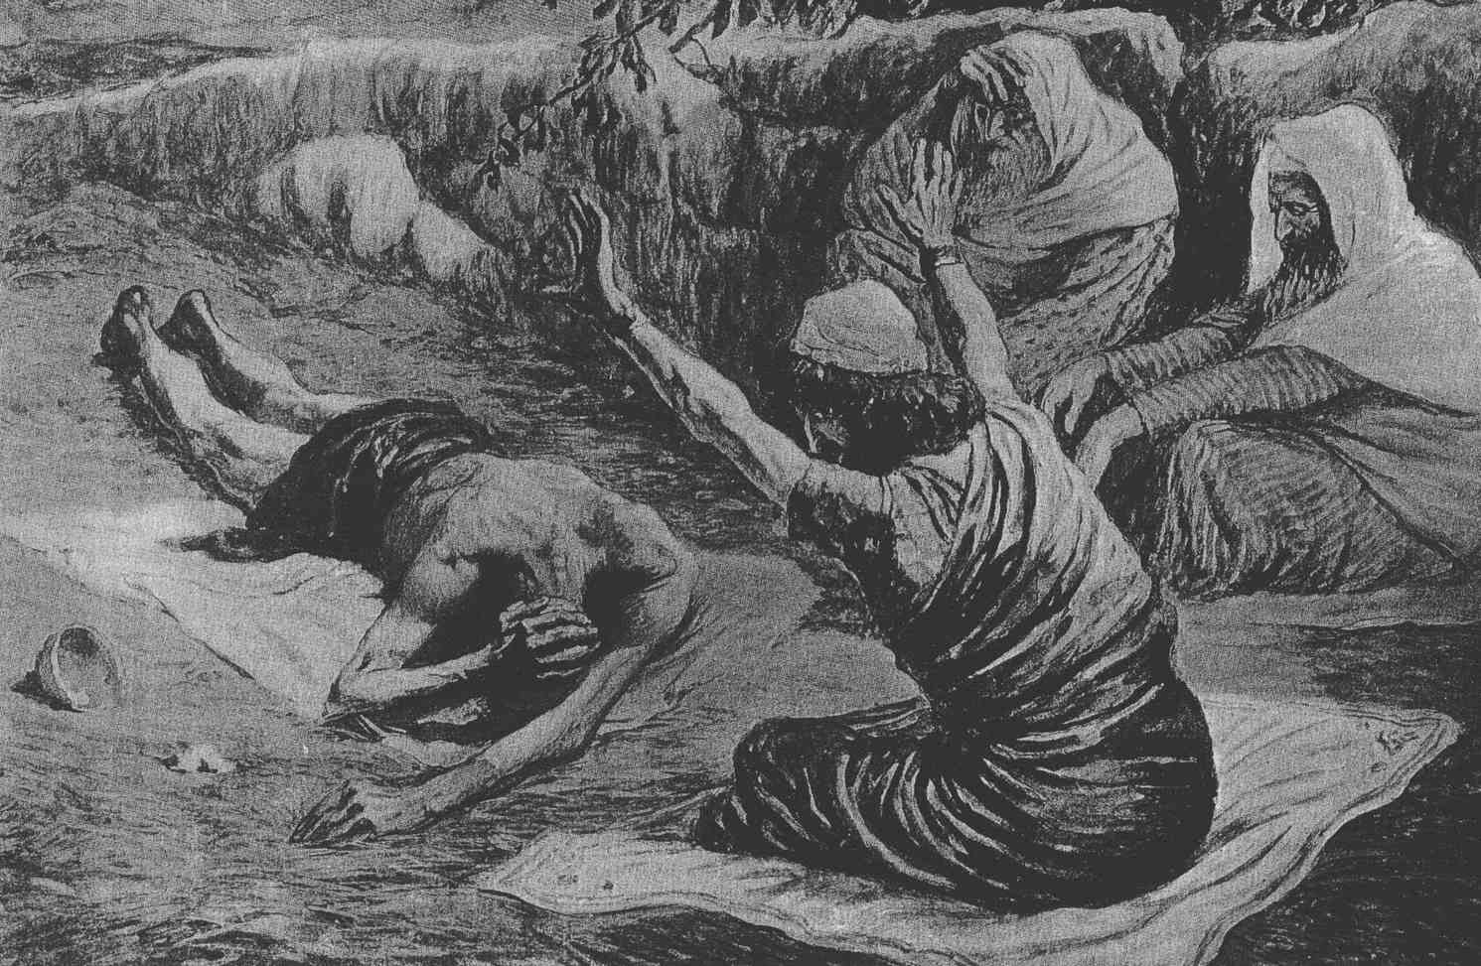
The First Sunday after Christmas Day.
The Collect.
A
LMIGHTY God, who hast given us thy only-begotten Son to take our nature upon him, and as at this time to be born of a pure virgin; Grant that we being regener- ate, and made thy children by adoption and grace, may daily be renewed by thy Holy Spirit; through the same our Lord Jesus Christ, who liveth and reigneth with thee and the same Spirit ever, one God, world without end. Amen.

1 Then answered Zophar the Naamathite, and said, 2 Should not the multitude of words be answered? and should a man full of talk be justified? 3 Should thy lies make men hold their peace? and when thou mockest, shall no man make thee ashamed? 4 For thou hast said, My doctrine is pure, and I am clean in thine eyes. 5 But oh that God would speak, and open his lips against thee; 6 And that he would shew thee the secrets of wisdom, that they are double to that which is! Know therefore that God exacteth of thee less than thine iniquity deserveth. 7 Canst thou by searching find out God? canst thou find out the Almighty unto perfection? 8 It is as high as heaven; what canst thou do? deeper than hell; what canst thou know? 9 The measure thereof is longer than the earth, and broader than the sea. 10 If he cut off, and shut up, or gather together, then who can hinder him? 11 For he knoweth vain men: he seeth wickedness also; will he not then consider it? 12 For vain man would be wise, though man be born like a wild ass's colt. 13 If thou prepare thine heart, and stretch out thine hands toward him; 14 If iniquity be in thine hand, put it far away, and let not wickedness dwell in thy tabernacles. 15 For then shalt thou lift up thy face without spot; yea, thou shalt be stedfast, and shalt not fear: 16 Because thou shalt forget thy misery, and remember it as waters that pass away: 17 And thine age shall be clearer than the noonday; thou shalt shine forth, thou shalt be as the morning. 18 And thou shalt be secure, because there is hope; yea, thou shalt dig about thee, and thou shalt take thy rest in safety. 19 Also thou shalt lie down, and none shall make thee afraid; yea, many shall make suit unto thee. 20 But the eyes of the wicked shall fail, and they shall not escape, and their hope shall be as the giving up of the ghost. (Job 11:1-20)

Enter now the constant example of doubter and human reasoner, Zophar. According to the ancient tradition, Zophar is likely the youngest of the three friends of Job, or the one most junior in position, since he speaks out last. Being perhaps less schooled in learned discourse, Zophar is the harshest of the three in his remarks to Job. The scene is a bit like the growing emotionalism of a mob. The first remarks are not as wild and furious as the latter – so it is with this discourse. Zophar has heard his two colleagues hammer at Job's sensitivities. As he listens, he conjures up even more vile charges against Job in order to impress the others.
There are no `lies' yet entered into evidence – only the weak opinions of men (including Job). Job has not denied God, or disclaimed His Power. Job has only stated unwise opinions about his own plight and the cause for it. Should not the multitude of words be answered? and should a man full of talk be justified? Should thy lies make men hold their peace? and when thou mockest, shall no man make thee ashamed? Zophar claims that he has now heard enough! He will now set Job, the elder, right. Zophar makes the careless and unsubstantiated charge of liar against Job. Are we well blessed with such friends who, at the moment of our greatest need, hurl false charges against us. Satan has charged Job with a lack of strong faith. Now comes Job's friends and side with the greatest enemy of men's souls – the Devil. When a friend expresses confusion in moments of great trial, does God need our efforts to defend His Person? I think not! God knows our frailties, and He knows those of Job under such hard trials. But Job's friends do not.
For thou hast said, My doctrine is pure, and I am clean in thine eyes. Job does, indeed, say this in Job10:7. It is true that Job is no accounted wicked by God as are none of those who lay claim to Christ. Ignorance is brave, and Zophar is the most valiant of them all for ignorance! Zophar actually tries to enlist the judgment of God on his own side of the argument, rather than striving to insure that he (Zophar) is on God's side. But oh that God would speak, and open his lips against thee. It would greatly please Zophar is God would openly rebuke Job (his so-called friend).
And that he would shew thee the secrets of wisdom, that they are double to that which is! Know therefore that God exacteth of thee less than thine iniquity deserveth. God's wisdom is far more than double that which man can comprehend, but Zophar is absolutely correct in his latter statement: God does, indeed, exact less from His children than their obedience deserves. In fact, God's love covers ALL sin. "….. love covereth all sins." (Prov 10:12) When I was in elementary school, I had difficulty understanding this principle, but having come to a more intimate knowledge of the nature of God in Christ, I do understand that God, like an obsessive parent, does not ascribe our frailties of obedience to our conscious intentions. He has given His only Begotten Son to cover those inadequacies of all who believe unto salvation.
Canst thou by searching find out God? canst thou find out the Almighty unto perfection? Though I wish it were not so, this same failing of Zophar in understanding is so very much like the prideful theologian in its latter application. What learned man of Scripture can you ask for an honest interpretation without being bombarded with big, sophisticated-sounding terms? It is quite difficult to find any mysteries between the pages of Holy Scripture that they feel incapable of discovering. They believe that their little pea-sized brains can comprehend the mysteries fully. The first part of Zophar's allegation above is what we here echoed constantly in the public square: "Can you prove God's existence by factual discovery?" To be honest, the existence of God is not a matter of science because God is the Doctor of Science itself. It is interesting that the Bible contains so many scientific facts of which the learned elders of science were oblivious until recent decades and centuries. (the Science of Metereology, for instance).
In the next verses, Zophar utters profound proof to prove a false premise: It is as high as heaven; what canst thou do? deeper than hell; what canst thou know? The measure thereof is longer than the earth, and broader than the sea. This is immutable Truth. It reminds me that every characteristic of God is just as measureless as Zophar describes. Remember the beautiful old hymn found scribbled on the walls of an insane infirmary? I do not believe there is a more complete human expression for the depth, height, or width of God's love than those recorded in this hymn:

The Love of God
by Fredrick Lehman

The love of God is greater far
Than tongue or pen can ever tell.
It goes beyond the highest star
And reaches to the lowest hell.
The guilty pair, bowed down with care,
God gave His Son to win;
His erring child He reconciled
And pardoned from his sin.

O love of God, how rich and pure!
How measureless and strong!
It shall forevermore endure
The saints' and angels' song.

When hoary time shall pass away,
And earthly thrones and kingdoms fall;
When men who here refuse to pray,
On rocks and hills and mountains call;
God's love, so sure, shall still endure,
All measureless and strong;
Redeeming grace to Adam's race—
The saints' and angels' song.

Could we with ink the ocean fill,
And were the skies of parchment made;
Were every stalk on earth a quill,
And every man a scribe by trade;
To write the love of God above
Would drain the ocean dry;
Nor could the scroll contain the whole,
Though stretched from sky to sky.

If he cut off, and shut up, or gather together, then who can hinder him? For he knoweth vain men: he seeth wickedness also; will he not then consider it? Zophar has an accurate, if judgmental, view of God here. But it is the very fact that "He knoweth vain men" that gives us a means of salvation in Christ. We are weak as water, and coherent as dust; yet, God loves us enough to die for us. Please correct me if I misapply Zophar's next words to Zophar himself: For vain man would be wise, though man be born like a wild ass's colt. Zophar is the one that appears vain to me in this comment – very much like the wild ass's colt to which he refers.
If thou prepare thine heart, and stretch out thine hands toward him; If iniquity be in thine hand, put it far away, and let not wickedness dwell in thy tabernacles. For then shalt thou lift up thy face without spot; yea, thou shalt be stedfast, and shalt not fear: Because thou shalt forget thy misery, and remember it as waters that pass away: Zophar has just run out of sound theology! No man can prepare his own heart towards Christ! How often have we heard a sinner, under conviction, say, "I cannot profess Christ now. I am not ready yet. I must get my life straight first?" Well, if we could attain righteousness first, we would not have needed Christ to die for us. We are incapable of "preparing our hearts." Let us leave that task to Christ whom we invite into our hearts as Sovereign, Lord, and Savior. If we were able alone to become righteous, we would not need Christ to clean out the cobwebs and sink holes in our hearts. Let us allow God to put our iniquity away for we cannot! As far as the east is from the west, so far hath he removed our transgressions from us. (Psalms 103:12)
There is little doubt that Zophar, and his companions, actually believe their counsel will benefit Job; but the counsel of man withers away before the consuming fire of God's Word. And thine age shall be clearer than the noonday; thou shalt shine forth, thou shalt be as the morning. And thou shalt be secure, because there is hope; yea, thou shalt dig about thee, and thou shalt take thy rest in safety. Also thou shalt lie down, and none shall make thee afraid; yea, many shall make suit unto thee. This is a very true statement, but one which is apparently totally misunderstood by its speaker. It is true that Job, in time to come, shall be brighter than the noonday sun. His future eternity will be as the morning dawn as it is with all who are born of God. Job shall, as well, be as secure in the Ark of Christ as Noah and his family in the Ark of the Deluge.
But the eyes of the wicked shall fail, and they shall not escape, and their hope shall be as the giving up of the ghost. Another profound truth uttered by Zophar with only half-knowledge. It is very true that the eyes of the wicked shall fail for there is no need of vision in the dark halls of Hell. Their only hope, and it is a false one, is that of death. Even death shall not grant a reprieve to the wicked. The moment of death to them only introduces a nightmare of eternity in the fires of Hell. Best to seek life in Christ rather than death in Hell with Satan and his fallen demons.

