Devotion on The Book of Job – Chapter Five - 7 December 2012, Anno Domini
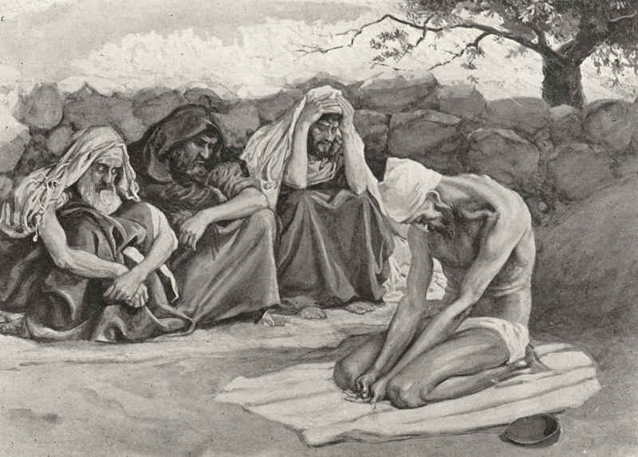
The First Sunday in Advent
The Collect.

A
LMIGHTY God, give us grace that we may cast away the works of darkness, and put upon us the armour of light, now in the time of this mortal life, in which thy Son Jesus Christ came to visit us in great humility; that in the last day, when he shall come again in his glorious majesty to judge both the quick and the dead, we may rise to the life immortal, through him who liveth and reigneth with thee and the Holy Ghost, now and ever. Amen.

¶ This Collect is to be repeated every day, after the other Collects in Advent, until Christmas Day.

Please read and meditate on the Fifth Chapter of the Book of Job along with your study of this devotion.
Job 5
King James Version (KJV)
5 Call now, if there be any that will answer thee; and to which of the saints wilt thou turn?
2 For wrath killeth the foolish man, and envy slayeth the silly one.
3 I have seen the foolish taking root: but suddenly I cursed his habitation.
4 His children are far from safety, and they are crushed in the gate, neither is there any to deliver them.
5 Whose harvest the hungry eateth up, and taketh it even out of the thorns, and the robber swalloweth up their substance.
6 Although affliction cometh not forth of the dust, neither doth trouble spring out of the ground;
7 Yet man is born unto trouble, as the sparks fly upward.
8 I would seek unto God, and unto God would I commit my cause:
9 Which doeth great things and unsearchable; marvellous things without number:
10 Who giveth rain upon the earth, and sendeth waters upon the fields:
11 To set up on high those that be low; that those which mourn may be exalted to safety.
12 He disappointeth the devices of the crafty, so that their hands cannot perform their enterprise.
13 He taketh the wise in their own craftiness: and the counsel of the froward is carried headlong.
14 They meet with darkness in the day time, and grope in the noonday as in the night.
15 But he saveth the poor from the sword, from their mouth, and from the hand of the mighty.
16 So the poor hath hope, and iniquity stoppeth her mouth.
17 Behold, happy is the man whom God correcteth: therefore despise not thou the chastening of the Almighty:
18 For he maketh sore, and bindeth up: he woundeth, and his hands make whole.
19 He shall deliver thee in six troubles: yea, in seven there shall no evil touch thee.
20 In famine he shall redeem thee from death: and in war from the power of the sword.
21 Thou shalt be hid from the scourge of the tongue: neither shalt thou be afraid of destruction when it cometh.
22 At destruction and famine thou shalt laugh: neither shalt thou be afraid of the beasts of the earth.
23 For thou shalt be in league with the stones of the field: and the beasts of the field shall be at peace with thee.
24 And thou shalt know that thy tabernacle shall be in peace; and thou shalt visit thy habitation, and shalt not sin.
25 Thou shalt know also that thy seed shall be great, and thine offspring as the grass of the earth.
26 Thou shalt come to thy grave in a full age, like as a shock of corn cometh in in his season.
27 Lo this, we have searched it, so it is; hear it, and know thou it for thy good.

This chapter (5) opens with Eliphaz essentially calling Job a fool. 1 Call now, if there be any that will answer thee; and to which of the saints wilt thou turn? No wise man will answer the ranting of a fool, and certainly will no saint of God deal with a fool. This sets Job apart in the mind of Eliphaz from the wise and the saintly. Obviously, to Eliphaze, Job has sinned and brought all of this evil upon himself. As I stated yesterday, the vision of Eliphaz does not seem to have come from God because it has no claim to be from God, and it also concludes that Job is not blameless. Moreover, the Lord Himself renounces the counsel of Eliphaz, Bildad and Zophar in the last chapter of this Book: And it was so, that after the LORD had spoken these words unto Job, the LORD said to Eliphaz the Temanite, My wrath is kindled against thee, and against thy two friends: for ye have not spoken of me the thing that is right, as my servant Job hath. (Job 42:7)
So easy is it to see the blemishes on the face of another for the carnal mind, but our eyes are fleshly and not made for looking inwardly. The eyes must be opened in a spiritual way to clearly perceive, from outside our own selves, those horrible marks and disgusting boils on our own hearts. Eliphaz so very clearly believes that he is above the plight of Job in his own self-righteousness. The accusations and insinuations he levels against Job come as readily to his mind as the bulging waters of the sea at high tide. Eliphaz, like so many judgmental pretenders to the faith, is quite gifted at the improper application of truth to the plight of others. ¡°If you are not rich and happy (Osteen), you are definitely out of the will of God,¡± claim the proponents of the wealth-and-health gospel. These ¡®miracles’ of stupidity and ignorance simply cannot behold the filthy rags and repugnant odors of their own persons. Being built up in pride and silken robes, they fail to see their own utter nakedness before God. But to the world, all unrighteousness is forever OUTWARD and never INWARD! Eliphaz even goes so far as to blame the demise of Job’s children on Job’s foolishness. Again, this is a subtle implication that God has disarmed Job while, truly, God is on the side of Job in all of his misery. Happy is the man that hath his quiver full of them: they shall not be ashamed, but they shall speak with the enemies in the gate. (Psalms 127:5) In actual fact, Job’s children are not judged (crushed) in the gate for crime, but died of natural calamity induced by Satan. So the judgment of Eliphaz is directly contrary to the Will of God.
Eliphaz further implies that Job has not sought the solace of God in his affliction which, according to Eliphaz, may have arisen from foolishness and craftiness. His words are wise, but applied improperly like a good medicine for headache applied to heal a rash. Here is a sterling example of the misdiagnosis of Eliphaz of Job’s circumstances: 17 Behold, happy is the man whom God correcteth: therefore despise not thou the chastening of the Almighty. Job is not suffering as a result of God’s correction â€" he is not being chastened by the Lord. The rational and non-spiritual mind tries to justify hardship and pain by blaming them on some logical cause such as sin or misconduct. But pain and suffering come upon the righteous as well as the unrighteous. We can see the point clearly because we have the explanation of the cause (Satan) in the first two chapters of Job, but Eliphaz does not have the benefit of that knowledge, so he uses human logic. Do we not do the same in judging others before we know the facts? Though we are commanded of Christ to judge, we are counseled to use an equal balance informed of righteousness: Judge not according to the appearance, but judge righteous judgment. (John 7:24) How do we know what is righteous judgment? It is when we do not use our own judgment, but that of God, in judging a matter. I can of mine own self do nothing: as I hear, I judge: and my judgment is just; because I seek not mine own will, but the will of the Father which hath sent me. (John 5:30) If we judge, seeking those merits of Christ which He heard of His Father, it is God that judges the matter and not we ourselves.
Though the judgment of Eliphaz is wrong, his words are full of the wisdom of the Lord. As we can see, Eliphaz takes the ¡°appearance¡± of Job’s condition to prove unrighteousness and foolishness. So he takes the true teachings of God, but judges by appearance and not with righteous judgment. Whether we admit it or not, we do the same to the hurt of our own souls almost daily. Even in our worship, we attempt to present ourselves as pious and possessed of strong faith. We dress to make a show of our piety. We adopt rituals and practices in worship which are not prescribed by God’s Word (Roman Catholicism). We worship the creature (dogs and other animals) more than the Creator. We prefer to bless the animals before we petition to bless the children. But if we simply follow the Godly principles and doctrines of the Reformed Church, we shall be on good ground biblically, and men such as Eliphaz cannot turn God’s Word against us. Do we keep holy in the things commanded of God, or do we seek to find holiness outside His True Word?

