Devotion of book of Job (Part 3) - 1 December 2012, Anno Domini
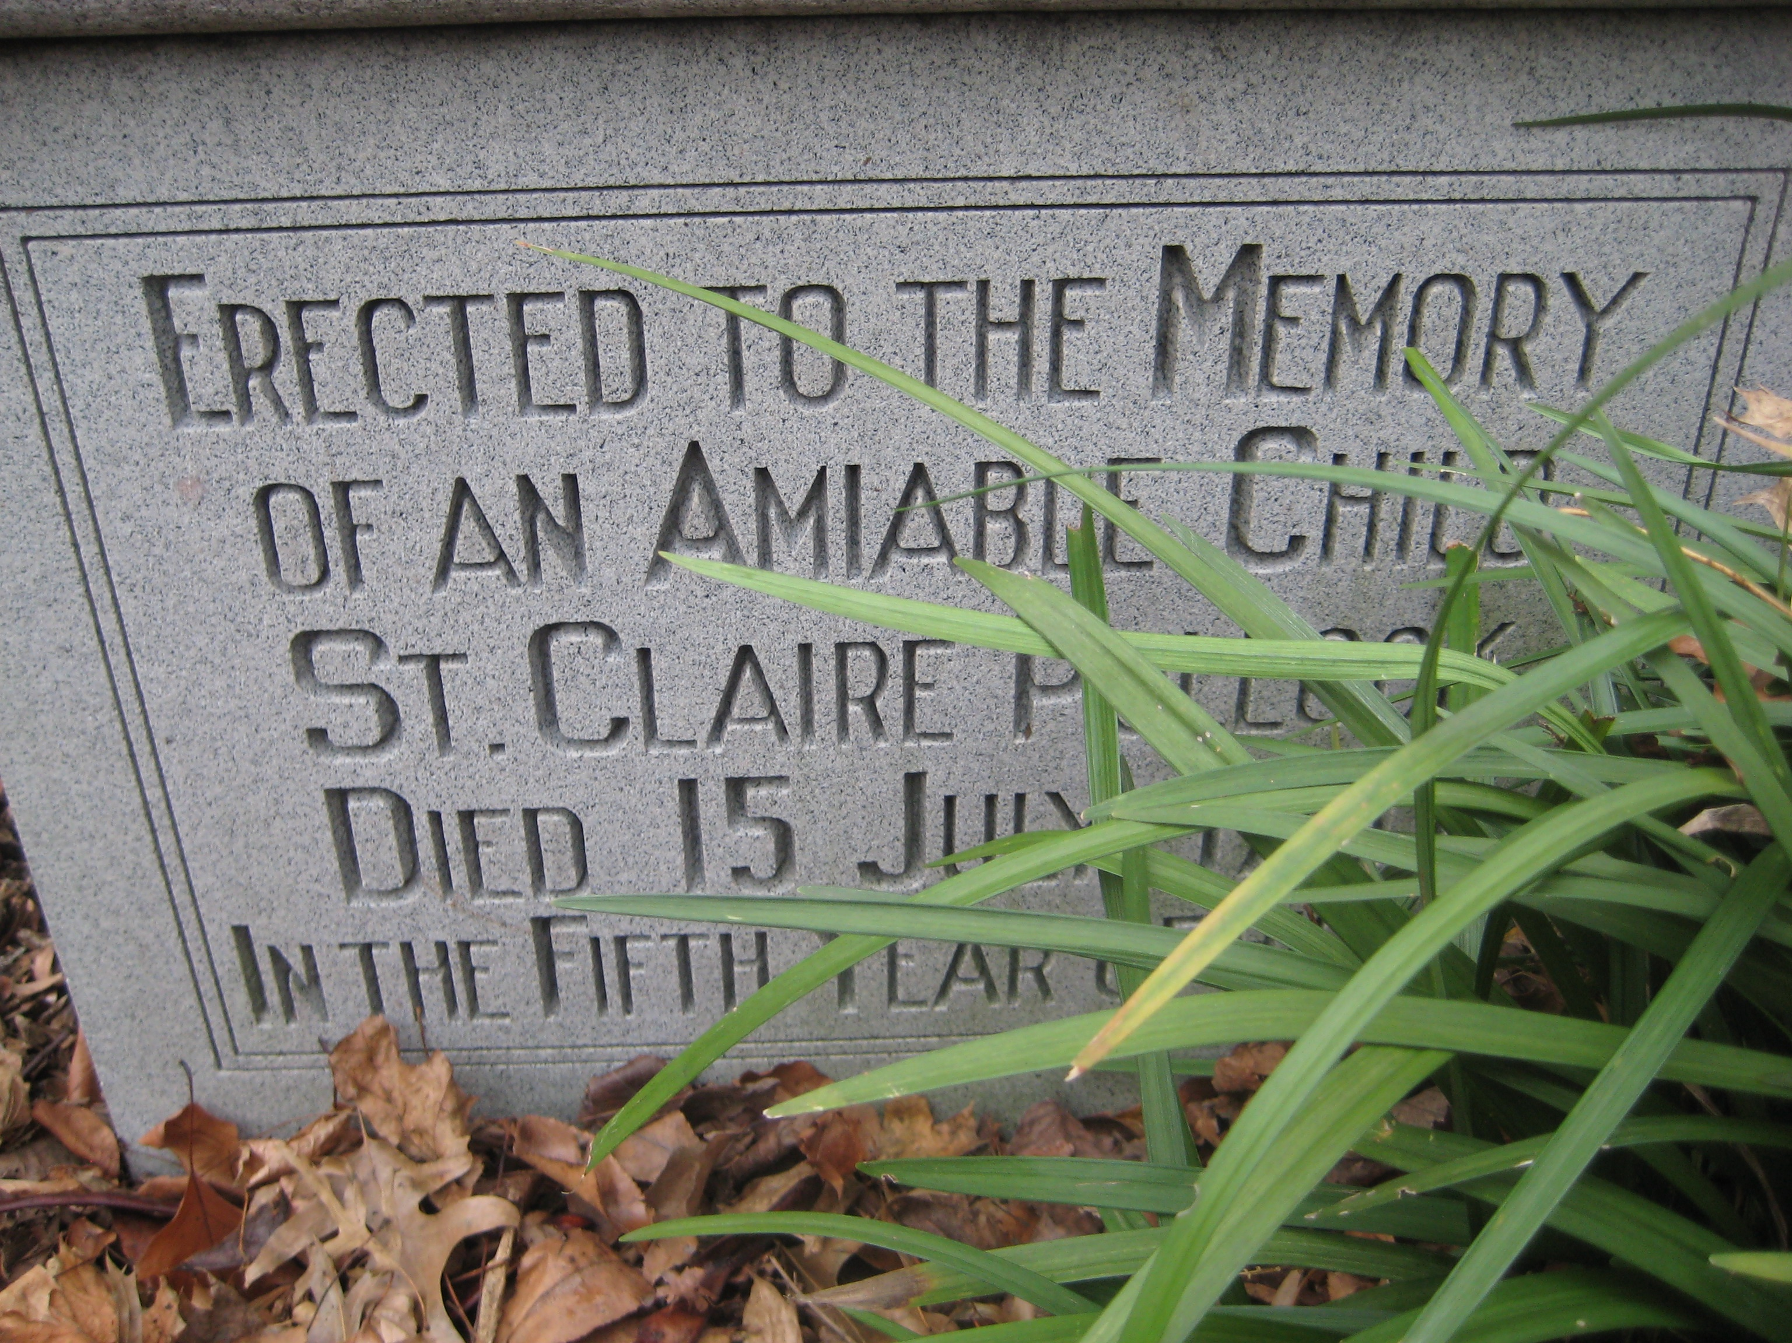
The Sunday next before Advent
The Collect.
S

TIR up, we beseech thee, O Lord, the wills of thy faithful people; that they, plenteously bringing forth the fruit of good works, may by thee be plenteously rewarded; through Jesus Christ our Lord. Amen.

14.And when they lifted up their eyes afar off, and knew him not, they lifted up their voice, and wept; and they rent every one his mantle, and sprinkled dust upon their heads toward heaven. 13. So they sat down with him upon the ground seven days and seven nights, and none spake a word unto him: for they saw that his grief was very great. (Job 2:12-13)
As mentioned in the study of the Second Chapter of Job, his three friends, Eliphaz, Bildad, and Zophar, came to visit Job when they heard of his suffering. They came with the best of intentions, yet failed to comfort him. In the final analysis, only the Holy Ghost can comfort those whose miseries arise from strong faith tested. They wept in grief of their friend’s hurt. Satan, like all times, is responsible for tears. The first tears were shed by the fallen couple in Eden. They still rain down all over the world because of the evil antics of Satan in his cunning deceptions. Only Christ can take our tears upon Himself and keep them in His Bottle. These friends rent their mantle, another sign of deep grieving. The sign is never the ultimate proof, for the hypocritical Pharisees did likewise in making the false claim against Christ of blasphemy. (Matt 26:65) The ultimate grief was that of God at the death of His Son, Jesus, on the cross that dark and dreadful day at Calvary. The Temple Veil was rent at His grief, but to our great satisfaction. No longer would there be a Veil of Separation between the Father and His people. God initiated the rent, for it was from top to bottom. Job’s three friends also threw dust in the air to express their grief. They sat with Job without speaking for seven days (the period of completeness). We are told that Joseph mourned for his father likewise: he made a mourning for his father seven days. (Gen 50:10) Job was so disfigured by his disease that he was unrecognizable as one near death. That is the result of Satan’s doing to every child that is born. The only remedy is Christ! It was also customary to allow the afflicted to speak first, so the friends sat silent with Job for seven days. The only remedy for such grief, caused by Satan, is Christ!
The concluding words of Job in verse 2:11 is prophetic in its anticipation, for Job would soon cross over the line of keeping his speech free of doubting his Maker’s purposes. Job was most likely moved by the presence of his friends, and wanted to openly express his dismay to gain their full sympathy. Job breaks hi sin in chapter 3 with an unseemly outburst of doubt which is shocking in view of his previous strength of faith. 3. Let the day perish wherein I was born, and the night in which it was said, There is a man child conceived. (Job 3:3) Though Job does not directly challenge God’s Providence, his words are full of implied doubt. Job rejects the gift of his life as a blessing, but rather labels it a curse. Life is a gift of God and never a curse. From Job’s perspective, everything is lost;his wealth, his livestock, his servants, his children, his home, and even his wife denies him. Job is looking upon the present circumstances only. He is not unlike many good Christians who view the wickedness of the world and are tempted to believe there can be no remedy. We cannot see what beauty lies just over the horizon. Neither could Job see what wonderful blessings God had in store for him. As we have said before, man judges by the present instant; but God judges by the whole scope of time. Job literally describes Hell as the kind of night for which he was born: 6 As for that night, let darkness seize upon it; let it not be joined unto the days of the year, let it not come into the number of the months. 7 Lo, let that night be solitary, let no joyful voice come therein. Job asks that the hired mourners deliver his own curse: 8. Let them curse it that curse the day, who are ready to raise up their mourning. Job selfishly hopes for the stars of twilight to give no light. If they do not, look at the beauty and wonder that is lost, not just to Job, but to all the world. (vv 10 & 11)
In verses 11 thru 19, Job bewails his birth. In so doing, he is perhaps unintentionally cursing his very parents. He yearns for the long dark night in which there is no consciousness, either of trouble or of blessing, either of good or of evil, either of God or of the devil. Such is death and such is that outer darkness into which Judas slunk away that fateful night. Job is unfortunately comparing the reward of the righteous to that of the wicked. An eternal night would eternally blot out Job’s view of God. This is not at all commendatory of Job’s blamelessness before God. Point to Ponder: Fault not Job for this human failure for, until we have suffered as did Job, how can we deny that our response would be the same? Job makes one mighty error of judgment in saying the servant is free of his master for the master of Hell is spiritually the devil himself.
Job questions (vv 20-22) why he is given light, being in pain. He rebels against the Light itself which is God for all Light comes from the Father of Lights (James 1:17). The devil is the author of darkness, but darkness cannot abide a single candle. 23 Why is light given to a man whose way is hid, and whom God hath hedged in? 24 For my sighing cometh before I eat, and my roarings are poured out like the waters. 25 For the thing which I greatly feared is come upon me, and that which I was afraid of is come unto me. 26 I was not in safety, neither had I rest, neither was I quiet; yet trouble came. A rather irrational question. Light is given to a man lost in the wilderness of pain and suffering so that he might find his way out. How many lives have been brought into the bright Sun of God by the presence of an exceptional moment, a Gideon bible on the night stand, an importunate stranger, or the witness of a little child? Job here seems to deny even the blessings of God of which he was heir BEFORE his illness. Suddenly, Job can see virtue in nothing! His mental faculties are grown stronger to recognize truths that are not truths, informed of a failing faith.
Allow me the license to anticipate the words of Job in the 14th chapter: 1 Man that is born of a woman is of few days, and full of trouble. 2 He cometh forth like a flower, and is cut down: he fleeth also as a shadow, and continueth not. (Job 14:1-2) These words of Job convey such a mournful spirit that they are incorporated in the Prayer Book Funeral Order. All of these dreadful thoughts are conjured up by the painful loss and sickness of Job and, ultimately, by Satan himself. While in a worldly way, these words bear certain truth, to the Christian, they are meaningless for physical death is only the beginning of life. Hard times and experiences can throw each of us a bit off balance. We, too, would question our core values and beliefs in times of unbearable adversity. But, like Job, we shall examine the treasures of our hearts even when the treasure box itself is in ruins, and find that God is still the Master and Keeper thereof despite the weary soul. There is little doubt that, when this ordeal is over, Job shall emerge stronger and fuller of faith than ever before the devil’s meddling.

