Devotion on the Book of Job (Intro) - 28 November 2012, Anno Domini
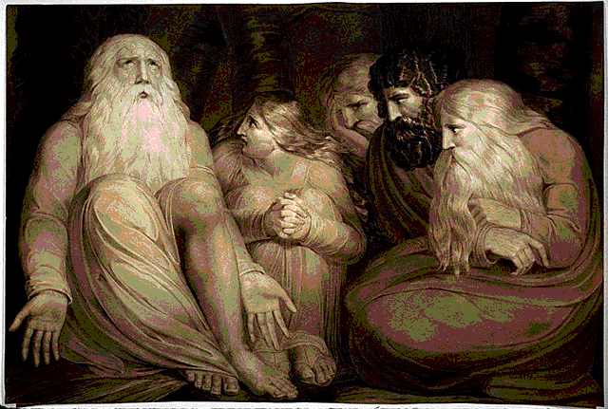
The Sunday next before Advent
The Collect.
S

TIR up, we beseech thee, O Lord, the wills of thy faithful people; that they, plenteously bringing forth the fruit of good works, may by thee be plenteously rewarded; through Jesus Christ our Lord. Amen.

1 There was a man in the land of Uz, whose name was Job; and that man was perfect and upright, and one that feared God, and eschewed evil. 2 And there were born unto him seven sons and three daughters. 3 His substance also was seven thousand sheep, and three thousand camels, and five hundred yoke of oxen, and five hundred she asses, and a very great household; so that this man was the greatest of all the men of the east. (Job 1:1-3)
Some have erroneously considered the Book of Job to be an Old Testament parable, but this would be in error for it is a real account of a real man of righteousness with details too explicit to be considered otherwise. The classical and traditional dating of the period described in Job is around 1500 B.C. Fragments discovered in the Dead Sea Scrolls confirms the ancient authenticity of Job. Job is filled with lessons that should strengthen our faith and perseverance as we often experience unwarranted challenges of hurt and pain in our walk with the Lord. The language is poetic and psalm-like. The narrative is not written by Job himself, but by a fellow Israelite believer whose descriptive language pays due honor and reverence to the issues at hand.
How often do we hear the refrain, "Poor old Job," but Job was blessed at the beginning of the story, as well as even more greatly at the end? But the blessings granted Job in the interim of the narrative goes unnoticed by the casual reader and is, instead, labeled as a curse. Nothing could be further from the truth. Every true Christian has undergone unfair and hurtful experiences at the hands of the world. It is not until such a Christian has, as Job, persevered that he comes to a fuller understanding of the cause of pain and suffering for believers everywhere, and of the hidden blessing that the experience grants finally. This is the overarching message of Job – not that he was blessed by God in family, wealth, and health at the beginning, lost it all to the devil, and then regained more of those riches; but the stronger message is in between the outward blessings. Job give s us an insight into the workings and plan of God in the life of a believer. Quite often that which appears to be a great calamity in a Christian's life is proven to be a God-sent blessing of strengthening faith and blessing after the clouds roll by.
There is an age-old question that is usually intended to chide those of faith, "Why do bad things happen to good people?" The Book of Job gives us a sterling response to that faithless inquiry! Solomon spoke truly when he exclaimed: "To every thing there is a season, and a time to every purpose under the heaven." (Eccl 3:1) The Christian experiences all of the trials and tribulations the world has to offer just as the unbeliever does, and sometimes in greater portions; however, we are not exempted from hard times or challenges as Christians. The power of God is revealed in the manner in which we confront and address these unfortunate experiences. No infantry inductee loves to crawl in the mud under barbed wire with a fifty-cal machine gun firing a few inches over his head; but he must do so in order to be conditioned for survival in close combat with the enemy that desires his death. The hard experiences are a trial and practice for the Christian as, not only a testimony to the world, but a process whereby we are made stronger in facing the world of evil.
The Christian confronts every trepidation life has to offer. Please remember that, if you have suffered, you have yet to suffer as Job and, more importantly, as your Lord Jesus Christ. Christ was the only One who was truly righteous and pure – without sin; yet He suffered the most violent of wrongs on our behalf. Please consider the great good to us-ward that ensued from the sufferings of Christ. Can it not be so in the life of the dedicated Christian as well? The disciple is not above his master, nor the servant above his lord. It is enough for the disciple that he be as his master, and the servant as his lord. If they have called the master of the house Beelzebub, how much more shall they call them of his household? (Matt 10:24-25) Our confession of faith in Christ is no exemption from trials and tribulations, but an invitation to them. A cross is not a beautiful instrument of service, but we must take up our crosses daily and follow Christ. Though the cross is crude and ugly, the results of its carriage are beautiful and blessed.
We learn in Job that righteous works do not entitle us to be free of suffering. We learn that our friends can play the devil's part just as well as the devil himself in giving false and unwholesome counsel. We learn that, regardless the trial and pain, we must keep the Light of our Faith burning warm and bright in the window of our heart. Though the night is dark and foreboding, the light in the window assures a lighted way in any case. The fire is not extinguished until the last cinder grows cold. It may be at the very last spark that God lights such a candle, as said Bishop Latimer to his fellow martyr at the stake: "Be of good cheer, master Ridley, and play the man; we shall this day light such a candle in England, as I hope, by God's grace, shall never be put out." Even at the stake of fire, we may glorify and praise God for His tender mercies – unless we consider only earthly comfort as the ultimate mercy.
The story of Job is actually an opportunity for us to observe an ongoing battle between God and Satan. It has waged since before the sin of Adam and Eve in the Garden eastward in Eden. It has raged on every continent and in every minute of man's existence. It rages now as I write. It often seems that the devil gains the high ground, but is there ground higher, or more exalted, than the Heaven upon which the Lord of Glory stands? I will offer one more quote of the good and valiant Bishop of Worcester:
"And now I would ask a strange question: who is the most diligentest bishop and prelate in all England that passeth all the rest in doing his office? I can tell for I know him who it is; I know him well. But now I think I see you listening and hearkening that I should name him. There is one that passeth all the other, and is the most diligent prelate and preacher in all England. And will ye know who it is? I will tell you: it is the devil. He is the most diligent preacher of all other; he is never out of his diocese; he is never from his cure; ye shall never find him unoccupied; he is ever in his parish; he keepeth residence at all times; ye shall never find him out of the way, call for him when you will he is ever at home; the diligentest preacher in all the realm; he is ever at his plough; no lording nor loitering can hinder him; he is ever applying his business, ye shall never find him idle, I warrant you. And his office is to hinder religion, to maintain superstition, to set up idolatry, to teach all kind of popery. He is ready as he can be wished for to set forth his plough; to devise as many ways as can be to deface and obscure God's glory...O that our prelates would be as diligent to sow the corn of good doctrine as Satan is to sow cockle and darnel." Hugh Latimer
I hope and pray that in our devotional study of Job, we each will learn to face adversity and suffering with our faces to the front, our sails full of the wind of the Holy Ghost, and our consciences free from the burden of compromise.

