Devotion on Hymns of the Church – Hymn 92 – Alleluia, Alleluia – 26 March 2018, Anno Domini

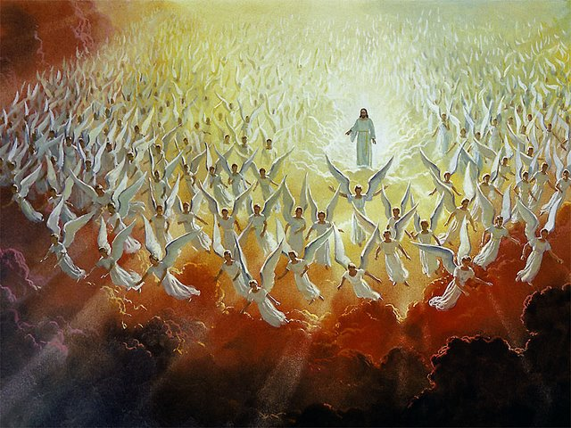

A
nd after these things I heard a great voice of much people in heaven, saying, Alleluia; Salvation, and glory, and honour, and power, unto the Lord our God: 2 For true and righteous are his judgments: for he hath judged the great whore, which did corrupt the earth with her fornication, and hath avenged the blood of his servants at her hand. 3 And again they said, Alleluia. And her smoke rose up for ever and ever. 4 And the four and twenty elders and the four beasts fell down and worshipped God that sat on the throne, saying, Amen; Alleluia. (Rev 19:1-4)

I believe the title of this song is most intended for angelic exclamation as it appears only in the New Testament, and there in the last Book – Revelations – and then near the end of that Book beginning at chapter 19. The word may also appear as Hallelujah. The word translated from the Greek means ‘praise ye Jah (God)’.

The tune for this hymn in the 1940 Hymnal is LUX EOI by Arthur S. Sullivan (1874). An excellent alternate tune is Beethoven’s ODE TO JOY – yes, of course, my favorite! The lyrics are the presumed composition of Christopher Wordsworth. (1872)

Alleluia, Alleluia!

Alleluia, alleluia!
Hearts to heav'n and voices raise:
sing to God a hymn of gladness,
sing to God a hymn of praise.
He, who on the cross a victim
for the world's salvation bled,
Jesus Christ, the King of glory,
now is risen from the dead.

Now the iron bars are broken,
Christ from death to life is born,
glorious life, and life immortal,
on the holy Easter morn.
Christ has triumphed, and we conquer
by His mighty enterprise;
we with Him to life eternal
by His resurrection rise.

Christ is risen, Christ, the first-fruits
of the holy harvest field,
which will all its full abundance
at His second coming yield.
Then the golden ears of harvest
will their heads before Him wave,
ripened by His glorious sunshine
from the furrows of the grave.

Christ is risen, we are risen!
Shed upon us heav'nly grace,
rain, and dew and gleams of glory
from the brightness of Thy face,
that we, with our hearts in heaven,
here on earth may fruitful be,
and by angel hands be gathered,
and be ever, Lord, with Thee.

Alleluia, alleluia!
Glory be to God on high!
Alleluia! to the Savior
who has gained the victory!
Alleluia! to the Spirit,
fount of love and sanctity!
Alleluia, alleluia
to the Triune Majesty.

1 Alleluia, alleluia! Hearts to heav'n and voices raise: sing to God a hymn of gladness, sing to God a hymn of praise. He, who on the cross a victim for the world's salvation bled, Jesus Christ, the King of glory, now is risen from the dead. Before the soul is granted entry to the gates of Heaven, the heart must already be sequestered there from the trappings of the world. When the heart is settled in Heaven, then the music of the angels can be heard in all its grandeur. We awaken with ‘songs in the night’ and prayers of praise upon our lips. Christ was not truly a victim on the cross – He cannot fit the description of a victim. He is rather a Victor! But He died to preclude our own victimhood to the Serpent of the Ancient Garden at Eden. Christ did not only die in our stead for our redemption on the cross, but rose from the borrowed tomb in order to open the gates of life for us.

2 Now the iron bars are broken, Christ from death to life is born, glorious life, and life immortal, on the holy Easter morn. Christ has triumphed, and we conquer by His mighty enterprise; we with Him to life eternal by His resurrection rise. What a long and triumphal column of believers follow in His trail from the tombs of the world from desert dune, mountain fastness, and the eternal ocean depths! In step with His victory anthem these march lockstep with His triumphal trumpeters straight to the Gate called Beautiful.

3 Christ is risen, Christ, the first-fruits of the holy harvest field, which will all its full abundance at His second coming yield. Then the golden ears of harvest will their heads before Him wave, ripened by His glorious sunshine from the furrows of the grave. The darkness of death brings sorrow and dread to the heart that is not secure in the Heart and Love of our Lord. Just as Peter wept bitterly from the moment he denied our Lord the third time, and at the very moment that the Lord turned and looked Peter directly in the eye (Matt 26:75, Luke 22:61-62), until the courageous women shared the news of His rising as commanded by the Angel at the Tomb. (Mark 16:7), we likewise suffer in doubt in hard times. Note that the Angel only mentioned the name of Peter of all the disciples. The Lord was gracious in His knowledge of the hurt that Peter was feeling since his denial and thereby eased his pain.

4 Christ is risen, we are risen! Shed upon us heav'nly grace, rain, and dew and gleams of glory from the brightness of Thy face, that we, with our hearts in heaven, here on earth may fruitful be, and by angel hands be gathered, and be ever, Lord, with Thee. The opening line is the most glorious of all, for it is only in Christ that we arise from our humble tombs of borrowed dust. He led the way as He always does in the lives of His people. The heart of the Christian does not belong in this world, but is on loan from Heaven. Just as the face of Moses shown with brightness at the sight of God, so will our faces alight with crimson fire when we come face to face with our Lord in Heaven. The Gospel is of the nature of that dragnet mentioned in Matthew 13:47: 47 Again, the kingdom of heaven is like unto a net, that was cast into the sea, and gathered of every kind: 48 Which, when it was full, they drew to shore, and sat down, and gathered the good into vessels, but cast the bad away. 49 So shall it be at the end of the world: the angels shall come forth, and sever the wicked from among the just, 50 And shall cast them into the furnace of fire: there shall be wailing and gnashing of teeth. (Matt 13:46-50) The Church itself is portrayed here as a dragnet which catches all manner of fish that comes into its borders – both good and bad. In the church there seems to be at least as many marginal Christians as genuine believers. In fact, I believe the unbelievers outnumber the believers by far. It will be the role of the Holy Angels to distinguish the difference at the end time.

5 Alleluia, alleluia! Glory be to God on high! Alleluia! to the Savior who has gained the victory! Alleluia! to the Spirit, fount of love and sanctity! Alleluia, alleluia to the Triune Majesty. We must beware that we do not forsake that Fountain of love and sanctity: O Lord, the hope of Israel, all that forsake thee shall be ashamed, andthey that depart from me shall be written in the earth, because they have forsaken the Lord, the fountain of living waters. (Jer 17:13) He is the Fountain of Living Waters which imparts life to all within its swelling flow.

