Devotion on Hymns of the Church – Hymn 70 - Go to Dark Gethsemane - 23 February 2016, Anno Domini

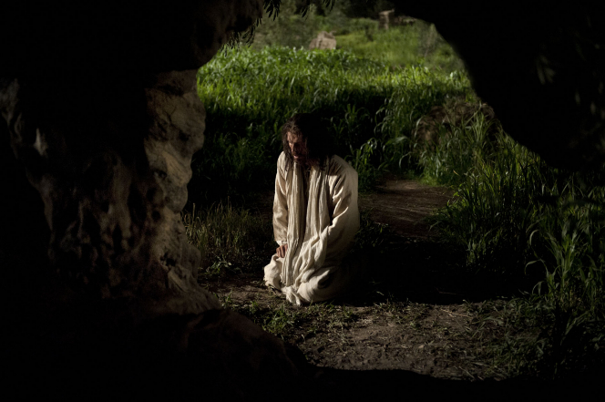

36 Then cometh Jesus with them unto a place called Gethsemane, and saith unto the disciples, Sit ye here, while I go and pray yonder. 37 And he took with him Peter and the two sons of Zebedee, and began to be sorrowful and very heavy. 38 Then saith he unto them, My soul is exceeding sorrowful, even unto death: tarry ye here, and watch with me. (Matt 26:36-38)

It strikes me as exceedingly contemptuous and brazen of these three choice disciples who could not watch with our Lord even a single hour after all of the mercies and love He had shown them heretofore. But are we not all of this party of fools? See what He has done for us - the same for which He did for Peter, James, and John by dying a death of horror and humiliation - and, yet, we dishonor Him in such petty ways when it would cost little to glorify Him in our lives!

The words to our hymn today were written by James Montgomery in 1820. There are two popular tunes for the hymn - REDHEAD (by Richard Redhead) and GETHSEMANE (by William H. Monk (1853). I regard the latter as the one most complementing the meaning and sense of the hymn. The tune, Gethsemane, is much like the dirge which is warranted for Christ in His Passion and Sacrifice.

Go to Dark Gethsemane

Go to dark Gethsemane, ye that feel the tempter’s power;
Your Redeemer’s conflict see, watch with Him one bitter hour,
Turn not from His grief's away; learn of Jesus Christ to pray.

See Him at the judgment hall, beaten, bound, reviled, arraigned;
O the wormwood and the gall! O the pangs His soul sustained!
Shun not suffering, shame, or loss; learn of Christ to bear the cross.

Calvary’s mournful mountain climb; there, adoring at His feet,
Mark that miracle of time, God’s own sacrifice complete.
It is finished! hear Him cry; learn of Jesus Christ to die.

Early hasten to the tomb where they laid His breathless clay;
All is solitude and gloom. Who has taken Him away?
Christ is risen! He meets our eyes; Savior, teach us so to rise.

Go to dark Gethsemane, ye that feel the tempter’s power; Your Redeemer’s conflict see, watch with Him one bitter hour, Turn not from His grief's away; learn of Jesus Christ to pray. Each soul, coming in the filthy rags which adorn every sinner born of woman, must come to a point of remorseful contemplation of the enormity of our sins committed against our Lord and Heaven itself. This is our own Gethsemane moment. We must enter that Dark Garden alone, as did Christ, for our prayers are not directed to men, but to God alone. We will be alone insofar as human company is concerned, but there will accompany us two others whose persons we may not behold. One is the Savior and Advocate of our Souls - the other the Dark Prince of the Air to tempt and dissuade. The greater pain of our repentance and salvation has already been suffered by our dear Lord. We need only to accede to His love and glory in our prayers of contrition. Just as none would wait and watch with our Lord Jesus even for one hour, neither does the world have an hour to spare for you in your moment of prayer. In fact, the world has no business in watching and waiting with you - your soul's redemption is solely a matter between you and your Lord. But God did not turn His face from His only Begotten Son in the Garden of Prayer. He sent angels to comfort Him there where no man would watch and wait to give Him solace.

See Him at the judgment hall, beaten, bound, reviled, arraigned; O the wormwood and the gall! O the pangs His soul sustained! Shun not suffering, shame, or loss; learn of Christ to bear the cross. Forgive me if I seemingly repeat certain episodes of the Gospel in my writings, but some possess such radiant splendor to my soul that I want to be certain that they do not go unnoticed by the reader. The first line of this verse reveals such a Gospel moment! Who do we know of the disciples that saw Jesus beaten, bound, reviled and arraigned before the Sanhedrin? Was it not the one upon whom Christ had pronounced that upon that stone of faith He would build His Church (meaning a stone of the same nature as the great Rock - Jesus Christ) from which he was hewn? (see Matthew 16:18) Who was it that denied our Lord, as Jesus had prophesied, three times in the court of Caiaphas? Was it not the same Peter? 56 But a certain maid beheld him as he sat by the fire, and earnestly looked upon him, and said, This man was also with him. 57 And he denied him, saying, Woman, I know him not. 58 And after a little while another saw him, and said, Thou art also of them. And Peter said, Man, I am not. 59 And about the space of one hour after another confidently affirmed, saying, Of a truth this fellow also was with him: for he is a Galilaean. 60 And Peter said, Man, I know not what thou sayest. And immediately, while he yet spake, the cock crew. 61 And the Lord turned, and looked upon Peter. And Peter remembered the word of the Lord, how he had said unto him, Before the cock crow, thou shalt deny me thrice. 62 And Peter went out, and wept bitterly. (Luke 22:55-62)

Poor Peter wept those bitter tears for three days and three nights until our Lord had arisen. The angels at the Tomb told the women to go and tell the other disciples - and to tell PETER - that Christ had risen. Because the Lord knew Peter's grief, He had his name mentioned particularly and to the exclusion of the others.

Consider with me the further depth of meaning of this stanza of the hymn. O the wormwood and the gall! O the pangs His soul sustained! Shun not suffering, shame, or loss; learn of Christ to bear the cross. The Lord suffered great sorrow, hurt, and indignities for us. But we shall also suffer shame and sorrow in the depths of our souls once we realize that Christ did not suffer simply for a mass of people, but for us individually. It is when the sinner first comes to a realization of the enormity of his sins and depravity that he feels a small measure of the wormwood and gall that our Lord tasted for us, and the pangs of soul - the shame of the cross. But there is no loss whatsoever to the sinner who places all of his burdens upon the Lord. It is as Charles Spurgeon says, All that I kept to myself, I lost. All that I gave to the Lord I kept. But there is a stipulation that we often miss - we must take up our cross daily and follow in the footprints of our Lord. If any man will come after me, let him deny himself, and take up his cross daily, and follow me. (Luke 9:23) Be not deceived, the cross He bore was more than sufficient for us; yet, we take upon our own shoulders a lesser cross for His yoke is easy and His burden is light.

Calvary’s mournful mountain climb; there, adoring at His feet, Mark that miracle of time, God’s own sacrifice complete. It is finished! hear Him cry; learn of Jesus Christ to die. It is good that we know not the grains of sand remaining in our hour glass for, if we knew, our lives would be altered and depressed to a point of untold grief looking for the day and moment of our passing. But Christ knew full well the shadow of Golgotha's brow lay just ahead of His 'Via Dolorosa' there. He knew, and the burden of our sin-debt lay more egregiously upon His broad shoulders than did that of the rough-hewn cross. Remember the apostle John mentioned earlier? He may have been the only man who followed Christ to hear those words, It is finished! for he stood with the women at the foot of the cross - despite the dangers of being accused as His follower. Love evokes unimaginable courage, and this was the Apostle that our Lord loved with a particular love. That Miracle of Time referred to marked the crux of all time and eternity. CRUX is a Latin word from which the cross and crucifixion are derived. The Cross, and the very moment of It is finished, marked that Crux of Purpose that divides Eternity Past from Eternity Future, and the eternal purpose of God to provide a Redeemer. Another related term is 'EXCRUCIATING' meaning unbearable pain (as from, EX, the cross, Crucis).

Early hasten to the tomb where they laid His breathless clay; All is solitude and gloom. Who has taken Him away? Christ is risen! He meets our eyes; Savior, teach us so to rise. The beloved Mary Magdalene came early, while it was yet dark, that first day of the week following the Sabbath. She came seeking the privilege to anoint a dead body of her Lord, but was shocked to find an empty tomb. It was a sorry sight to find an empty tomb in Mary's opinion. But she may have forgotten that the Garden Tomb was merely a BORROWED Tomb! Every soul who lays claim to the Salvation made available in Christ has a borrowed and empty tomb in their future. Blinded by tears of great grief, Mary's tears were changed in a moment to tears of joy as she heard the Gardener call her name, Mary! I am sorry, but I am overtaken with that joy that Mary felt at hearing her name so called by her Lord, and our Lord. We shall all meet face-to-face the compassionate and loving eyes of Christ if we are His on that resurrection morning; for if we are in Christ and have followed Him bearing our own crosses, we shall also follow Him in rising from our borrowed tombs.

