Devotion on Hymns of the Church - Hymn 579 – Rejoice Ye Pure in Heart – 25 July 2017, Anno Domini (In the Year of our Lord)

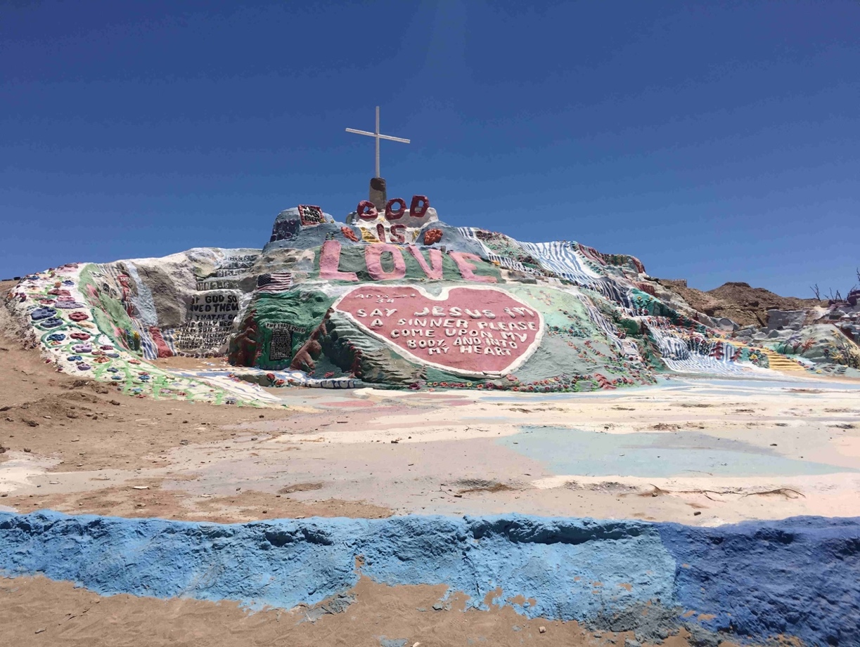

Salvation Mountain in the California Desert

R
ejoice in the Lord alway: and again I say, Rejoice. Let your moderation be known unto all men. The Lord is at hand. (Phil 4:4-5)

o the Christian, rejoicing is not a matter of choice but of nature. When we are overjoyed at the birth of a child, it is not a reaction that we planned for – it is simply a natural outcome of our hearts. When we have been forgiven the profligate’s life of sin (and we were all profligates in time past), we can do no other than rejoice. This is a general hymn of reverence and affirmation of the benefits of salvation.

The author is Mr. Edward H. Plumptre (in 1865). The most popular tune to which the hymn is sung is MARION by Arthur Messiter (1883). Alternate hymn tunes are Carlisle by Charles Lockhart (1791) and Peterborough by William Monk (1868).

Rejoice Ye Pure in Heart

Rejoice ye pure in heart;
Rejoice, give thanks, and sing;
Your glorious banner wave on high,
The cross of Christ your King.

Refrain
Rejoice, rejoice, rejoice,
Give thanks and sing.

Bright youth and snow crowned age,
Strong men and maidens meek,
Raise high your free, exultant song,
God’s wondrous praises speak.
Refrain

With all the angel choirs,
With all the saints of earth,
Pour out the strains of joy and bliss,
True rapture, noblest mirth.
Refrain

Your clear hosannas raise;
And alleluias loud;
Whilst answering echoes upward float,
Like wreaths of incense cloud.
Refrain

Yes, on through life’s long path,
Still chanting as ye go;
From youth to age, by night and day,
In gladness and in woe.
Refrain

Still lift your standard high,
Still march in firm array,
As warriors through the darkness toil,
Till dawns the golden day.
Refrain

At last the march shall end;
The wearied ones shall rest;
The pilgrims find their heavenly home,
Jerusalem the blessed.
Refrain

Then on, ye pure in heart!
Rejoice, give thanks and sing!
Your glorious banner wave on high,
The cross of Christ your King.
Refrain

Praise Him Who reigns on high,
The Lord Whom we adore,
The Father, Son and Holy Ghost,
One God forevermore.
Refrain

Rejoice ye pure in heart; Rejoice, give thanks, and sing; Your glorious banner wave on high, The cross of Christ your King. Many battle-flags of history have born the ‘CROSS’ as witness of the faith of the combatant. One such battle flag was the Battle Flag of the Southern Confederacy (the Cross of St. Andrews embedded with the thirteen stars of the contending states). But the Church bears a different Cross which symbolizes the sacrificial love of our Savior who purchased our freedoms. The one who died for us has invited us to His great Banquet beyond the Gates of Splendor. He brought me to the banqueting house, and his banner over me was love. (Song 2:4)

Bright youth and snow crowned age, Strong men and maidens meek, Raise high your free, exultant song, God’s wondrous praises speak” Regardless our state in life – whether young, old, a king, or a servant – we all have the innate joy to sing praises to our wonderful Savior. I will declare thy name unto my brethren, in the midst of the church will I sing praise unto thee. (Heb 2:12)

With all the angel choirs, With all the saints of earth, Pour out the strains of joy and bliss, True rapture, noblest mirth. The angel choirs sang at the early morning of Creation, and they sing continually before the Throne of God. Our voices are privileged to join with them in singing of praises to the Great King of Kings. The heavens declare the glory of God; and the firmament sheweth his handywork. (Psalm 19:1) If our hearts are attuned to the will of the Lord, our mouths shall declare His praises. As the clerical prayer counseled before the sermon in the Book of Common Prayer suggests, Let the words of my mouth, and the meditation of my heart, be acceptable in thy sight, O LORD, my strength, and my redeemer. (Psalms 19:14)

Your clear hosannas raise; And alleluias loud; Whilst answering echoes upward float, Like wreaths of incense cloud. In our joyous hymns we do not send for an uncertain sound, but one of abject joy and happiness. Our ‘alleluias’ are distinct in meaning – “praise ye Jah (the Lord).” As we have said so many times before the Love of God is the prime source of love. Our love is simply an echo of hearts whose nature is in accord with His. We love him, because he first loved us” (1 John 4:19)

Yes, on through life’s long path, Still chanting as ye go; From youth to age, by night and day, In gladness and in woe. Our Lord gives us a song, even in the night. Ye shall have a song, as in the night when a holy solemnity is kept; and gladness of heart, as when one goeth with a pipe to come into the mountain of the LORD, to the mighty One of Israel. (Isaiah 30:29) No matter if we are burdened with full field packs, and a heavy weapon, we think on the things for which we fight and continue the march in joy.

Still lift your standard high, Still march in firm array, As warriors through the darkness toil, Till dawns the golden day. There is nothing more daunting to the enemy then to see a solid, well-ordered line of soldiers advancing in battler array. Our standard, the Colors of the Cross, in the leading line of advance, assures the enemy of our intent to take back the mal-appropriated ground. Many great victories have been squandered by the failure to capitalize on the victory even in darkness. More battles are won by fighting in the most undesirable of field conditions than only on beautiful sunny days. Satan attacks us when the field is miry and our lives seem to us to be in shambles. But when the dawn of a golden day arises, we see the victory has been consolidated and our Standard Color posted above the fallen enemy. Christians must be persevering.

At last the march shall end; The wearied ones shall rest; The pilgrims find their heavenly home, Jerusalem the blessed. If we ‘fall out’ along the route of march at the first sign of fatigue, we shall not be at the site of victory. The Army of God moves unrelentingly against the hateful brigades of Satan and his beleaguered columns. There is no glory in falling from the lines. But at the moment of victory, what a marvelous rest we shall have! Every man, woman, and child has a part in the coming battle between right and wrong. We cannot accept truancies, or AWOL’s. The gleaming spires of New Jerusalem await our triumphant entry, but if we fall by the wayside, we shall miss that glorious march into the City.

Then on, ye pure in heart! Rejoice, give thanks and sing! Your glorious banner wave on high, The cross of Christ your King. What a blessing to be called the “pure in heart” if such heart we truly have, for we shall see God. “Blessed are the pure in heart: for they shall see God. (Matt 5:8) Christ is our Ensign – the perfect upright Standard about which we rally. 3 All ye inhabitants of the world, and dwellers on the earth, see ye, when he lifteth up an ensign on the mountains; and when he bloweth a trumpet, hear ye. 4 For so the LORD said unto me, I will take my rest, and I will consider in my dwelling place like a clear heat upon herbs, and like a cloud of dew in the heat of harvest. (Isaiah 18:3-4)

A Proper Benediction
Praise Him Who reigns on high, The Lord Whom we adore, The Father, Son and Holy Ghost, One God forevermore.

