Devotion on Hymns of the Church - Hymn 566 – Jesus Calls Us o’er the Tumult – 22 September 2015, Anno Domini (In the Year of our Lord)

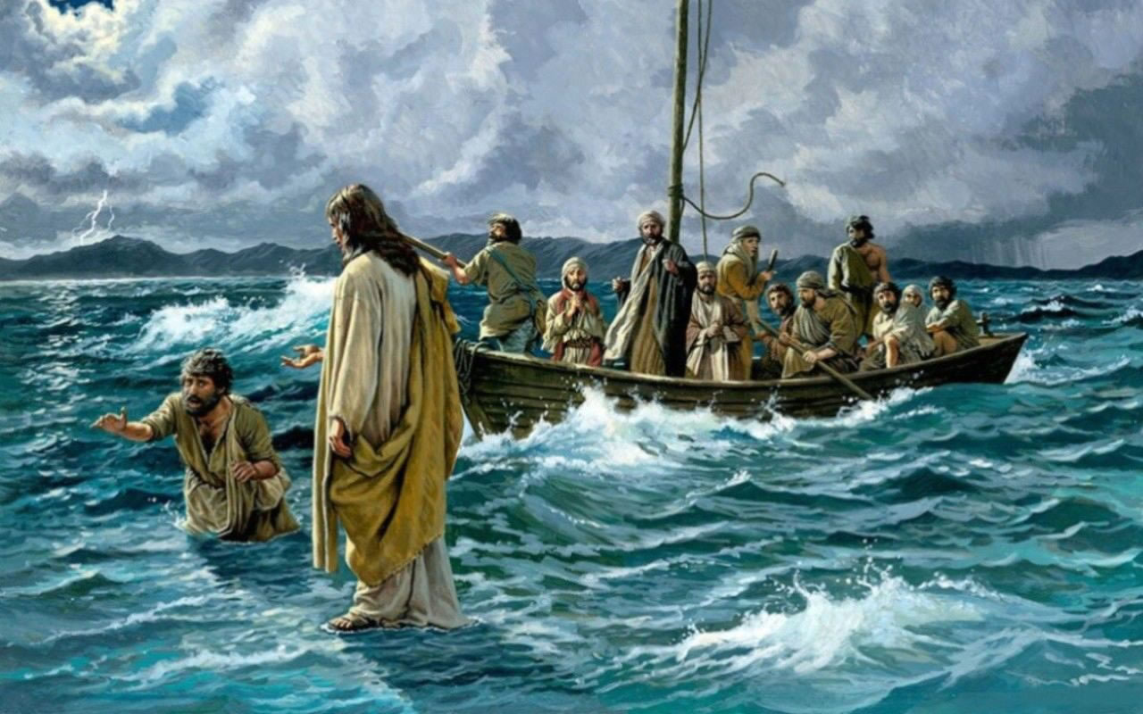

Lord, if it be thou, bid me come unto thee on the water. And he said, Come. And when Peter was come down out of the ship, he walked on the water, to go to Jesus. But when he saw the wind boisterous, he was afraid; and beginning to sink, he cried, saying, Lord, save me. And immediately Jesus stretched forth his hand, and caught him, and said unto him, O thou of little faith, wherefore didst thou doubt? (Matt 14:28-31)

The lyrics of this hymn were composed by Mrs. Cecil Francis Alexander of Tyrone, Ireland, in 1852. She was the wife of the Bishop of Derry, Rt. Rev. W. Alexander. The author composed more than 400 hymns mostly for youth. There are two primary tunes offered in the The Hymnal – Galilee by William H. Jude; and Chester by William Slidell Chester. The hymn is most commonly sung to Galilee since the spirit of this tune fits perfectly the sentiments expressed in the hymn. The Hymnal presents only the first three stanzas, however, I prefer to include all five here written by the author since the beauty of the whole is not diminished.

Jesus Calls Us

Jesus calls us over the tumult
Of our life’s wild, restless, sea;
Day by day His sweet voice soundeth,
Saying, “Christian, follow Me!”

As of old Saint Andrew heard it
By the Galilean lake,
Turned from home and toil and kindred,
Leaving all for Jesus’ sake.

Jesus calls us from the worship
Of the vain world’s golden store,
From each idol that would keep us,
Saying, “Christian, love Me more!”

In our joys and in our sorrows,
Days of toil and hours of ease,
Still He calls, in cares and pleasures,
“Christian, love Me more than these!”

Jesus calls us! By Thy mercies,
Savior may we hear Thy call,
Give our hearts to Thine obedience,
Serve and love Thee best of all.

Jesus calls us over the tumult Of our life’s wild, restless, sea; Day by day His sweet voice soundeth, Saying, Christian, follow Me! The raging deep of the stormy Galilean Sea separated Peter and the other disciples from Christ that fateful night when they saw the Lord walking calmly in the midst of the storm toward them. In the midst of their striving and despair, seeing what they mistook for a spirit approaching was nearly like the straw that could break the camel’s back! And when the disciples saw him walking on the sea, they were troubled, saying, It is a spirit; and they cried out for fear. (Matt 14:26) In times of distress, we are often more inclined to see the enormity of our troubles to the detriment of our seeing the presence of the Lord as the solution thereto. Though Peter could have gotten out of the boat at his own volition and presumed free will, he would have immediately become the salty diet of deep sea creatures. He had the spiritual insight to know that, if the Lord called him forth, he could go upon the waters to meet Him.

Every storm that arises in life has a Godly solution, but that solution is made available to us only by the beckoning will of God. Jesus does not only approach the believer in times of peril, but also in the stillness of the morning dews and damps when we seek His face. In the twilight of our days, as the shadows lengthen, He knows the fears and worries of our soul and He comes to stand in the shadows near to us. If we have taken up our crosses daily and followed Him, we will follow Him through verdant pastures and along crystal waters; and we shall also follow Him to the open and borrowed Tomb of the Garden. But we fear not, for it is only borrowed for a time before the glorious sunrise of the King of Glory.

The next stanza is one which the rich young ruler of Matthew 19:16-21 (and Mark 10:17-31 & Luke 18:18-30) would have profited in doing. As of old Saint Andrew heard it By the Galilean lake, Turned from home and toil and kindred, Leaving all for Jesus’ sake. The rich young ruler could not forsake his wealth and follow the Lord in accordance with the very First Commandment. Can we do better? I love this stanza since it relates to the name sake of my parish church of St. Andrews. He was the first to follow Jesus, and went immediately to find his brother, Simon (later Peter) and brought him to Christ. (John 1:40-42) What were our own first actions after answering the call of Christ? Who did we seek out with whom to share the wonderful news? What have we abandoned of the world to follow hard after Christ? Have we deserted all for Christ, or have we retained a hidden wedge of gold that binds us to the world? (Joshua 7:21)

What was the focus of your worship before you were called to Christ? Every living soul worships SOMETHING – either Godly or demonic. Jesus calls us from the worship Of the vain world’s golden store, From each idol that would keep us, Saying, Christian, love Me more! We must love Christ more than all others – even our loved ones at home. Why? Because all good things come from Him. Loving Christ will never result in a deficit of love for others, but rather greatly enlarge our heart’s capacity to love. In fact, our Cup of Love over flows. The golden store of the world is inordinate desire for wealth, a lust for sex, drugs, or leisure. But a burning love for Christ will put wheels on our prayers and compassion for others. We cannot remain standing idly by at the sight of a malnourished child, an poor widow, or a victim who has been beaten, robbed and left for dead on the Jericho Road of Life. Our love for Christ is an echoed love for we could not love Him had He not loved us first. We love him, because he first loved us. (1 John 4:19)

In our joys and in our sorrows, Days of toil and hours of ease, Still He calls, in cares and pleasures, Christian, love Me more than these! Jesus calls us in moments of victory as well as trouble. Quite often the storms of life – like that on the Galilean Sea – are sent to garner our attention upon Him. It may be most difficult to hear His beckoning voice during times of prosperity for we fill no need of the benefactor who granted us all things. But the humble heart of the Christian is humble both in storm and sunshine to hear His voice.

Jesus calls us! By Thy mercies, Savior may we hear Thy call, Give our hearts to Thine obedience, Serve and love Thee best of all. The CALL of Jesus is the most important call you will ever hear! Had Lazarus not heard that CALL from outside the stone walls of his tomb, he could never have arisen; but that Voice cannot be ignored. It penetrates stone. It penetrates time and space; it penetrates the corrupting and rotting flesh of a dead heart; and it will not be silenced! If you are not a Zombie, you have heard and responded to that VOICE.

I suppose you wonder what I mean by ZOMBIE? I mean the walking dead, and every sinner is already dead in trespasses and sins until that dead soul is made alive (quickened0 by the magnetic pull of the Holy Ghost! And you hath he quickened, who were dead in trespasses and sins; 2 Wherein in time past ye walked according to the course of this world, according to the prince of the power of the air, the spirit that now worketh in the children of disobedience: 3 Among whom also we all had our conversation in times past in the lusts of our flesh, fulfilling the desires of the flesh and of the mind; and were by nature the children of wrath, even as others. But God, who is rich in mercy, for his great love wherewith he loved us, Even when we were dead in sins, hath quickened us together with Christ, (by grace ye are saved;) And hath raised us up together, and made us sit together in heavenly places in Christ Jesus: That in the ages to come he might shew the exceeding riches of his grace in his kindness toward us through Christ Jesus. (Eph 2:1-7)

Are you still a Zombie or have you awakened to the Voice of Christ outside your tomb?

