Hymn 55 - Forty Days and Forty Nights - 24 February 2015, Anno Domini (In the Year of our Lord)

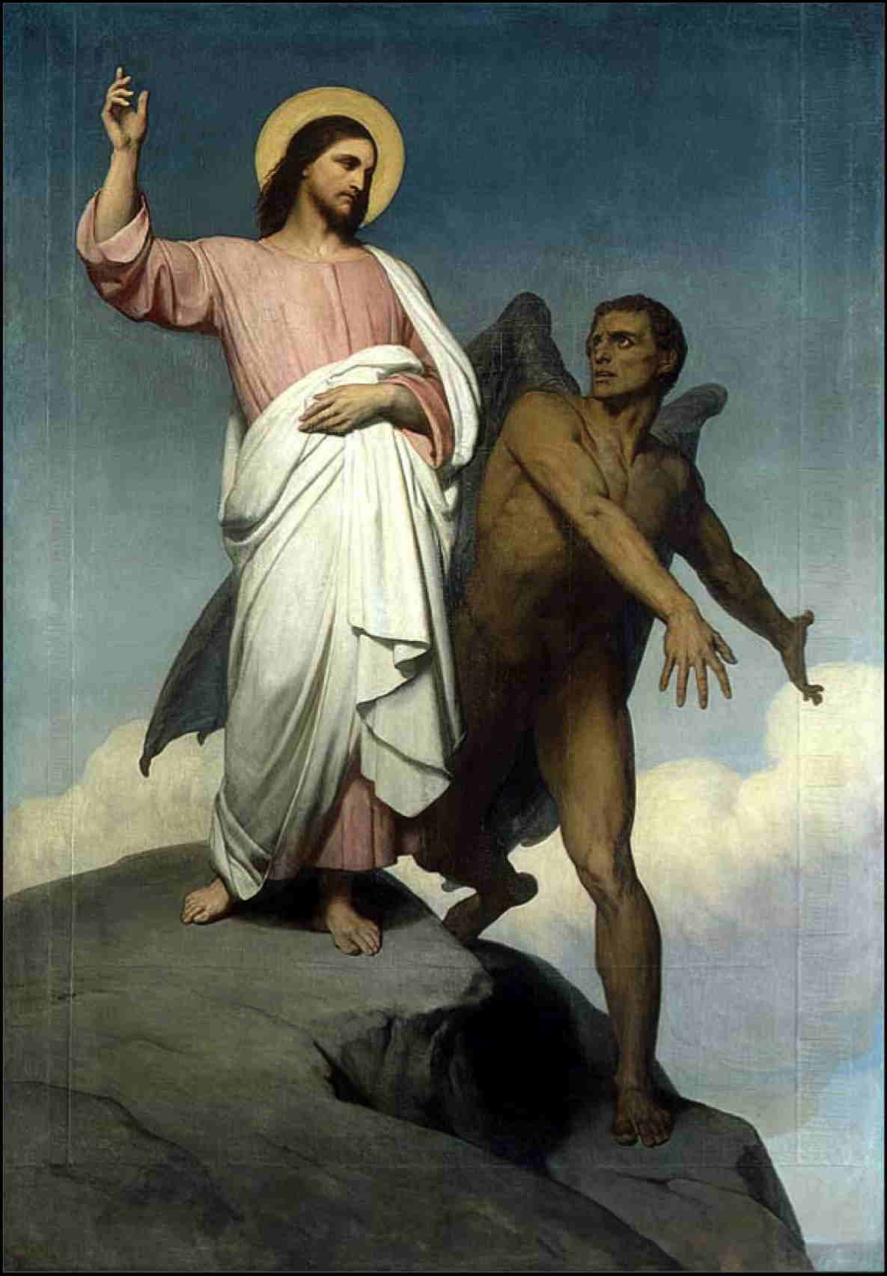

And when he had fasted forty days and forty nights, he was afterward an hungred.
(Matt 4:2)

Our Lord began His earthly ministry with a fast following the joyful occasion of His baptism at which the entirety of the Holy Trinity was present – Father, Son, and Holy Ghost. The Spirit drove Jesus into the Wilderness to be tempted of the Devil. It was not until Jesus was at His most vulnerable moment of fasting (the fortieth day) that Satan came to Him with His temptations. Satan is not omniscient, but he does observe us and marks our weaknesses and weak moments. It is Satan who chooses the battlefield to war against us. He almost always seeks to take the high ground by quoting Scripture, but he quotes it always with some deceitful play on words.

The lyrics to this Lenten hymn were written by George Hunt Smyttan (1822-1870), and published in 1856. The primary tune is Aus der Tiefe rufe ich (Heinlein) (Nürnbergisches Gesangbuch, 1676, attributed to Martin Herbst, 1654-1681) – taken from the Hymnal 1940 Companion.

Forty Days and Forty Nights

Forty days and forty nights
thou wast fasting in the wild;
forty days and forty nights
tempted, and yet undefiled.

Should not we thy sorrow share
and from worldly joys abstain,
fasting with unceasing prayer,
strong with thee to suffer pain?

Then if Satan on us press,
Jesus, Savior, hear our call!
Victor in the wilderness,
grant we may not faint or fall!

So shall we have peace divine:
holier gladness ours shall be;
round us, too, shall angels shine,
such as ministered to thee.

Keep, O keep us, Savior dear,
ever constant by thy side;
that we thee we may appear
at the eternal Eastertide.

Our Lord came to satisfy every demand of the Law and of example. He would experience a greater temptation and suffering than those for whom He came to save. Fasting in the Wilderness for forty days and nights would have worked a great want in His physical body, and a great loneliness in His soul. He no doubt resorted to continual prayer in communion with the Father. “Forty days and forty nights thou wast fasting in the wild; forty days and forty nights tempted, and yet undefiled.” Christ came as our Ensign about which we rally in righteousness. He is the perfect example and Plumb-line of our Faith, but more than this, He is the only One whose Person is completely without sin or perfectly righteous. Being exposed to the most awful conditions of the elements of desert, mountain and heat, the Lord withstood the yearnings of His flesh for food, and persevered as you and I must do in the Wilderness of this life.

“Should not we thy sorrow share and from worldly joys abstain, fasting with unceasing prayer, strong with thee to suffer pain?” It is not a reasonable expectation that we could ever share in full His sorrow and pain; but could we not watch and pray even for one hour? “What, could ye not watch with me one hour? Watch and pray, that ye enter not into temptation: the spirit indeed is willing, but the flesh is weak.” (Matt 26:40-41) It is for our own good that the Lord asks us to wait upon Him and pray. Prayer and Patience wards off the temptations to which the flesh is heir. We grow stronger in depriving ourselves, at least at appointed times, the desires of the flesh – food and comfort being two of the most grievous to withhold. How weak are we compared to that great strength of Christ in overruling the desperate desires of the flesh with such unyielding spiritual power.

“Then if Satan on us press, Jesus, Savior, hear our call! Victor in the wilderness, grant we may not faint or fall!” The word ‘IF’ in this stanza is a waste of the scribes pen, for certainly Satan WILL press on us with delightsome temptations of the flesh – and even dark spiritual ones. The Bishop and Captain of our Soul, the Lord Jesus Christ, as the perfect and ideal Commander, has led the way for us. He has set the Standard on the forward lines of battle. He has conquered, and offers us the victory for which we have not fought, have not bled, and could not have died – He did it ALL! We are as the lost sheep in the Wilderness. When we find ourselves parted from our caring Shepherd, we bleat until He comes to us. He hears our wavering cry, and comes to whatever ditch or rocky slope on which we find our perishing souls. He ALWAYS hears our voices of pleading and mercy. Do we as often hear the Voice of our Shepherd? We must for “. . . when he putteth forth his own sheep, he goeth before them, and the sheep follow him: for they know his voice. And a stranger will they not follow, but will flee from him: for they know not the voice of strangers.” (John 10:4-5) If we claim His strength in moments of temptation, Satan will flee as does the hyena the Lion (of Judah).

“So shall we have peace divine: holier gladness ours shall be; round us, too, shall angels shine, such as ministered to thee.” If we are willing to abide its shackles, the world offers a kind of peace that is based on surrender of person and rights; but the peace that the Lord offers is that true Peace of Liberty and good conscience available only to those who are subjects of that great sovereign called the Prince of Peace. Such peace is not subject to environmental depravities, but rather abides in the heart of the believer forever. The Peace that Christ offers is not that enslaving peace of the world, but a Divine Peace; not the peace that entails a fearful doubt of things to come upon the earth, but engenders the highest hopes and expectations of the Coming Glory of Heaven: “Peace I leave with you, my peace I give unto you: not as the world giveth, give I unto you. Let not your heart be troubled, neither let it be afraid.” (John 14:27) The Christian enjoys such a blessing of which the world knows not. We have the ministry of God’s Angels to watch over and care for us in times of trouble – angels sent by God Himself.

“Keep, O keep us, Savior dear, ever constant by thy side; that with thee we may appear Glorious at thy Eastertide.” It is vain for believers to speculate on which Holy Day is more Holy – Christmas, Easter, Whitsunday, etc. It is not profitable to do so because all are required. Christ did not come to wash away some sins and leave others as blight upon our souls. He did all. He came at Christmas (where would Easter be without Christmas?); He rose from the Tomb at Easter (where would the Ascension be if Easter had not happened?); and His Holy Ghost was given at Pentecost (where would we be without the Holy Ghost?). But the great event of Easter sealed the whole of the works of Christ in a single stroke. He became our Passover Lamb of God at Easter. He is, indeed, constant by our side: “There shall not any man be able to stand before thee all the days of thy life: as I was with Moses, so I will be with thee: I will not fail thee, nor forsake thee.” (Joshua 1:5) and in another place: “Let your conversation be without covetousness; and be content with such things as ye have: for he hath said, I will never leave thee, nor forsake thee.” (Heb 13:5)

The voice of the Adversary and Enemy of your soul may whisper doubt in your ear regarding the Savior that is with you always. But regardless the tempter’s lies, God has spoken, and we of faith believe every word that proceeds from the mouth of God, do we not?

