Hymn 50 – Saw You Never – 20 January 2015, Anno Domini (In the Year of our Lord)

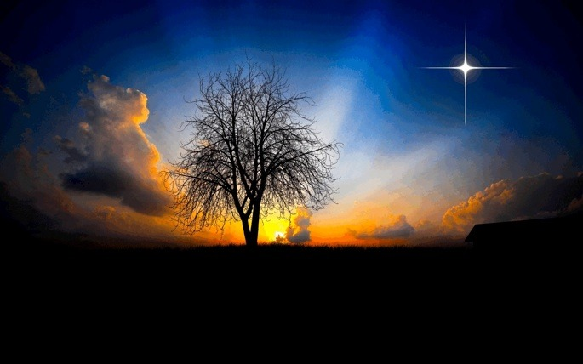

I Jesus have sent mine angel to testify unto you these things in the churches. I am the root and the offspring of David, and the bright and morning star. (Rev 22:16)

The most beautiful metaphor for the Lord Jesus Christ in Scripture, according to my personal opinion, is that of Bright and Morning Star. Mrs. Cecil F. Alexander, author of this Epiphany Hymn, incorporates that metaphor wonderfully in this hymn. She composed the hymn in 1853 to the tune of The Wise Men (Berthold Tours). The author was born in Ireland in 1823 and married the Rt. Rev. W. Alexander, DD, Bishop of Derry and Raphoe. Altogether, her hymns number almost 400 and were mostly composed for children. The greater number of her hymns was, like this one, dedicated to the Holy Seasons of the Church.

Saw you never, in the twilight

Saw you never, in the twilight,
When the sun had left the skies,
Up in heav'n the clear stars shining
Through the gloom, like silver eyes?
So of old the wise men, watching,
Saw a little stranger star,
And they knew the King was given,
And they followed it from far.

Heard you never of the story
How they crossed the desert wild,
Journeyed on by plain and mountain
Till they found the holy Child?
How they opened all their treasure,
Kneeling to that infant King;
Gave the gold and fragrant incense,
Gave the myrrh in offering?

Know ye not that lowly baby
Was the bright and morning Star?
He who came to light the Gentiles,
And the darkened isles afar?
And we, too, may seek his cradle;
There our hearts' best treasures bring;
Love, and faith, and true devotion
For our Savior, God, and King.

Twilight is the time of closing day when the sun has vanished beneath the western horizon, yet it leaves behind tokens of glowing light to remind the observer of its former brilliance. There was a twilight time for those who longed and lingered to see the end of day for the darkness in which they had walked for more than 400 years (from the last word of the Old Testament in Malachi). For centuries, darkness had pervaded the days and nights of those who looked for the Savior promised by God the Father.

“Saw you never, in the twilight, When the sun had left the skies, Up in heav'n the clear stars shining Through the gloom, like silver eyes? So of old the wise men, watching, Saw a little stranger star, And they knew the King was given, And they followed it from far.” Though we experience periods of night as a portion of our earthly lives, the nights are not unending for, at length, comes the dawn and the burst of brilliant rays of the sun across the eastern horizon. But the fading of the light at twilight is followed by wonderful beauties in the heavens. The light of glimmering stars – so far away in light years that they may no longer exist – pierces the night canopy and is symbols to us of hope and promise. The sky itself may appear dark, but there is no darkness at all where these thousands of points of light adorn the sky. Some dreamer has said that the stars are simply holes in the sky where the brilliance of heaven shines through.

There is one special star that is first of all of the stars to appear at twilight, and to disappear at dawn – that would be the Bright and Morning Star that represents the over-watching presence of Christ in our lives. He is the brightest Star in our heaven at night, and He goes with us to light our way ‘all through the night.’ He is our Lily of the Valleys – even the Valley of the Shadow of Death. He is first to appear at the fading of the light of day, and the last to leave the field at the coming of the dawn. Perhaps that ‘little stranger’ star so long studied and spied by the Wise Men was a foretoken of that Bright and Morning Star whose birth it proclaimed. Of course, the Star of Bethlehem was a “Little Stranger” as stars go according to the compass of heaven. It was not charted by astrologers of the day. It was not fixed in the heavens.

It remained a “Little Stranger” except to those who yearned to know the Lord and Sovereign whose coming it announced. This was so true of the little Christ Child that was born at Bethlehem. He was not considered of proper status to warrant comfortable lodging, so He was born in a stable and laid in a manger. He came unto his own, and his own received him not. But as many as received him, to them gave he power to become the sons of God, even to them that believe on his name. (John 1:11-12) While it is true that the religious rulers of Israel did not know and receive their Lord, the Gentile Wise Men from the East did! The Gates of Splendor were thrown open to all men, women, and children of faith, regardless of nation, tribe or clan, at the coming of the Lord Jesus Christ. What a Light was come into the world! We all came from a far country when we became citizens of the Kingdom of Heaven – just like the Wise Men!

“Heard you never of the story How they crossed the desert wild, Journeyed on by plain and mountain Till they found the holy Child? How they opened all their treasure, Kneeling to that infant King; Gave the gold and fragrant incense, Gave the myrrh in offering?” The two men on the Road to Emmaus were incredulous that the Stranger who walked with them had asked, “What things?” Who has not heard the story of the Wise Men? While it is true that most of us, Christian or not, have heard the story; have we REALLY studied it and considered it in detail? The Wise Men were, in all likelihood, from central Persia (near the Holy Mountain of the Zoroastrians) at Esfahan, or else from Pasargadae (home of Cyrus the Great). They were seekers of truth, and studied all Hebrew prophecies regarding that Star that “would arise out of Jacob.” They were ready for it! When they identified that strange star, they immediately followed on. They followed the symbol of Christ more ardently than many Christians today follow the risen Savior!

They were forced to travel under demanding circumstances much as the traders of the caravans did – by loaded camels. They would have crossed over the snow clad heights of the Zagros range of mountains that divide the Persian Empire. From there, passing north of the Persian Gulf estuary, they would have crossed the Tigris and Euphrates Rivers, on to the desert of Arabia. Finally, they would have come to the tiny Jordan Banks which they would have easily crossed. But the journey was extensive and full of hardship and challenge. Some theologians estimate the time of travel to have been two years. It was obviously well after the Baby Jesus had been moved from the stable yard for the Wise Men found Him and His mother, Mary, settled in a house when they came with their prophetic gifts of Gold, Frankincense, and Myrrh.

“Know ye not that lowly baby Was the bright and morning Star? He who came to light the Gentiles, And the darkened isles afar? And we, too, may seek his cradle; There our hearts' best treasures bring; Love, and faith, and true devotion For our Savior, God, and King.” You may not consider Epiphany as of any particular significance to your faith, but it was truly significant and profound because it was the event of Epiphany at which God acted us-ward to make the Gospel accessible to both Gentile and Jew. Yes, we were a people who only knew God by shadows and gossamer veils. The little Star of Bethlehem was dwarfed by that Bright and Morning Star which it proclaimed. We gentiles were in a far country from God and a darkened land. The Light of His Coming was a brilliant gleaming star that lighted all the world – even the Islands of the Sea. Not only is Christ the Bright and Morning Star, but He is also the great Sun of our Heaven that shall “arise with healing in its wings.” (Malachi 4:2) He is not only the Morning Star of our night, but the great Day Star of our mornings. “We have also a more sure word of prophecy; whereunto ye do well that ye take heed, as unto a light that shineth in a dark place, until the day dawn, and the day star arise in your hearts.” (2 Peter 1:19)

Has that Day Star arisen on the Eastern Horizons of your heart, friend?

