Hymn 49 – From the Eastern Mountains – 6 January 2015, Anno Domini (In the Year of our Lord) That is, two thousand and fifteen years since the birth of Christ)

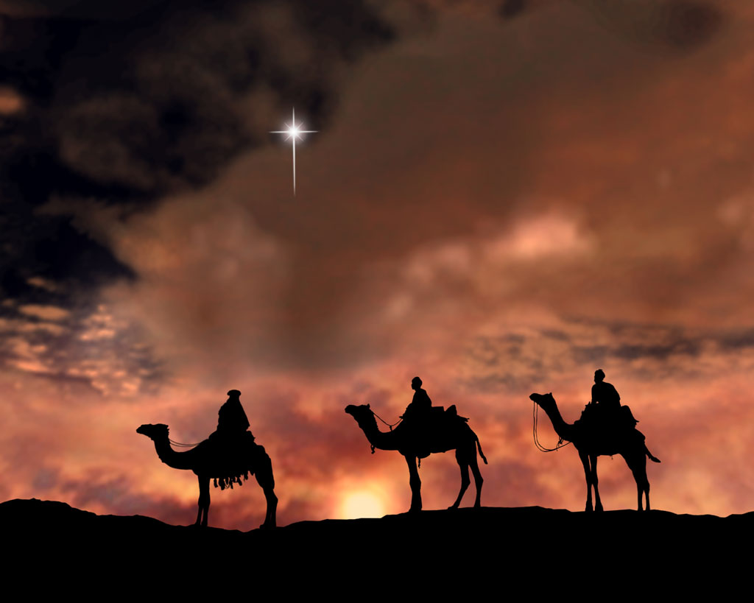

6 For God, who commanded the light to shine out of darkness, hath shined in our hearts, to give the light of the knowledge of the glory of God in the face of Jesus Christ. 7 But we have this treasure in earthen vessels, that the excellency of the power may be of God, and not of us. (2 Cor 4:6-7)

4 But when the fulness of the time was come, God sent forth his Son, made of a woman, made under the law, 5 To redeem them that were under the law, that we might receive the adoption of sons. 6 And because ye are sons, God hath sent forth the Spirit of his Son into your hearts, crying, Abba, Father. 7 Wherefore thou art no more a servant, but a son; and if a son, then an heir of God through Christ. (Gal 4:4-7)

My favorite Carol of Epiphany is “We Three Kings,” however, there was a devotion on that hymn-carol last year; so, I will proceed to write about my second favorite – “From the Eastern Mountains.” Perhaps you will find, as I find, that our favorites need to be more expansive in nature and not strictly the old familiar provincial songs of our youth. Practically all of the classic old hymns have different hues and beams of light to shed on the meaning of our worship experience. The Epiphany hymn under current consideration is no exception.

This is the Day of Epiphany celebrated by Reformed churches around the globe. The term, Epiphany, derives from the Koine Greek, ἐπιφάνεια, epiphaneia, meaning manifestation, or brilliant appearance. In the ancient Greek, the term is ‘Theophany’ (Θεοφάνεια’). Theophany means to see God, or image of God. Epiphany is the Christian feast day that celebrates the revelation of the only Begotten Son of God as Jesus Christ who is the Word Incarnate. In the Western Church, the feast commemorates principally the visit of the Magi to the Christ child, and thus Jesus' physical manifestation to the Gentiles. In the early Church of England, the eve of Epiphany was celebrated as the Twelfth Night (of Christmas) also known as Plough Day (don’t ask me why).

‘From the Eastern Mountains’ was composed by Godfrey Thring in 1873 as a processional for the Epiphany. Certainly the mood of the lyrics, and even the tune, suggest movement toward Christ just as does a genuine processional for worship service. The tune was composed by Arthur Henry Mann in 1889 entitled Valour. (British spelling, of course).

From the Eastern Mountains

From the eastern mountains, pressing on, they come,
wise men in their wisdom, to his humble home;
stirred by deep devotion, hasting from afar,
ever journeying onward, guided by a star.

There their Lord and Savior meek and lowly lay,
wondrous Light that led them onward on their way,
ever now to lighten nations from afar,
as they journey homeward by that guiding star.

Thou who in a manger once hast lowly lain,
who dost now in glory o'er all kingdoms reign,
gather in the heathen who in lands afar
ne'er have seen the brightness of thy guiding star.

Onward through the darkness of the lonely night,
shining still before them with thy kindly light.
Guide them, Jew and Gentile, homeward from afar,
young and old together, by thy guiding Star.

Until every nation, whether bond or free,
'neath thy starlit banner, Jesus, follows thee.
O'er the distant mountains to that heavenly home,
where nor sin nor sorrow evermore shall come.

From the eastern mountains, pressing on, they come, wise men in their wisdom, to his humble home; stirred by deep devotion, hasting from afar, ever journeying onward, guided by a star. This opening stanza is descriptive of the journey that the Wise Men took in leaving their mountainous home in the East (possibly just beyond the Zagros Range of mountains in west central Persia – origin of the Zoroastrian religion whose priests are called, Magi. These were learned and refined men of the East, and they were not given to shunning difficult obstacles or challenges. They had studied the ancient texts and prophecies of the Hebrews, and they had studied the source of those prophecies as well – the high Heavens. When they discovered the unusual Star of Brilliance, they hesitated not to follow immediately without delay. When the Light of Christ first dawned in our own hearts, it is hoped that we, too, followed with a similar vigor. Why did these men abandon the comfortable and commodious circumstances of their station in the East to follow that Star? As the hymn rightly points out, it was owing to a heavenly wisdom, deep devotion, and a persevering nature. The journey was no simple weekend trek. They were forced to cross the heights of snow clad mountains (Zagros), burning sands of the desert, and cross gullies and rivers in the way. They encountered many dangers of travel on the way, and met many strangers whose language may have been strange to them – yet they traveled on with a tenacity of spirit born out of the kind of super-human devotion that only the Holy Spirit can impart.

There their Lord and Savior meek and lowly lay, wondrous Light that led them onward on their way, ever now to lighten nations from afar, as they journey homeward by that guiding star. These men were not casual believers – humility of circumstance did not deter them from the more majestic circumstances of character and nature. It is a credit of distinction that they cared little for the dignity and opulence of the palace compared to the mild and meager accommodations of where the Christ Child laid. The man-made lights of the palace yet has corners and crevices that are darkened; but the Baby Jesus was a Light unto Himself. In Him there is no darkness, nor in His Presence. The Light of the Star prefigured the Light that was Christ! In order to see and know the Star, these men studied the higher things of Scripture and of the skies. When they saw that Light, they followed. As Christians, we must study the Light of Christ and every text that relates to Him in Scripture. Here is a mystery, if you haven’t heard or read: All Scripture points to Christ. He is the Whole Word and nothing less. Once we have studied His identifying ways and marks, we must follow Him just as did the Wise Men those many years ago. The Light appeared to Gentile Wise Men at the same instant it appeared to the shepherds over Bethlehem. It took them perhaps as long as two years to follow it to their destination – the Christ Child. They followed it to Christ, but in finding Christ, they also found their home in Heaven.

Thou who in a manger once hast lowly lain, who dost now in glory o'er all kingdoms reign, gather in the heathen who in lands afar ne'er have seen the brightness of thy guiding star. We are, by nature, a proud race, we humans! We are offended if the Maitre d’ does not recognize us, or our names are misspelled in some periodical or church bulletin. We strive to maneuver to the front rows in church meetings, and believe that we are entitled, by either our labors or our titles, to be accounted privileged among others. What a disparity of character is Jesus from this manner of thinking! He deigned to be born in a lowly stable, laid in a barren and rough-hewn manger, and subjected to the elements of bitter cold and other deprivations at His birth. He left the pristine and crystalline mansions of Heaven to humble Himself – not just to OUR level, but below that level – in order that we might know God, and that He might redeem us from our wanton sins. The Star led the way to an even greater Star! 19 We have also a more sure word of prophecy; whereunto ye do well that ye take heed, as unto a light that shineth in a dark place, until the day dawn, and the day star arise in your hearts. (2 Peter 1:19) The Star of Bethlehem arose in the skies over the men of the Eats and they followed. Has that Day Star arisen in our own hearts, and have we followed on regardless the perceived dangers and hardships?

Onward through the darkness of the lonely night, shining still before them with thy kindly light. Guide them, Jew and Gentile, homeward from afar, young and old together, by thy guiding Star. It might be supposed that the Wise Men were elders of their people because of their wisdom and tenacity, but some who came to the Baby Jesus were young men and, perhaps, even boys! David was a young child when he served as his father’s shepherd on the hills overlooking Bethlehem. It is most likely that some of those shepherds, keeping watch over their flocks, that great and beautiful night of the appearing of the Angel of the Lord in those skies, were merely boys of tender age. Young and old alike are drawn to the Light of Christ – “the Bright and Morning Star!” (Revelations 22:16) The darkness of the night leads to a greater loneliness for the despondent, but the Light of Christ is a singular Light that overcomes the most pervasive of darkness that night can offer. Christ is not only the brightest Light in our Heavens, but He is also a ‘Kindly Light’ that guides us home. I love that classic old hymn, ‘Lead Kindly Light,’ that is so illustrative of the Light that is Christ:

Lead, kindly Light, amid th'encircling gloom,
lead thou me on!
The night is dark, and I am far from home;
lead thou me on!
Keep thou my feet; I do not ask to see
the distant scene; one step enough for me.

Until every nation, whether bond or free, 'neath thy starlit banner, Jesus, follows thee. O'er the distant mountains to that heavenly home, where nor sin nor sorrow evermore shall come. If we have the character of those ancient Wise Men to follow the Light of the Star of Christ all of the way to where HE Abides, we shall find that He takes His abode in our hearts. After finding Him, and surrendering to Him, and following Him, we shall discover that in our long days of sorrow and aged blindness, if we turn about on our Roads to Emmaus, we will find that He also is following close by to us. He will never leave nor forsake us. He will remain with us always, even unto the end of the world. We do not have to have any diplomatic or immigration papers to become part of His Kingdom. In Christ, men of all tribes and nations are free-born at last. Christ leads, but He also follows. He leads us in the way, and follows to pick us up when we straggle behind. Those distant mountains to which the song refers is the Mountain of God. The same at which Moses saw the Burning Bush, and the same to which we look for our daily inspiration. 1 I will lift up mine eyes unto the hills, from whence cometh my help. 2 My help cometh from the LORD, which made heaven and earth. 3 He will not suffer thy foot to be moved: he that keepeth thee will not slumber. 4 Behold, he that keepeth Israel shall neither slumber nor sleep. 5 The LORD is thy keeper: the LORD is thy shade upon thy right hand. 6 The sun shall not smite thee by day, nor the moon by night. 7 The LORD shall preserve thee from all evil: he shall preserve thy soul. 8 The LORD shall preserve thy going out and thy coming in from this time forth, and even for evermore. (Psalms 121:1-8)

If you know the Lord Jesus Christ, you need not wonder what Heaven will be like. You need only remember that you will be with Him, and He does all things right.

May your Epiphany Feast be filled with Light and wonder of Love.

