Hymn 48 – Earth has many a Noble City - 13 January 2015, Anno Domini

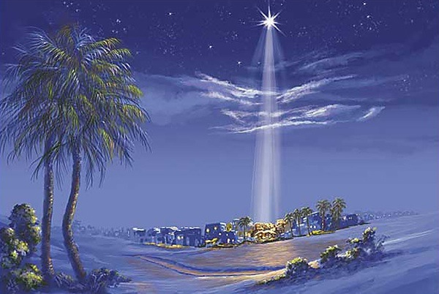

But thou, Bethlehem Ephratah, though thou be little among the thousands of Judah, yet out of thee shall he come forth unto me that is to be ruler in Israel; whose goings forth have been from of old, from everlasting. (Micah 5:2)

If the nature of antiquity defines the classical nature of a hymn, then this hymn would rank superior for its antiquity. Of course, antiquity is not determinate in measuring the classical nature of a hymn unless the hymn has maintained its broad appeal from its ancient composition. This hymn has done so. It was written during the third century Anno Domini by Aurelius Clemens Prudentius who lived from 348 to 413 AD. Prudentius also wrote the Advent/Christmas Hymn, From the Father’s Love Begotten. The tune for today’s hymn is most popularly Stuttgart. The hymn has earned a place among those classical hymns of the church that have the enduring qualities of beauty, truth, and spiritual appeal that show that they have been ear-marked of God. In fact, all classical works of worth and transcendent beauty come from the inspiration of God. This was a firmly stated adage of the great Bach and many other great composers.

Mendelsohn, a giant composer of the Lutheran faith, wrote, in echo of the words of the Psalmist: “Pray to God that He may create in us a clean heart and renew a right spirit within us.” To his nephew, he wrote these lines: “Nothing is attained, without the fulfillment of one fervent wish – May God be with you! This prayer comprises consolation and strength, and also cheerfulness in the days to come.” So why mention Bach and Mendelsohn in my devotion on a hymn by Prudentius? It is to establish my understanding of both classical hymns, music, and classical character that attends their construction. Most works that pass for music today is not music at all, much less classical in nature. It lacks tone, melody, harmony, and, as Mendelsohn says, a “right spirit” that honors God and does not flaunt the singer.

Earth has Many a Noble City

Earth has many a noble city;
Bethlehem, thou dost all excel:
out of thee the Lord from heaven
came to rule his Israel.

Fairer than the sun at morning
was the star that told his birth,
to the world its God announcing
seen in fleshly form on earth.

Eastern sages at his cradle
make oblations rich and rare;
see them give, in deep devotion,
gold and frankincense and myrrh.

Sacred gifts of mystic meaning:
incense doth their God disclose,
gold the King of kings proclaimeth,
myrrh his sepulcher foreshows.

Jesus, whom the Gentiles worshiped
at thy glad epiphany,
unto thee, with God the Father
and the Spirit, glory be.

“Earth has many a noble city; Bethlehem, thou dost all excel: out of thee the Lord from heaven came to rule his Israel.” Yes, there are many noble cities (according to the accounting of men) such as Paris, Moscow, Rome, London, New York, Athens, and Tokyo; but despite their wealth and pelf, none has produced so great a figure as the Lord Jesus Christ. No, that was left to humble, sleepy little Bethlehem – the City of the boy-shepherd, David. So, based on that fact alone, Bethlehem excels all other cities - both large and small.

“Fairer than the sun at morning was the star that told his birth, to the world its God announcing seen in fleshly form on earth.” That unique Star that foretold the Savior’s birth was exceeding fair for it cast its guiding light from the purple-canopied heavens of the Eastern skies. It was a singular light of brilliance and beauty. Though the Son of God was made of a woman and shared in our total humanity, He also shared the Divine Nature of His Father. 4 In him was life; and the life was the light of men. 5 And the light shineth in darkness; and the darkness comprehended it not. (John 1:4-5) The Star symbolized a far greater Light than that which gleamed from the high desert heavens. Jesus became like us in the flesh so that we might know His Father in a real way. 10 He was in the world, and the world was made by him, and the world knew him not. 11 He came unto his own, and his own received him not. 12 But as many as received him, to them gave he power to become the sons of God, even to them that believe on his name: 13 Which were born, not of blood, nor of the will of the flesh, nor of the will of man, but of God. 14 And the Word was made flesh, and dwelt among us, (and we beheld his glory, the glory as of the only begotten of the Father,) full of grace and truth. (John 1:9-14)

“Eastern sages at his cradle make oblations rich and rare; see them give, in deep devotion, gold and frankincense and myrrh.” The Wise Men were not of a common and vulgar class – they were well read, and of great influence among their brethren in the East. But they had a wisdom that exceeded their fellows – enough to follow the Star and discover the Christ Child. They came neither out of curiosity nor as seekers of fame and fortune – they came in high devotion to the great God whose Son they knew had been born. Their gifts, too, were symbols of prophetic import – Gold which was worthy of a king; frankincense which imparted a divine nature worthy of worship; and myrrh that bore an omen of His sacrificial death since it was an herb used in the care of bodies prior to burial.

“Sacred gifts of mystic meaning: incense doth their God disclose, gold the King of kings proclaimeth, myrrh his sepulcher foreshows.” I am touched at the universal understanding Prudentius displays here of the mystical meaning of the three gifts. It might be believed that even the Wise Men themselves had not notion of the deep significance and meaning of the gifts they bore.

“Jesus, whom the Gentiles worshiped at thy glad epiphany, unto thee, with God the Father and the Spirit, glory be.” In the day that Prudentius lived, the Roman Church had not been so corrupted with false doctrine as at present and in the Dark Ages that fell upon Europe at the Fall of Rome to Barbarians. The doctrine he advances in the symbolism of the gifts, as well as the epiphany of Jesus to the Gentile Wise Men, is simple and profound at once. It is such a comfort to the true Church today that the truth of the Gospel was so well defined, preached, and defended three hundred years from the death, burial, and resurrection of Christ; and that that same Gospel, once preached by the Apostles, has come down to us in pristine form and inviolate in its purity and truth. His (Prudentius) benediction well concludes the great matter in paying a creedal homage to Father, Son, and Holy Ghost. All glory belongs to the Triune God and not some tin-horned saint who proclaims himself as Pope or Prelate.

The final line of the hymn also reinforces the importance of the Apostles’ and Nicene Creeds which we repeat with great regularity, and I hope – reverence, in our worship. It is the summary of faith and belief that unites the Church Catholic and Universal. “I believe” just as does every other professing Christian, in the terms and proclamations of the Gospel of Jesus Christ as set forth in Holy Scripture. Do YOU so believe, friend?

