Hymn 44 – In the Bleak Mid-Winter – 23 December 2014, Anno Domini (In the Year of our Lord) That is, two thousand and fourteen years since the birth of Christ)

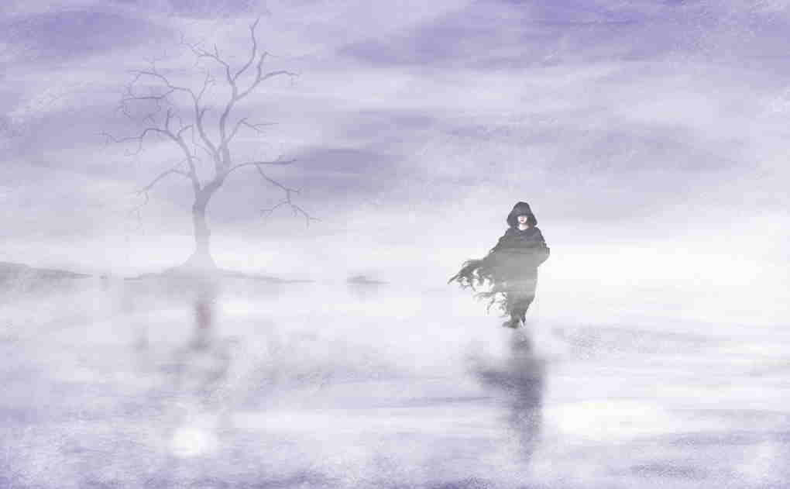

As I sit by the hearth of a warm fire at present, there is bleak and cold weather without. In writing about this beautiful carol by Christina Georgina Rosetti, I am musing about the time of Christmas and how the day itself approaches the longest and darkest night in our calendar. The glow of embers in the fire makes a warmth and soft golden glow on all around the room in which I sit year. It is a feeling of peace and comfort. But I could not appreciate this warm fire without realizing that bleak winter without the walls of my home. The book of the prophet, Malachi (the last utterance of the Old Testament), was completed four hundred years before the Coming of Christ. Utter spiritual darkness reigned for those four hundred years as men waited for some word of Hope from Heaven – but none came until that fateful night in a little village called Bethlehem. Miss Rosetti penned these words in the bleak of winter of 1872 – more than 140 years ago. I am sure she must have had a warm fire before her when she wrote so beautifully this illustrative poem of Christmas – one of hundreds of her prolific spiritual poems and writings. The tune, CRANHAM, was composed by Gustav Theodore Holst in 1906.

In the Bleak Midwinter
In the bleak midwinter,
frosty wind made moan,
earth stood hard as iron,
water like a stone;
snow had fallen, snow on snow,
snow on snow,
in the bleak midwinter,
long ago.

Our God, heaven cannot hold him
nor earth sustain;
heaven and earth shall flee away
when he comes to reign:
in the bleak midwinter
a stable place sufficed
the Lord God incarnate,
Jesus Christ.

Angels and archangels
may have gathered there
cherubim and seraphim
thronged the air;
but his mother only,
in her maiden bliss,
worshiped the beloved
with a kiss.

What can I give him,
poor as I am?
If I were a shepherd,
I would bring a lamb;
if I were a wise man,
I would do my part;
yet what I can I give him
give my heart.

“In the bleak midwinter, frosty wind made moan, earth stood hard as iron, water like a stone; snow had fallen, snow on snow, snow on snow, in the bleak midwinter, long ago.” This stanza reminds me of those warmest feelings that come on winter nights – warmer than would be possible in the heat of summer. In the winter of 1957, there was a very hard freeze and snow that came to our little mountain community. My father was at his office and had been unable to call due to power and telephone lines being downed by ice. So my mother sent me the short distance (five miles) to my father’s office to see if he was alright. It was bitterly cold, and I walked through snow that was phenomenally deep for our region. I met my father, also walking toward me about halfway to our home. The roads were closed and he was coming home. When we arrived at home, it was around 9 PM. My mom had a big fire going in the fireplace, and we sat before it drinking hot chocolate and eating hot snacks. What a precious winter memory! Had the weather been mild, there would be no such memory. Had there not been four hundred years of silence between the last word of the Old Testament (Malachi) and the Angel chorus on the hills overlooking Bethlehem proclaiming Messiah’s birth, the joy would have been less compelling. Only when we have experienced utter darkness can we better appreciate the beauty of Light. Only when we have endured abject silence can we better appreciate the sound of an infant’s cry.

It is the contrasts of reality that makes beauty of things that might otherwise go unappreciated. The frosty wind moaned as gales blew across the hill country. The earth, frozen, became like iron; and the frozen waters became as stone. The One who made that Wind, that Earth, and provided that Water was being quietly born away from the Madding Crowds in Jerusalem, or Rome, that midwinter night. There is a bit of natural science associated with the nature the Lord gave that water we sing about. Every element and compound known to man contracts as it cools to lower temperatures – including water. All continue to contract as the temperature drops below freezing – but NOT water! Water contracts until it reaches + 4‫ﹾ‬ C at which time, surprisingly, it begins to expand. This expansion makes it lighter than its equivalent volume of water and, therefore, gives it the property to float on rivers and lakes. If God did not design that property into water, rivers and lakes would freeze from the bottom up killing all life dwelling in those waters.

“Our God, heaven cannot hold him nor earth sustain; heaven and earth shall flee away when he comes to reign: in the bleak midwinter a stable place sufficed the Lord God incarnate, Jesus Christ.” Please take note of the particular humility of Christ in deigning to come to us, His miscreant creatures, in a way that was low and lowly – even more so than His own people. No, Heaven and Earth cannot contain the Lord for He is Creator of both. The world itself is dark and bleak. All darkness flees away before the tiniest light; but what shall that melting away be like when the Sun of Righteousness bursts forth in all His brilliance? The Lord Jesus Christ does not value a man or woman for the style of dress, costly jewels, stately homes, or important political connections. He cares not our race, our wealth, or our physical appearance. He is far too good to consider these things important. He looks beyond the outward rags to the HEART – to that manger which holds our soul. That heart may be a palace, or a stable, but it is not the external that is important to Christ – it is the Heart inside that is the essence of who we are in Christ.

“Angels and archangels may have gathered there cherubim and seraphim thronged the air; but his mother only, in her maiden bliss, worshiped the beloved with a kiss.” Though kings, potentates and wealthy men slept during the birth of Christ, there were simple shepherds “keeping watch over their flocks by night” on those same hills overlooking Bethlehem – those same pastures where the shepherd David kept his father’s flocks. These were awake and not sleeping. So the great Angel of the Lord appeared to these lowly men before any persons of greater prestige had any word of the amazing event. God always chooses people who are busy at their works to work and testify of His Wonders. The baby Jesus received no greater, or less, worship from Mary His Mother than any child receives from its good mother – a kiss and a loving caress.

“What can I give him, poor as I am? If I were a shepherd, I would bring a lamb; if I were a wise man, I would do my part; yet what I can I give him - give my heart.” At this Christmas Season, men and women are feverishly searching out gifts for their friends and associates. But whose birthday is it that we celebrate? Is it not the birth of our Lord Jesus Christ? The spirit of Christmas is warm with love, and it is right and meet at Christmas (and all other days) to give gifts of goodwill to those we care about. But what of Christ? After all, it is HIS birth that we celebrate. What have we given the Lord Jesus Christ? He has given us a gift that transcends earthly treasures – salvation! That salvation was earned by His shed blood at Calvary, and that blood was shed out of a heart that overflows with LOVE. The greatest gift is LOVE!

“Greater love hath no man than this, that a man lay done his life for his friends.” Jesus did that for you! The heart He created in your bosom is designed to hold His overflowing Springs of Love that He shares. It should belong to Him. If it does not, give THAT to Christ at Christmas, and every day of the year.

