Devotion on Hymns of the Church - Hymn 421 – From Every Stormy Wind that Blows – 18 September 2018, Anno Domini (In the Year of our Lord)
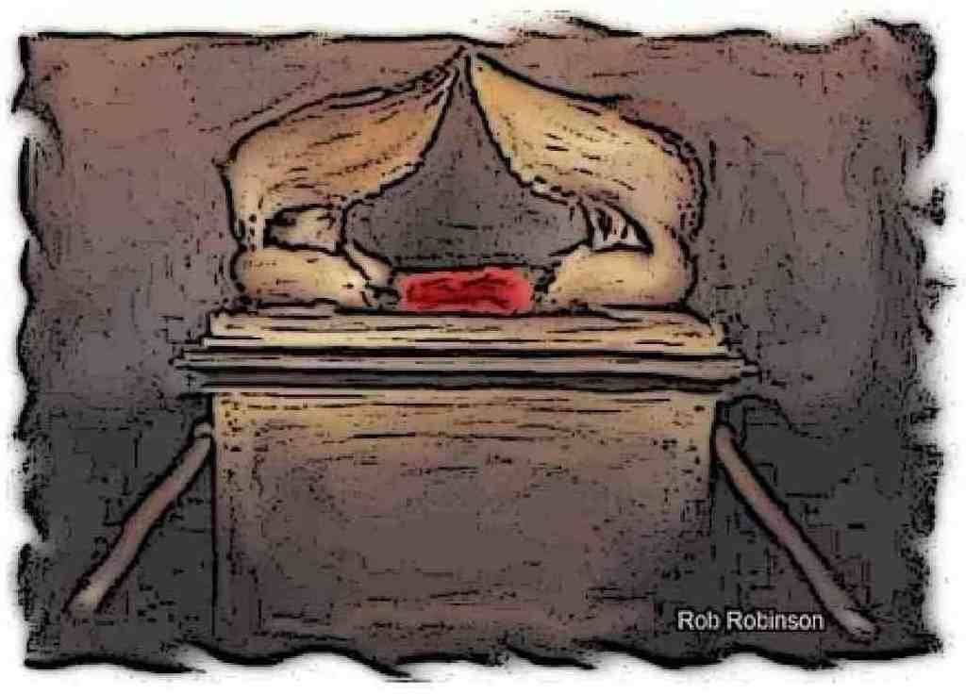

A
s the whirlwind passeth, so is the wicked no more: but the righteous is an everlasting foundation. (Proverbs 10:25)

B
ehold, a whirlwind of the LORD is gone forth in fury, even a grievous whirlwind: it shall fall grievously upon the head of the wicked. (Jeremiah 23:19)

Today’s hymn is particularly germane to the weather events of recent days during which a great storm has ravaged the coastal and inland regions of the states of North Carolina, South Carolina, and Virginia leaving floods of water and many homeless.

This is a hymn of the Trinity Season written by an Anglican cleric, the Rev. Hugh Stowell, in 1828. The music, RETREAT, by Hastings, has remained unchanged from its early publication. The hymn has been in the Anglican and Episcopal Hymnals since 1874.

Prominently and repeatedly mentioned in this hymn is the Mercy Seat of God. It embodies the fullness of our salvation and is ABOVE the Ark containing the Law behind the veil of the Holy of Holies in the Wilderness Tabernacle. Were it not for the Mercy Seat, all that would remain to us would be the unachievable perfection required by the Law of God; but just as the grace which flowed from the Rock before Mt. Sinai, at which the Law was later given, so the Mercy Seat is exalted above the Ark of the Covenant and Law of God.

From Every Stormy Wind that Blows

From ev'ry stormy wind that blows,
from ev'ry swelling tide of woes,
there is a calm, a sure retreat;
'tis found beneath the mercy seat.

There is a place where Jesus sheds
the oil of gladness on our heads,
a place than all besides more sweet;
it is the blood-stained mercy seat.

There is a spot where spirits blend,
where friend holds fellowship with friend,
tho' sundered far; by faith they meet
around the common mercy seat.

There, there on eagle wings we soar,
and time and sense seem all no more,
and heav'n comes down our souls to greet,
and glory crowns the mercy seat.

From ev'ry stormy wind that blows, from ev'ry swelling tide of woes, there is a calm, a sure retreat; 'tis found beneath the mercy seat. The judgment of God is often realized by storm, flood and wind; but there is also a common experience of such natural events throughout the world that are common to all races, tribes, and nations. I recall the great Hurricane Katrina that destroyed Biloxi and New Orleans on 29 August 2005. Perhaps by coincidence, and perhaps not, there was scheduled to transpire a 250,000 man gay parade on that day which did not occur. Were it not for the mercy of God, no soul would have been saved from either city; but God does spare His people in grace and mercy. There is a great calm and comfort at the Mercy Seat, and it does not depend upon the severity of the stormy blast or the raging waters – it is, rather, an inward peace and calm that cannot be approached by any calamities of nature in the physical world.

There is a place where Jesus sheds the oil of gladness on our heads, a place than all besides more sweet; it is the blood-stained mercy seat. We are an obstreperous and incorrigible people even under the best conditions of grace, but just as the Rock of Christ was struck by Moses at Mt. Horeb (the Mountain of God) to provide life-giving waters to a murmuring bunch of Israelites, so today He offers Mercy and Grace to His people who have fallen, as have all, from the righteousness that God is. The original ending of this stanza is presented here. Later editions of the Church Hymnal changed that wording to: It is the blessed Mercy Seat instead of the author’s it is the blood-stained mercy seat. It seems that the very mention of the blood of Christ is found to be offensive to the sensibilities of some sophisticated Anglicans.

Was it offensive to those disciples who witnessed His cruel death as a Redemption for our sins? It was certainly hurtful to our Lord, so why change the author’s Godly reference to something more ‘sterile.’ 13 And he shall put the incense upon the fire before the LORD, that the cloud of the incense may cover the mercy seat that is upon the testimony, that he die not: 14 And he shall take of the blood of the bullock, and sprinkle it with his finger upon the mercy seat eastward; and before the mercy seat shall he sprinkle of the blood with his finger seven times. 15 Then shall he kill the goat of the sin offering, that is for the people, and bring his blood within the veil, and do with that blood as he did with the blood of the bullock, and sprinkle it upon the mercy seat, and before the mercy seat: (Leviticus 16:13-15) Why change that line, Reader? Does it improve the power, or lessen it?

There is a spot where spirits blend, where friend holds fellowship with friend, tho' sundered far; by faith they meet around the common mercy seat. There is, as Paul makes reference, a Great Cloud of Witnesses. Wherefore seeing we also are compassed about with so great a cloud of witnesses, let us lay aside every weight, and the sin which doth so easily beset us, and let us run with patience the race that is set before us, (Hebrews 12:1) Our spirits blend with those of our common faith in Christ to remove divisions and contentions. Moreover, the Hosts of Heaven oversee our every thought, word, and deed. Together, we gain power and courage from one another to persevere on the Hard Road to New Jerusalem. Love knows neither distance nor death - it is ever lasting and imperishable. And let us consider one another to provoke unto love and to good works: Not forsaking the assembling of ourselves together, as the manner of some is; but exhorting one another: and so much the more, as ye see the day approaching. (Hebrew 10:24-25) Christ is that blood-stained Mercy Seat, and wherever two or three are gathered together in His name, there is the Mercy Seat.

There, there on eagle wings we soar, and time and sense seem all no more, and heav'n comes down our souls to greet, and glory crowns the mercy seat. The eagle can soar above the storm if he KNOWS it. There is a story of Hatteras Joe – a great eagle of the North =Carolina coast who perished following such a storm because he remained behind with his talons sunk into a stump at which he had recovered from a broken wing long before. He put his trust in the arm of flesh instead of soaring above the storm on the winds of the Holy Ghost which God had provided. The eagle at mid-age renews its strength by pulling out all of its old and oil caked feathers and grows new ones. He then appears as a new eagle with a new life. So should we. If the sinner becomes sorely disgusted with himself and turns to God, how different are his days on earth and his eons in Heaven! But they that wait upon the LORD shall renew their strength; they shall mount up with wings as eagles; they shall run, and not be weary; and they shall walk, and not faint. (Isaiah 40:31)

Look to the Mercy Seat!

