Hymn 392 – From Glory to Glory Advancing – 8 January 2019, Anno Domini (In the Year of our Lord)

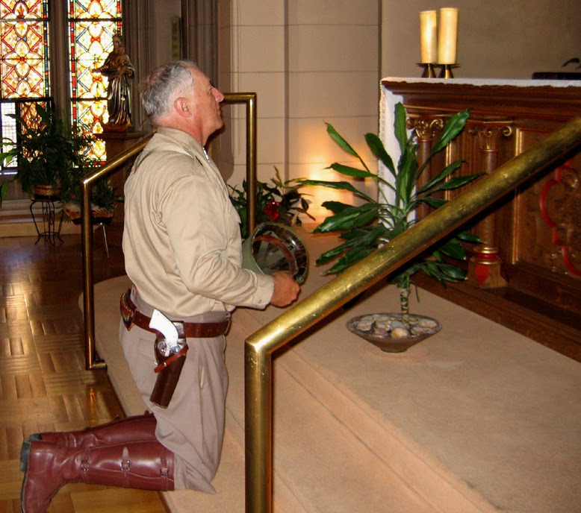

S
eeing then that we have such hope, we use great plainness of speech: 13 And not as Moses, which put a vail over his face, that the children of Israel could not stedfastly look to the end of that which is abolished: 14 But their minds were blinded: for until this day remaineth the same vail untaken away in the reading of the old testament; which vail is done away in Christ. 15 But even unto this day, when Moses is read, the vail is upon their heart. 16 Nevertheless when it shall turn to the Lord, the vail shall be taken away. 17 Now the Lord is that Spirit: and where the Spirit of the Lord is, there is liberty. 18 But we all, with open face beholding as in a glass the glory of the Lord, are changed into the same image FROM GLORY TO GLORY, even as by the Spirit of the Lord. (2 Cor 3:12-18)

This hymn devotion was requested by a member of our Church for today. It is a Hymn whose purpose is to prepare our hearts to attend the invitation to the Lord’s Table given in the Invitation just prior to the Prayer of General Confession in the Service of Holy Communion:

Y
E who do truly and earnestly repent you of your sins, and are in love and charity with your neighbours, and intend to lead a new life, following the commandments of God, and walking from henceforth in his holy ways; Draw near with faith, and take this holy Sacrament to your comfort;and make your humble confession to Almighty God, devoutly kneeling. (1928 Book of Common Prayer, pg 75)

The Lord’s Supper is not to be understood in isolation to all other aspects of our Christian living. It is intended to prepare our souls in strength to face the challenges of the world which unfailingly attend the Christian life. Just as the laborer needs food for strength to labor, so does the Christian believer draw spiritual strength from partaking of the Communion elements which in elemental form represent our Lord Jesus Christ which is the whole Word of God. Though He is always present where “two or three are gathered together in His Name,” His presence at the Lord’s Table is peculiarly and especially powerful in all that it represents to us.

The opening line is taken from the Liturgy of St. James. The lyrics are the composition of C.W. Humphreys (1906); and the tune is, ST. KEVERNE, by Craig Sellar Lang (1936) – so called after the name of a Cornish fishing village which was a favorite place of the score’s author.

From Glory to Glory Advancing

From glory to glory advancing, we praise thee, O Lord;
thy name with the Father and Spirit be ever adored.
From strength unto strength we go forward on Sion's highway,
to appear before God in the city of infinite day.

Thanksgiving and glory and worship and blessing and love,
one heart and one song have the saints upon earth and above.
O Lord, Evermore to thy servants thy presence be nigh;
ever fit us by service on earth for thy service on high.

From glory to glory advancing, we praise thee, O Lord; thy name with the Father and Spirit be ever adored. From strength unto strength we go forward on Sion's highway, to appear before God in the city of infinite day. General George Patton was one of the greatest field commanders of World War II, if not the greatest. He rejected the notion of stationary defenses, but advocated a constant movement of offense against the enemy’s defenses. Simply holding conquered ground was not acceptable to Patton as long as there was an enemy threat that existed any place at the front of his maneuver elements. The Christian warrior must be of the same mold. We cannot cower behind defense works while the enemy of our Lord occupies any parcel of spiritual ground at our front. We must ADVANCE, and ADVANCE, and ADVANCE against his mal-appropriated holdings. WE cannot allow the enemy of our souls to rob our cradles, enter in at our schools, banish prayer and Bible reading from our public forums, or even to occupy his favored citadel - politics. By the way, another favorite stronghold of Satan is our modern churches rife with spiritual delusions and apostasy. We have God our Father as our strength and fortress – why should we not act with overwhelming force against our enemy? We must be on the march on Sion’s Highway despite the enemy’s spiritual roadblocks and tempting detours. Only by unfailing faith and soldierly courage can we break through every impediment of faith to seize the remunerative objective and victory at the road’s end – the City of God!

Thanksgiving and glory and worship and blessing and love, one heart and one song have the saints upon earth and above. O Lord, Evermore to thy servants thy presence be nigh; ever fit us by service on earth for thy service on high. All of worship, blessings and thanksgiving are solely to the Glory of God and not to that of any man – including ourselves. The one heart of the Christian belongs to our Lord without corners of reserved sin. We do not come to Christ with a single coveted sin – all must be surrendered to him. That heart surrendered to Christ will be cleaned and sanctified by His Spirit day by day. We are incapable of doing that work for ourselves – it is a work of God. Our hearts cannot hold Christ ‘AND’ anything else. It’s deed must be signed over wholly to Him. A good man out of the good treasure of the heart bringeth forth good things: and an evil man out of the evil treasure bringeth forth evil things. (Matt 12:35) In our daily walks, devotions, works, and study, Christ is as near to us as He was to the two men on the Road to Emmaus though we may not be aware of it at all times. But when we come to His Table, we are made spiritually whole in the proper reception of His Body and Blood through the spiritual Presence and memorials we receive. He is with us at that Table in the Presence of His Holy Spirit. Without that Presence, we can do nothing of worth.

Footnote:
O Lord, Evermore to thy servants thy presence be nigh; ever fit us by service on earth for thy service on high. Our service on earth is a reflection of our adherence to those General Orders we have received from God’s Word. It is not only an expression of God’s expectations of His adopted children, but also a Mirror to our souls. We see our depravity in King David, in Jacob, in Paul, in Peter, and a thousand others of the Bible. 12 Seeing then that we have such hope, we use great plainness of speech: 13 And not as Moses, which put a vail over his face, that the children of Israel could not stedfastly look to the end of that which is abolished: 14 But their minds were blinded: for until this day remaineth the same vail untaken away in the reading of the old testament; which vail is done away in Christ. 15 But even unto this day, when Moses is read, the vail is upon their heart. 16 Nevertheless when it shall turn to the Lord, the vail shall be taken away. 17 Now the Lord is that Spirit: and where the Spirit of the Lord is, there is liberty. 18 But we all, with open face BEHOLDING AS IN A GLASS the glory of the Lord, are changed into the same image from glory to glory, even as by the Spirit of the Lord. (2 Cor 3:12-18) The very thoughts and contemplations of our heart will manifest itself in the outward appearance and actions of the believer. As we dwell, day by day, in the spiritual Land of Beulah, we shall come to be like the proper citizen of Beulah Land. There is a beautiful old song that reflects that truth:

I am dwelling on the mountain,
Where the golden sunlight gleams
O’er a land whose wondrous beauty
Far exceeds my fondest dreams;
Where the air is pure, ethereal,
Laden with the breath of flow’rs,
They are blooming by the fountain,
’Neath the amaranthine bow’rs.
Refrain:
Is not this the land of Beulah?
Blessed, blessed land of light,
Where the flowers bloom forever,
And the sun is always bright!

Where do you dwell daily, friend?

