Devotion on Hymns of the Church (Hymn 385 - Glorious Things of Thee are Spoken) – 8 July 2014, Anno Domini (In the Year of our Lord)

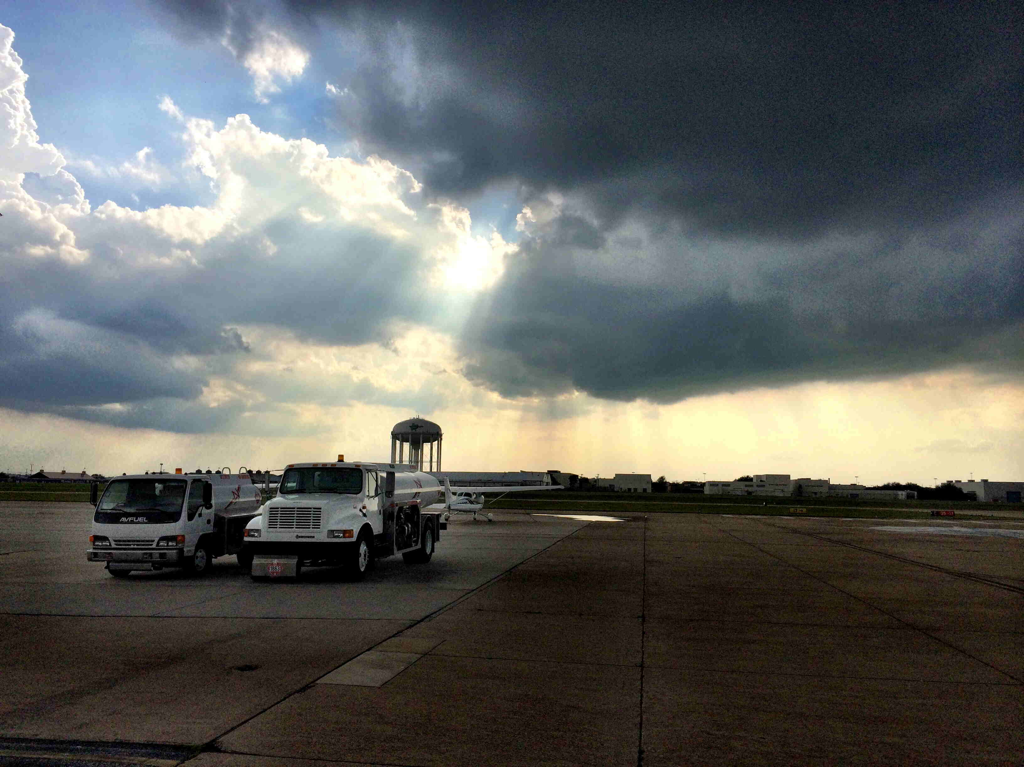

Give ear, O ye heavens, and I will speak; and hear, O earth, the words of my mouth. My doctrine shall drop as the rain, my speech shall distil as the dew, as the small rain upon the tender herb, and as the showers upon the grass: Because I will publish the name of the LORD: ascribe ye greatness unto our God. He is the Rock, his work is perfect: for all his ways are judgment: a God of truth and without iniquity, just and right is he. (Deut 32:1-4)

The term “Praise and Worship” is bandied about these days to describe churches that have practically become free-for-alls as far as reverence in worship is concerned, but this great old gem of reverential majesty has survived to reveal the true nature of biblical praise and worship. It was composed in 1779 by that old “Reprobate of the Seas” turned preacher who was saved by the very grace of which he wrote in the hymn, Amazing Grace – John Newton. The musical score is by Franz Joseph Haydn entitled, Austria. The same is the tune for the German National Anthem, “Deutschland Ober Alles.”

Glorious Things of Thee are Spoken

Glorious things of thee are spoken,
Zion, city of our God;
he whose word cannot be broken
formed thee for his own abode;
on the Rock of Ages founded,
what can shake thy sure repose?
With salvation's walls surrounded,
thou may'st smile at all thy foes.

See! the streams of living waters,
spring form eternal love,
well supply thy sons and daughters
and all fear of want remove.
Who can faint, when such a river
ever flows their thirst to assuage?
Grace which, like the Lord, the Giver,
never fails from age to age.

Round each habitation hovering,
see the cloud and fire appear
for a glory and a covering,
showing that the Lord is near.
Thus they march, their pillar leading,
light by night, and shade by day;
daily on the manna feeding
which he gives them when they pray.

Blest inhabitants of Zion,
washed in the Redeemer's blood!
Jesus, whom their souls rely on,
makes them kings and priests to God.
'Tis his love his people raises
over self to reign as kings:
and as priests, his solemn praises
each for a thank-offering brings.

Savior, if of Zion's city,
I through grace a member am,
let the world deride or pity,
I will glory in thy Name.
Fading is the worldling's pleasure,
all his boasted pomp and show;
solid joys and lasting treasure
none but Zion's children know.

If that old saint, John Newton, had a besetting weakness, it was a failure to comprehend the fullness of God’s Grace of which he sang. The grace of God was, indeed, sufficient for a depraved old slave-trader such as Newton, and it is sufficient for you and me if we turn to Christ by faith and receive His grace – for we are saved: “Even when we were dead in sins, hath quickened us together with Christ, (by grace ye are saved;)” (Eph 2:5) and “Who hath saved us, and called us with an holy calling, not according to our works, but according to his own purpose and grace, which was given us in Christ Jesus before the world began.” (2 Tim 1:9) It is likely that John Newton had been such a great sinner that he sometimes wondered, “How could God forgive all of those egregious sins?” But God can, and did for John Newton.

“Glorious things of thee are spoken, Zion, city of our God; he whose word cannot be broken formed thee for his own abode; on the Rock of Ages founded, what can shake thy sure repose? With salvation's walls surrounded, thou may'st smile at all thy foes.” The Heavenly Kingdom is our Zion – not some broken and dusty little town of violence. It is the City of God and His dwelling place, and, in the last instance, it is the heart of the believer. He formed the believer’s heart for His own abode so that temple walls built by human hands will not suffice for the Temple of God – it is the Chambers of Faith of the human heart that believes. “Know ye not that ye are the temple of God, and that the Spirit of God dwelleth in you? If any man defile the temple of God, him shall God destroy; for the temple of God is holy, which temple ye are.” (1 Cor 3:16-17)

Men and churches today read books that are designed for sensation that extol the efforts of the Jews to rebuild the Temple in Jerusalem and renew there the Temple sacrifices. This is heralded as some great movement of God. Why do you suppose God would view the resumption of animal sacrifices with favor and approval? Such sacrifices flatly reject the once-and-for-all sacrifice of God’s beloved son on our behalf. “But Christ being come an high priest of good things to come, by a greater and more perfect tabernacle, not made with hands, that is to say, not of this building; Neither by the blood of goats and calves, but by his own blood he entered in once into the holy place, having obtained eternal redemption for us. For if the blood of bulls and of goats, and the ashes of an heifer sprinkling the unclean, sanctifieth to the purifying of the flesh: How much more shall the blood of Christ, who through the eternal Spirit offered himself without spot to God, purge your conscience from dead works to serve the living God?” (Heb 9:11-14)

Have we forsaken logic and common sense in desiring a return to those inefficacious sacrifices? Surely, when Satan’s great hordes gather about the Camp of the Saints and the Holy City of God, we may smile at his multitudes and at his presumption in offending the Sovereign of Heaven. “And shall go out to deceive the nations which are in the four quarters of the earth, Gog and Magog, to gather them together to battle: the number of whom is as the sand of the sea. 9 And they went up on the breadth of the earth, and compassed the camp of the saints about, and the beloved city: and fire came down from God out of heaven, and devoured them.” (Rev 20:8-9)

“See! the streams of living waters, spring from eternal love, well supply thy sons and daughters and all fear of want remove. Who can faint, when such a river ever flows their thirst to assuage? Grace which, like the Lord, the Giver, never fails from age to age.” Those streams of Living Waters flow, unchecked, by the blessed Tree of Life that our old father Adam rejected in favor of the bitter tree beside. But those Waters now flow in Paradise before and around the Tree of Life: “And he shewed me a pure river of water of life, clear as crystal, proceeding out of the throne of God and of the Lamb. In the midst of the street of it, and on either side of the river, was there the tree of life, which bare twelve manner of fruits, and yielded her fruit every month: and the leaves of the tree were for the healing of the nations.” (Rev 22:1-2)

In every description of the term, our Lord Jesus Christ is that Tree of Life which Adam rejected. He is also that River of Life that bathes the Tree of Life with the dew-drops of Love. What a magnificent provision God has made from His Heart of Grace to those who belong to Him!

“Round each habitation hovering, see the cloud and fire appear for a glory and a covering, showing that the Lord is near. Thus they march, their pillar leading, light by night, and shade by day; daily on the manna feeding which he gives them when they pray.” This is the Glory Cloud our Founding Fathers placed above the Shield on the Great Seal of the United States containing the Thirteen Stars. The Great Pillar was a Light by Night and a Cloudy Shade by day. It both led and defended the Children in the Wilderness. His Providence led, also, this great nation for many decades of our existence; but of late, the people of America have grown dim of memory and have forgotten the Pillar of fire that led our fathers and have sought out false and superficial lights of the world. If we will, before the Lord lowers judgment, return to following that Pillar of Fire by night, and cloud by day, we shall again find healing for our sorrows and a Balm of Gilead for our distresses as a nation. The Manna (Bread of Heaven) which is Christ will again flow down in torrents as in the day of hunger in the Wilderness, if we shall only repent, pray, and turn from our wicked ways. (2 Chron 7:14). Not only have our national leaders gone after those false lights of the world, but even so have our churches.

“Blest inhabitants of Zion, washed in the Redeemer's blood! Jesus, whom their souls rely on, makes them kings and priests to God. 'Tis his love his people raises over self to reign as kings: and as priests, his solemn praises each for a thank-offering brings.” You will remember that great day when, terrified, the Children of Israel came upon the Banks of the Red Sea. They looked behind and their hearts fainted within their breasts to see the mighty army of Pharaoh in close pursuit. There was no earthly hope for their salvation, but there was a Divine remedy. The Pillar of Fire descended to separate them from Pharaoh until that same Pillar could lead across the dry causeway miraculous made for them through the parted waters of the Sea. The entire nation was, on that day, baptized in the restrained waters of the Red Sea. The same miracle that saved Israel that day was the one by which the armies of Pharaoh were doomed. It can be true again for America if we will only turn and be saved – else only the looming abyss remains for us.

“Savior, IF of Zion's city, I through grace a member am, let the world deride or pity, I will glory in thy Name. Fading is the worldling's pleasure, all his boasted pomp and show; solid joys and lasting treasure none but Zion's children know.” The second word, IF, in this verse is quite telling of the preacher of Grace (John Newton). He stills wonders that God could forgive a swearing, drunken, harsh slave trader such as he was before the floodgates of grace were opened for him. No need for the ‘IF.’ We have all become ‘naturalized citizens’ of the City of Zion by Grace if we have become a Child of God – no ifs, ands, or buts about it, as my mother used to say. We may be derided by the world, but we are a large people of two, or even three, if the Lord is among us. Yes, as we advance ever onward to the Holy City, the scenery of the world fades into oblivion. The saint should scarce remember the sins that preceded his gift of grace. We may, at times, hear the faint peels of false pride and pomp of the world, but we are climbing the Mountain of God. As we climb, we shall find the peak to be surrounded by the heavens and not the world. It is a great mystery that only the eyes of God’s chosen can see His Glory, or find His Grace. We wonder, “Why do the lost struggle in blindness when their vision will be clear if they will only come to the Light of the World” but they are blind – not only in their visual organ, but in their hearts as well. They may never come.

Have you come to the Light, friend?

