Hymn 377– Holy Spirit, Love Divine – 23 August 2016, Anno Domini (In the Year of our Lord)

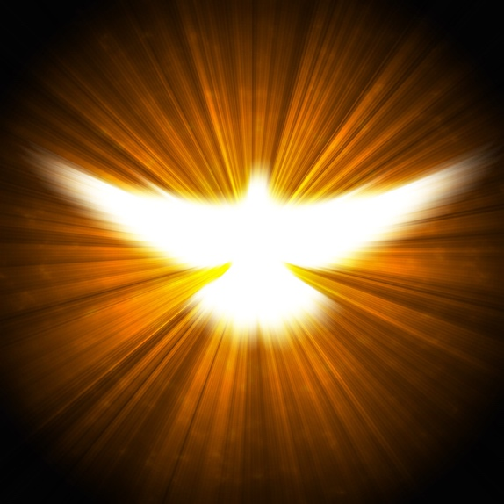

7 For God hath not called us unto uncleanness, but unto holiness. 8 He therefore that despiseth, despiseth not man, but God, who hath also given unto us his holy Spirit. 9 But as touching brotherly love ye need not that I write unto you: for ye yourselves are taught of God to love one another. (1 Thess 4:7-9)

16 This I say then, Walk in the Spirit, and ye shall not fulfil the lust of the flesh. 17 For the flesh lusteth against the Spirit, and the Spirit against the flesh: and these are contrary the one to the other: so that ye cannot do the things that ye would. 18 But if ye be led of the Spirit, ye are not under the law. (Gal 5:16-18)

In our modern day of nebulous biblical doctrine being propagated from the pulpits around the world, the Holy Spirit gets credited with much for which He has not spoken. If you believe the modern health and wealth gospelers, you would believe that the Holy Spirit utters things separate and apart from that contained in the Holy Gospel of Scripture. The Holy Spirit is accused of telling ministers all sorts of things that may line their own pockets by defrauding the consciences (and bank accounts) of their adherents. It will be wise to note two things about the Holy Spirit at the onset of any discussion of His nature:

- He never claims any recognition for Himself, but always points to our Lord Jesus Christ and Him crucified (we are a Christian Church, not a Holy Spirit Church) 13 Howbeit when he, the Spirit of truth, is come, he will guide you into all truth: for he shall not speak of himself; but whatsoever he shall hear, that shall he speak: and he will shew you things to come. 14 He shall glorify me: for he shall receive of mine, and shall shew it unto you. (John 16:13-14)

- He will never make any utterance that is not directly reflected in Holy Scripture – simply bringing to our own remembrance all things written of our Lord, and that is every Word of the Bible. (see John 14:26)

This is a beautifully descriptive hymn revealing the nature of the Holy Spirit. It was unfortunately composed by a Unitarian – Samuel Longfellow, brother to Henry Wadsworth Longfellow, in 1864: however, in his mature years, Longfellow rejected the title, Unitarian. It does not appear that Unitarian theology influenced the words of the hymn since it does not demean the Trinitarian Gospel. The musical score is by Lew Trenchant. The hymn is similar in wording to a previously written devotion on the Bible – Holy Bible, Book Divine, published in our media (of AOC) on September 16th of last year.

Holy Spirit, Love Divine
(#377, 1940 Hymnal)

Holy Spirit, Truth divine,
dawn upon this soul of mine;
Breath of God and inward Light
wake my spirit, clear my sight.

Holy Spirit, Love divine,
glow within this heart of mine;
kindle every high desire;
perish self in thy pure fire.

Holy Spirit, Power divine
fill and nerve this will of mine;
by thee may I strongly live,
bravely bear and nobly strive.

Holy Spirit, Right divine,
King within my conscience reign;
be my Lord, and I shall be
firmly bound, forever free.

Holy Spirit, Peace divine,
still this restless heart of mine;
speak to calm this tossing sea,
stayed in thy tranquility.

Holy Spirit, Joy divine,
gladden thou this heart of mine;
in the desert ways I sing,
“Spring, O Well, forever spring.”

Holy Spirit, Truth divine, dawn upon this soul of mine; Breath of God and inward Light wake my spirit, clear my sight. The coming of the Holy Spirit upon the soul that has languished in darkness all prior days of life is a stunning example of a glorious sunrise in that soul after long nights of abject thirst for light. In fact, it is like the first burst of Light that God commanded in Creation, for that soul is truly a new creation. We are inherited the physical breath of life through Adam, and the spiritual breath of eternal life through our Lord. The Holy Spirit is our inward Light.

desire; perish self in thy pure fire. The glow of the Holy Spirit in the secret chambers of our hearts is our inner light of which Christ spoke. 34 The light of the body is the eye: therefore when thine eye is single, thy whole body also is full of light; but when thine eye is evil, thy body also is full of darkness. 35 Take heed therefore that the light which is in thee be not darkness. 36 If thy whole body therefore be full of light, having no part dark, the whole shall be full of light, as when the bright shining of a candle doth give thee light. (Luke 11:34-36) The light of every Christian heart is like a candle burning in a dark place (the world). The only way to receive the fullness of light into the eye is to look full face into the beam so that no dark corner is excluded. If we look askance, our eye will not be single in focus or purpose. Light destroys organisms harmful to life and, so, those sins of desire and greed that infect the soul of every man are checked by the Light of Christ. We die daily to self, and live for others.

Holy Spirit, Power divine fill and nerve this will of mine; by thee may I strongly live, bravely bear and nobly strive. The Holy Spirit is truly Power Divine acting through the Third Person of the Trinity. By infusing our hearts with divine love, it builds courage and strength otherwise lacking. To live strongly is to live by Gospel principles. To bravely bear is to stand without compromise. To nobly strive is to live as Christ lived. He lived as the Son of God, and we may live as the adopted sons and daughters of God.

Holy Spirit, Right divine, King within my conscience reign; be my Lord, and I shall be firmly bound, forever free. What does it mean for the Holy Spirit to rule in our conscience as King? It means to have been set free by the redeeming blood of our Lord Jesus Christ. It means to accept the Sovereignty of Christ in our lives, obeying every command as we would do a great and benevolent king of this world, but only more so. It means to accept that perfect will of Christ for our own wills and disposing of the so-called free will of the sinner. To be bound by freedom is to accept the laws and ordinances of the Constitution (Gospel) of the Kingdom.

Holy Spirit, Peace divine, still this restless heart of mine; speak to calm this tossing sea, stayed in thy tranquility. The heart can be most restless when there seems a worldly peace without. Those matters of the conscience and of doubt and worry can afflict the heart on battlefields as well as peaceful meadows. But the heart in which the Holy Spirit reigns supreme can be at perfect peace on the raging seas, the turmoil of war, or the crime-ridden streets of the city.

Holy Spirit, Joy divine, gladden thou this heart of mine; in the desert ways I sing, Spring, O Well, forever spring. The Holy Spirit is a Creator of Light just as when it moved upon the face of the waters. And God said, Let there be Light, and there was Light. That was the visible light of the heavenlies; but the Holy Spirit also creates an invisible light of the soul. It is the still, small voice that only the intended audience can hear or perceive. It makes glad the heart is wilderness areas where all others are forlorn and sorrowful. That Fountain of Living Waters that greeted poor Hagar in the wilderness will also make glad our hearts to the refreshing of the soul.

8 And when he is come, he will reprove the world of sin, and of righteousness, and of judgment: 9 Of sin, because they believe not on me; 10 Of righteousness, because I go to my Father, and ye see me no more; 11 Of judgment, because the prince of this world is judged. (John 16:8-11)

